***SQL***: *Structured Query Language. 5432*

***Database:***

* *Any collection of related information (-Tout ensemble d'informations connexes)*

*Database Management Systems (DBMS)*

* *Software program that helps you create and maintain databases*
* *C.R.U.D (Create, Read/Retrieve, Update, Delete) --- (Création, lecture/récupération, mise à jour, suppression)*
* *Security*
* *Backups*
* *Import/Export Data.*

***Two Types of Databases :***

* *Relational databases*
* *Non-Relational databases*

***Relational DBMS***

*• Helps you organize data into tables.*

*• Each table has rows and columns and a unique key that identifies each row*

*• PostgreSQL, MySQL, Microsoft SQL Server*

*• SQL is the standardized language for interacting with RDBMS*

*• SQL is used for C.R.U.D operations, admin tasks, user management, security, database access, etc.*

*• SQL code used in one RDBMS isn't always compatible with another without changes*

***Non-Relational DBMS***

*• NoSQL or Not Just SQL*

*• Organize data into anything but traditional tables*

*• Key-value stores, JSON, XML, graph*

*• Apache Cassandra, mongoDB, dynamoDB*

*• No set coding language - most NRDBMS implement their own language*

*• Apache Cassandra uses the Cassandra Query Language*

***Tables may have Primary key: A column that identify uniquely rows and Foreign Key: A column that link us to a primary Key in another tables. Primary Key may be Composite (2 0r more)***

**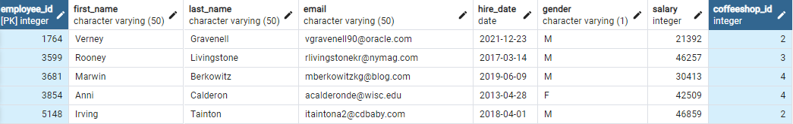*Employees Table:***

***Suppliers Table:***

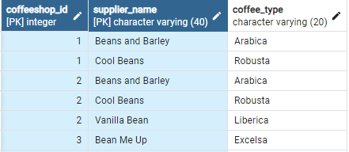

***Locations Table:***

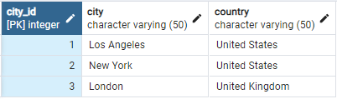

***Shops Table:***

