|  |  |
| --- | --- |
|  |  |

Validation Matrix Converter Kvint 39

## Overview

The validation matrix converter converts DRS results in csv format in a validation matrix in excel format.

This done by Python 3 code:

* config.py
* csvToExcel.py

Validation matrix converter need to have 3 folders:

* csv  
  This folder is where user put csv data that user wants to have in the   
  validation matrix.
* output   
  It where the validation matrix will be created.
* template  
  Where the template of the validation matrix is stored.

To start the validation matrix converter, just left klick on the config.py

The program will then will read all the csv files stored in csv and the template Excel file.

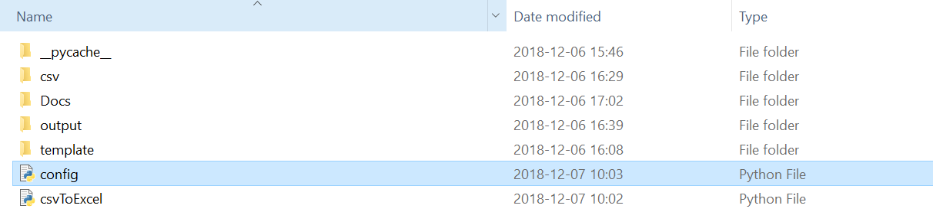

Figur 1: Show the files and folder in validation matrix folder.

After loading all files, it starts with cheek the signum that is in login on the computer and will be stored in validation matrix.

The matrix convert will also store the name of csv files that have been used.

The code has some error handling gives user an error text  
An example is if user have not the python packages needed.

## Setting options

## In config.py use have some options to set where read template, where to read csv, save files validation matrix

Also have the option set the frequency list for singleton in GHz and the frequency modulation bandwidth offset in GHz.

In csvToExcel.py you have the setting where put data depending on PCB,   
front-ends, temperature matrix id, polarization mode and frequency

## CSV structure

## The csv files that validation matrix converter is converting and need have some structure for the heads name. Some unique headers name that validation matrix converter used to decide some and filter the data. They are:

## Matrix id The data stored in Matrix id need have this structure as fowling: M1;M2;M4;M7

* Polarization
* RF Freq
* FE
* Temp target

There other header names that is impotent do but that just depend on what matrix id the csv have.

## Python packages

To run the validation matrix converter, it need to have some python packages done.

The easiest way to install this package use pip that’s is a tool for installing Python packages.

* Pandas  
  Python Data Analysis Library  
  cmd:   
   pip install pandas
* Openpyxl  
  cmd:   
   pip install openpyxl
* Pilow  
  cmd:   
   pip install pillow