**Model Results**

**Stateless**

- Results over 20 epochs:

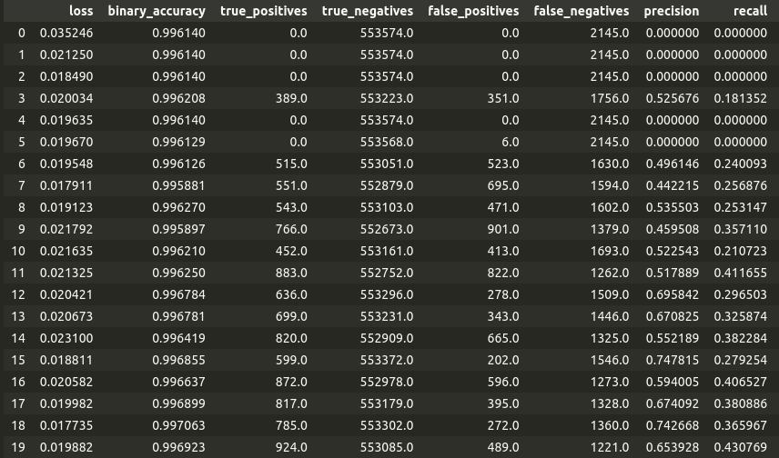

Charts for best epoch: **epoch 16**

**-** Confusion Matrix - ROC curve

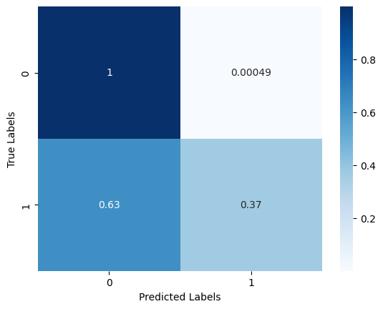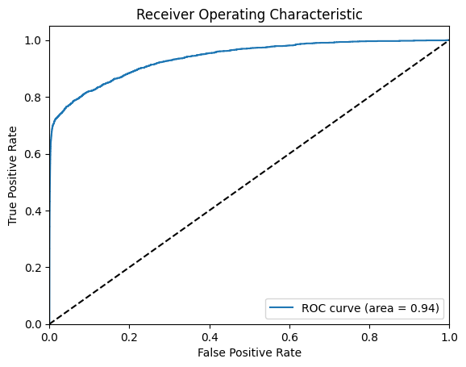

**Global State (single GRU that processes all transactions)**

- Results over 20 epochs:

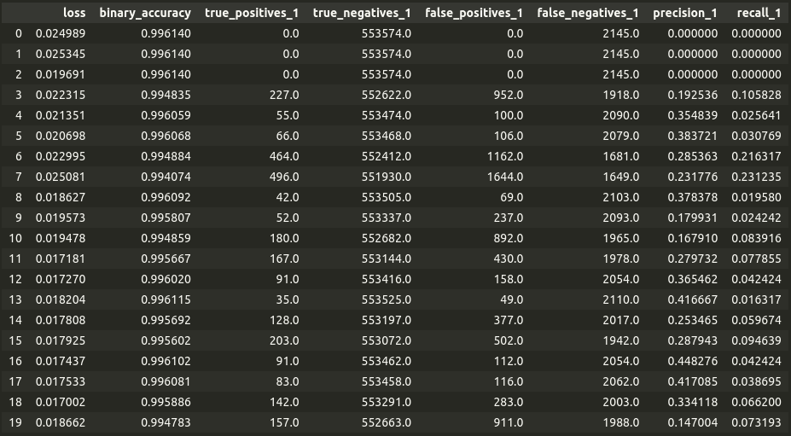

Charts for best epoch: **epoch 14**

**-** Confusion Matrix - ROC curve

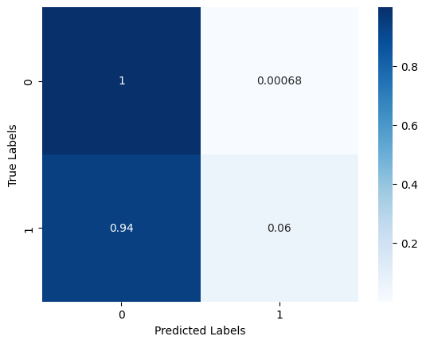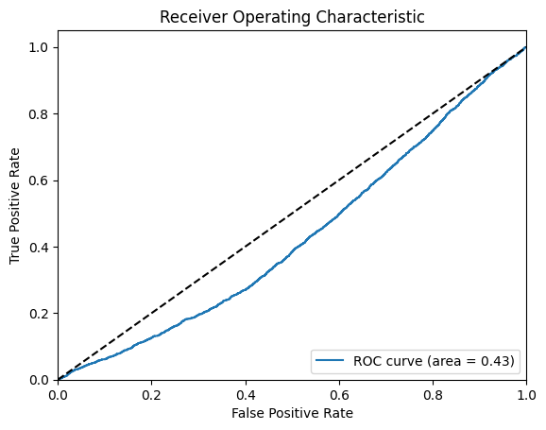

**Feedzai (single shared state for credit cards)**

- Results over 20 epochs:

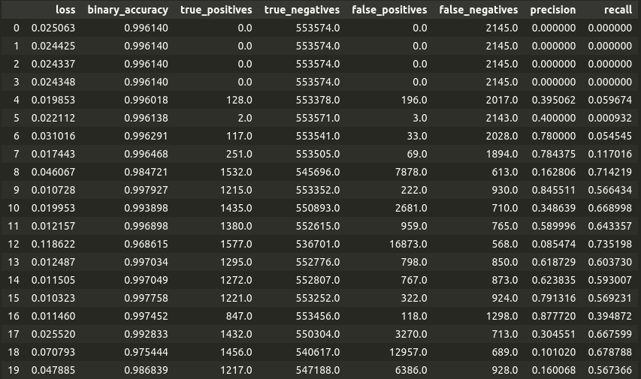

Charts for best epoch: **epoch 9**

**-** Confusion Matrix - ROC curve

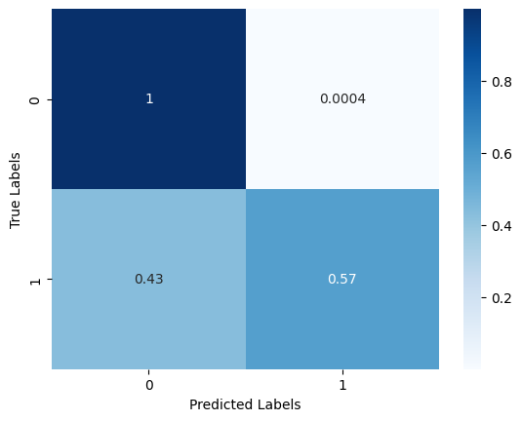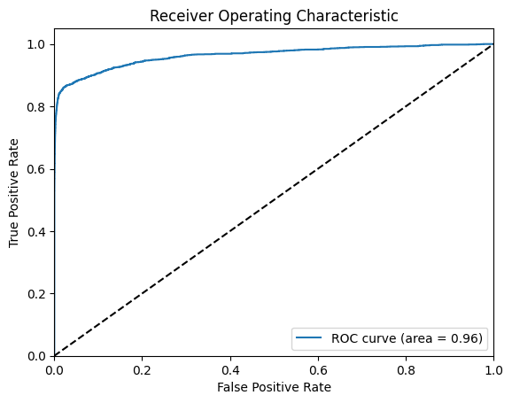

**Double (two shared states, one for credit cards and one for transaction category)**

- Results over 20 epochs:

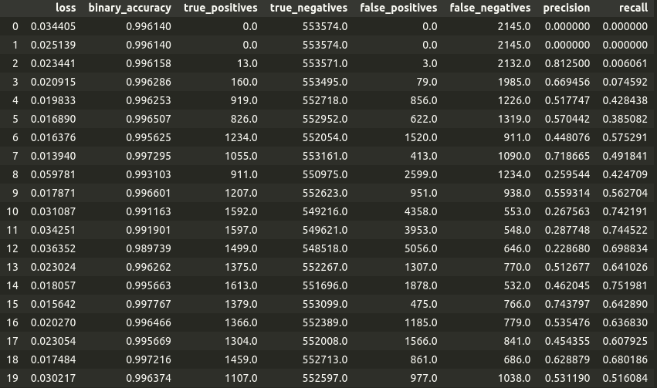

Charts for best epoch: **epoch 15**

**-** Confusion Matrix - ROC curve

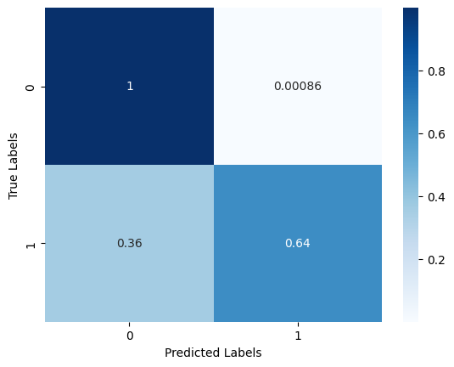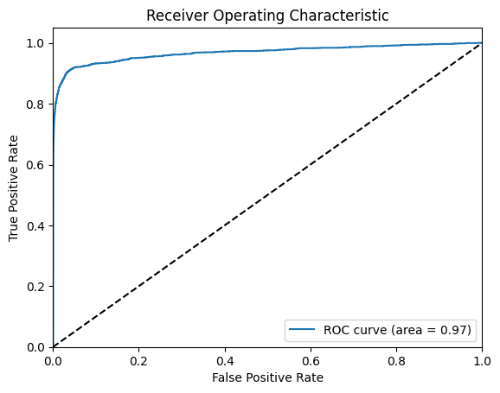

**Global Comparison**

**-** ROC curves

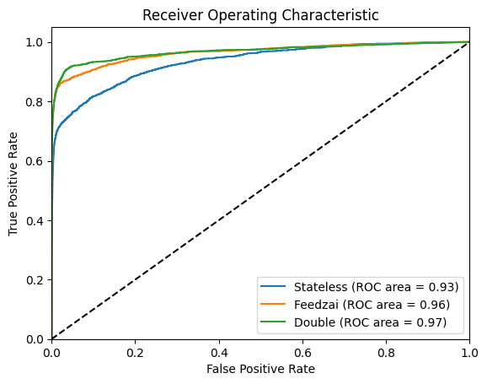

- Predictions for the first 500 transactions

