## INPUT OUTPUT SCREENS

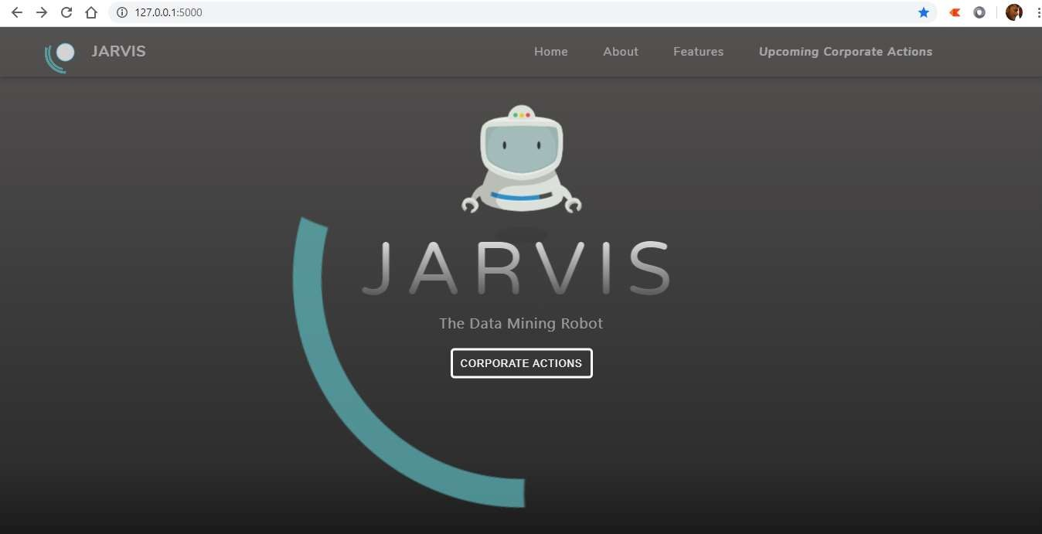

**Fig 8.1** The User Interface Of JARVIS

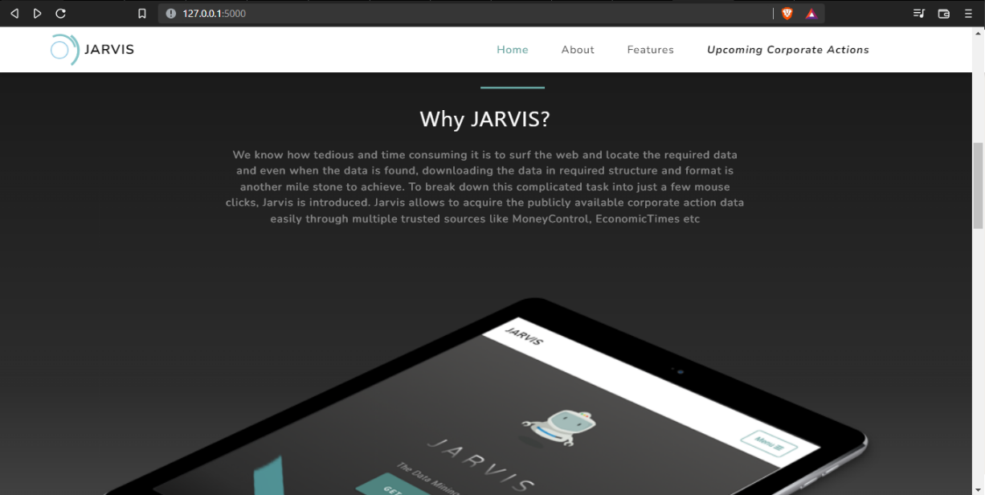

**Fig 8.2** The Figure Shows Why We Need To Use JARVIS

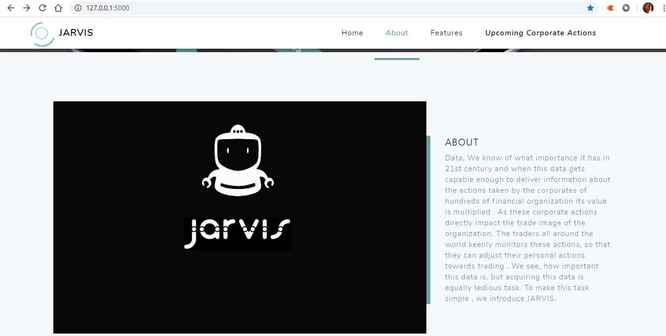

**Fig 8.3** The Figure Shows Brief View Of JARVIS

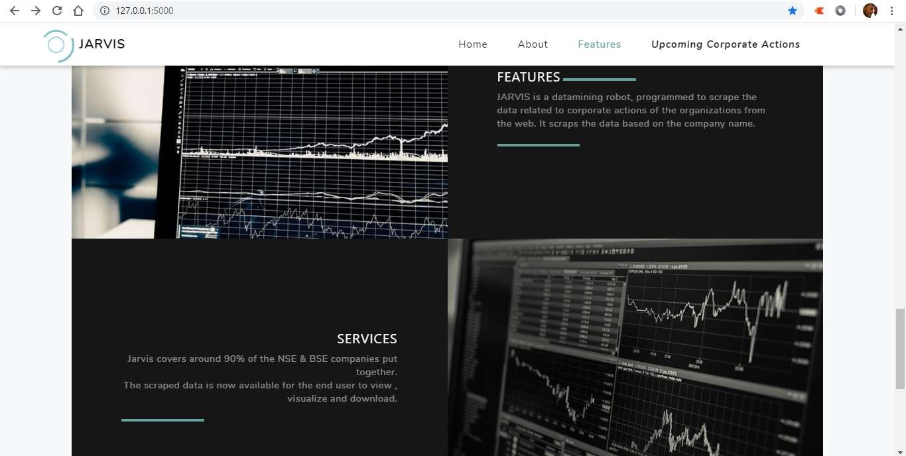

**Fig 8.4** The Figure Shows Features And Services Of JARVIS

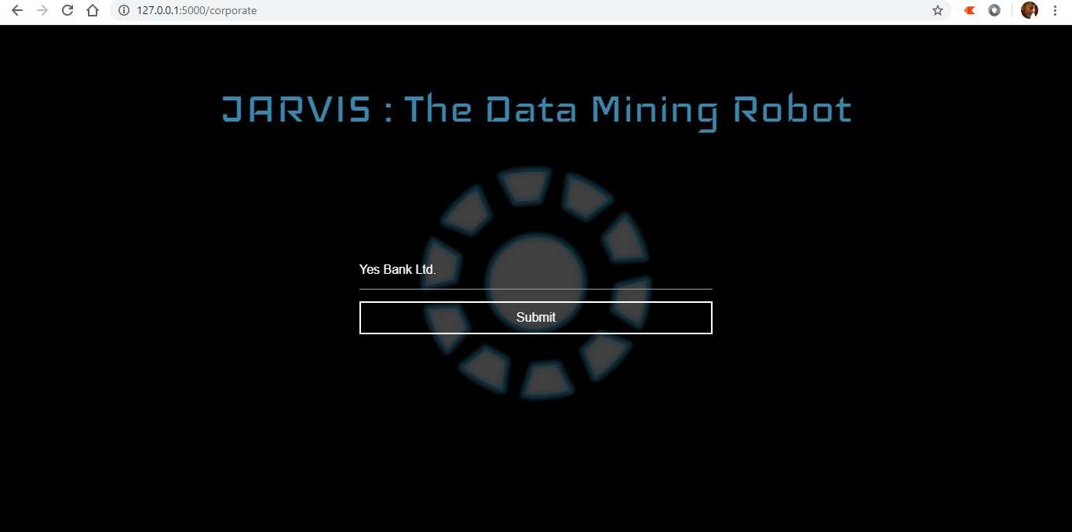

**Fig 8.5** Figure Shows Form For Scrapping Corporate Actions

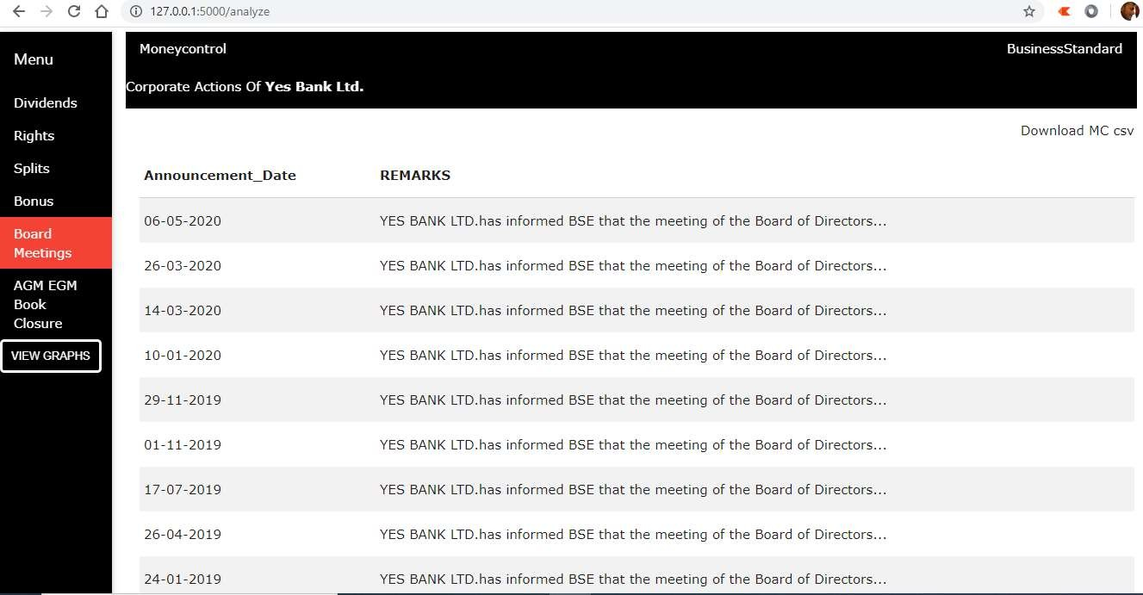

**Fig 8.6** Sample Scrapped Corporate Action Data

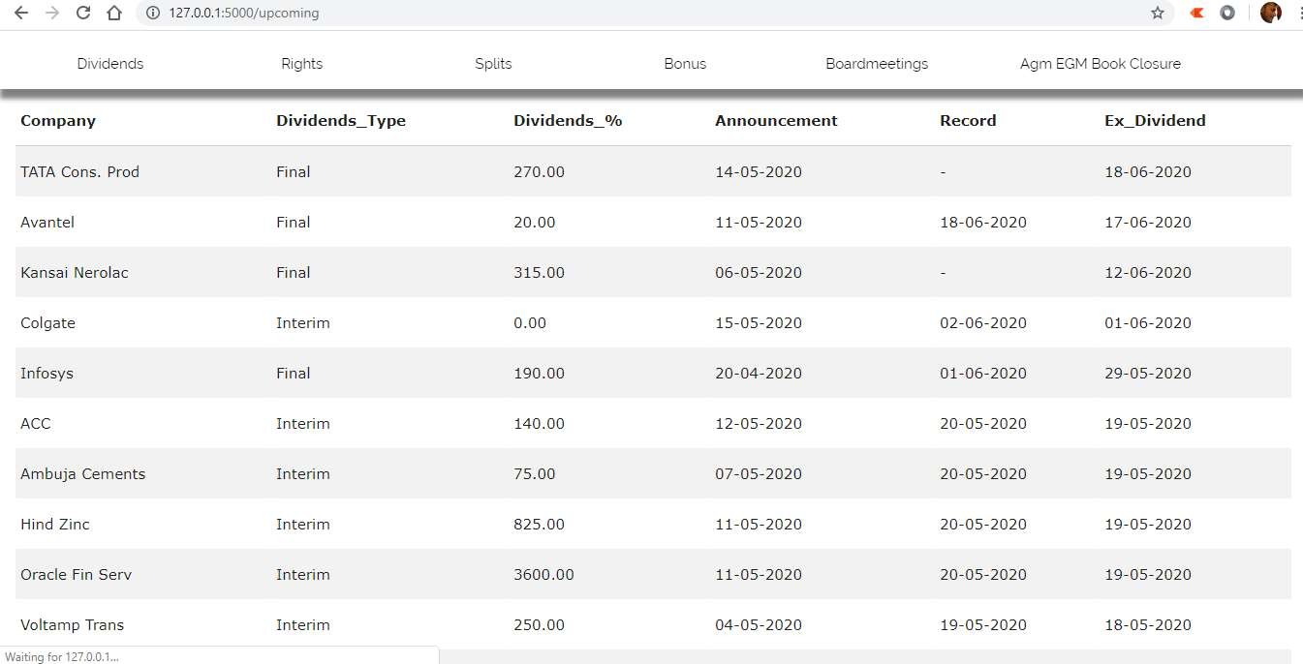

**Fig 8.7** Sample Scrapped Upcoming Corporate Action Data

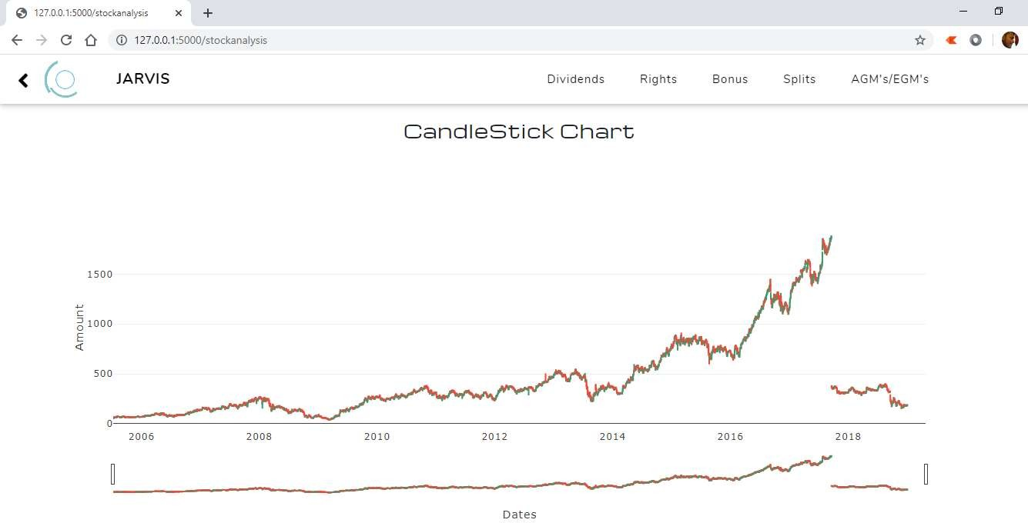

**Fig 8.8** Trend Graph of Stock Market Data

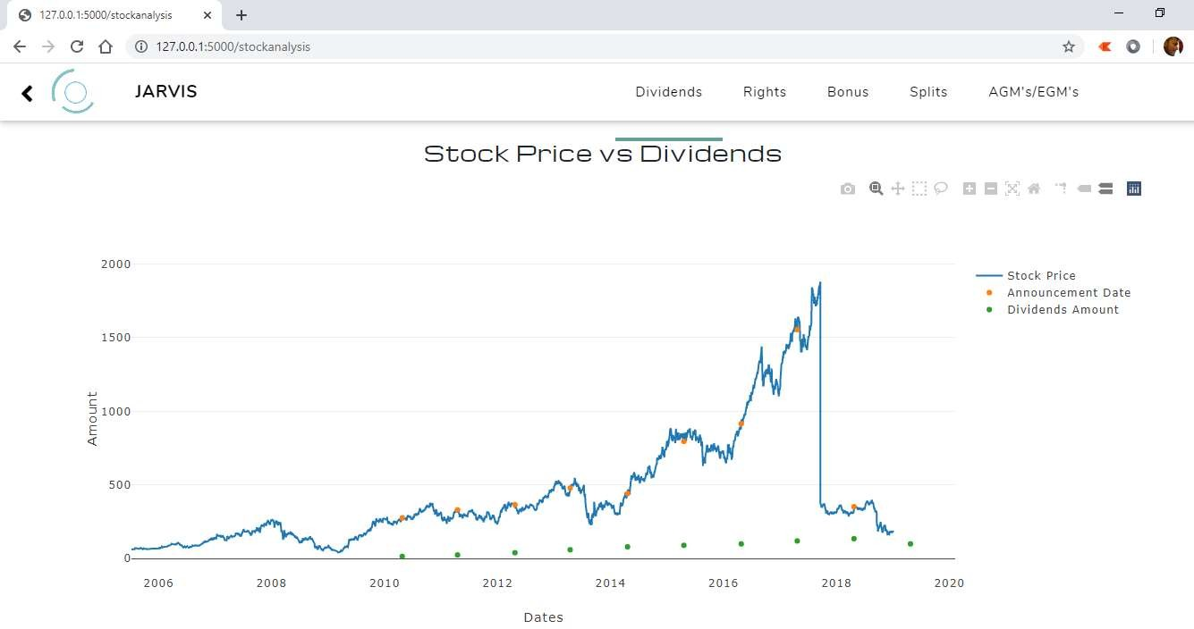

**Fig 8.9** Comparison Graph between Stock Price vs. Dividends

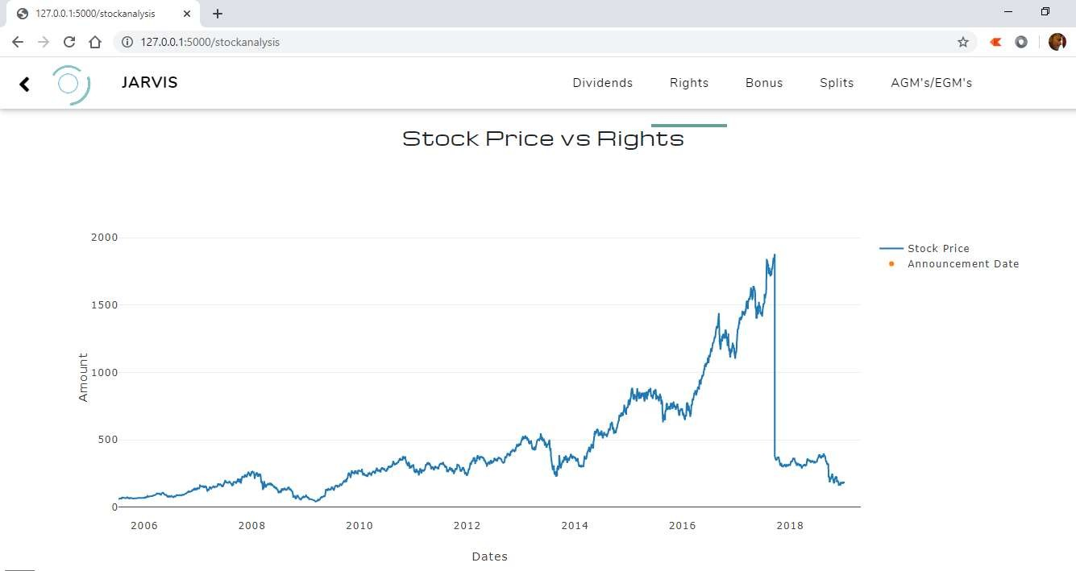

**Fig 8.10** Comparison Graph between Stock Price vs. Rights

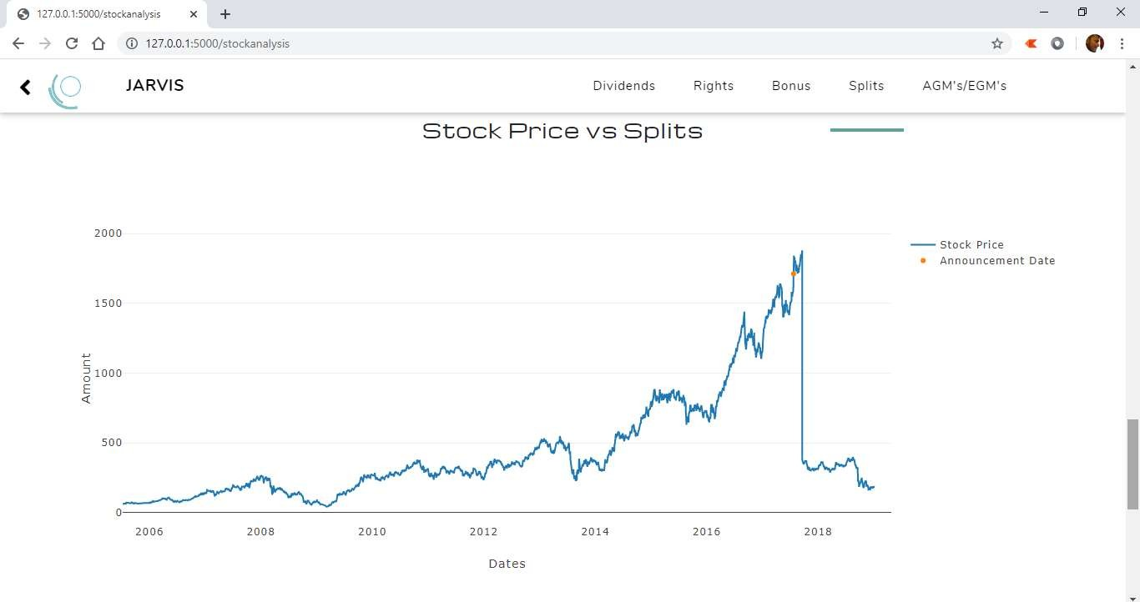

**Fig 8.11** Comparison Graph between Stock Price vs. Splits

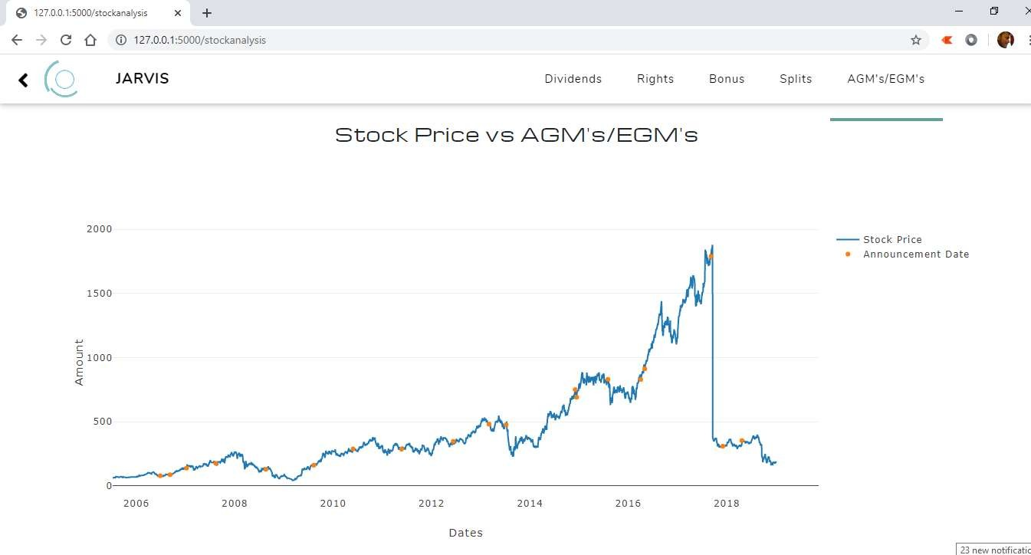

**Fig 8.12** Comparison Graph between Stock Price vs. AGM/EGN’s