**1. INTRODUCTION**

In this problem, we will try to visualize what would happen to a metal plate with a hole at the center of it if two temperature sources are connected to its opposing sides. To do so, we will make use of the relaxation method.

**2. PROBLEM STATEMENT**

A rectangular metal plate with width and height has a rectangular hole at its center, which has width and height . Initially, the plate is at temperature .

We will connect a source with a constant temperature of to its left side, while connecting a source with a constant temperature of to the opposing side. Then, we will wait for a long time, so that the plate reaches a steady state.

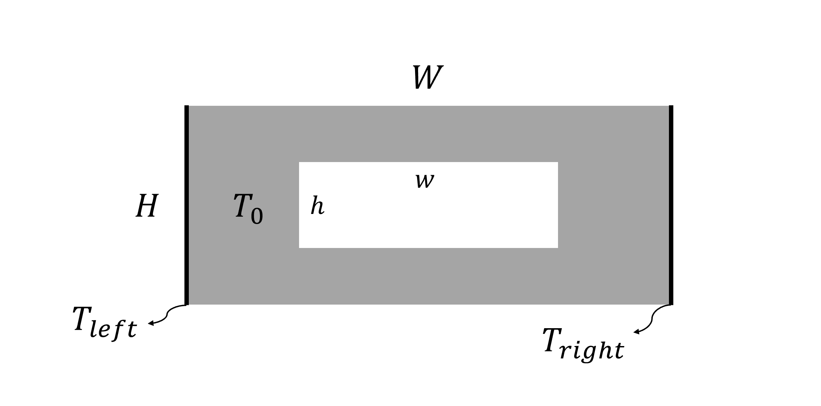

In order to describe how heat evolves with respect to time, we make use of the 2D heat equation:

|  |  |
| --- | --- |
|  | (1) |

where is thermal diffusivity.

To treat this equation numerically, we have to discretize the plate and define a grid of nodes in this way:

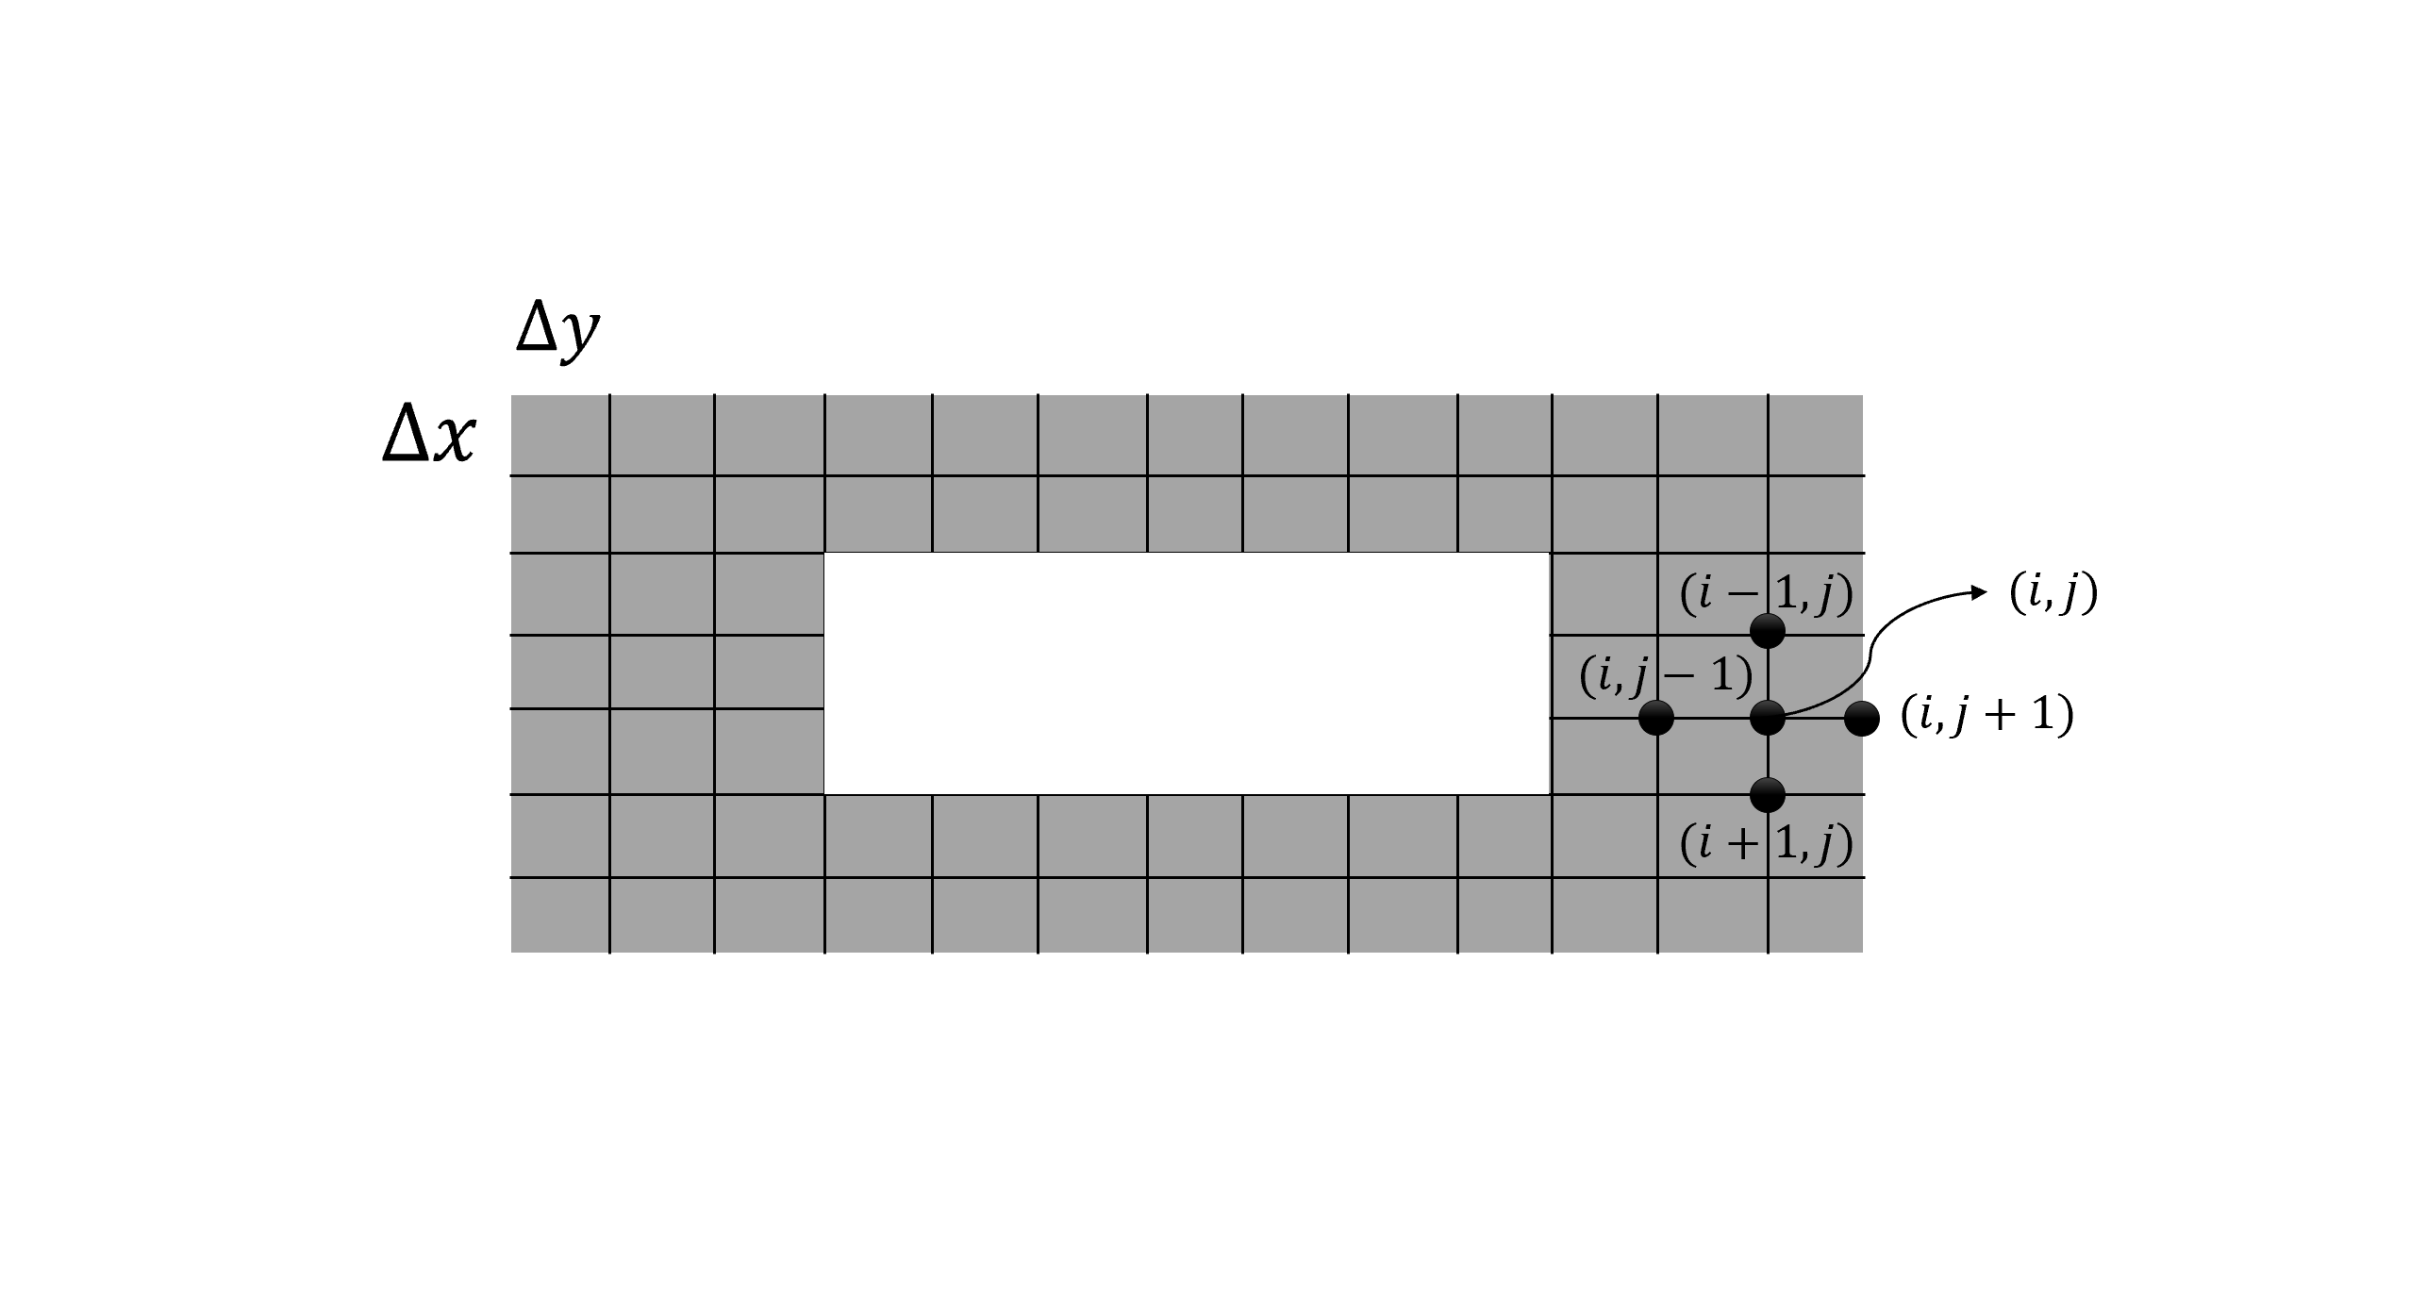

We will assume that . After discretizing Eq. 1, we could arrive at:

|  |  |
| --- | --- |
|  | (2) |

To see how Eq. 2 was derived, please refer to [this link](http://www.u.arizona.edu/~erdmann/mse350/_downloads/2D_heat_equation.pdf). Basically, the temperature at each node would be the average of its neighboring nodes. Note that the condition has to be satisfied in the simulation. Otherwise, Eq. 2 does not hold.

In this problem, you are asked to use Eq. 2 to plot the temperature of the plate at each node **when the plate reaches its steady state**. A great way to visualize the temperature would be to plot the temperature surface as a function of position ( and on the plate).

**3. CHECKING YOUR RESULTS**

In order to check your results, you can compare your results with the provided solution files in the GitHub repository.

**4. TABLE OF CONSTANTS**

|  |  |
| --- | --- |
|  |  |
|  |  |
|  |  |
|  |  |
|  |  |
|  |  |
|  |  |