**1. INTRODUCTION**

In this problem, we are going to explore the motion of a particle subject to two position-dependent forces. To do so we will find equilibrium positions of the particle using recently-learned root finding methods.

**2. PROBLEM STATEMENT**

A particle is subject to two forces, $F_{1}$ and $F_{2}$, which are functions of the distance, $r$, from an origin.

$$F_{2}$$

$$F_{1}$$

$$F_{1}=2e^{\frac{3}{4}r} \\ F_{2}=-r^{3}+\frac{11}{2}r$$

The net force on the particle as a function of the distance from the origin is plotted below.

$$F=2e^{\frac{3}{4}r}-r^{3}+\frac{11}{2}r$$

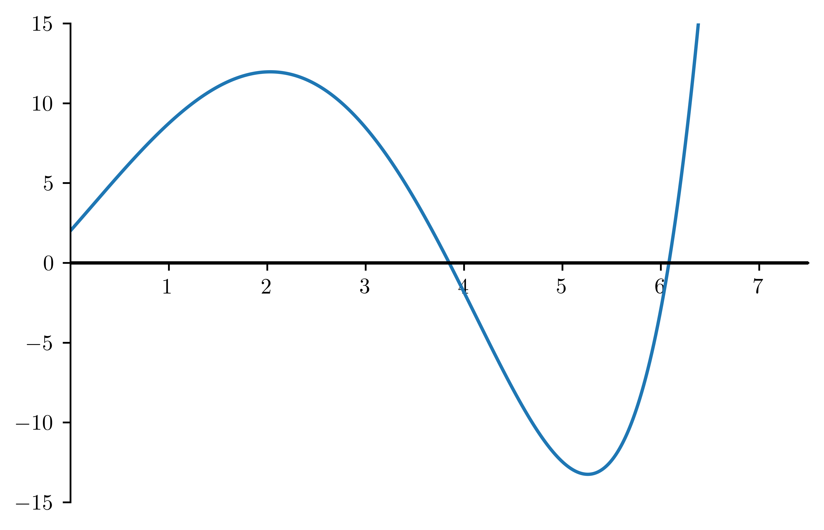

*F*

*r*

Stable Equilibrium

Unstable Equilibrium

The stable equilibrium is the point where the net force is zero and decreasing. The unstable equilibrium is the point where the net force is zero and increasing.

Find the positions, $r$, away from the origin of the stable and unstable equilibrium. To do so, use either the bisection method or Newton’s method to find the roots of the function $F\left(r\right)$.

**3. CHECKING YOUR RESULTS**

To check your work, you can compare your solution with the provided files in the GitHub. The stable equilibrium point should be at approximately $r=3.85043$ and the unstable equilibrium point should be at approximately $r=6.08390$.