**1. INTRODUCTION**

In this problem, we are going to analyze the motion of a tower of blocks after the bottom block is removed abruptly. To do so, we will track a video of the tower using OpenCV.

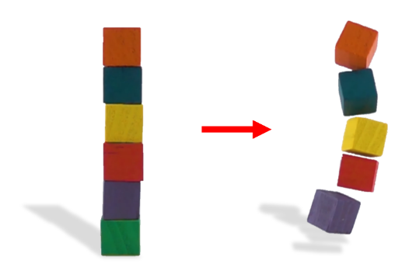**2. PROBLEM STATEMENT**

[Adapted from IYPT 2020 Problem 14 – *Falling Tower*]

Identical blocks are stacked one on top of another to form a freestanding tower. The bottom block is removed by applying a sudden horizontal force such that the rest of the tower will drop down onto the surface. Under certain conditions, the tower may remain standing.

Track both the x-position of the bottom block and the y-position of the block above it for either the unstable or stable case. On separate axes, plot both positions against time.

Use either of the videos provided [here](https://github.com/A-Niksa/comp-physics-tutorials/tree/main/tracking/exercises/falling_tower/videos) in GitHub or take your own! (Note that the provided videos are in slow motion and are thus taken at a higher framerate then they are played back.)

**3. CHECKING YOUR RESULTS**

To check your results, compare your solution with the provided solution files in the GitHub repository.

**4. TABLE OF CONSTANTS (For Provided Videos)**

|  |  |
| --- | --- |
| Unstable Video | |
| Pixel to Meter Ratio | $$1:5×{10}^{-4}$$ |
| Slow Motion Factor | $$1/32$$ |
| Stable Video | |
| Pixel to Meter Ratio | $$1:2×{10}^{-4}$$ |
| Slow Motion Factor | $$1/32$$ |