ED-AutoLoader

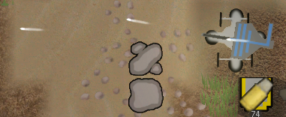

Adds an Autoloader that can be used to supply things to some of the buildings in this mod.  
This is functionally identical to a Hopper in the base game, but is helpful for comparability to avoid having to edit the stock Hopper.

**How to change Turrets**

One of the main uses of this is to supply ammunition to turrets, this is a list of the changes that need to be made to convert a turret to using this system.

Change:

<ThingDef Class="Jaxxa_EMRG.MyThingDef" ParentName="BuildingBase">

Add between the building tags:

<building>

<wantsHopperAdjacent>true</wantsHopperAdjacent>

</building>

Add Tags:

<ammoAmmount>5</ammoAmmount>

<ammoType>Missiles</ammoType>

<thingClass>Jaxxa_EMRG.Building_TurretGun_Ammo</thingClass>