DeepStrike

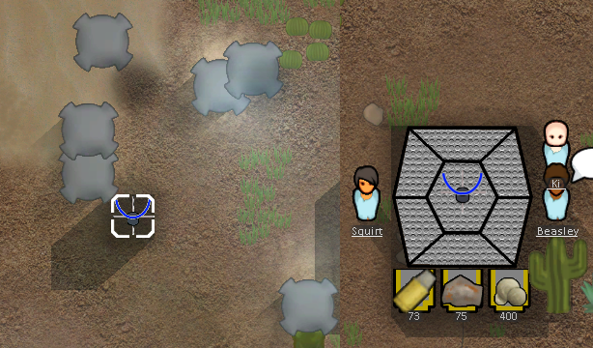  
This adds a Drop Pod system to the game, allowing you to build a command building to deploy your Colonists and resources to any point on the map almost instantly.

**How To use**

1. Research "Orbital Drop Command".
2. Build a "OrbitalCommand" building and power it up.
3. Load Colonists or Resources.  
   3a. Load Colonists by standing them next to the building OrbitalCommand building and pressing the load colonist button.  
   3b. Load resources by placing them in Autoloaders attached to the OrbitalCommand building and pressing load resources.
4. Place a "Orbital Beacon" (builds instantly and free)
5. Press the Deepstrike button on the Orbital Beacon to drop pod down your stored resources and colonists.