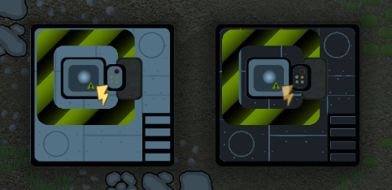  
Adds a Laser Drill that allows the creation of new steam vents, and a Laser laserFill that allows you to remove unwanted steam vents. Both of these operations will take a considerable amount of time.