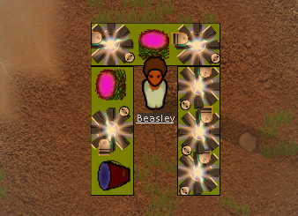  
This mod allows you to have a renewable source of Metal and Stone. You start by planting and harvesting the OmniGel plant. You then need to research and build a MK1Replicator. This is a workbench that allows you to transform the OmniGel that you harvest into slag or rock. You then use this in the standard rock cutting or slag refining benches are in rimworld to get usable materials.

**Recipes**

**MK1:**

10 OmniGel -> 1 ChunkSlag  
10 OmniGel -> 1 ChunkRock

**MK2:**

75 OmniGel -> 50 Metal  
75 OmniGel -> 50 StoneBlocks  
75 OmniGel -> 50 Silver

**MK3:**

75 OmniGel -> 1 Uranium  
75 OmniGel -> 1 Shells  
75 OmniGel -> 1 Medicine