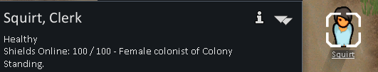

Adds Personal Shields into the game. Allows you to construct a building capable of upgrading your colonists to have a personal shield capable of protecting them from damage.

**How to use**

1. Research the personal shields
2. Build the Colonist Upgrade Station
3. Draft a colonist and have then stand near it
4. Press "Upgrade to Nanno Shield" button to have that individual colonist upgraded to use shields (they should now show the shield status) - The upgrade building will need to recharge itself before it can do this again. Repeat this for all colonists
5. To recharge shields have them stand near the building when it is charged, if their shields are offline it must charge to 100% before it will come online again.

Tip: I like to build a upgrade station near the kitchen table so they recharge when eating, all upgrade building stare the same charge with each other.

Building multiple upgrade stations will give you multiple positions to Upgrade and Recharge from, but will NOT allow you to recharge faster.