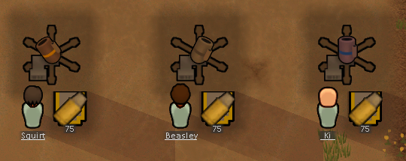  
Adds the requirement for the base Mortars to require Ammunition to fire.  
The Raider constructed Mortars during sieges will also require this but they start with a high initial Ammunition.