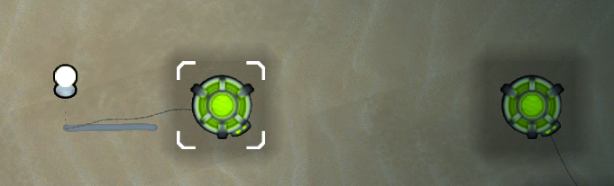Allows the creation of a Wireless power grid.  
Wireless power Nodes can transmit or receive power from the grid.  
If the grid is overloaded it will completely shutdown all receiving nodes and require you to reactivate them.