**Enhanced Development**

Contents

**Enhanced Development** 1

Install 3

Changing load locations 3

FAQ and Problem Solving 4

**ED-AutoLoader** 6

Description 6

**ED-Core** 7

Description 7

Details 7

**ED-Embrasure** 8

Description 8

Details 8

**ED-Laser Drill** 9

Description 9

Details 9

**ED-OmniGel** 10

Description 10

Details 10

Recipes 10

MK1: 10

MK2: 11

MK3: 11

**ED-OmniGel_24H** 12

Description 12

**ED-Personal Shields** 13

Description 13

How to use 13

**Plant 24H** 14

Description 14

Adding more plants 14

**ED-Reverse Cycle Cooler** 15

Description 15

**ED-Shields** 16

Description 16

How to use 16

Details 16

Modding 17

**ED-Stargate** 18

Description 18

How to Use 18

**ED-WirelessPower** 20

Description 20

History 21

Credits 22

## Install

The general procedure for installing the mod is as follows:

1. Extract the .zip file somewhere temporarily (desktop or download folder work).
2. Enter the folder that you extracted until you go into the folder that contains README.md, this document and a number of folders starting with "ED-", these folders are the different modules that are available in this mod.
3. Find your Rimworld mods folder. This will be wherever you installed/extracted Rimworld to. Then go to the "Mods" folder will be inside it. It will contain a folder called "Core" and folders for any other mods that you have installed previously.
4. If you have an old version please delete the existing ED- Modules. (or move them, see next section on Upgrading)
5. Copy the modules (the different “ED-“ folders from step 2) into the Rimworld mods folder (found in step 3)
6. Open Rimworld and Enable any of the modules that you want to use. **Note that some modules will have requirements that must be activated before they are activated, as noted in their description.** Most modules will depend on “ED-Core”, so this will usually be the first thing you enable.
7. Restart Rimworld
8. Play the game

If you are having issues please Read this FAQ section of this document.

## Changing load locations

In the current version of Rimworld it is possible to specify the location that the configuration and save files will be located. For detailed instructions on how this works read the “Readme.txt” that came with Rimworld.

# FAQ and Problem Solving

If you are having trouble with the mod this is a good place to check first.

**Q:** I like part of this mod but hate the idea of X

**A:** The mod has been designed with separate modules for the different parts of the mod so you can enable what you want without having to use everything. Check the description of a module to see if it has any dependencies on other modules.

**Q:** Something is not working right, or I am getting errors like "Could not find a type named Enhanced_Development.###" or when I construct a building it just disappears. Really if anything else is not working it is usually best to check this first.

**A:** This issue can mean that the mod is unable to find .dll file that contains the code of the mod. The most common cause of this is loading the modules in the wrong order, or not having the core module enabled at all. You will want to make certain that ED-Core is loaded before any of the other ED mods. The load order is shown in numbers next to the name of the mod, you will need to make certain that ED-Core has a lower number than any of the other ED- Modules that list ED-Core as a requirement. You can do this by disabling and enabling mods until they are in the needed order. After this you will need to restart the game before it will take effect.

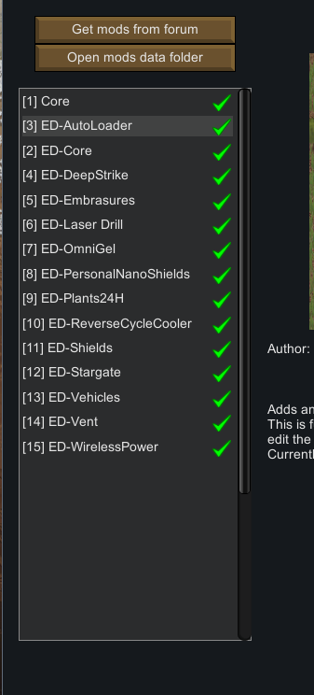

**Q:** I am still having problems.

**A:** Your best bet is to post on the forum thread describing in detail what your issue is.

If you have errors, rather than screen shots please include the log file. \RimWorld###Win\RimWorld###Win_Data\output_log.txt

Also including the ModsConfig.xml can be helpful so I can see your mod configuration.  
C:\Users\USERNAME\AppData\LocalLow\Ludeon Studios\RimWorld\Config\ModsConfig.xml

Please also include the version of the mod and the version of Rimworld you are using.

**ED-AutoLoader**

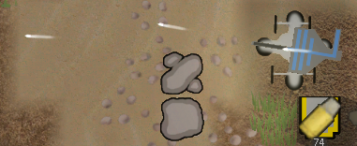

## Description

This module adds an Autoloader that can be used to supply things to some of the buildings in this mod. If a building in a module requires it, then this module will be listed as a requirement.  
This is functionally identical to a Hopper in the base game, but accepts a wider variety of resources without cluttering the stock Hopper or causing incompatibilities with other mods.

# ED-Core

## Description

This is the Core module of Enhanced Defence. It contains all of the .dll code that can be used by the other modules.

This will usually have to be the first part that you activate.

## Details

This module also contains the source code for the binary portion of the mod. This can be found in the “Mods\ED-Core\Source” folder.

**ED-Embrasure**

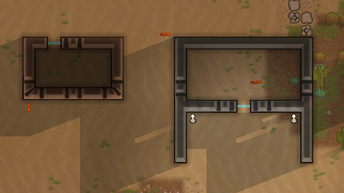

## Description

This is a module that adds a new class of wall. These walls have openings for colonists to shoot at their enemies, while not allowing anyone to pass through.

## Details

Because of the added complexity in creating was with precise locations to fire from, constructing embrasures take additional work to build when compared to a similar wall.

**ED-Laser Drill**

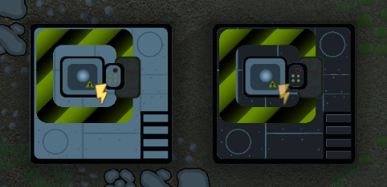

## Description

Requires: ED-Core

Adds a Laser Drill that allows for the creation of new steam vents. Also adds a LaserFiller that allows you to remove unwanted steam vents. Both of these operations will take a considerable amount of time. To avoid geological instability only one laser Drill can be active at any time**.**

## Details

**ED-OmniGel**

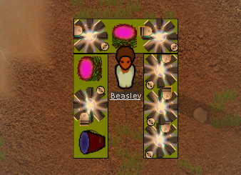

## Description

Requires: ED-Core

This mod allows you to have a renewable source of various materials.

## Details

You will need to start by obtaining OmniGel. This is usually done by planting it, waiting for it to grow and then harvesting, it is also possible to acquire it from traders and random crashed escape pods.

For the next part you will have to research and build the MK1Replicator. There are higher level replicators that you can build to allow you to produce more advanced resources, but the MK1 is the easiest and cheapest to acquire. These are workbenches that allow your colonists to refine the OmniGel that you harvest into usable resources. The MK1 version can only produce slag or rock that will then have to be further refined using the standard methods in Rimworld, but more advanced versions will create usable resources directly.

## Recipes

The following are the resources that are available from the various levels of the replicator.

### MK1:

10 OmniGel -> 1 ChunkSlag  
10 OmniGel -> 1 ChunkRock

### MK2:

75 OmniGel -> 50 Metal  
75 OmniGel -> 50 StoneBlocks  
75 OmniGel -> 50 Silver

### MK3:

75 OmniGel -> 1 Uranium  
75 OmniGel -> 1 Shells  
75 OmniGel -> 1 Medicine

**ED-OmniGel_24H**

## Description

Requires: ED-Core, ED-OmniGel

This modifies the OmniGel plant to grow regardless of the time of day, in the same way that the 24Hour plants module does for the base plants.

**ED-Personal Shields**



## Description

Requires: ED-Core

This module adds an alternate version of Personal Shields into the game. Technically I had the first version of my personal shields out before they were in the base game, so the base game is the alternate version. These shields function differently to the base game in that they require additional infrastructure, they are limited in the amount of charge that they can store and need to return to base to recharge. The advantage that these have is that they block both incoming Melee and Ranged attacks while still allowing the user to deploy ranged weapons.

## How to use

1. Firstly the research must be done.
2. Then you need to build a Colonist Upgrade Station.
3. Have a colonist and have then stand near the building, drafting them can be useful to make certain that they stay where you want them.
4. Press "Upgrade to Nanno Shield" button on the building to have a close colonist upgraded to use shields (they should now show the shield status)
5. The upgrade building will have been drained will need to recharge itself before it can do this again.
6. Repeat this for all colonists

To recharge shields have them stand near the building when it has charged, if their shields are offline it must charge to 100% before it will come online again.

Tip: I like to build an upgrade station near the kitchen table or other place that colonists gather around so they recharge when doing another task.

Building multiple upgrade stations will give you multiple positions to Upgrade and Recharge from, but will NOT allow you to recharge faster as they all share a single charge source.

**Plant 24H**

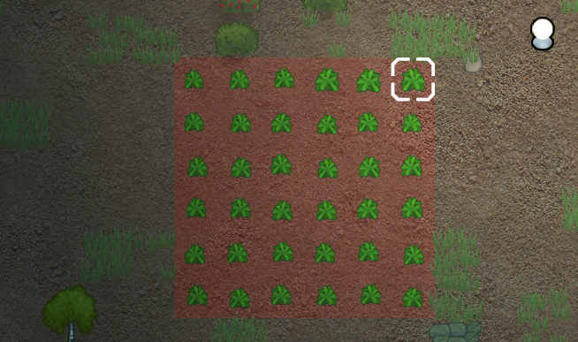

## Description

Requires: ED-Core

The module changes the plants to grow 24 Hours a day. In the base game plants will rest at night time and stop growing, regardless of the light levels. This removed that restriction so plants will keep growing, if all the other conditions such as light are still met, allowing your sunlamps to effectively increase the growing speed.

## Adding more plants

If you want to add the ability for another plant to grow 24Hours you can do this by editing XML.

1. First you need the plant XML that you will edit. This can be from another mod that adds plants, or you can create a new mod that will override the definitions, by copying the plant definition you want to edit from either the Rimworld core(probably best to not edit this directly) or another mod.
2. In that new mod change the thingClass of any plants that you want to edit in xml to be <thingClass>Enhanced_Defence.Plants24H.Plant</thingClass> Most files will have this defined in a Base Plant so changing just the one will change every plant in the file.
3. Make certain that this mod is loaded after "ED-Core", and any other mods that you based it on.

**ED-Reverse Cycle Cooler**

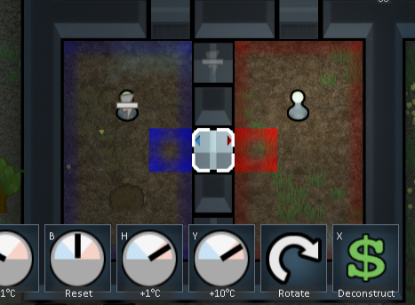

## Description

Requires: ED-Core

This module changes the cooler to have a rotate option; this allows you to switch it between cooling a room and using its output to warm the same room.

**ED-Shields**

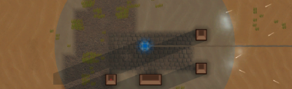

## Description

Requires: ED-Core

This mod allows you to place shield generators. They are expensive and power hungry but can really strengthen your defences. The standard shields will stop projectiles that try to enter it, but allow weapons to be fired out.

## How to use

After activating the mod and starting to play the first thing you will have to do is the research "Basic shield generator" this will unlock the "Basic shield" building. After placing a Shield and providing it with enough power it will enter a warmup state. During this time there will be a countdown timer showing you how long until the shield is activated (if you select the shield). After this time has elapsed the shield will activate showing a circle on the screen that shows where is covered by the shield. This shield will stop all projectiles that enter it, but allow you to fire out from within the shield. The shield will start with a certain amount of health and will increase until it reaches it's maximum health. This will be reduced whenever the shield is used to block a projectile. If the shield is reduced to zero it will have to compleate the warmup phase again before it can block anything.

## Details

There are currently 4 Shields in this version of the Mod.  
**Standard Shield:** This is the standard shield generator.  
**Small shield:** This shield required additional research. It is smaller in size, lower strength, uses less power and allows power to stand on it.  
**Fortress shield:** This shield has been modified to only block indirect fire weapons. It will protect a large area from Mortars attack, but will allow bullets to pass through in any direction.  
**SIF Generator:** Rather than creating a large circular shield this generator will create an small individual shield over each wall/door object.

|  |  |  |  |  |
| --- | --- | --- | --- | --- |
| Name | Strength | Radius | Power Usage | Charging Power Usage |
| Small shield | 1000 | 2 | 500 | 1000 |
| Standard Shield | 2000 | 8 | 1000 | 1500 |
| Fortress shield | 8000 | 20 | 2500 | 5000 |
| SIF shield | 3000 | 8 | 1500 | 2500 |

## Modding

One of the main modifications that I made was making information about the shield to be read in from the XLM files rather than hard coded into the C# code. Because of this it should be easy to make your own shield generator of any size or strength.

The new XML variables that I have added that will be needed by shields are:

**shieldMaxShieldStrength:** Maximum shield strength  
**shieldInitialShieldStrength:** Shield strength when going online  
**shieldShieldRadius:** Radius of the Shield  
**shieldPowerRequiredCharging:** The power when the shield is up but not at full strength  
**shieldPowerRequiredSustaining:** The power used when the shield is up and at full strength  
**shieldBlockIndirect:** Should it block projectiles that fly overhead  
**shieldBlockDirect:** Should it block projectiles that fly direct  
**shieldFireSupression:** Should it put out fires (in squares that it is blocking)  
**shieldStructuralIntegrityMode:** Should it only work on walls  
**shieldRechargeTickDelay:** How many ticks between recharging the shield by 1 (lower number will recharge faster)  
**shieldRecoverWarmup:** How long to wait before starting to charge  
**colourRed:** Float value, Colour between 0 and 1  
**colourGreen:** Float value, Colour between 0 and 1  
**colourBlue:** Float value, Colour between 0 and 1

**ED-Stargate**

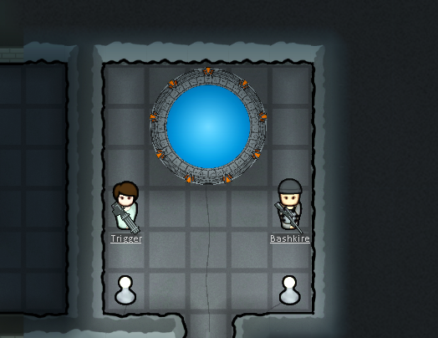

## Description

Requires: ED-Core, ED-Autoloader

The Stargate system allows you to transport materials over the great distances between colonies.

## How to Use

The main way to get a Stargate is to Research and then build it. Once you have done this you can begin to use it for travel. The Stargate has a Capacitor and a buffer system. The Capacitor is charged with electricity and provides the power needed to establish a wormhole. The buffer stores the equipment and personnel that you want to send to another Stargate.

You can add all close colonists into the buffer by pressing the Add Colonist button on the Gate UI panel; this will add any colonists that are in range into the buffer. Pressing add resource will add any resources that are located in adjacent Autoloaders.

After you have loaded the colonists and resources that you want you can press "Dial Out" button. This will send your team off world as long as the capacitor is full of power. The capacitor will be discharged in the process and will have to be recharged before another team can be sent.

On a different (or the same) gate pressing "Incoming Wormhole" will cause the off world team to arrive at the currently selected destination gate.

Using this system it is possible to transfer personnel and equipment between colonies. This could be used for a variety of situations, including establish a mining / farming colonies to support a main colony or completely evacuate a colony to a new location.

To assist you in exploration there is a second way to get a Stargate. This is the Offworld gate. This can be built for free, instantly and without any research requirements. When it is completed you can turn it into a full Stargate. But this comes at the cost of removing all colonists from the current map. This can be used to simulate a team arriving at a new uninhabited location.

**ED-WirelessPower**

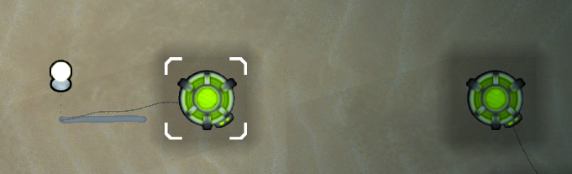

## Description

Requires: ED-Core

This module allows for the creation of a Wireless power grid.  
Wireless power Nodes can transmit or receive power from the grid spanning the entire map. This allows you to establish a remote power generation location such as using a geothermal vent at a far side of the map, or set up advanced turrets, all without having to run power wires across the entire map.

If the grid is overloaded by trying to draw more power that it provides it will completely shut down all receiving nodes and require you to reactivate them.

# History

This is just a bit on information about the history of some of the various stages that this mod has gone through.

Originally there was a shields mod by Darker available for Alpha 3. This was updated by Halpo to Alpha 4 and then I did an Update to Alpha 5. https://ludeon.com/forums/index.php?topic=2677.0

Then for Alpha 6 I released my “Jaxxa Shields” mod that expanded on the shields and added a few more ideas and different types of shields. https://ludeon.com/forums/index.php?topic=4701.0

Then for Alpha 7 to 11 I released my Enhanced Defence mod. That mod was gradually expanded with different modules and ideas that I have had beyond just shield generators. https://ludeon.com/forums/index.php?topic=6636.0

Now for Alpha 12 I am releasing this mod, Enhanced Development, this carries on with the same general idea as Enhanced Defence, but has been renamed to reflect that it has evolved to more than just combat.

# Credits

A large number of people in the Rimworld community have helped me out along the way of making this mod. Please view the most up-to-date credits inside “README.md” file included in the download.