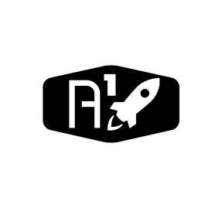

DESIGN DOCUMENT

Area : Converse Engine

Category: Feed (Piping)

TEAM: Propulsion

Nyameaama Gambrah

The communication system between the ECU and sub controllers which control valves and other peripherals is done using a simple coded system which implements a string of characters indicating peripheral type, number and task.

Engine Control Unit

Sub-Controller 1

Sub-Controller 1

Sub-Controller 1

Non-Return Peripheral

Non-Return Peripheral

Return Peripheral

The peripheral devices are Non Return and Return devices. Return devices send back data.

The coded system is known as the "Working ID". The "Working ID" consists of two sections. The base ID and the control assignment.

Each sub-controller carries a unique base ID related to the system. Below are examples of base IDs:

Controller 1 ID = "SBC01"

Controller 2 ID = "SBC02"

The base ID's consist of two parts. The "SBC" tag and the number preceding it. The SBC is used to indicate the ECU that it is a sub controller and the numbers preceding it indicate the unique number corresponding to the controller.

The second section of each Working ID is the control assignment. The control assignment is a number appended to the base ID which corresponds to a certain action. The actions vary depending on the peripheral type.

Below is a list denoting peripheral action to control assignment number.

Valve |OPEN| - "1"

Valve |CLOSE| - "0"

Measuring device |Reading| = "2"

**Principle of operation**

ECU

- System request for communication with a controller

- Retrieval of base ID of destination controller

- Appending of control assignment to base ID to create "Working ID"

- Sending of Working ID to destination controller

Sub Controller

- Sub Controller receives Working ID

- Sub Controller parses Working ID

- Sub Controller verifies base ID

- Sub Controller executes control assignment