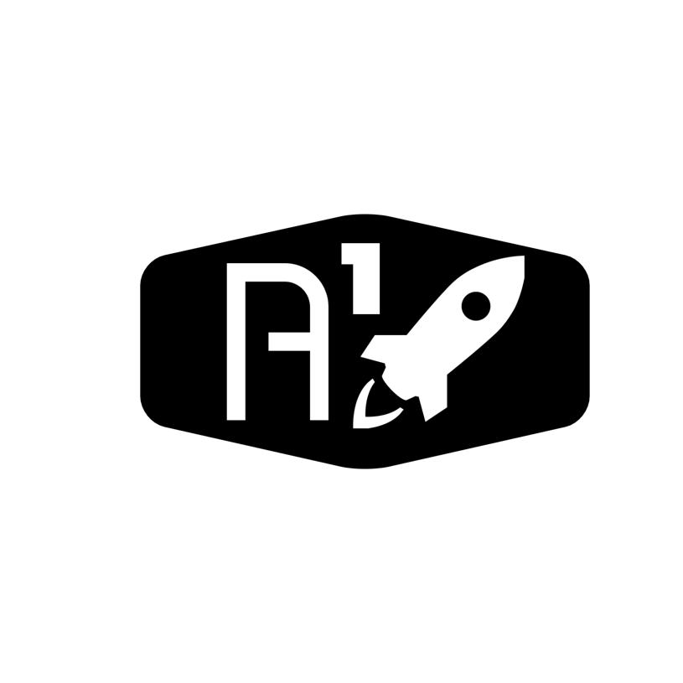

Lead: ……………………………

Nov 26, 2020

Nyameaama Gambrah

**A-OneSpace : Converse Engine Chamber Nozzle Design**