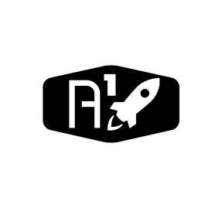

DESIGN DOCUMENT

Area : Converse Engine

Category: Feed (Struct)

TEAM: Propulsion

Nyameaama Gambrah

Injector Assembly

Engine Mount

Merge Plates

Merge Plates

Chamber