Sampling Process for the rCARI Validation Study - Burkina Faso Pilot

APP-FA rCARI study team April 12, 2024

Background
The rCARI validation study is a global research project commissioned by WFP and funded by the BHA to investigate and compare remote and face-to-face (F2F) modules of the consolidated approach for reporting food insecurity (CARI).
The overall goal of the study is to understand to what extent food insecurity reported by rCARI is comparable or compatible with the standard CARI. Both remote and F2F data collection modules & methodologies for collecting food insecurity will used in the study.
This document outlines the study methodology, specifically the sampling process adjusted for country specific context of Burkina Faso. The study has been designed and implemented as a survey experiment with stratified sample selected across 2 regions (ADMIN1) in each pilot country.

Overall study sampling design
The following considerations underpin the study areas and final sample selection.
  - Phone ownership & accessibility within the pilot country
  - Distribution of food insecurity
  - Areas of accessibility taking adjusting for difference in livelihoods
It is important to emphasize that the purpose of data collection for this study is not to produce population-level estimates but rather to compare the two methodologies with the same comparable population. While it is desirable to collect data from a variety of livelihood zones both urban and rural communities to assess the impact of these differences with respect to modality, national coverage is not the primary objective of this current study.
Figure 1 below presents the generic study sampling procedure. As mentioned earlier, selection and inclusion of study areas followed a 3-point criterium: i.e., 1) phone coverage, 2) accessibility, and 3) food security situation. Phone coverage is important consideration allowing for equal probability of reaching equal number of households for both remote and F2F interviews, while field accessibility ensures that enumerators can successfully access and interview households in F2F. The food security consideration would ensure that at least areas that have different acute food insecurity (AFI) situations are adequately represented in the study sample.

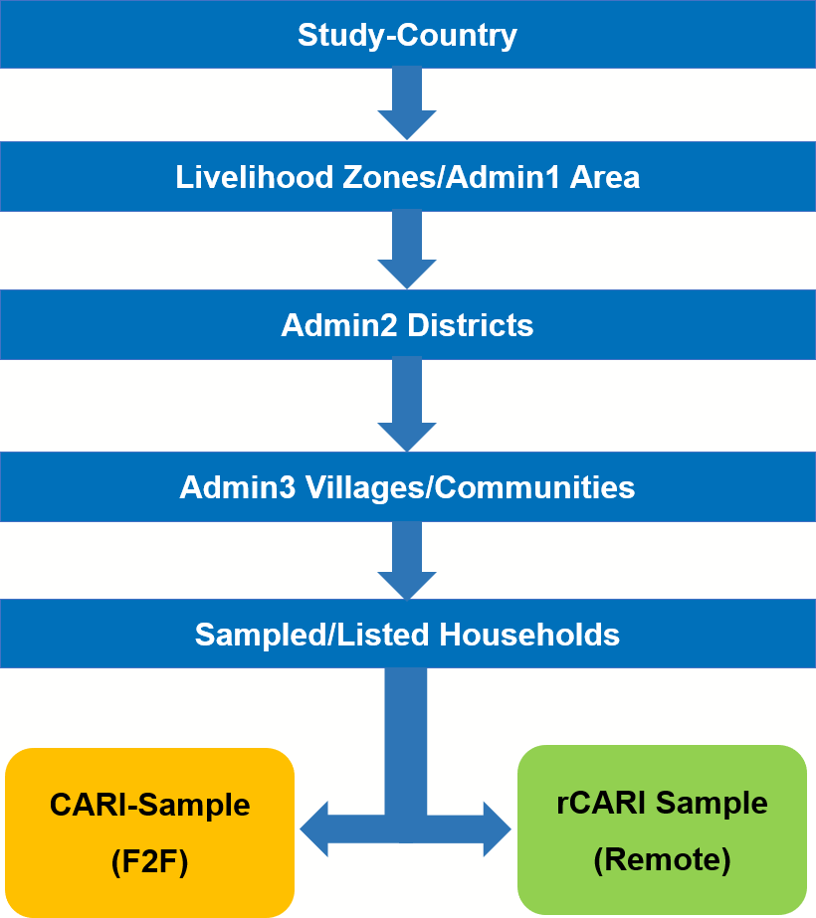

Figure 1: Sampling and Randomization Procedure

The main steps followed in identifying and selecting the admin areas at the various stages are listed and explained below.

Step 1 - Selection of ADMIN1 (Livelihood zones)
The first stage involves the identification and selection of Admin1 or livelihood areas that meets the inclusion criteria. A minimum of 2 Admin1 Areas will be purposively identified and selected (on the recommendation WFP country offices) based on phone coverage, food security situation and accessibility. If more than 2 Admin1 Areas meet the inclusion criteria, a simple random approach will be used to select 2 Areas.

Step 2 - Selection of ADMIN2
In the second stage, a minimum of 4 ADMIN2 areas were randomly selected (2 per ADMIN1 Area based on the outcome of Step 1) from the ADMIN1 areas that have been identified and selected.

Step 3 - Selection of ADMIN5 - (Lowest Admin Areas i.e., villages)
After identifying and selecting the Admin2 areas, all villages (ADMIN5 areas) in the selected ADMIN2 areas that met the inclusion criteria set out in Step 1 are listed as primary sampling
units (PSUs). A list of 20 PSUs will be randomly selected (distributed equally across the selected 2 ADMIN1 from Step 1). The study sample (households) will be selected from these 20 PSUs.

Step 4 - Sampling of households (HHs)
The final stage of the sampling procedure involves enlisting eligible households into the study. The sampling frame for the study is all households in each of 20/25 selected PSUs. Sampling households for the study follows a simple random (in the absence of any recent household census). The aim is to collect information from households that are as accurate and representative as possible in each study area. Thus, the idea is to give equal chance of selection to all households in each PSU as much as practicable. The study will therefore enlist an equal of number of households, a minimum of 150 households per each PSU taking into consideration attrition data from VAM at the CO. Trained and conscientious enumerators will be used for the household selection process. A sampling interval of 3 will be adopted for the listing.
To ensure the integrity and ethics of the study are maintained, informed consent will be taken from all households at the listing phase to ensure that all households understand and agree to participate in the study. Based on the number of PSUs per country, around 3000HHs will be listed for the study. The listed households will be used for the randomization in the next stage.

Step 5 - Randomization of household (HHs)
Consented final sampled households in Step 4 are randomly assigned into one of two survey modalities/groups: F2F (CARI group) and Remote (rCARI group). The design is such that the sample will be divided equally between the two groups using a standardized randomization process.
All interviews (both F2F & remote) will be conducted simultaneously over the same time frame to ensure that households are reporting food security situation over the same window and affected by similar geographical situations.

Burkina Faso pilot
Following the study framework illustrated in Figure 1, the first three steps have already been completed. In conjunction with the Burkina Faso CO, two prefectures (ADMIN1s) namely: Centro and North prefectures have been selected as study areas (selection based on accessibility and phone coverage).

ADMIN1 AREAS (3)
      - Plateau Region
      - North Region, and
      - Centro-Nord Region

ADMIN3 AREAS (4)
Two each have been sampled from the North and Centro prefectures respectively. These Admin areas have been carefully selected to ensure that they representative a broad composition of livelihoods.
      - Boulsa
      - Guibare
      - La-Todin and,
      - Oula

ADMIN5 AREAS (20)
Based on a census of ADMIN5 areas in the ADMIN1s selected that is available to VAM at the CO, a list of ADMIN5 areas available to the CO, 20 villages (Admin5 areas) were selected to form the main PSUs from which participating households would be selected.
Selection of the ADMIN5 areas followed a simple random sampling procedure drawing randomly from a census of villages in each of the 4 Admin3 areas. In total, 20 ADMIN5s, 10 from each Admin1 have been selected. Selected areas are listed in Table 1 below.

Table 1: List of ADMIN5 Areas by ADMIN3’s

ADMIN1 | ADMIN2 | ADMIN3 | ADMIN5
Centro Prefecture | Namentenga Province | Boulsa | Secteur 6
 |  |  | Kiendsom
 |  |  | Secteur 5
 |  |  | Nièga
Kobouré
Bam Province Guibare Barsa Yilou Vousnango Wattinoma Sakoudi
Nord Prefecture Passore Province La-Todin Minissia
Gogho Pendogo Ramessoum Lâ-Todin
Yatenga Province Oula Bourbo
Reka Bouro Tilli
Ouro Mossi

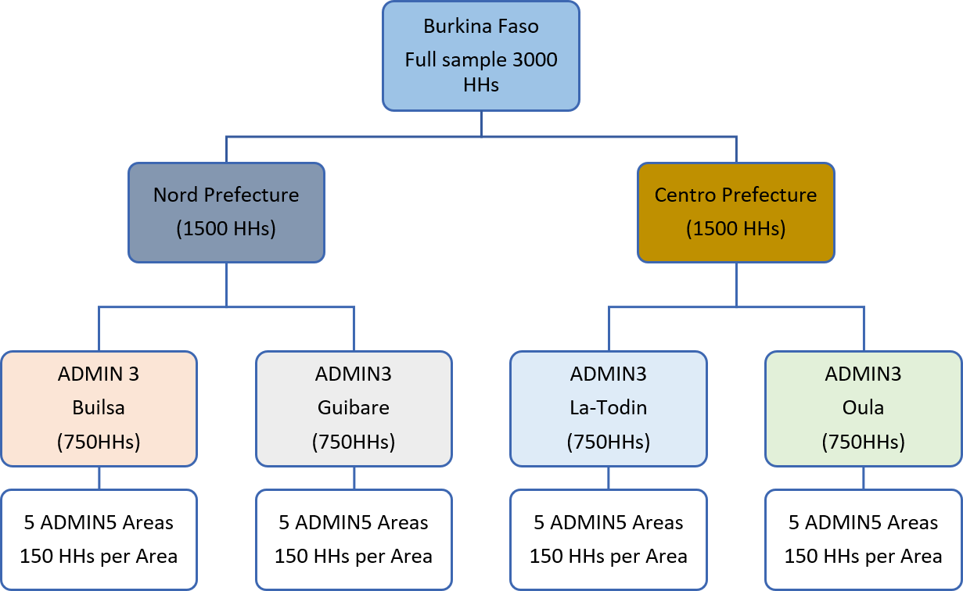

Figure 2: Systematic sampling & sample size in Burkina Faso

Selection of respondents (Households)
The sampling frame in Burkina Faso is all households in the 20 ADMIN5 areas (PSUs). Households will be enrolled for the study through listing at the PSU.
Carefully selected, trained and conscientious enumerators will be engaged to conduct the listing of households in each PSU. This involves the enumerator visiting the PSU, identifying, and starting from a known point and walk through each village, and sample households systematically following the predefined interval of 3, i.e., the enumerator will contact and sample every 3rd household (consent of participation of the sampled household will be requested to at this stage). If a sampled household refuses to consent, the next immediate household in the direction of the enumerator’s walk will be considered and contacted to be sampled.
During the listing phase, once a household head agrees to participate in the study, a standardized listing questionnaire to collect basic household and respondent characteristics such as household head’s age, gender, education, the composition of the household, ownership of some basic assets, mobile phone ownership, housing, WASH, etc. (these are to be used later for the purpose of randomization) will be administered.
Only households that have consented and completed the listing questionnaire will be included in the final sample.

Randomization of sample
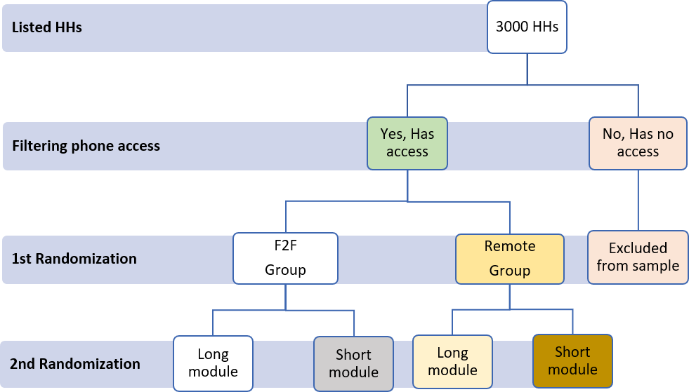
Households enlisted that do not have access to mobile phones in within the household or phone coverage will be dropped during the randomization. Similarly, households with incomplete baseline and contact information will be dropped from the final.

Figure 3: Step by step randomization of the survey sample

Training & assignment of enumerators
To be qualified to be engaged as an enumerator for both the listing and data collection, all potential enumerators should have the following.
- Formal education with a minimum of first degree,
- First-hand knowledge of the study areas (preferably speak the local language/dialect), and
- Prior data collection experience (at least must have been involved in two separate food security surveys) in BF.
To ensure consistency in data collection, a 5-day in person training will be organized for both F2F and remote enumerators. Training of will be conducted jointly by the BF CO (VAM team), RBD and rCARI team from HQ. Training will be largely conducted in French the predominant language of the study area. Local dialects will be used in cases where required to increase comprehension. A day’s hands-on field pilot will be conducted at the end of the training session to test both the practical knowledge of enumerators and interview instruments for both cohorts (F2F and remote). A comprehensive field guide translated into French will be prepared at the end of the enumerator training. This will be provided to all enumerators to serve as quick reference in the field when they are in doubt. In addition, field supervisors with adequate understanding of food security and livelihoods of the study area will be engaged to work closely with all enumerators in the field to increase data quality.

Possible limitations & suggested ways to address them
Although a lot of thought has been given to the methodological design of the study, it must be mentioned that there remain some potential unavoidable sources of biases in this current experimental design setup. The potential sources and how the current design would remedy or reduce them are discussed below.
- Lack of national representativeness of the survey. One of the key limitations of the methodology is its lack of nationwide coverage which is likely to affect the generalization of the results. However, given the main objective of the study, the sample design has been adapted in such a way to ensure that the study sample will represent the study sample as much as practicable.
- Geographical variation in the distribution of respondents. With the traditional phone survey likely to have lower response rates than F2F, there is a likelihood that completed surveys may be skewed in favor of F2F group which can affect the final analysis. To address this limitation and ensure that the final interview sample is large enough to allow for statistical analysis, a number of strategies will be adopted. First, the study will only be rolled out in areas that allow for both F2F and remote surveys. Second, a comprehensive listing (census) phase has been incorporated to ensures that we are able to achieve a uniform pre-survey distribution of both F2F and remote cohorts. Third, increase sensitization of the study regions through the listing phase. A standard questionnaire will be used for the census that will pre-inform all households in selected PSUs about the study including time frames that they may be contacted for the respective interviews. Forth, increase the number of follow-up in the remote cohort. Specifically, in addition to the stated time by respondents to contacted, 3 additional time windows, i.e., mornings, afternoons and evenings will be used to make calls. This will ensure that more households are reached within the survey period.
- Confounding through enumerator effects (gender, training, and motivation). Given that both survey cohorts are to be collected simultaneously, the same enumerator cannot be used to collect both cohorts which can inadvertently influence the results. To address this potential bias, randomization will be adopted when assigning enumerators to the PSUs and modalities (a minimum of two enumerator will be assigned to each PSU). Also, to ensure equivalence of comprehension of the questionnaire across all enumerators, F2F and remote enumerators will be trained together by the same facilitators. Also, knowledge test will be conducted at the end of the enumerator training with the lowest scoring enumerators being or retrained or dropped all together. Finally, daily frequency speed checks will be put in place by the data management team to be based in Rome access the performance of each enumerator. Those with questionable data inputs will either be asked to re-do the interviews or where it is extreme are dismissed at together. Finally, a conscious effort will be made to increase the number of female enumerators conducting the remote interviews (evidence how that female enumerators tend to achieve higher response rates compared to males in phone survey).
- High attrition particularly in the remote cohort. High attrition rates particularly in the remote is likely to affect the statistical power and by extension the overall analysis of sub-groups in the final completed surveys. To minimize this limitation, the initial sample size of 2000 households will be increased by 50% to 3000 households. This is expected to create adequate allowance to take care of sample attrition.

