Sampling Process for the rCARI Validation Study - Burkina Faso Pilot

APP-FA rCARI study team April 12, 2024

Background
The rCARI validation study is a global research project commissioned by WFP and funded by the USAID Bureau of Humanitarian Affairs (BHA) to investigate and compare remote and face-to-face (F2F) modules of the consolidated approach for reporting food insecurity (CARI). The study runs in six pilot countries.
The overall goal of the study is to understand to what extent food insecurity reported by remote CARI (rCARI) is comparable with the standard CARI collected through face-to-face interviews. Both remote and F2F data collection modules & methodologies for collecting food insecurity will be examined in the study.
This document outlines the study methodology, specifically the sampling process adjusted for country specific context of Burkina Faso. The study has been designed and implemented as a survey experiment with stratified sample selected across 2 regions (ADMIN1) in each pilot country.

Overall study sampling design
The following considerations underpin the study areas and final sample selection.
  - Phone ownership & accessibility within the pilot country
  - Distribution of food insecurity
  - Areas of accessibility taking adjusting for difference in livelihoods
It is important to emphasize that the purpose of data collection for this study is not to produce population-level estimates but rather to compare the two methodologies within a statistically comparable population. While it is desirable to collect data from a variety of livelihood zones in both urban and rural communities to assess the impact of these differences with respect to modality, national coverage and representativeness is not the primary objective of the current study.
Figure 1 below presents the generic study sampling procedure. As mentioned earlier, selection and inclusion of study areas followed a 3-point criterium: i.e., 1) phone coverage, 2) accessibility, and 3) food security situation. Phone coverage is an important consideration allowing for equal probability of reaching an equal number of households for both remote and F2F interviews, while field accessibility ensures that enumerators can successfully access and interview households in F2F. The food security consideration would ensure that areas that have different acute food insecurity (AFI) situations are adequately represented in the study sample.

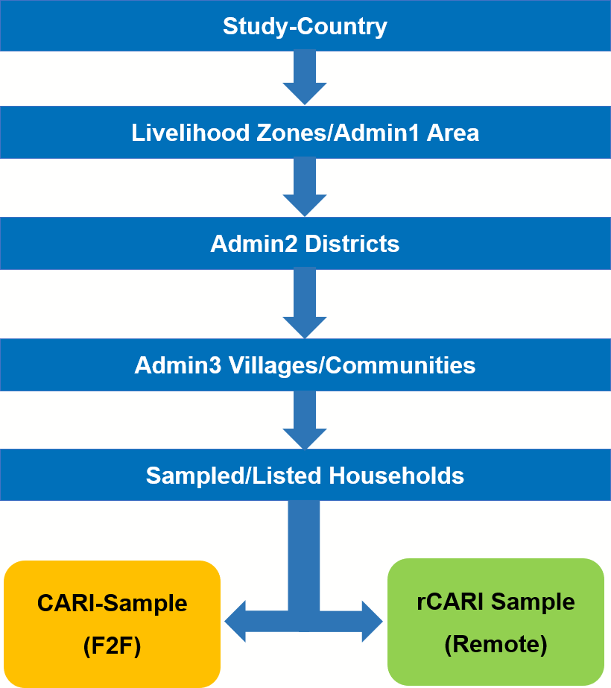

Figure 1: Sampling and Randomization Procedure

The main steps followed in identifying and selecting the admin areas at the various stages are listed and explained below.

Step 1 - Selection of ADMIN1 (Livelihood zones)
The first stage involves the identification and selection of Admin1 or livelihood areas that meet the inclusion criteria. A minimum of 2 Admin1 Areas will be purposively identified and selected (on the recommendation WFP country offices) based on phone coverage, food security situation and accessibility. If more than 2 Admin1 Areas meet the inclusion criteria, a simple random approach will be used to select 2 Areas.

Step 2 - Selection of ADMIN2
In the second stage, a minimum of 4 ADMIN2 areas are randomly selected (2 per ADMIN1 Area based on the outcome of Step 1) from the ADMIN1 areas that have been identified and selected.

Step 3 - Selection of ADMIN5 - (Lowest Admin Areas i.e., villages)
After identifying and selecting the Admin2 areas, all villages (ADMIN5 areas) in the selected ADMIN2 areas that met the inclusion criteria set out in Step 1 are listed as primary sampling units (PSUs). A full census of PSUs will be conducted in each selected ADMIN2 area to ensure equal chance of selection once the inclusion criteria is met. A list of 20 PSUs will be randomly selected (distributed equally across the selected ADMIN1s from Step 1). The study sample (households) will be selected from these 20 PSUs.

Step 4 - Sampling of households (HHs)
The final stage of the sampling procedure involves enlisting eligible households into the study. The sampling frame for the study includes all households in each of 20/25 selected PSUs. Sampling households for the study follows a simple random sampling approach (in the absence of any recent household census, there will be a fresh census conducted by the CO team with support from HQ). The aim is to collect information from households that is as accurate and representative as possible in each study area. Thus, the idea is to give equal chance of selection to all households in each PSU as much as practicable. The study will therefore enlist an equal number of households, a minimum of 150 households per each PSU taking into consideration previous attrition and experience of the CO. Trained and conscientious enumerators will be used for the household selection process. A sampling interval of 3 will be adopted for the listing.
Informed consent will be taken from all households at the listing phase to ensure that all households understand and agree to participate in the study. Based on the number of PSUs per country, around 3000HHs will be listed for the study. The listed households will be used for the randomization in the next stage.

Step 5 - Randomization of household (HHs)
Consented final sampled households in Step 4 will be randomly assigned into one of two survey modalities/groups: F2F (CARI group) and Remote (rCARI group). The design is such that the sample will be divided equally between the two groups using a standardized randomization process.
All interviews (both F2F & remote) will be conducted simultaneously over the same time frame to ensure that households are reporting food security situation over the same window and affected by similar geographical situations.

Burkina Faso pilot
Following the study framework illustrated in Figure 1, the first three steps have already been completed. In conjunction with the Burkina Faso CO, two prefectures (ADMIN1s) namely: Centro-Nord and North prefectures have been selected and earmarked for the study. These areas were selected based on accessibility and phone coverage. Since 2021, Burkina Faso has faced a lot of security challenges from violent extremist fighting the central government. A risk assessment conducted together with the CO in 2023 showed that the state of Burkina Faso remains exposed to several security threats from violent extremist armed groups. These acts may impact on ability to conduct onsite F2F interviews as well as build rapport over the phone for a successful interview. With some level of normality in terms of security in Sahel, Centre-Nord, Nord and Est regions, WFP together with other partners such as the UNHCR, local leaders and the government since 2021 have put in place extensive protocols to mitigate security risk in the above regions to improve access and operations for local partners. This has significantly improved access to these regions particularly Center-Nord and the Nord regions where WFP has a strong collaborative presence. On the second pillar, i.e., phone accessibility, the two regions have a mobile phone penetration rate of between 85-110 percent.

ADMIN1 AREAS (2)
      - North Prefecture, and
      - Centro-Nord Prefecture

ADMIN3 AREAS (4)
Two Admin3s per study Prefecture have been selected i.e., 2 in Centro-North and 2 in Nord. The selection of communes has been done with special consideration to allow for a mix of rural and urban areas households. The following four Admin3 areas have been selected.
      - Boulsa
      - Guibare
      - La-Todin and,
      - Oula

ADMIN5 AREAS (20)
Based on a census of ADMIN5 areas in the ADMIN1s selected that is available to VAM at the CO, a list of ADMIN5 areas available to the CO, 20 villages (Admin5 areas) were selected to form the main PSUs from which participating households would be selected.
Selection of the ADMIN5 areas followed a simple random sampling procedure drawing villages randomly from a census of villages in each of the 4 Admin3 areas. In total, 20 ADMIN5s, 10 from each Admin1 were selected. Table 1 shows the list of ADMIN5 areas selected with approximate size (number of households). The number of households are based on data from 2019 and may be slightly different on the ground at the time of the study. If for any reason the sampled villages listed in Table 1 do not meet the population threshold to allow for sampling of the required sample (150 households), that village will be replaced with a new one randomly selected from the same ADMIN3 listed villages. This will maintain the original strata design.

Table 1: List of ADMIN5 Areas by ADMIN3’s

ADMIN1  (Prefecture) | ADMIN2  (Province) | ADMIN3  (Commune) | ADMIN5  (Village) | Total HHs in village
Centro-Nord | Namentenga | Boulsa | Secteur 6 | 902
 |  |  | Kiendsom | 199
 |  |  | Secteur 5 | 844
 |  |  | Nièga | 982
 |  |  | Koboure | 560
 | Bam | Guibare | Barsa | 243
 |  |  | Yilou | 1331
 |  |  | Vousnango | 907
 |  |  | Wattinoma | 188
 |  |  | Sakoudi | 454
Nord | Passore | La-Todin | Minissia | 355
 |  |  | Gogho | 325
 |  |  | Pendogo | 182
 |  |  | Ramessoum | 203
 |  |  | Lâ-Todin | 1963
 | Yatenga | Oula | Bourbo | 235
 |  |  | Reka | 196
 |  |  | Bouro | 175
 |  |  | Tilli | 220
 |  |  | Ouro Mossi | 188

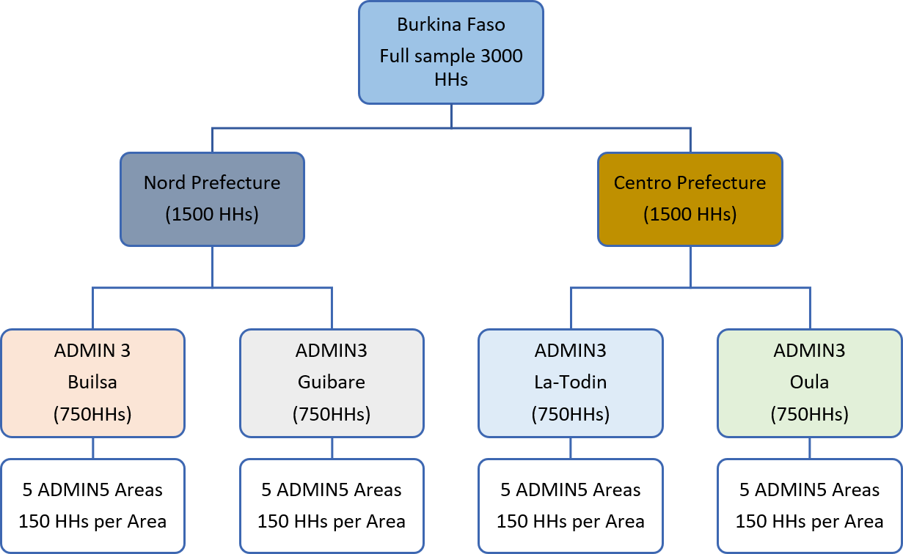

Figure 2: Systematic sampling & sample size in each ADMIN area

Selection of respondents (Households)
The sampling frame in Burkina Faso is all households in the 20 ADMIN5 areas (PSUs). Households will be enrolled for the study through listing at the PSU.
Carefully selected, trained and conscientious enumerators will be engaged to conduct the listing of households in each PSU. Since there is no recent census data available for the selected areas (according to the CO), a full village level census will be conducted in each of the 20 ADMIN5 areas in the listing phase. All households will be contacted, consent of participation taken and their baseline and contact information. During the listing phase, once a household head agrees to participate in the study, a standardized listing questionnaire to collect basic household and respondent characteristics such as household head’s age, gender, education, the composition of the household, ownership of some basic assets, mobile phone ownership, housing, WASH, etc. (these are to be used later for the purpose of randomization) will be administered.
The final sampling frame will then be households that have consented, have access to mobile phones, and completed the listing questionnaire will be included in the final sample. Sampling of actual study participants will then follow a simple random process based on the final cleaned census list.

Randomization of sample
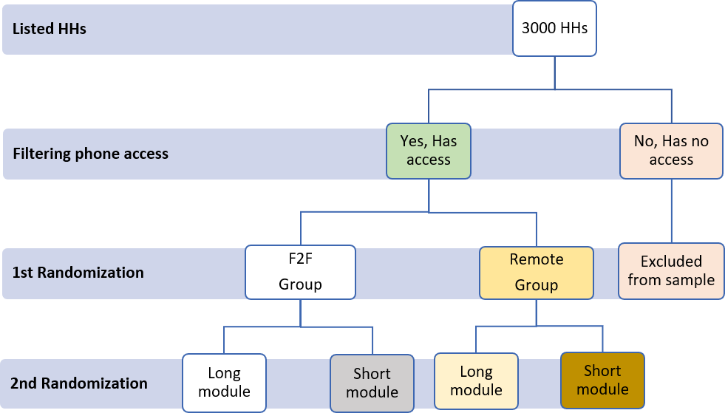
Households enlisted that do not have access to mobile phones within the household or phone coverage will be dropped during the randomization. Similarly, households with incomplete baseline and contact information will be dropped from the final. Randomization will be done independently for each ADMIN5 sample separately. This is to ensure comparability in the livelihood answers that will be reported across modalities in each ADMIN5 area.
Figure 3: Step by step randomization of the survey sample

Training & assignment of enumerators
To be qualified to be engaged as an enumerator for both the listing and data collection, all potential enumerators should have the following.
- Formal education with a minimum of first degree,
- First-hand knowledge of the study areas (preferably speak the local language/dialect), and
- Prior data collection experience (at least must have been involved in two separate food security surveys) in BF.
To ensure consistency in data collection, a 5-day in person training will be organized for both F2F and remote enumerators. Training will be conducted jointly by the BF CO (VAM team), RBD and rCARI team from HQ. Training will be largely conducted in French, the predominant language of the study area. Local dialects will be used in cases where required to increase comprehension. A day’s hands-on field pilot will be conducted at the end of the training session to test both the practical knowledge of enumerators and interview instruments for both cohorts (F2F and remote). A comprehensive field guide translated into French will be prepared at the end of the enumerator training. This will be provided to all enumerators to serve as quick reference in the field when they are in doubt. In addition, field supervisors with adequate understanding of food security and livelihoods of the study area will be engaged to work closely with all enumerators in the field to increase data quality.

Possible limitations of the design & suggested mitigation strategies
Although a lot of thought has been given to the methodological design of the study, it must be mentioned that there remain some potential unavoidable sources of biases in this current experimental design setup. The potential sources and how the current design would remedy or reduce them are discussed below.
- Lack of national representativeness of the survey. One of the key limitations of the methodology is its lack of nationwide coverage which is likely to affect the generalization of the results. However, given the main objective of the study, the sample design has been adapted in such a way to ensure that the study sample will represent the study sample as much as practicable.
- Geographical variation in the distribution of respondents. With the traditional phone survey likely to have lower response rates than F2F, there is a likelihood that completed surveys may be skewed in favor of F2F group which can affect the final analysis. To address this limitation and ensure that the final interview sample is large enough to allow for statistical analysis, a number of strategies will be adopted. First, the study will only be rolled out in areas that allow for both F2F and remote surveys. Second, a comprehensive listing (census) phase has been incorporated to ensures that we are able to achieve a uniform pre-survey distribution of both F2F and remote cohorts. Third, increase sensitization of the study regions through the listing phase. A standard questionnaire will be used for the census that will pre-inform all households in selected PSUs about the study including time frames that they may be contacted for the respective interviews. Forth, increase the number of follow-up in the remote cohort. Specifically, in addition to the stated time by respondents to contacted, 3 additional time windows, i.e., mornings, afternoons and evenings will be used to make calls. This will ensure that more households are reached within the survey period.
- Confounding through enumerator effects (gender, training, and motivation). Given that both survey cohorts are to be collected simultaneously, the same enumerator cannot be used to collect both cohorts which can inadvertently influence the results. To address this potential bias, randomization will be adopted when assigning enumerators to the PSUs and modalities (a minimum of two enumerator will be assigned to each PSU). Also, to ensure equivalence of comprehension of the questionnaire across all enumerators, F2F and remote enumerators will be trained together by the same facilitators. Also, knowledge test will be conducted at the end of the enumerator training with the lowest scoring enumerators being or retrained or dropped all together. Finally, daily frequency speed checks will be put in place by the data management team to be based in Rome access the performance of each enumerator. Those with questionable data inputs will either be asked to re-do the interviews or where it is extreme are dismissed at together. Finally, a conscious effort will be made to increase the number of female enumerators conducting the remote interviews (evidence show that female enumerators tend to achieve higher response rates compared to males in phone survey).
- High attrition particularly in the remote cohort. High attrition rates particularly in the remote is likely to affect the statistical power and by extension the overall analysis of sub-groups in the final completed surveys. To minimize this limitation, the initial sample size of 2000 households will be increased by 50% to 3000 households in Burkina Faso. This is expected to create adequate allowance to take care of sample attrition.

