**ITECH2301 – Network Architecture and Design**

**Term 1, 2020**

**Assignment- 2**

Lecturer: Greg Lynch

Tutor: Greg Lynch

Prepared by:

Abhi Jitendrabhai Patel

ID 30383266, IIBIT Adelaide.

Due Date: 2020, June 12

## **Task 1: Logical Design**

1. **Network Architecture Component:** Network architecture is used to categorize all layer one by one in term of logical design to understand its procedure. There are seven architecture components which involve in logical diagram is below:
2. **Access Layer:** The new network has developed in two building: office building that have 5 floors and Admin building which is single story. Here, I have used VLAN with layer 2 switches (Virtual Local Area Network) instead only LAN on each floor in office building and admin building as well. This VLAN covered both wired and wireless network which provide access network to wireless devices such as employees’ laptops, mobile phone etc.
3. **Distribution Layer (Building Backbone Network):** Distribution layer administer packet traffic to and from access layer and core layer of network. Here, switches are faster because they have to carry whole traffic and manage it for specified VLAN. So, I used layer 3 switches here.
4. **Core layer (Campus Core Backbone):** As per its name core layer, it connects all campuses at one point which obviously more faster than all other layer because it carries all campuses traffic and manage it. I used layer 3 switches for this layer.
5. **Data Center (Server Room):** The server room has the database servers, e-commerce edge server, email server etc. In my diagram it is located in admin building and has very fast speech connection with core layer and ISP.
6. **Internet Access:**
7. **E-commerce edge:**
8. **Application Systems:**

|  |  |  |  |  |  |
| --- | --- | --- | --- | --- | --- |
| **No** | **Application Name** | **Type of Flow of Traffic** | **Protocol** | **Allowed Departments/people**  **To use the application** | **Servers/Hots** |
| **1** | Document/files Transfer | Server/Client | FTP (File Transfer protocol) | All Employee/person | Servers |
| **2** | Mail Sharing (G-Mail, Outlook, Yahoo) | Client/Server | SMTP (Simple  Mail Transfer Protocol) | All Employee/Department/Person | Host |
| **3** | Web Browser | Client/Server | HTTP | All Employee/Department/Person | Host |
| **4** | HRM/Payroll | Client/Server | FTP, EFTP (Electronic Fund Transfer Protocol) | Financial Operation Department | Server |
| **5** | Video Conferencing Application | Client/Server | UDP, RTP & TCP | All Employee/Department | Server |
| **6** | Printing Protocol | Client/Server | IPP (Internet Printing Protocol), SMB, FTP | All Employee/ Department | Server |

1. **Network Users:**

* Here, in my network, these are education campuses. So, they may have financial operation Team/Department, Skill Development team/Department, IT Services Team/Department, Assessment and Examination Team/Department, Administration Team/Department etc.
* These all employee are generating traffic and receive network traffic to and from internet. They all will not use this produced network directly. It will be filtering from security devices such as firewall and packet filter etc.
* Here, Administration department, IT Service and Financial Operation department may generate high traffic because they have to face day to day activity. While, all other department or employee will generate typical traffic.
* The requirement is email, web browsing, desktop video conferencing, printing etc. for all department/employees.
* There are 120 computers and 300 employees, so some employee may use their own laptop or tablet etc and they will use Wi-Fi (access point) for internet connectivity.

1. **Categorizing Network Needs:**

* These campuses will have internet connection with VLAN on each floor for the employee. As I illustrated above that Admin, IT Service and Financial Operation department will have more traffic due they have to perform day to day tasks. Moreover, the employee can connect their mobile phone, laptop, tablet or other wireless devices to access point. Any computer can share and provide shared resources. Here, this network has VLAN, anyone can share resources.
* There are some mandatory applications such as file sharing, mail sharing, web browsing for internal and external web, Payroll (Financial Operation) application etc and also, its application may require more amount of multimedia data.

1. **Deliverables:**

Below, Image shows the logical diagram of network.

**Image 1**

## **Task 2: Physical Design**

1. **Designing Client and Servers:**

* Here, client-server is the one type of network process where many client requests and get service from host server (Server Room). In addition, client computer gives a permission to users to interact with servers for various services and to see the result in term of graphics that server response.
* In the same way, host severs wait for request from client server and provide service. Typically, host server located on anywhere on network while client computer/server or workstation located at personal computers. Usually, host server has more powerful devices or machines which are extra ordinary fast.
* Typical network traffic clients/departments are assigned medium-level computers while high traffic users/department are assigned advanced level computer with latest generation and with high speed CPU.
* Here, both client and host server are intelligent machine, so many clients can access the database simultaneously at the same time.

1. **Designing Circuit:**

* The VLAN has designed as a physical star topology which connect the computers (24 Computers), Access points (4 Aps) and printer (2 Printer) on each floor in office building.
* As per the requirement, these two building will also have wireless network with IEEE 802.11ax access points. The network has been categorized in high traffic and typical traffic. In office building, there are two floor which have high traffic and these floors: floor number 2 and 4 will have high speed 10 Gbps layer 2 two switch (Distribution/backbone layer) with Cat 6, 10 BASE-T ethernet cable connectivity with computers and printers (Access Layer). Admin building will also have same 1 Gbps layer 2 switch (Distribution/backbone layer) with Cat 6, 10 GBASE-T connectivity with computers and printers (Access Layer).
* While, other floors in office building are considered as typical traffic network and will have 1000 Mbps Layer 2 switch (Distribution/backbone layer) with Cat 6, 1GBASE-T ethernet cable connectivity with computers and printers (Access Layer).
* Here, All Access Points will connect with distribution switch with Cat 7 ethernet cable because IEEE 802.11ax have been used considering future requirement. If company want more than 14 Gbps speed for wireless network because IEEE 802.1ax have max 14 Gbps, they need to change only Access Point switch for those VLAN not whole cable network. In this network, Aps, can provide 10/100 Gbps for high traffic floors and 1/10/1000 Mbps for typical traffic floors due to switch transmission speed.
* Now, these all backbone switches will have connectivity to 100 Gbps layer 3 switch (campus core backbone) with optical fiber 10/100 Gbps faster speed which will manage heavy network of all floors perfectly. Moreover, the database, e-commerce edge server etc. will have connectivity to layer 3 switch with optical fiber 10/100 Gbps to manage and response all request from clients’ computers.
* At the last, the network circuit will be connecting to ISP through Router and firewall with optical fiber 100 Gbps faster speed.

1. **Network Design Tools:**

* Network design and modeling tools carry out a many function to help in the designing technology and modeling process. Today’s world, there are many designing tools available on internet platform. Some of them are open source and some are on paid version.
* Some modeling tools are need to the client to draw the network diagram by hand. Here, the client has to enter servers, client computer, diagram circuit and all other network component and also, they have to define it. For example, SmartDraw, ConceptDraw Pro etc.
* Other tools discover current network. IN this scenario, client provide commence point and these types of software traverse the current network and automatically produce or draw the network diagram itself. When it complete, client can change to desired network diagram. These types of modeling software are most helpful when existing network diagram is very multiplex. After completing diagram, the next step is to add data about the desired network traffic and look if the diagram will support the level of the traffic that you expected. For example, SolarWind Network Performance Monitor, OpManager, OpUtils etc.
* On other hand, simulation modeling software are also one option. It is a mathematical technique where network design reacts as it is under real situation. When simulation completed the user can check the result to see the approximate response time and performance. It is crucial to know that this type of tools only give estimate, that is might vary from real result. So, client can change the network design to remove the problem and re-compile the simulation. In addition, proficient modeling software also all attention to difficult spot including bottleneck. For example, Riverbed Modeler, TETCOS NetSim, NS-3 etc.

1. **Deliverable:**

Below image 2 shows the physical diagram of the network. Please Zoom In the below diagram to see it properly.

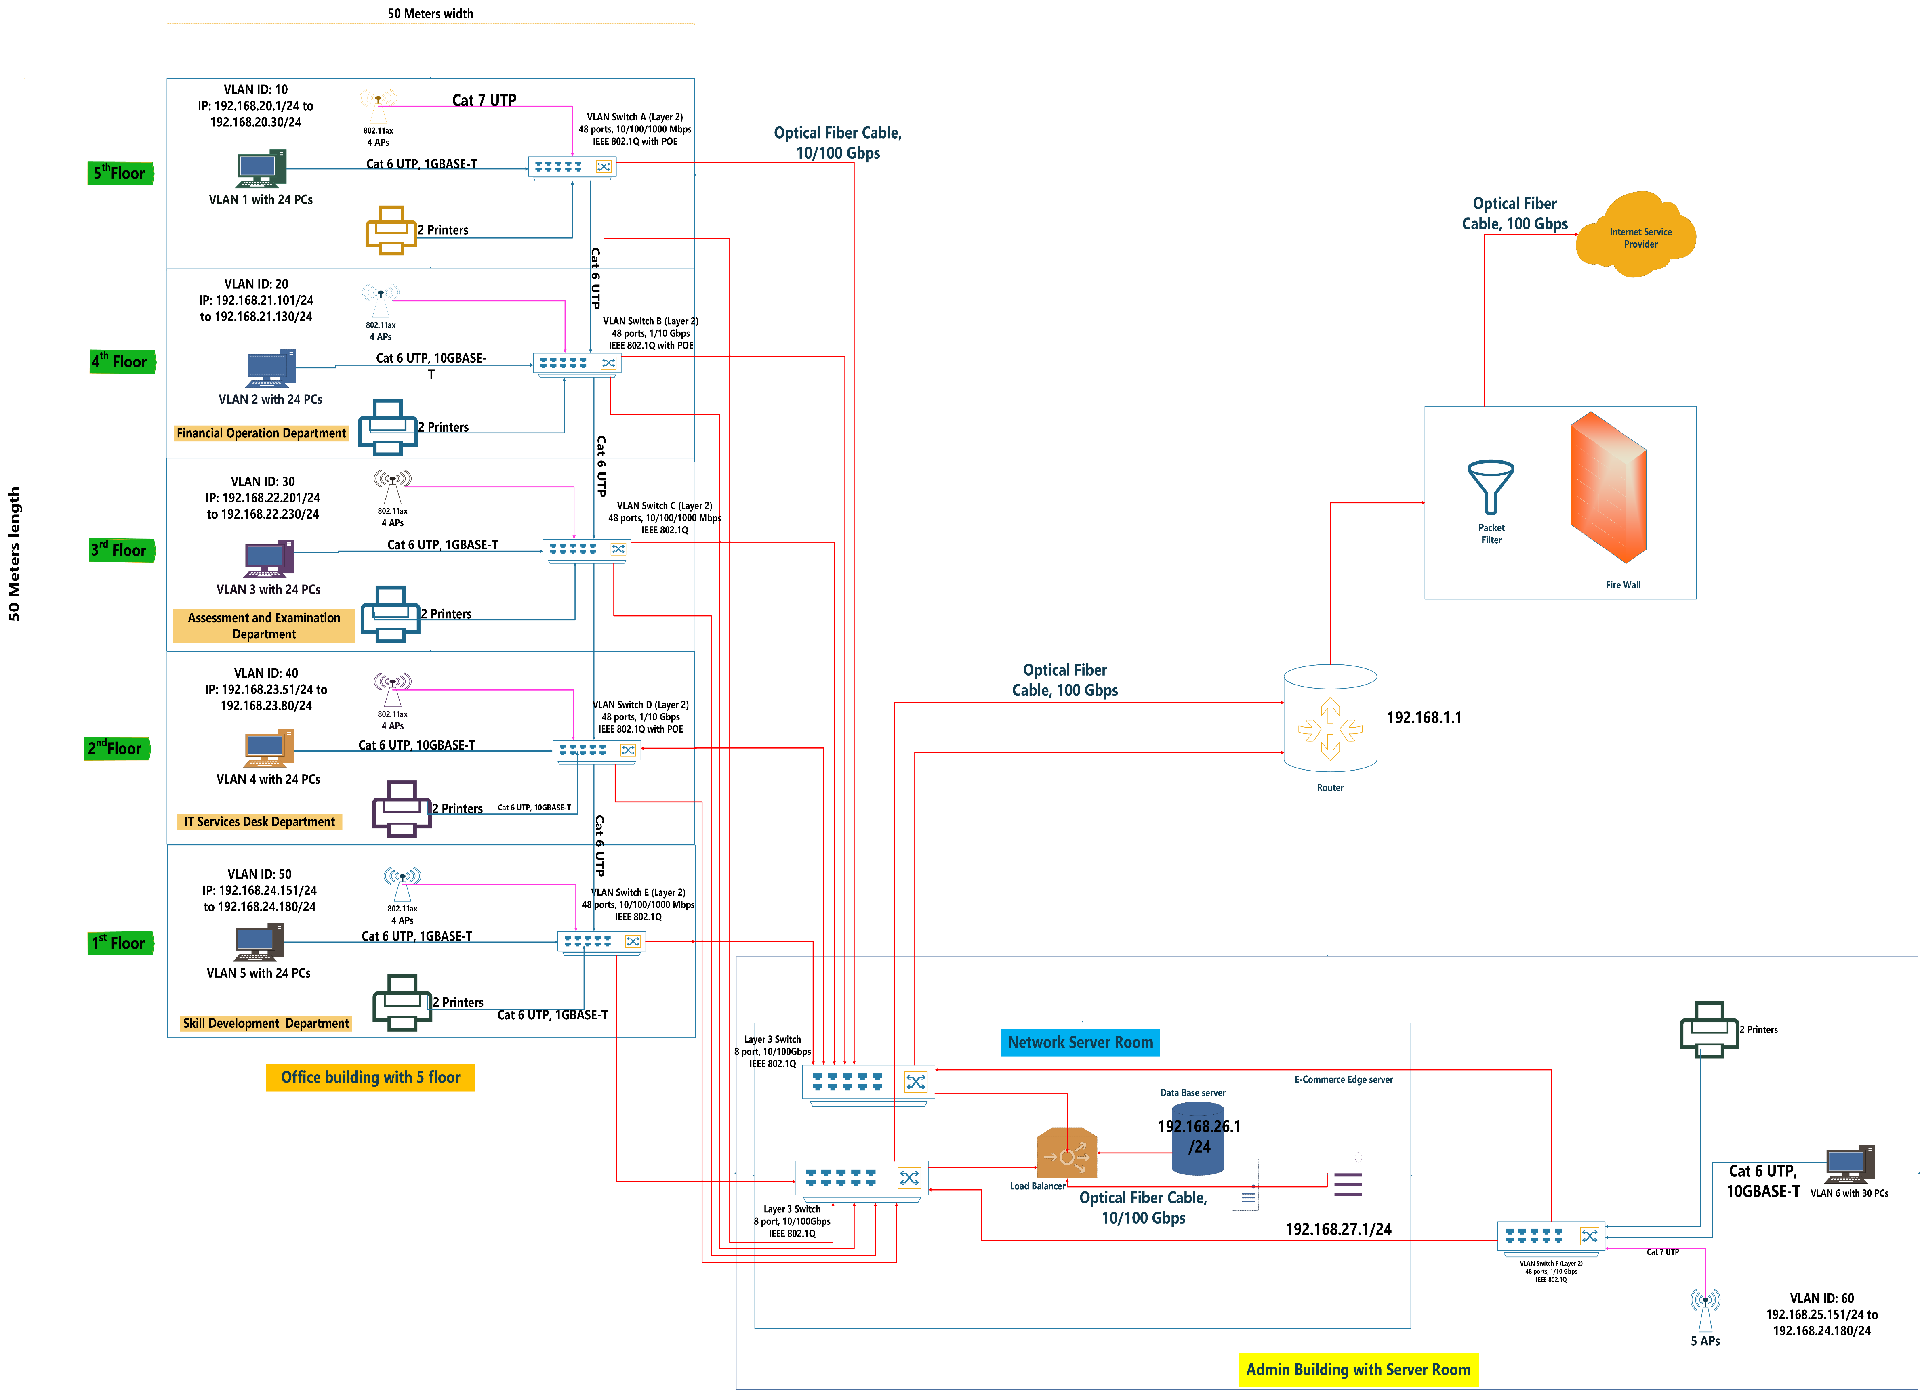

**Image 2**

* Here, in image 2, the optical fiber cables have shown by red line, Cat 6 cables have shown by blue line and Cat 7 cables for Access point connection have shown by pink line.

## **Task 3: Briefly describe how you will minimise the interference from Wi-Fi access points on different floors.**

* Here, I have assumed the length and width for office building is same, 50 meters length and 50 meters width. So, the building would be square. So as per my physical diagram, there are 4 Access Points on each floor. I have used IEEE 802.11ax Wi-Fi access points which are 6th generation of Access Point.
* These Access Point will be operating on 5 GHz bandwidth with 1,6 and 11 number channels.
* These access points are directional Wi-Fi. So, it will be hanging on wall rather than ceiling of each floor to avoid the interference between Wi-Fi. I am doing so because 802.11ax has approx. 70 meters indoor range as per my research which is enough good range for the building. So, if I use the omnidirectional access point and hang it on ceiling, it would interference with another floor Wi-Fi as well. On other hand, if we use the directional Wi-Fi and hang it on ceiling, it also would interreference to other WIFI.
* So, I would hang the directional access points on wall on each floor. So, it will not interference with other Wi-Fi in both downward and upward direction floors.

## **Task 4: Assumption during creation of diagram.**

* Here, I have assumed many things during the creating the diagram.
* First, I assumed that the building is in square and have same length and width. These are education campuses, so I have assumed some department on different floors which are usually an education provider have such as Financial Department, Skill Development Department, Assessment and Examination Department, IT Services Help Department, Admin Department etc.
* Secondly, I have assumed that each floor has same number of computers on each floor and printers as well. I have assumed that Financial (Floor 4), IT Service Help (Floor 2) and Admin (Admin Building) departments will generate more traffic than other. Thant’s why, I have used faster switches for distribution layer for those floors than other.
* I have used Cat 7 cable for access point connection with switch by thinking future. So, in future if company want to high speed, they need to change only the VLAN switch for that typical traffic floor only because these floors has 1000 Mbps layer 2 speed only now.
* Also, I have assumed that the server room is located in Admin building because I assumed that office building has no space for it.
* I assumed that the campus core backbone will have two switches as a core layer. If one will out of order, then other one can manage the network.
* I assumed that the company is not worried about cost of network. But still I did not create too much expenses diagram.

## Overview of Old network of the Campuses (Assumed):

After looking the new network, let’s see the summary of old network:

* Here, also the office building has same number of computers on each floor.
* The old network has been created using LAN rather VLAN which is quite flexible.
* The cabling in old network in was created by using Cat 5 which is quite low compare to current high-speed requirement.
* The hub was used for each LAN on floors in office building and admin building. There is no e-commerce edge server as well. The main switch was layer two switch and connected to hub by cat 6.
* The number of Aps are only 3 in office building and it was 802.11n only 600 Mbps max.

The below image shows the overview of old network. See image 3.

**Image 3**

**References:**

* Jerry F., Alan D., & Alexandra D. (2017). *business-data-communications-and-networking* (11th ed.). John Wiley & Sons, INC
* Creately. (2019). Logical Network Diagram. <https://creately.com/diagram/example/ihc1vmnk1/LOGICAL%20NETWORK%20DIAGRAM>
* Springer Link (2020). Electronic Fund Transfer Protocol. <https://link.springer.com/chapter/10.1007/10719994_21>
* Rathnam, L., (2019), What is layer 3 switches and why we need it? [Blog Post] <http://techgenix.com/layer-3-switch/>
* Business.com (2020). Why we care about IEEE 802.11ax. <https://www.business.com/articles/what-is-802-11-ax-wi-fi/>