**SQL Query Report(Lab 3)**

***1. Customers with Loans but No Accounts***

This query retrieves a list of customers who have taken out loans but do not hold any accounts with the bank. It helps in identifying potential customers who may be in need of banking services.

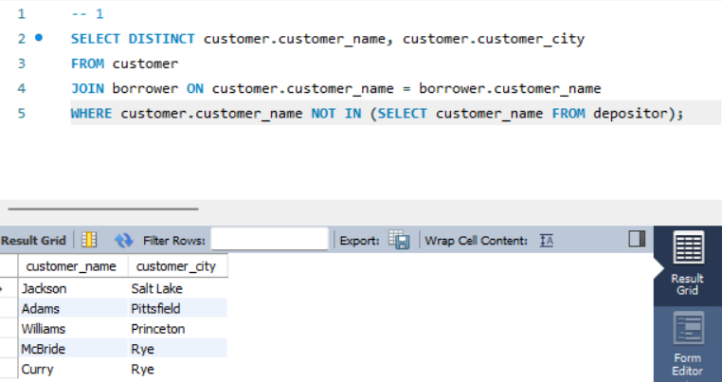

**2. Customers with Both Accounts and Loans**

Two approaches were used to find customers who have both an account and a loan:

* **Set Operator**: This method uses a subquery to find customer names present in both the borrower and depositor tables.

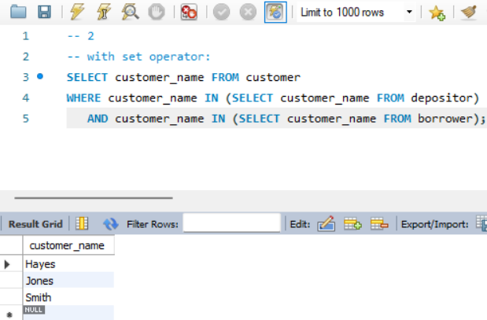

* **Without Set Operator**: This approach utilizes joins to directly obtain customer names from both tables, providing a more efficient execution plan.

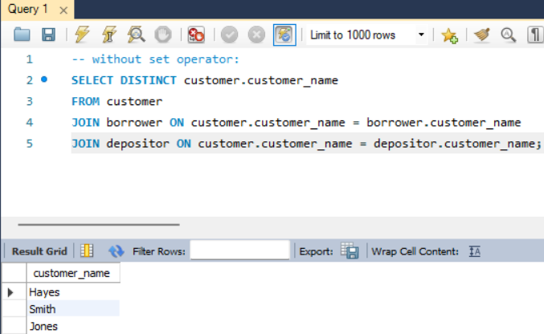

**3. Customers with Accounts or Loans**

Similar to the previous task, this query identifies customers who have either an account or a loan:

* **With Set Operator**: It uses subqueries to find customers in either table.

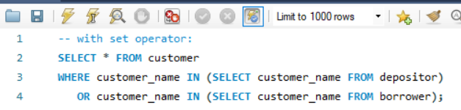

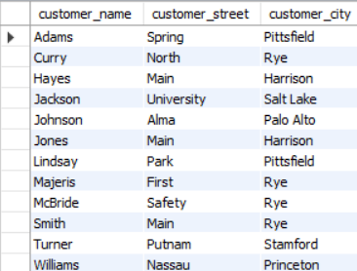

* **Without Set Operator**: This method employs left joins to gather all customer information where they have an account or a loan.

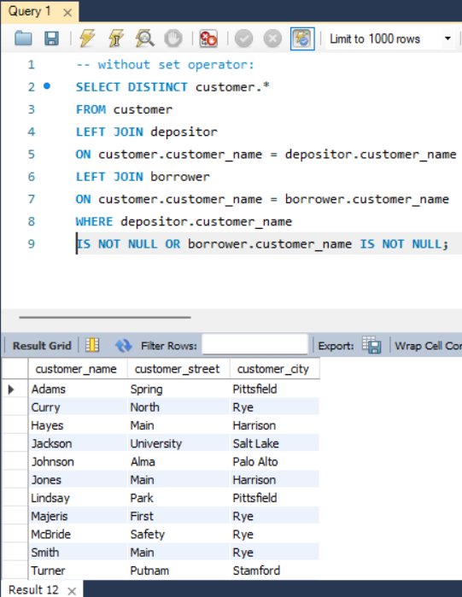

**4. Total Assets of Branches**

This query computes the total assets held across all branches, providing insight into the overall financial health of the bank.

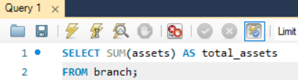

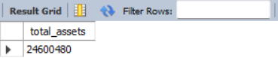

**5. Total Number of Accounts by Branch City**

This query counts the number of accounts in each branch city, allowing for geographical analysis of account distribution.

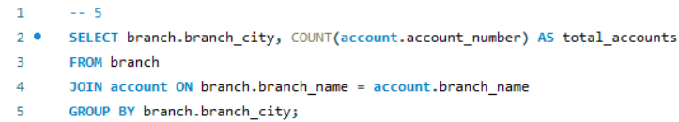

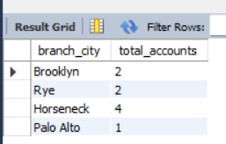

**6. Average Balance of Accounts by Branch**

This query calculates the average balance of accounts at each branch and sorts the results in descending order. It is valuable for assessing the financial status of different branches.

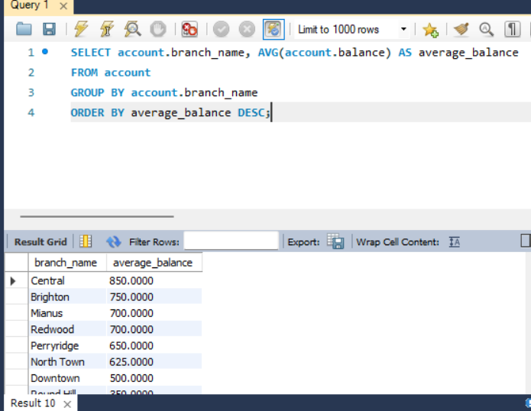

**7. Average Loan Amount by Branch Excluding Certain Cities**

This query finds the average loan amount for each branch while excluding branches located in cities containing "Horse" in their names. This can help focus on specific geographical areas.

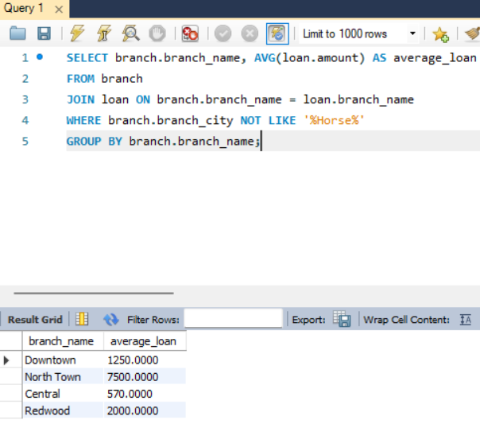

**8. Account with the Highest Balance**

This query identifies the customer and their account number for the account with the highest balance, assisting in recognizing top clients.

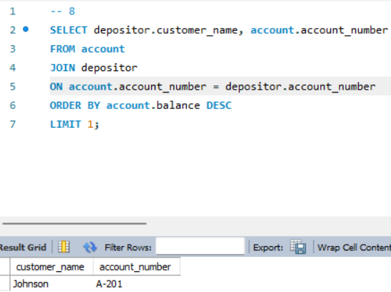

**9. Customers with Accounts in Their City of Residence**

This query retrieves customer information for those who have accounts in branches located in the same city where they reside, promoting personalized banking services.

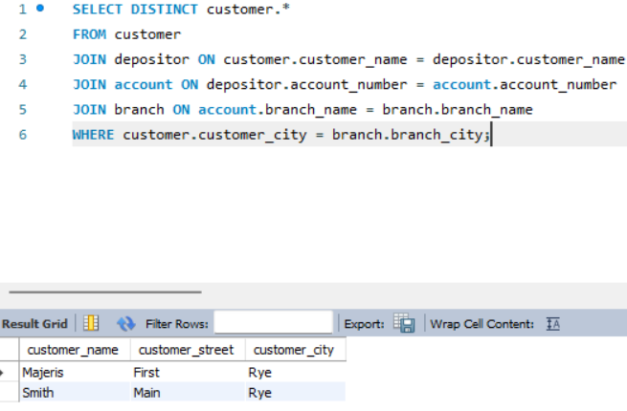

**10. Average Loan Amount by Branch City with a Minimum Threshold**

This query calculates the average loan amount for loans opened in each branch city, filtering out cities where the average amount is below 1500. This helps identify cities with significant lending activity.

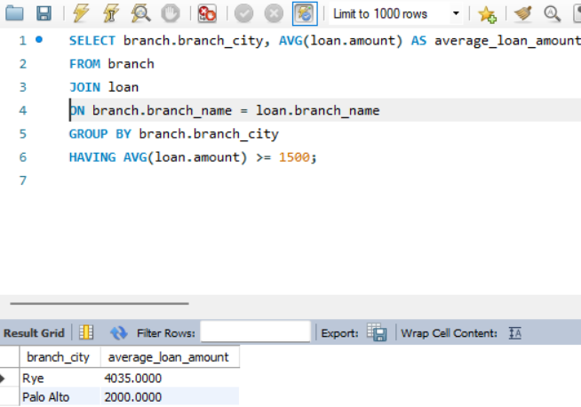

**11. Branches with Higher Total Account Balances**

This query determines which branches have a total account balance exceeding the average balance among all branches, highlighting financially stronger branches.

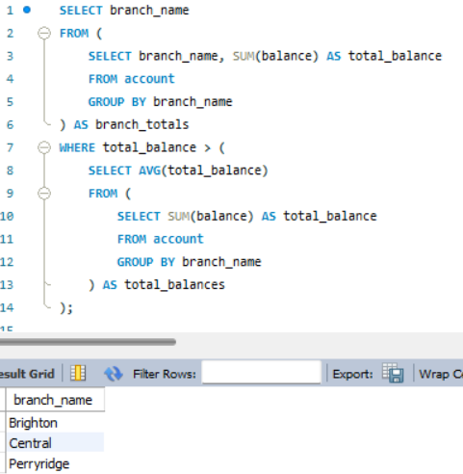

**12. Customers Who Can Pay Off Their Loans**

This query finds customers who have at least one loan that can be paid off using their total account balance, indicating their financial stability.

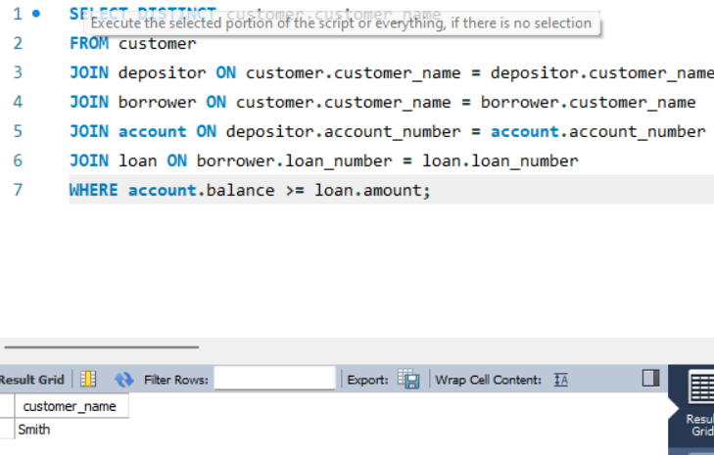

**13. Branch Information for Cities with Customers Lacking Accounts or Loans**

This query retrieves branch information for cities where at least one customer lives without any accounts or loans, provided the branch has active accounts and loans from other customers. This can highlight underserved markets.

