**SQL Query Report(Lab 4)**

1. **Create Tables and insert the data.**
2. CREATE TABLE pokemon(
3. pokemon_id INT PRIMARY KEY,
4. name VARCHAR(50),
5. type VARCHAR(20),
6. hp INT,
7. attack INT,
8. defense INT,
9. speed INT
10. );
11. CREATE TABLE trainer(
12. trainer_id INT PRIMARY KEY,
13. first_name VARCHAR(30),
14. last_name VARCHAR(30),
15. city VARCHAR(30)
16. );
17. INSERT INTO pokemon(pokemon_id, name, type, hp, attack, defense, speed)
18. VALUES
19. (1, 'Bulbasaur', 'Grass', 45, 49, 49, 45),
20. (2, 'Ivysaur', 'Grass', 60, 62, 63, 60),
21. (3, 'Venusaur', 'Grass', 80, 82, 83, 80),
22. (4, 'Charmander', 'Fire', 39, 52, 43, 65),
23. (5, 'Charmeleon', 'Fire', 58, 64, 58, 80),
24. (6, 'Charizard', 'Fire', 78, 84, 78, 100),
25. (7, 'Squirtle', 'Water', 44, 48, 65, 43),
26. (8, 'Wartortle', 'Water', 59, 63, 80, 58),
27. (9, 'Blastoise', 'Water', 79, 83, 100, 78),
28. (10, 'Pikachu', 'Electric', 35, 55, 40, 90),
29. (11, 'Raichu', 'Electric', 60, 90, 55, 110);
30. INSERT INTO trainer(trainer_id, first_name, last_name, city)
31. VALUES
32. (1, 'Ash', 'Ketchum', 'Pallet Town'),
33. (2, 'Misty', 'Williams', 'Cerulean City'),
34. (3, 'Brock', 'Harrison', 'Pewter City'),
35. (4, 'Gary', 'Oak', 'Pallet Town'),
36. (5, 'Erika', 'Green', 'Celadon City');

*Output Tables :*

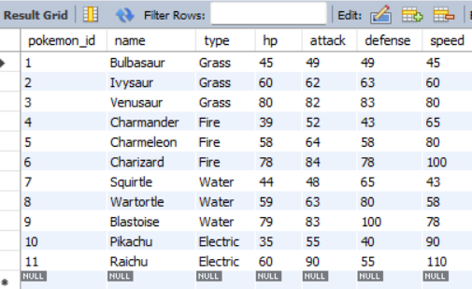 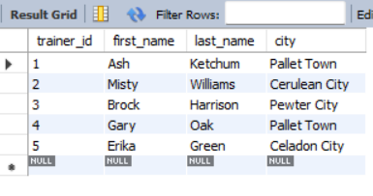

**2. Write a query to display the different types of Pokémon available in the pokemon table. Ensure that each type is listed only once.**

SELECT DISTINCT type

FROM pokemon;

Output:

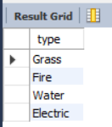

**3. List all Pokémon whose attack stat is between 50 and 80, inclusive.**

SELECT name, attack

FROM pokemon

WHERE attack BETWEEN 50 AND 80;

Output:

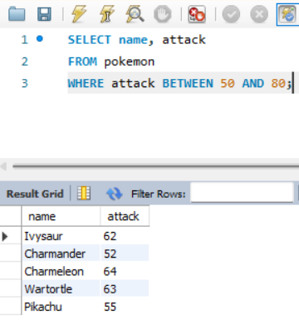

**4. Find all Pokémon whose names start with the letter ’C’.**

SELECT name

FROM pokemon

WHERE name LIKE 'C%';

Output:

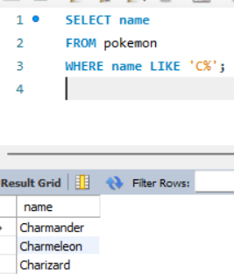

**5. Find all Pokémon whose names contain ‘saur’ anywhere in their names.**

SELECT name

FROM pokemon

WHERE name LIKE '%saur%';

Output :

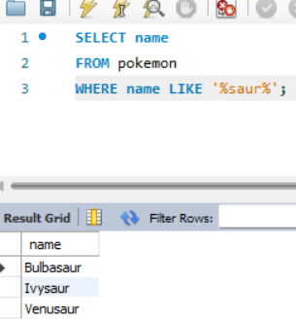

**6. Find all Pokémon whose names have exactly 9 characters and the fifth character is ’e’.**

SELECT name

FROM pokemon

WHERE name LIKE '____e____';

Output:

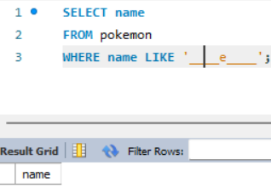 **(No name with such structure)**

*If we set ‘e’ as the 6th character :*

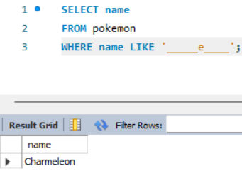

**7. Create a query to display the full names (first name and last name concatenated) of all trainers, along with their city.**

SELECT CONCAT(first_name, ' ', last_name) AS full_name, city

FROM trainer;

Output:

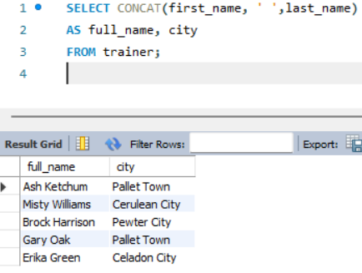

**8. List all Pokémon sorted first by type in ascending order and then by attack stat in descending order.**

SELECT name, type, attack

FROM pokemon

ORDER BY type ASC, attack DESC;

Output:

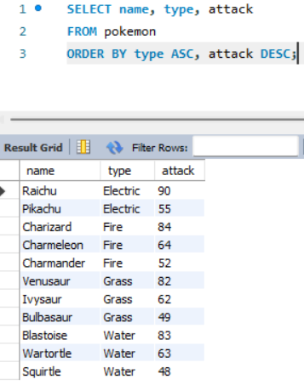

**9. Create the trainer_pokemon Table.**

CREATE TABLE trainer_pokemon (

    trainer_id INT,

    pokemon_id INT

);

**10. Add a foreign key constraint on trainer_id referencing trainer(trainer_id) and another on pokemon_id referencing pokemon(pokemon_id).**

ALTER TABLE trainer_pokemon

ADD CONSTRAINT fk_trainer

FOREIGN KEY (trainer_id) REFERENCES trainer(trainer_id);

ALTER TABLE trainer_pokemon

ADD CONSTRAINT fk_pokemon

FOREIGN KEY (pokemon_id) REFERENCES pokemon(pokemon_id);