**SQL Report(Lab 8)**

**ID : 220042146**

***Added MySQL Connector in the Java Project :***

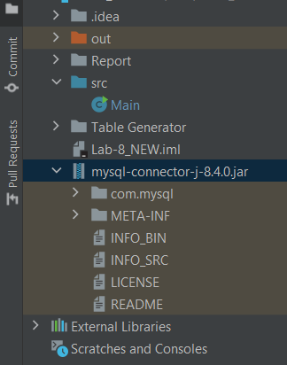

***Connected the Database Schema to Java Project:***

static final String *URL* = "jdbc:mysql://localhost:3306/lab-8";  
static final String *USER* = "root";  
static final String *PASSWORD* = "*********";

Class.*forName*("com.mysql.cj.jdbc.Driver");  
  
Connection con =

DriverManager.*getConnection*(*URL*, *USER*, *PASSWORD*);

System.*out*.println("Connected to database successfully.");

***Task-1:Count total transactions for account 49:***

Statement stmt1 = con.createStatement();  
ResultSet rs1 =

stmt1.executeQuery("SELECT COUNT(*)

AS totalTransactions

FROM TRANSACTIONS

WHERE A_ID = 49");

if (rs1.next()) {  
 System.*out*.println("Total transactions for account 49: " +

rs1.getInt("totalTransactions"));  
}  
rs1.close();  
stmt1.close();

***Task 2: Count number of credit transactions :***

Statement stmt2 = con.createStatement();  
ResultSet rs2 =

stmt2.executeQuery("SELECT COUNT(*)

AS creditCount

FROM TRANSACTIONS WHERE TYPE = 0");  
if (rs2.next()) {  
 System.*out*.println("Total credit transactions: "+

rs2.getInt("creditCount"));  
}  
rs2.close();  
stmt2.close();

**Output for Task 1 & 2:**

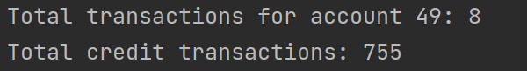

==========================))*((============================

***Task 3: List transactions in the last 6 months of 2021 :***

String query3 = "SELECT * FROM TRANSACTIONS

WHERE DTM BETWEEN '2021-07-01' AND '2021-12-31'";

ResultSet rs3 = stmt3.executeQuery(query3);  
System.*out*.println("Transactions from the last 6 months of 2021:");

while (rs3.next()) {  
 int t_id = rs3.getInt("T_ID");  
 Date dtm = rs3.getDate("DTM");  
 int a_id = rs3.getInt("A_ID");  
 double amount = rs3.getDouble("AMOUNT");  
 int type = rs3.getInt("TYPE");  
 System.*out*.println("T_ID: " + t_id + ", Date: "

+ dtm + ", Account: " + a_id  
 + ", Amount: " + amount + ", Type: "

+(type == 0 ? "Credit" : "Debit"));  
}

*?? But No Transaction is occurring in the output because no transaction has been done within last six month of 2021 :*

**

* *If we enlist those of Last 6 years, then it showed output like this :*

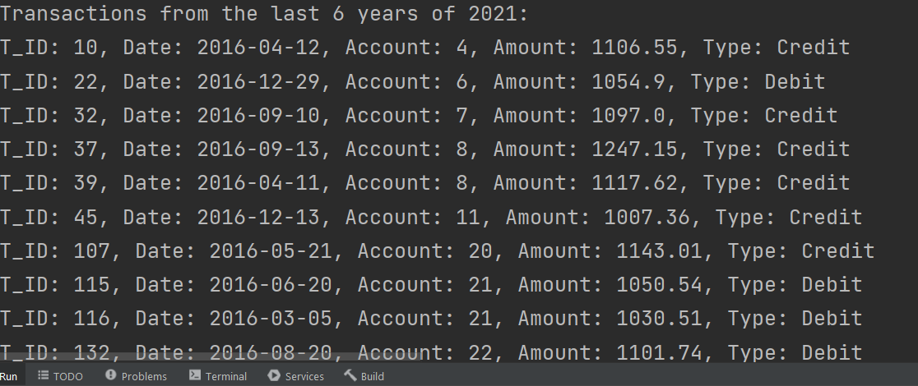

***Task 4 - Classify Accounts into CIP, VIP, OP, and Others :***

* ***Querry:***

Statement stmt4 = con.createStatement();

String query4 = "SELECT A_ID, " +  
 "SUM(CASE WHEN TYPE = 0 THEN AMOUNT ELSE 0 END) AS totalCredit, " +  
 "SUM(CASE WHEN TYPE = 1 THEN AMOUNT ELSE 0 END) AS totalDebit, " +

"SUM(AMOUNT) AS totalTransacted, " +

"(SUM(CASE WHEN TYPE = 0 THEN AMOUNT ELSE 0 END) - " +  
 " SUM(CASE WHEN TYPE = 1 THEN AMOUNT ELSE 0 END)) AS balance, " +

"CASE " +  
 "WHEN (SUM(CASE WHEN TYPE = 0 THEN AMOUNT ELSE 0 END) - " +  
 "SUM(CASE WHEN TYPE = 1 THEN AMOUNT ELSE 0 END)) > 1000000 " +  
 "AND SUM(AMOUNT) > 5000000 THEN 'CIP' "

+  
 "WHEN (SUM(CASE WHEN TYPE = 0 THEN AMOUNT ELSE 0 END) - " +  
 "SUM(CASE WHEN TYPE = 1 THEN AMOUNT ELSE 0 END)) BETWEEN 500000 AND 900000 " +  
 "AND SUM(AMOUNT) BETWEEN 2500000 AND 4500000 THEN 'VIP' "

+  
 "WHEN (SUM(CASE WHEN TYPE = 0 THEN AMOUNT ELSE 0 END) - " +  
 "SUM(CASE WHEN TYPE = 1 THEN AMOUNT ELSE 0 END)) < 100000 " +  
 "AND SUM(AMOUNT) < 1000000 THEN 'OP' "

+  
 "ELSE 'Other' "

+  
 "END AS AccountType "

+  
 "FROM TRANSACTIONS " +  
 "GROUP BY A_ID";  
  
ResultSet rs4 = stmt4.executeQuery(query4);

* ***Counters:***

int cipCount = 0, vipCount = 0, opCount = 0, otherCount = 0;  
while (rs4.next()) {  
 String type = rs4.getString("AccountType");  
 switch (type) {  
 case "CIP":  
 cipCount++;  
 break;  
 case "VIP":  
 vipCount++;  
 break;  
 case "OP":  
 opCount++;  
 break;  
 default:  
 otherCount++;  
 }  
}

* ***Printing result :***

System.*out*.println("Account classification:");  
System.*out*.println("CIP: " + cipCount);  
System.*out*.println("VIP: " + vipCount);  
System.*out*.println("OP: " + opCount);  
System.*out*.println("Others: " + otherCount);

***Output for Task 4:***

