🚔 KRIME AI
Hackathon Demo Guide
Datathon 2026 · Challenge 1 · Zoho Catalyst

A step-by-step script for demoing KRIME AI to judges,
with real screenshots of every feature.

Live App: https://krime-ai-60078097690.development.catalystserverless.in/app/index.html
Slate Frontend: https://krime-ai-slate-jjmjpohd.onslate.in/
Catalyst Console: https://console.catalyst.zoho.in/baas/60078097690/index#/

⏱ Suggested Demo Flow (8–10 minutes)
# | Feature | Time
1 | Secure Sign-In / Role-Based Access | 1 min
2 | Conversational AI Chat (NL→SQL + Context) | 2 min
3 | Dashboard & KPIs | 1 min
4 | Predictive Analytics + AI Anomaly Detection | 1.5 min
5 | Crime Heatmap | 0.5 min
6 | Criminal Network Visualization | 1 min
7 | Document Intelligence (RAG) | 1 min
8 | Audit Trail / Explainability | 0.5 min
9 | Voice Interaction + Role Restriction Demo | 1 min

1️⃣ Secure Sign-In · Role-Based Access
Open the live app URL. Judges will see a gated login screen — nothing is accessible without authentication.
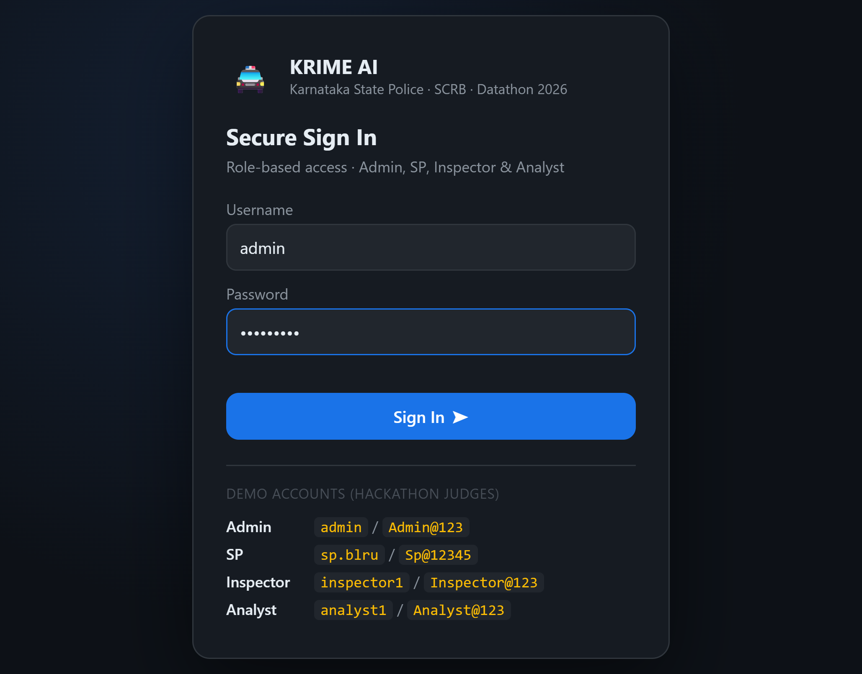
Login screen
Talking points:
- 4 distinct roles: Admin, SP, Inspector, Analyst — each with a different permission slice.
- Demo credentials are shown directly on the screen for judges to try themselves.
- Enforcement happens server-side (require_role() decorator on every Flask route) — not just hidden UI, so it can't be bypassed by calling the API directly.
Try it: Sign in as admin / Admin@123 for full access.
────────────────────────────────────────────────────────────

2️⃣ Conversational AI Chat — NL → SQL + Context Awareness
After signing in, you land on the AI Chat tab with example queries.
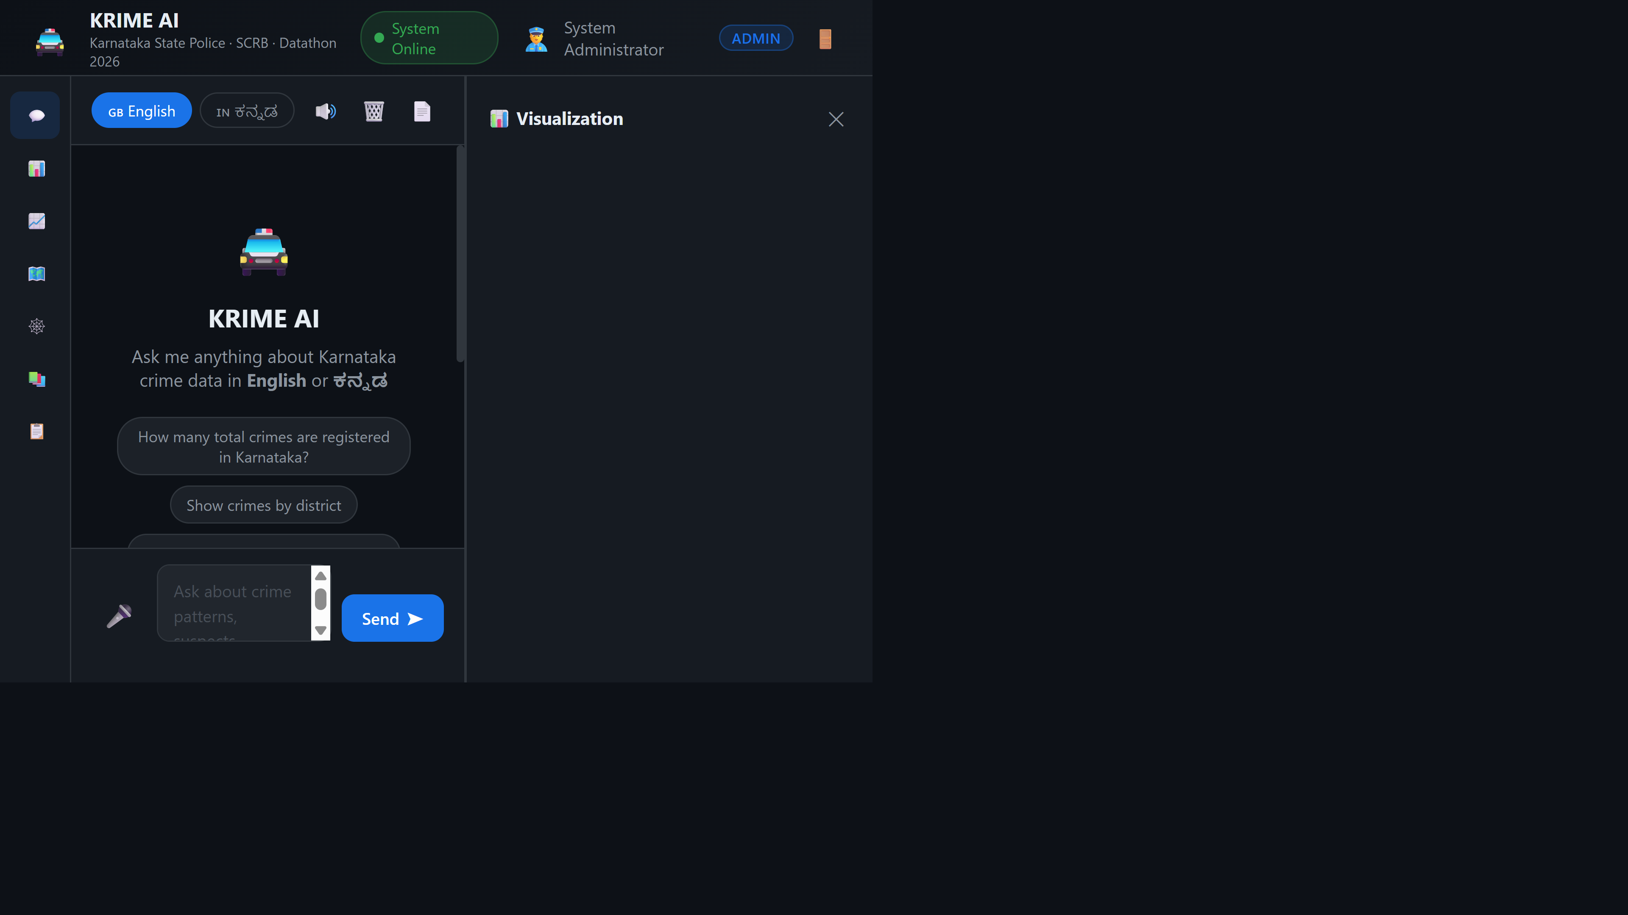
Chat welcome screen
Type or click a suggestion, e.g. "Show crimes by district". The AI:
- Detects intent → builds parameterized SQL
- Executes against the SQLite database (1,500 synthetic FIR records)
- Generates a natural-language insight via Catalyst QuickML (GLM-4.7-Flash)
- Shows the exact SQL query for transparency
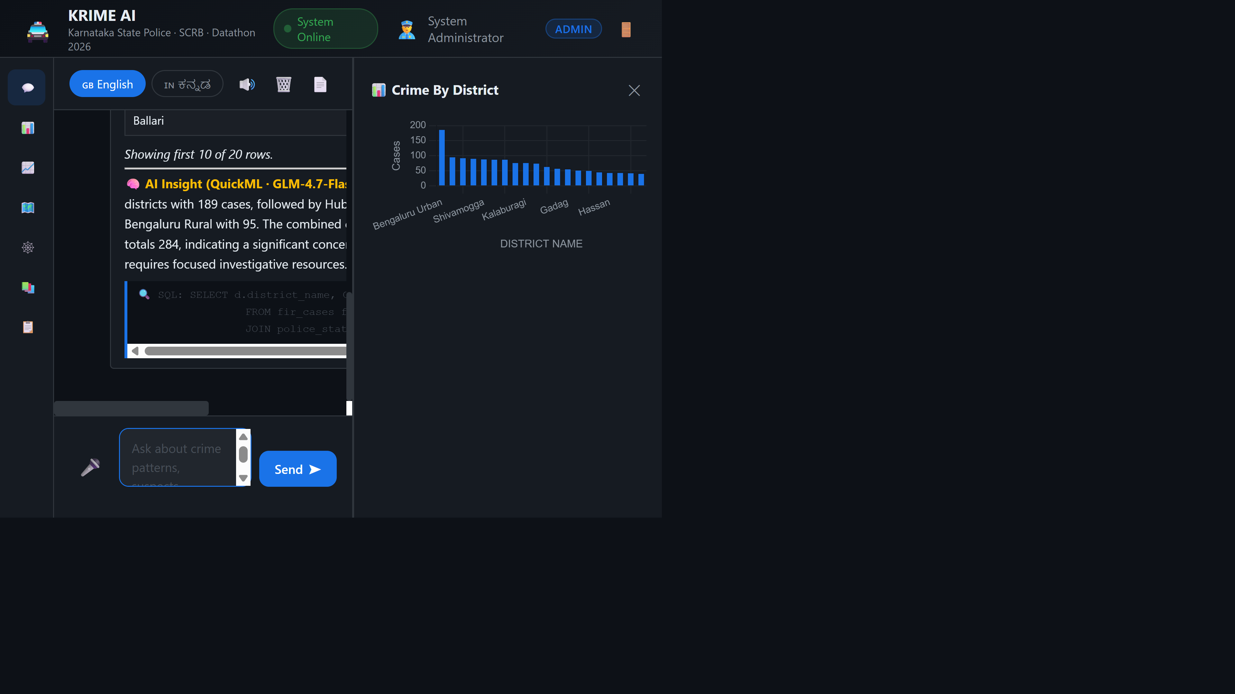
Chat response with chart, table, and AI insight
Talking points:
- Notice the chart panel auto-renders alongside the answer.
- The AI Insight line is LLM-generated commentary on the data — not hardcoded.
- The SQL badge shows exactly what query ran — full explainability.
Context-awareness demo: Ask a follow-up like "What about theft?" without repeating the district — the AI remembers what you were just discussing and carries the context forward (visible later in the Audit Trail tab with a "Context carried over" badge).
Bilingual demo: Switch to Kannada and ask ಬೆಂಗಳ್ೂರಿનಲ್ಲಿ ನೆಕ್ಷರಿಸಲೋಕ అಮರಿಕ ಎಷ್ಲಿ ತಿಳೆಸಿ
────────────────────────────────────────────────────────────

3️⃣ Dashboard — Key Performance Indicators
Click Dashboard in the sidebar.
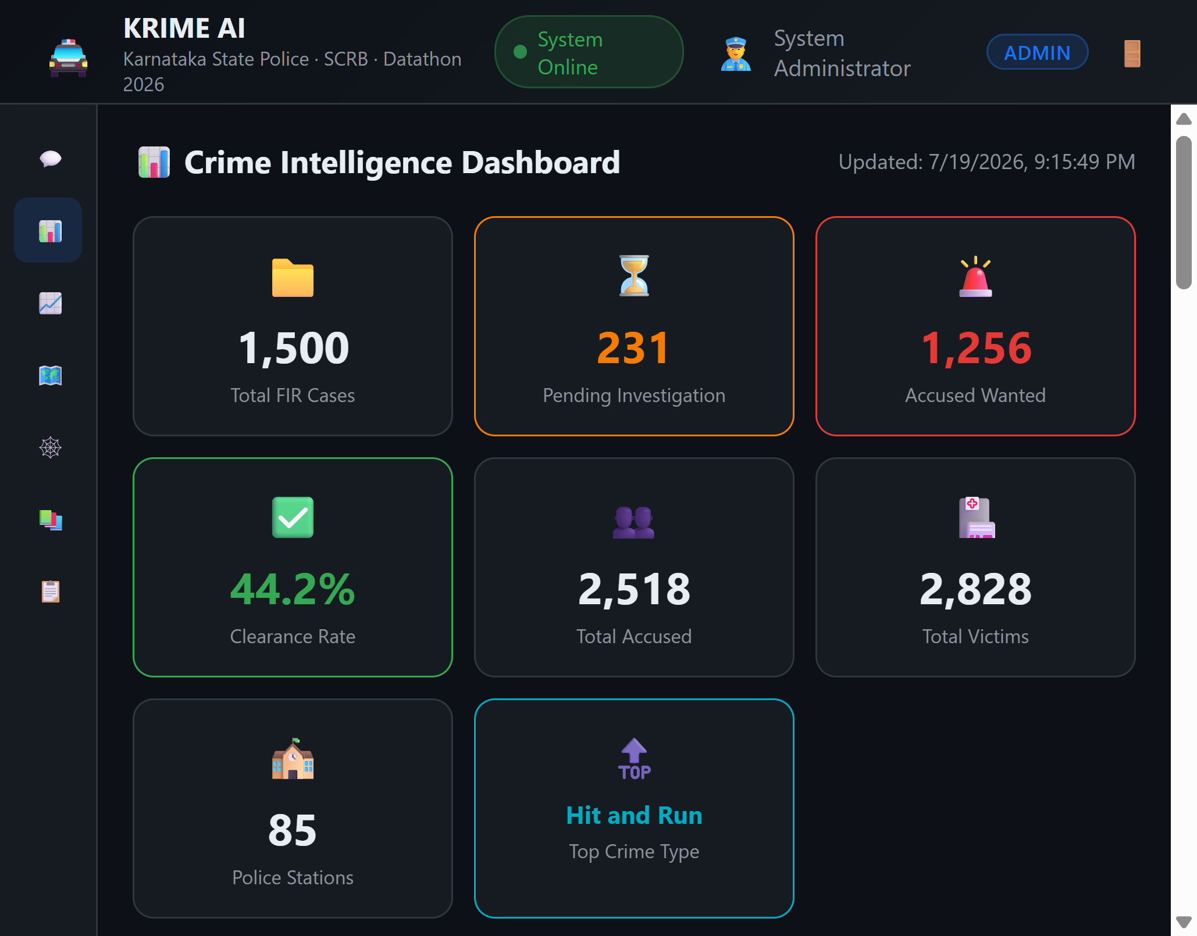
Dashboard with KPIs and charts
Talking points:
- 8 KPI cards: total cases, pending investigations, wanted accused, clearance rate, total accused/victims, station count, top crime type.
- 6 interactive Chart.js visualizations: yearly trend, crime type distribution, case status, top districts, arrest status, severity distribution.
- All data-driven from the live SQLite database — click Reload DB (Admin only) to reseed with fresh synthetic data live during the demo if desired.
────────────────────────────────────────────────────────────

4️⃣ Predictive Analytics + AI Anomaly Detection
Click Analytics.
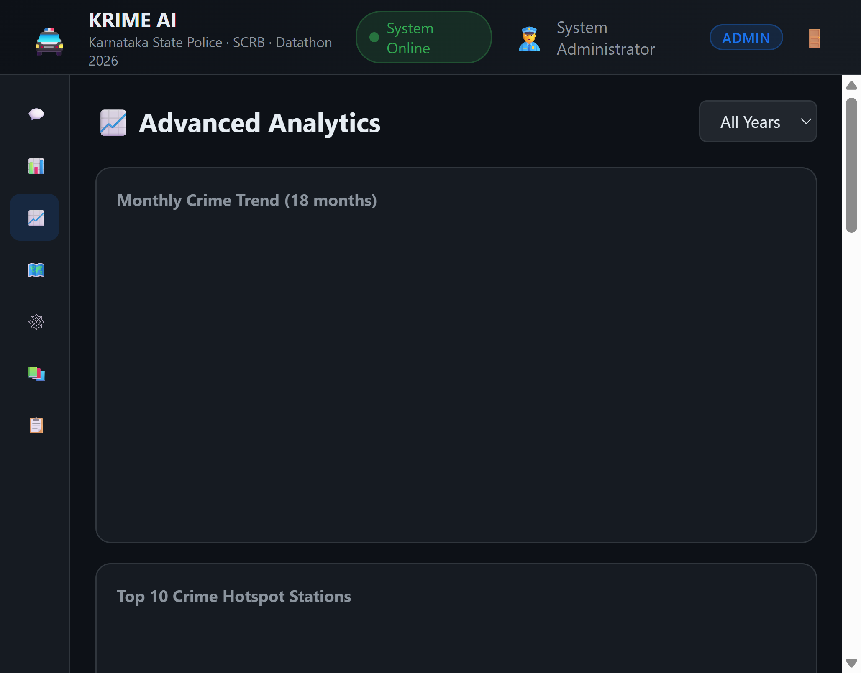
Analytics tab with predictive insights
Talking points:
- AI Predictive Insights box: QuickML-generated commentary on year-over-year trends, flagging upward/downward trajectories as early warnings.
- Scroll down and click "Scan Stations" to trigger the custom QuickML AutoML pipeline — a trained classification model that flags police stations whose case volume/severity statistically deviates from normal.
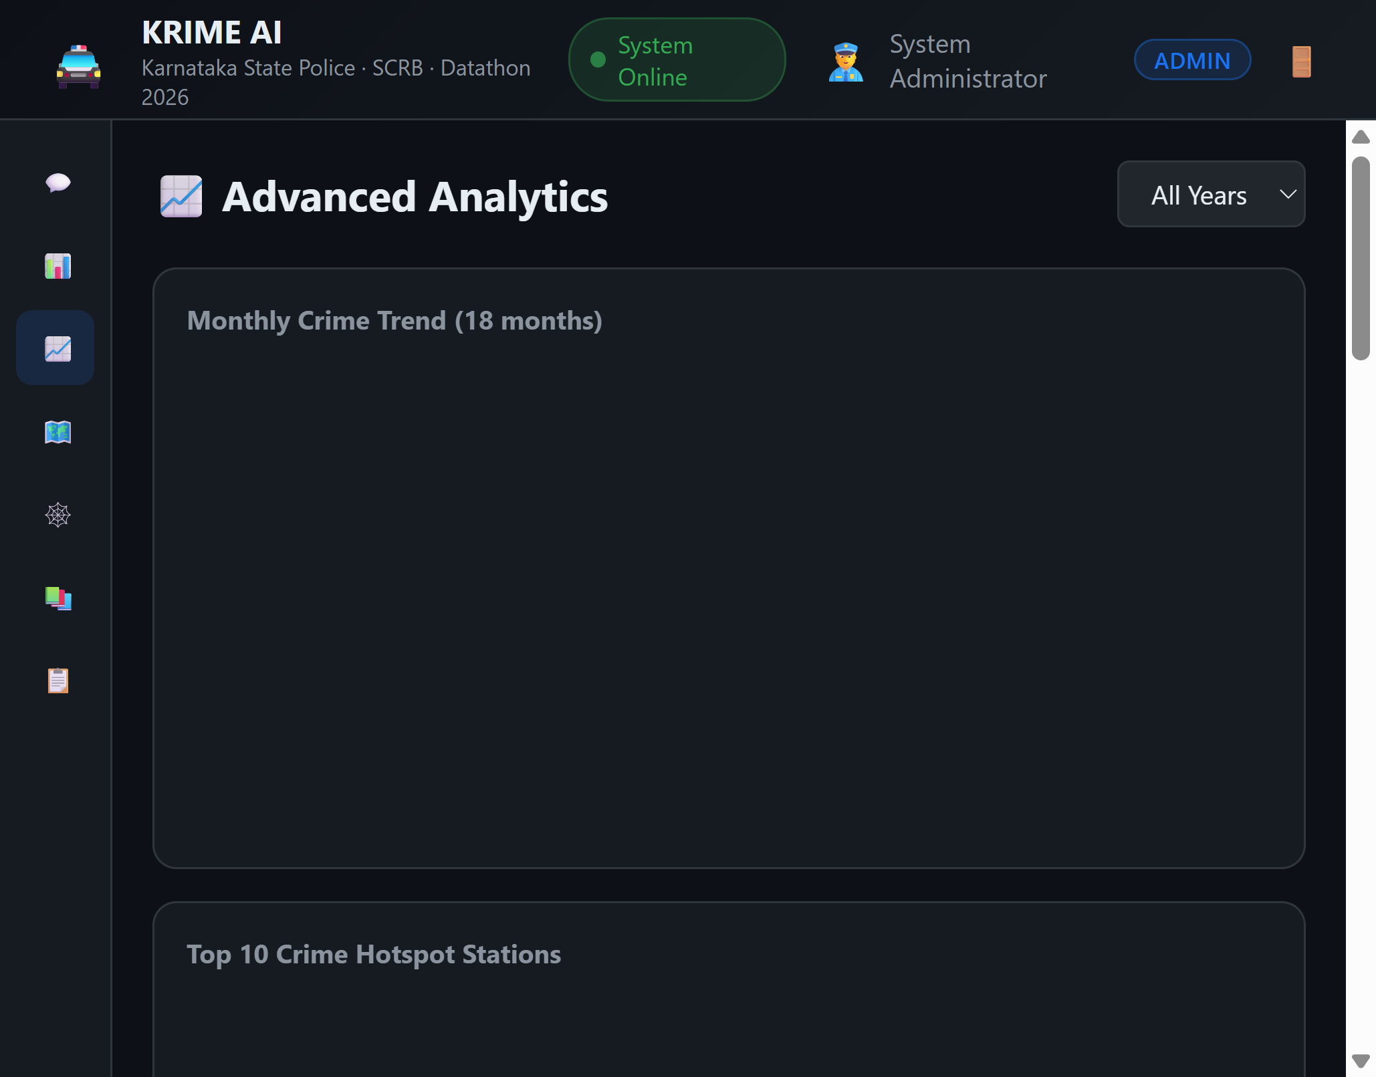
Anomaly detection results flagging 2 stations
Talking points:
- This directly satisfies the "custom pipeline builders for anomaly or fraud detection models" requirement — it's a real trained AutoML endpoint, not a mock.
- Flagged stations (e.g. Bajpe, Ullal in Mangaluru) show case count, average severity, pending count, and high-severity count — actionable for administrative review.
────────────────────────────────────────────────────────────

5️⃣ Crime Heatmap
Click Heatmap.
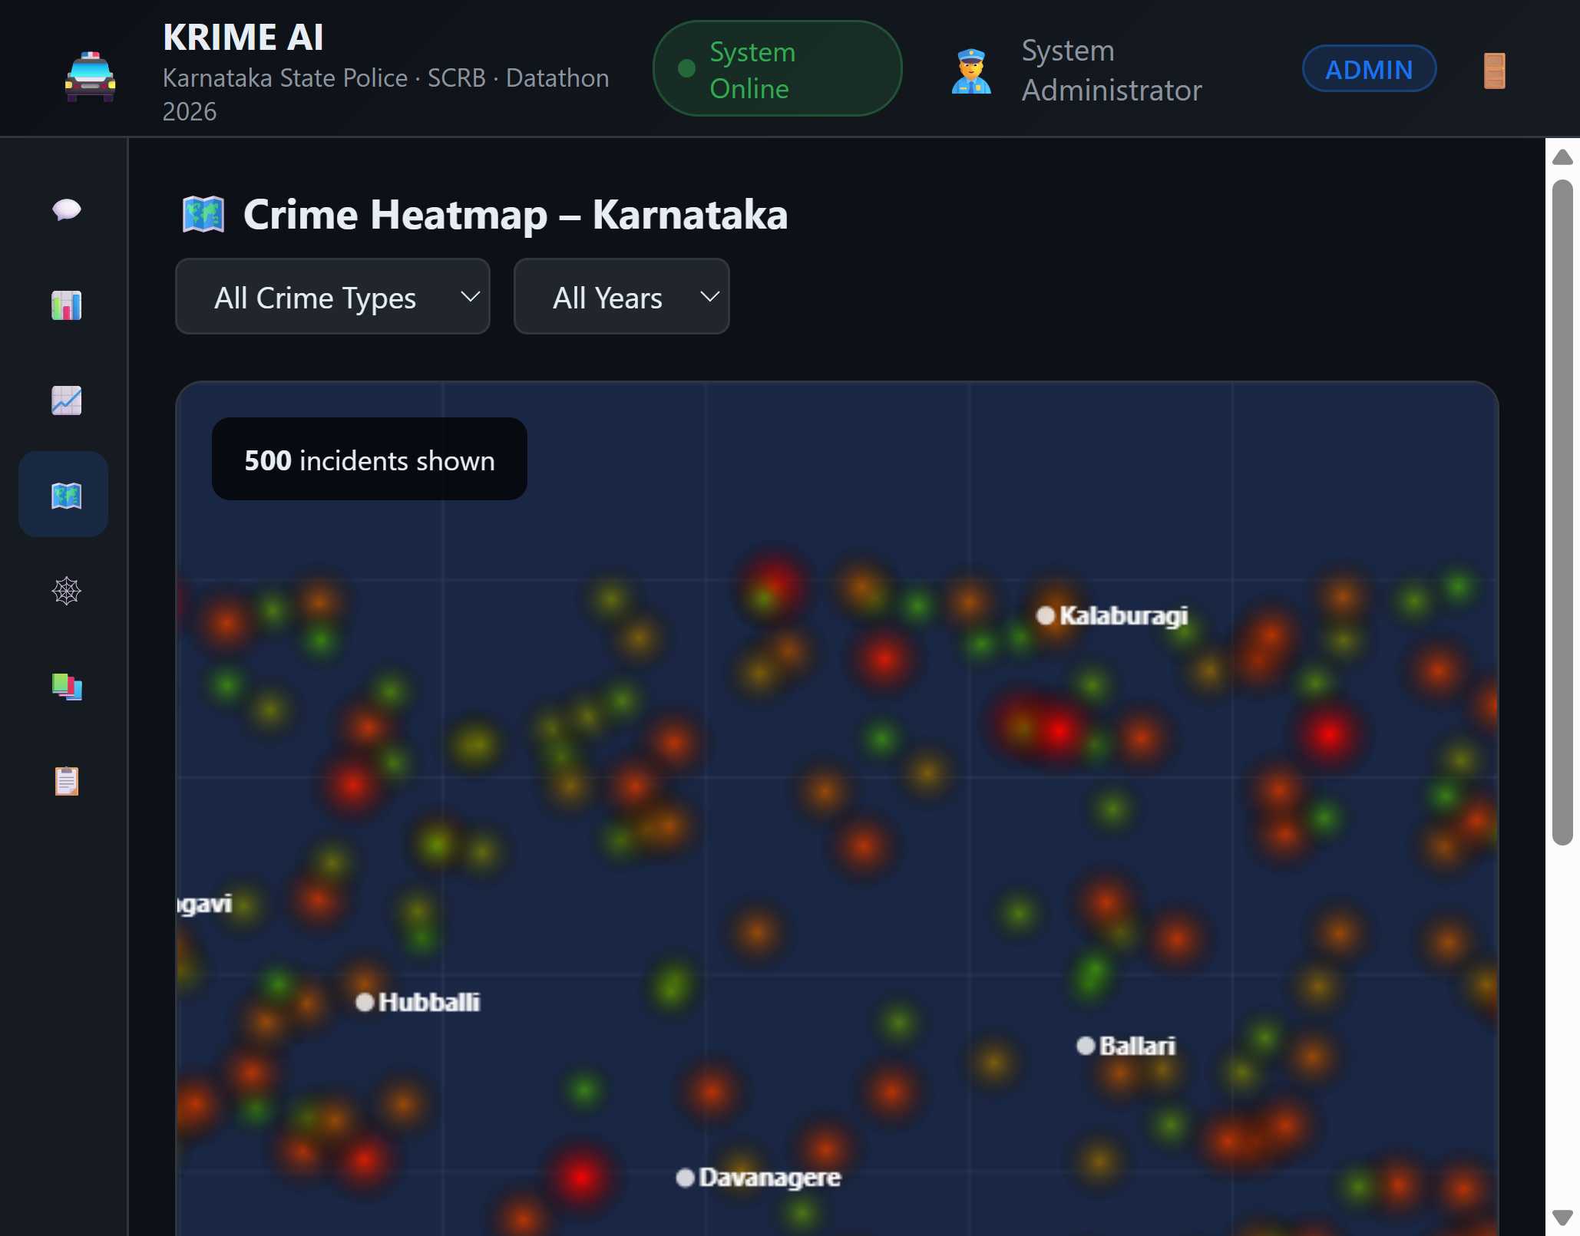
Crime heatmap of Karnataka
Talking points:
- Custom canvas-rendered heatmap of Karnataka with major cities labeled.
- Filter by crime type and year using the dropdowns — the glow intensity/color encodes severity.
- 500 incident points rendered live from /api/heatmap.
────────────────────────────────────────────────────────────

6️⃣ Criminal Network Visualization
Click Network (visible only to Admin/SP/Inspector — hidden for Analyst).
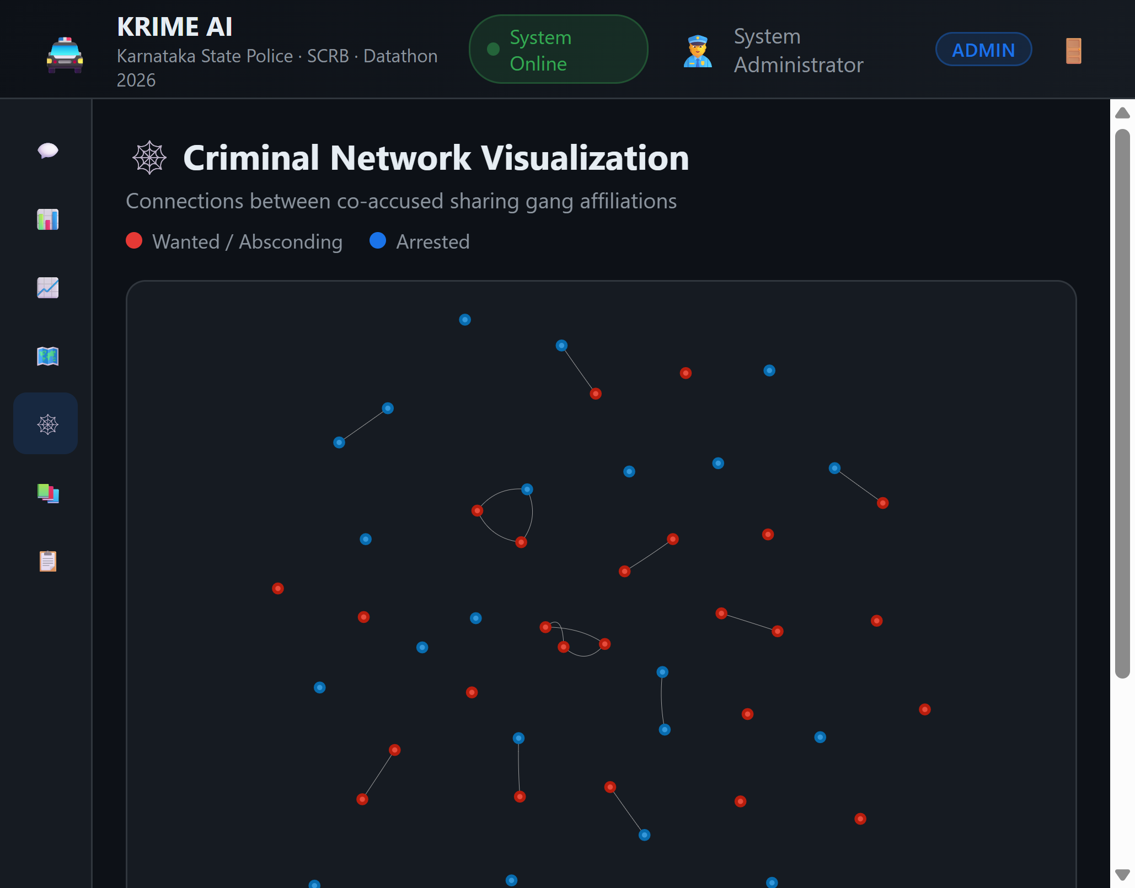
Criminal network graph
Talking points:
- Interactive force-directed graph (vis-network) showing co-accused sharing gang affiliations.
- Red nodes = Wanted/Absconding, Blue nodes = Arrested.
- Click any node to see full criminal profile details and connection count.
- This is the feature explicitly role-gated — demonstrates how sensitive identity-linked data is restricted from the Analyst role.
────────────────────────────────────────────────────────────

7️⃣ Document Intelligence — RAG over the KSP SOP Manual
Click Documents.
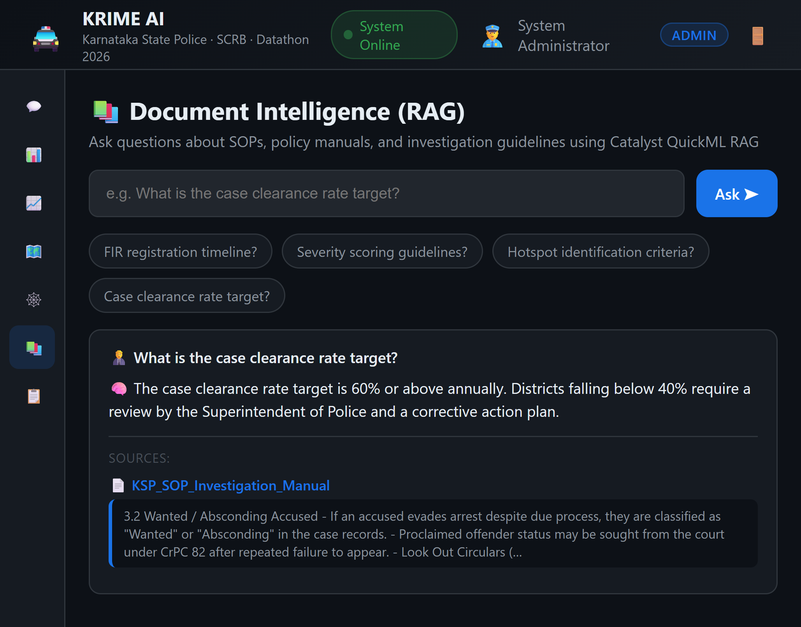
RAG document Q&A with cited sources
Talking points:
- Ask natural-language questions about the KSP SOP Investigation Manual (uploaded to Catalyst's QuickML Knowledge Base).
- Answers are grounded — the response cites the exact source document and snippet, not a hallucinated answer.
- Try: "What is the case clearance rate target?" → returns the real policy figure with a citation.
────────────────────────────────────────────────────────────

8️⃣ Audit Trail — Explainable AI
Click Audit Trail.
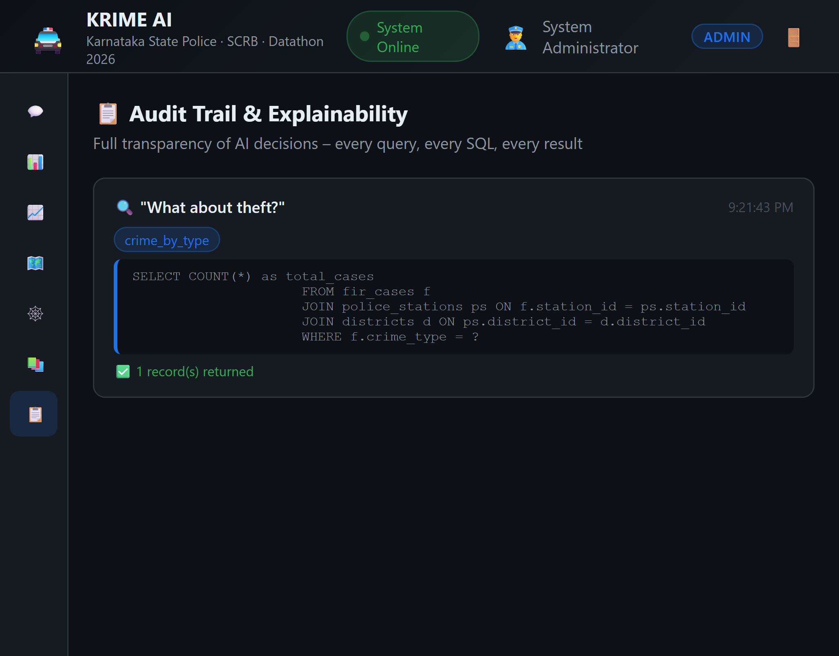
Audit trail showing SQL and context tracking
Talking points:
- Every single query is logged with: original question, detected intent, exact SQL executed, and result count.
- This is the "explainable AI with audit trails" requirement — nothing is a black box; every answer can be traced back to its exact query.
- Context-carried-over queries show a badge indicating which entity (district/year/crime type) was remembered from earlier in the conversation.
────────────────────────────────────────────────────────────

9️⃣ Voice Interaction + Role-Based Restriction (side-by-side)
Voice input/output: Click the mic button in the chat toolbar and speak a query (English or Kannada supported via en-IN/kn-IN). It auto-sends once you stop talking. The AI's response is read back aloud automatically — toggle with the speaker button.
Role restriction: Log out and sign back in as analyst1 / Analyst@123. Notice:
- The Network tab has disappeared from the sidebar.
- The Export PDF button is gone from the chat toolbar and sidebar footer.
- The Reload DB button is gone (Admin-only).
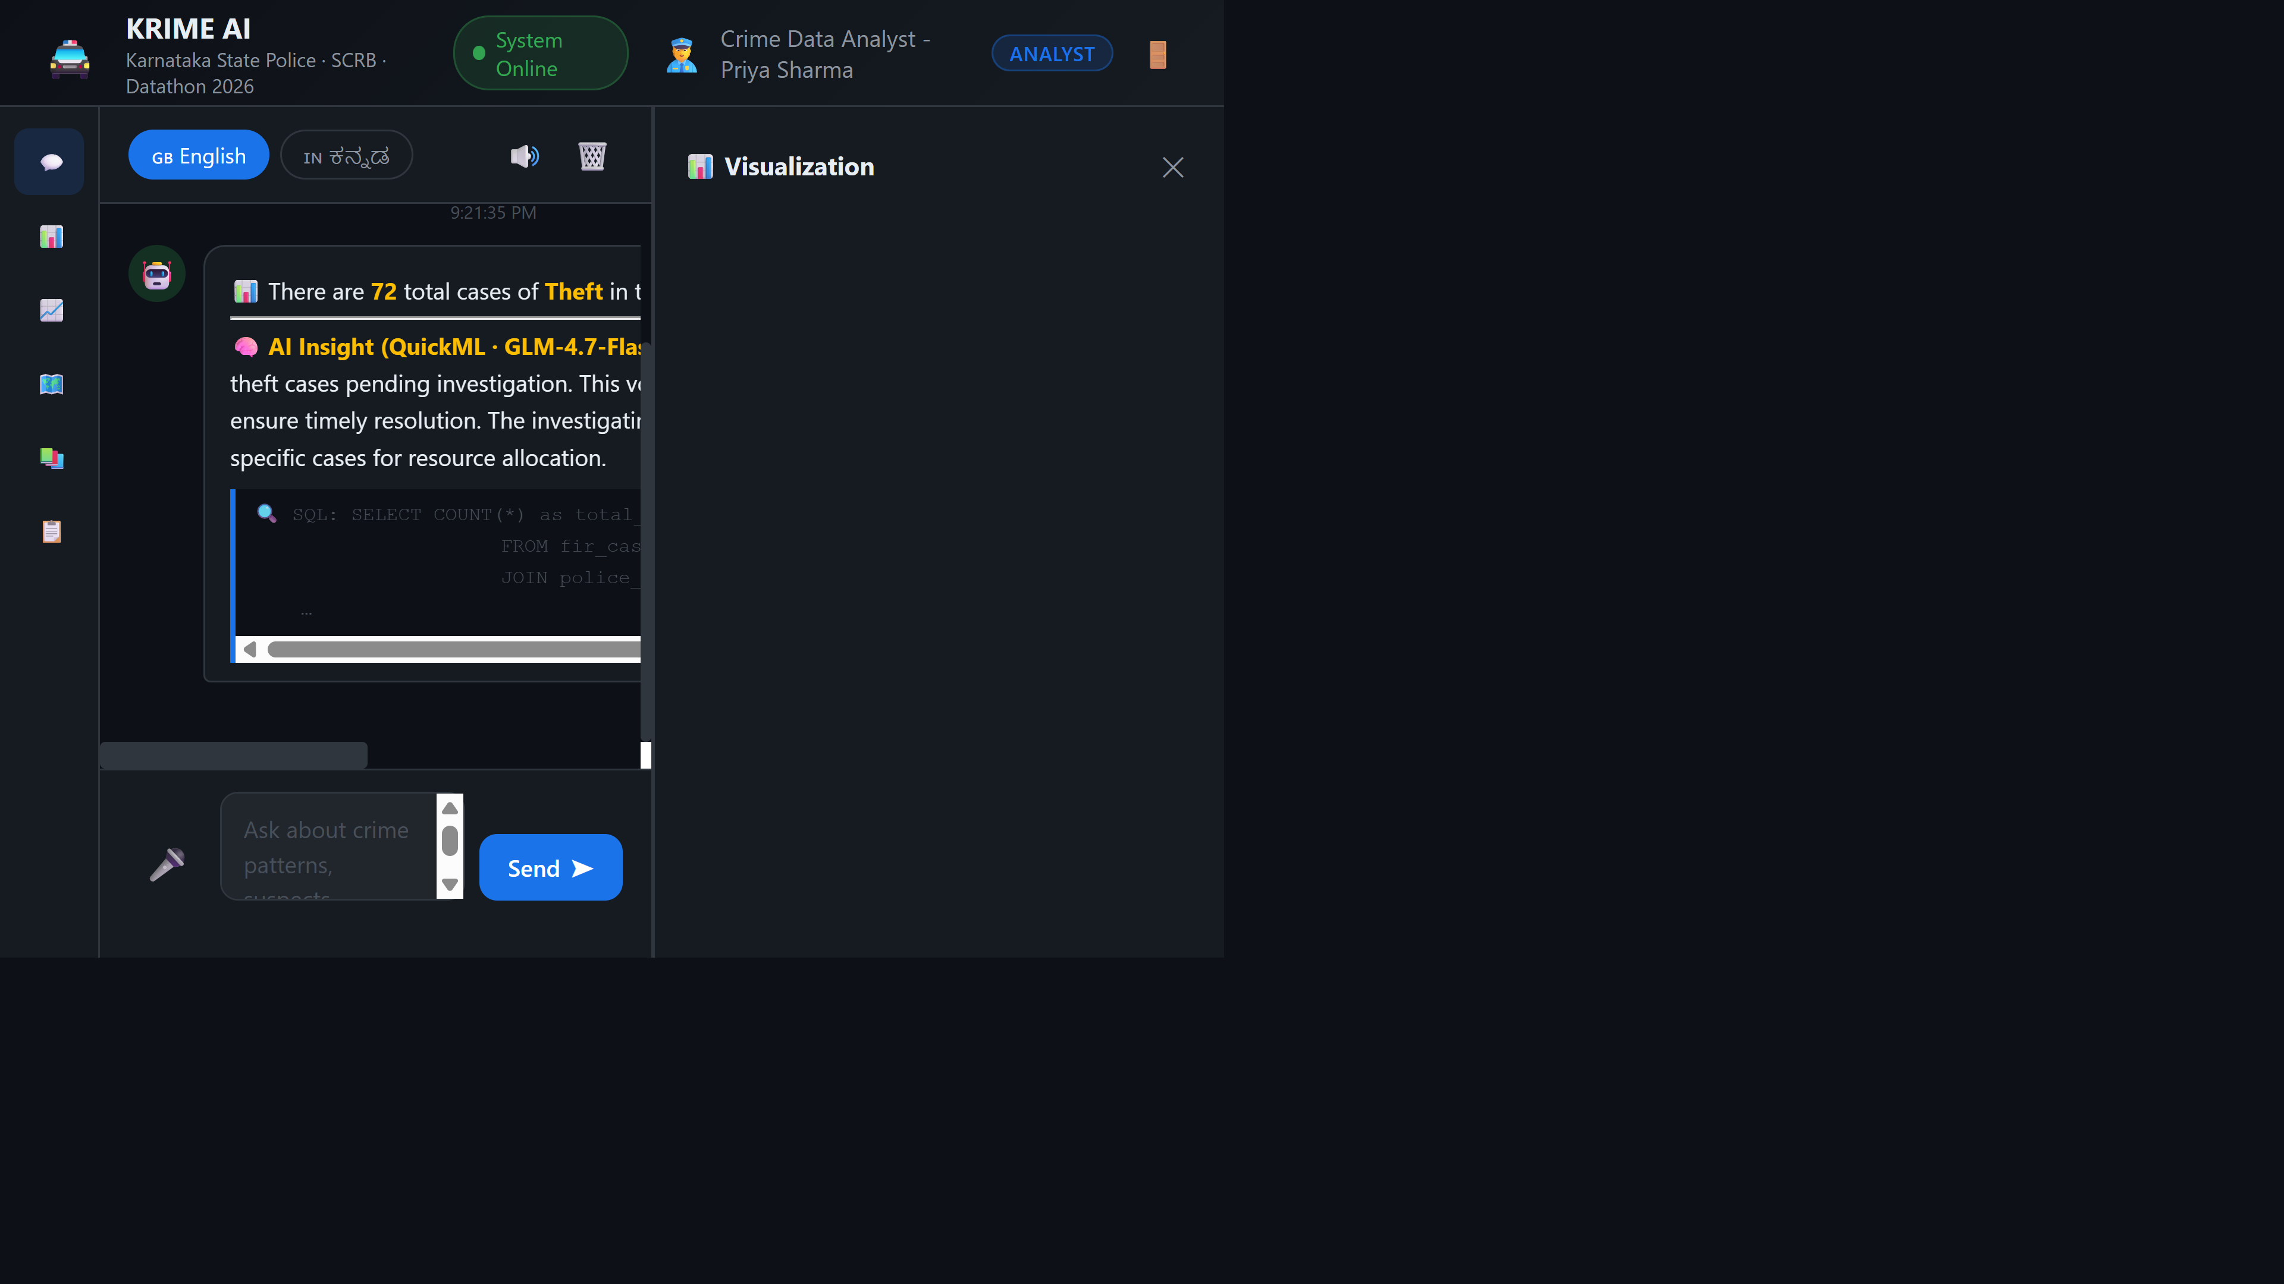
Analyst role with restricted UI — no Network tab, no Export PDF button
Talking points:
- Compare the sidebar icon count: 7 icons for Admin/SP/Inspector vs 6 icons for Analyst (Network hidden).
- This isn't just cosmetic — calling /api/network directly as an Analyst returns an HTTP 403 Forbidden from the backend, proving the restriction is enforced server-side, not just hidden in the UI.
────────────────────────────────────────────────────────────

🏗 Architecture Reference
See README.md (Architecture section) for the full system architecture diagram covering the frontend (Catalyst Slate + Web Client), backend (Flask Advanced I/O function), data layer (SQLite), and the three QuickML AI integrations (GLM chat insights, RAG document Q&A, AutoML anomaly detection).
(Architecture diagram is provided separately as docs/images/architecture.svg in the project repository — SVG format is not embedded in this Word document.)
────────────────────────────────────────────────────────────

🔑 Quick Reference — Demo Accounts
Role | Username | Password | Notable Restrictions
Admin | admin | Admin@123 | None — full access incl. DB reseed
SP | sp.blru | Sp@12345 | None — full investigative access
Inspector | inspector1 | Inspector@123 | No DB reseed
Analyst | analyst1 | Analyst@123 | No Network graph, PDF export, Anomaly scan, DB reseed

💬 Sample Queries to Showcase Range
Category | Query
Aggregate | How many total crimes are registered in Karnataka?
District breakdown | Show crimes by district
Trend | Show crime trend from 2019 to 2025
Hotspot | Top crime hotspot stations
Context follow-up | How many crimes in Mysuru? → then What about theft?
Predictive | Predict crime trend for next months
Kannada | ಬೆಂಗಳ್ೂರಿનಲ್ಲಿ ನೆಕ್ಷರಿಸಲೋಕ అಮರಿಕ ಎಷ್ಲಿ ತಿಳೆಸಿ
RAG | What is the case clearance rate target? (Documents tab)

