## Add CSS rules to the webpage so that it looks like the screenshot below.

# http://www.teaching-materials.org/htmlcss-1day/css-selectors/exercise_screenshot.png

# Create a webpage that looks like the one below.

Follow these steps:

1. Copy previous web page
2. Add a div for all of the content. Add styles to that div so it is centered on the page and has appropriate border and padding.
3. Add a div for the footer links. Add styles to that div so that the links are centered and it has appropriate border, padding, and margin.
4. Add a div for the locations list. Add styles to that div so that it floats to the right and has appropriate border, padding, and color.

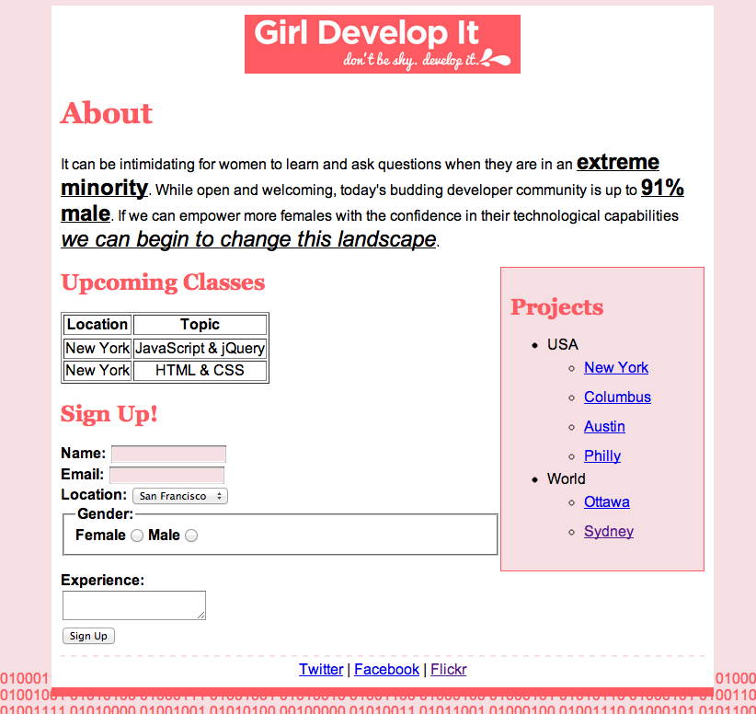

# Create elements with rounded corners. Take div element and use border-radius property.

# Creating Horizontal Dropdown menu using HTML 5 & CSS 3 as below

# 

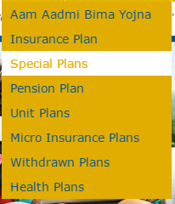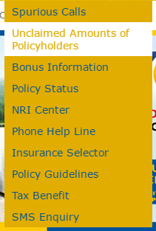

# Create a personal portfolio

Using only HTML5 and CSS, you are to create three (3) personal web pages:

**resume.html** - Your resume. It shall include the following sections:

1. Full name
2. Education
3. Professional Experience. For each job, list accomplishments. Use bullets-points, an unordered list.
4. Skills (HTML, CSS, Javascript etc)
5. Activities that are related to your field of study or work

**bio.html -** A short biography of yourself. This can be real or fictitious.

**index.html -** Your personal home page.

This page shall contain:

1. Your name
2. A photo of you
3. A link to your resume
4. A link to your short biography