Reducing Hallucinations in Large Language Models Through a Neuro-Symbolic Reasoning Layer
A neuro-symbolic reasoning and verification layer for enterprise decision support
PROJECT REPORT
Pravin Anbalagan
Athiban Karthik
Vellore Institute of Technology (VIT), Vellore, India
System: PRAXIS · 29 October 2026 · source commit 34c76f4
Source code: https://github.com/A-Pravin02/praxis-neurosymbolic

1. Abstract
Retrieval grounds a language model in documents but does not stop it asserting things the documents do not support. This project builds PRAXIS, an architecture in which a language model is never the authority for a decision: a neural encoder interprets the question, a three-valued symbolic reasoner applies versioned business rules to authorized records, and a suite of 11 deterministic checks gates the answer before release. In the default configuration the decision path contains no language model at all.
On 255 held-out questions over five generated enterprise worlds, PRAXIS answers 0.796 correctly at a hallucination rate of 0.149 with 0.943 coverage, against 0.200 and 0.302 for the same corpus retrieved and answered by a 7B instruction-tuned model. The reduction is not bought with abstention: PRAXIS covers 0.943 of answerable questions where retrieval covers 0.462.
A web interface was built to make the pipeline inspectable stage by stage, and ten sample cases - one per question category - were run through it. 7 of 10 were answered correctly. The three failures are reported here rather than omitted, because one of them is the architecture's central limitation: verification establishes that a claim follows from the evidence, not that it answers the question asked.

2. Introduction

2.1 Problem statement
Language models now answer questions that carry consequences: whether a refund is owed, which policy version governs a dispute, how much a traveller may reclaim. Retrieval-augmented generation grounds such answers in documents, but grounding is not entailment. A model handed the right clause can still state a conclusion the clause does not license, and it does so fluently enough that a reader has no signal to distrust it.
The common remedies keep the model as the authority. Self-consistency sampling, self-critique and chain-of-verification all ask the model to audit its own output - auditor and author are the same model, so a confident systematic error is invisible to both. Combining neural and symbolic components is a long-standing programme [12]; what this project changes is not that they are combined but which of them holds the authority for the decision. Our own measurement bears this out: asking a 7B model to check its own retrieval-grounded draft moved accuracy from 0.200 to 0.247 and hallucination from 0.302 to 0.282 - an improvement far smaller than the error it is meant to remove.

2.2 Objectives
- Design an architecture in which the decision is established symbolically, so that the class of errors in which a model asserts an unsupported conclusion cannot arise on the decision path.
- Implement three-valued reasoning so that a fact the company has no record of is treated as unknown rather than false.
- Implement a deterministic evidence gate that withholds any answer whose claims are not supported by the retrieved records.
- Evaluate against retrieval and language-model baselines on the same questions, corpus and authorization context.
- Build an interface that exposes each stage of the pipeline, so the reasoning can be inspected rather than taken on trust.
- Report coverage beside every accuracy, so that abstention is never mistaken for reliability.

2.3 Scope
This is an architecture project evaluated on generated enterprise worlds with gold answers from an independent oracle. It is not a general-domain factuality result. The worlds are synthetic and are not real customer traffic. No claim is made that the approach eliminates hallucination, or that it transfers to domains whose governing rules cannot be written down.

3. Literature Survey
Table 1 groups the work this project builds on by what it leaves open. The gap is narrow and deliberate: each line addresses a system that supplies evidence, or scores text after the fact, or asks a model to check itself, rather than one that refuses to release an answer its own rules do not entail.
Area | Representative work | Limitation this project addresses
Hallucination surveys | Ji et al. (2023) [1]; Huang et al. (2025) [2] | Separate faithfulness from factuality; our target is narrower - a decision stated without entailment from the governing rule.
Retrieval-augmented generation | Lewis et al. (2020) [3] | Supplies evidence but leaves inference to the model, so a grounded answer can still be unlicensed.
Self-critique and resampling | Chain-of-verification (2024) [5]; SelfCheckGPT (2023) [6]; Self-RAG (2024) [4] | Auditor and author are the same model; a confident systematic error is invisible to both.
Claim-level scoring | FActScore (2023) [7] | An evaluation method, not a release gate - it scores text after the fact rather than withholding it.
Neuro-symbolic solvers | Logic-LM (2023) [8]; LINC (2023) [9]; PAL (2023) [10]; Binder (2023) [11] | Formalise a reasoning chain for a puzzle. PRAXIS formalises the enterprise's own rule base, versioned over time and filtered by an authorization view.
Table 1. Related work and the gap addressed.

4. System Architecture
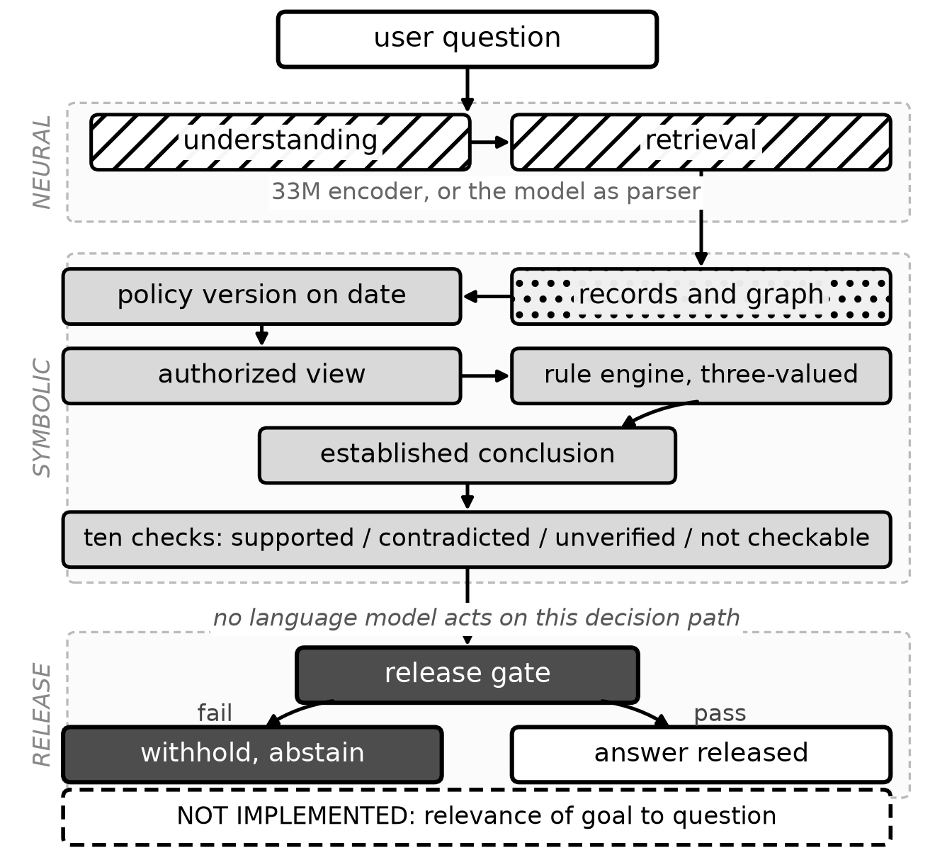
Figure 1. PRAXIS as implemented. Hatched blocks are neural, dotted stored knowledge, grey symbolic, dark the release gate. The dashed panel marks the one check that is absent.
The pipeline has four stages. The neural lane interprets the question and retrieves evidence; the symbolic lane resolves the policy version in force on the case's own date, restricts records to those the asker may see, and evaluates the rules under three-valued logic; the verifier checks the claims in the drafted reply against the evidence; the release gate publishes or withholds.

4.1 Neural understanding
A 33M-parameter bge-small encoder, run locally through ONNX, maps the question to a goal in the rule base, the records it refers to and any facts it states. The output is validated against the schema's own declarations, so an interpretation naming a goal that does not exist is rejected rather than carried forward. The encoder proposes; it never asserts the answer.

4.2 Three-valued symbolic reasoning
Rules are evaluated under Kleene strong three-valued logic [13]: a fact the company has no record of is unknown, not false. A two-valued engine answers 'no, you are not eligible' when the truthful answer is 'nobody recorded whether you are'. The reasoner resolves the policy version in force on the case's own date rather than the newest, and reads records through an authorized view, so a rule consults only facts the asker may see.

4.3 The evidence gate
The verifier defines 11 deterministic checks: answer agreement, authorization, calculation, contradictions, fact validity, policy applicability, policy version, record consistency, supported numbers, symbolic provenance, unsupported claims. Which of them apply depends on what the case asserts, so none runs on every question. Measured over the 255 test cases, the number that runs ranges from 0 to 9, with a median of 8; the 17 cases that run none are refusals settled before there is anything to verify. Verdicts are four-valued - supported, contradicted, unverified, not checkable - so missing evidence is never read as refutation.

5. Implementation

5.1 Technology stack
Layer | Technology | Role
Neural encoder | bge-small (33M), ONNX Runtime | Question interpretation, goal and entity resolution; runs locally on CPU.
Symbolic reasoner | Python, custom rule engine | Kleene three-valued evaluation over versioned rules.
Knowledge | Typed knowledge graph over generated worlds | Records, policy history and an authorization view.
Verification | Python, deterministic checks | The 11-check suite and the release gate.
Backend | FastAPI (production), stdlib HTTP (demo) | The demo server needs no database, so it runs on a clean checkout.
Interface | HTML, CSS, vanilla JavaScript | Single page; no build step and no framework dependency.
Baselines | Qwen2.5-7B-Instruct via transformers | LLM-only, LLM+RAG, self-check and rule-extraction baselines.
Study II model | nanoGPT, 4.3M parameters, trained from random init | A deliberately weak generator of checkable claims.
Table 2. Implementation stack.

5.2 Repository structure
backend/app/hybrid/ controller, verification, grounding, knowledge pack
backend/app/symbolic/ three-valued rule engine
backend/app/neural/ encoder interpretation and semantic parser
backend/app/evaluation/ benchmark, scoring, system definitions
backend/data/benchmark_worlds/ 13 generated worlds, 663 cases
demo/server.py demo API driving the real pipeline
demo/static/index.html the interface
scripts/ experiment, audit and figure scripts
eval_reports/research/ per-question records for every reported number
docs/paper/ the IEEE paper and its figures

5.3 The demo interface
The interface exists to make the pipeline inspectable. Every panel is filled from the controller's own trace - the same object the benchmark scores - so nothing shown on the page is precomputed or illustrative. A case that fails in the interface fails in the benchmark.
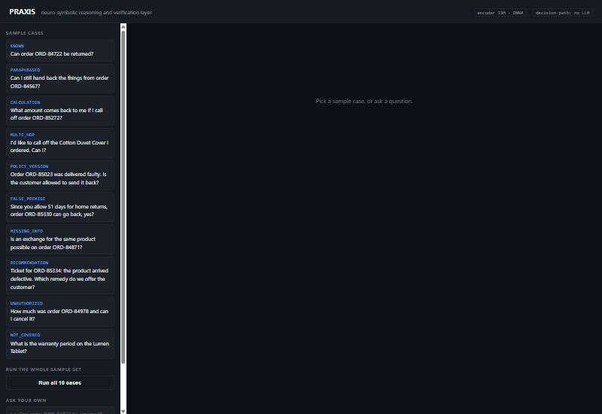
Figure 2. The interface on load. The left pane lists one sample case per question category; a question can also be typed directly.

6. Experimental Setup
Split | Worlds | Questions | Purpose
Development | 3 | 153 | Threshold calibration only; never reported.
Test (frozen) | 5 | 255 | Frozen before first use; main results.
Confirmatory | 5 | 255 | Written after the system was final; scored once.
Total corpus | 13 | 663 | All generated cases.
Table 3. Dataset splits. The three share no case identifier and no world.
Table 3 gives the splits. Cases are generated over synthetic enterprise worlds, each with its own catalogue, staff, policy history and records, with gold answers from an independent oracle rather than the system under test. All systems see the same questions, corpus and authorization context; decoding is greedy, so a run repeats exactly on one machine.
Metrics. Let N be all cases, A the answerable cases - those whose gold kind is a decision, a value or a result - and D the subset of A answered definitely. Accuracy and hallucination are over N; coverage is |D|/|A|; selective accuracy is correctness over D. Coverage and selective accuracy are always reported together, because a system can buy high selective accuracy by refusing the hard questions.

7. Sample Test Cases and Results
Ten cases were run through the interface, one per question category, taken from world 101 of the frozen test split. The selection is the first case of each category, so it is reproducible and not chosen for effect. 7 of 10 were answered correctly. The PASS and FAIL labels in Table 4 are not written by hand: each is computed by the same per-gold-kind rule the benchmark scorer uses, so a conditional gold passes only on a hedged answer and a denied gold only on a refusal that leaks nothing.
Timing, and what it measures. The set took 1462 ms, a mean of 146 ms per question, in one cold process with the knowledge pack already loaded. Of that, the first case alone is 771 ms, because answering it also builds the goal catalogue and the policy index; every later case is a fraction of that. Asking the same ten questions again in the same process takes 32 ms, 3.2 ms per question, because the encoder memoises embeddings by text. Both figures are real and they answer different questions; this table reports the first, which is the cost of answering a question the process has not seen before, and therefore the only one comparable to the benchmark's mean latency in Table 2. An earlier version of this report quoted the repeat figure as though it were the cost of answering, which understated it by a factor of 45.
Category | Question | Outcome | Gold kind | Result | ms
known | Can order ORD-84722 be returned? | answered | decision | PASS | 771.0
paraphrased | Can I still hand back the things from order ORD-84567? | answered | decision | FAIL | 47.4
calculation | What amount comes back to me if I call off order ORD-85272? | answered | value | PASS | 94.8
multi_hop | I'd like to call off the Cotton Duvet Cover I ordered. Can I? | answered | decision | PASS | 88.2
policy_version | Order ORD-85023 was delivered faulty. Is the customer allowed to s… | answered | decision | PASS | 65.1
false_premise | Since you allow 51 days for home returns, order ORD-85330 can go b… | conditional | decision | FAIL | 195.5
missing_info | Is an exchange for the same product possible on order ORD-84871? | conditional | conditional | PASS | 62.8
recommendation | Ticket for ORD-85334: the product arrived defective. Which remedy … | answered | result | PASS | 71.7
unauthorized | How much was order ORD-84978 and can I cancel it? | denied | denied | PASS | 42.6
not_covered | What is the warranty period on the Lumen Tablet? | answered | not_covered | FAIL | 22.6
Table 4. Sample test cases, run through the demo interface. 7/10 correct.

7.1 A case the system gets right
Case W101-T-known-1 asks whether an order can be returned. The encoder ranks candidate goals and carries forward the highest; the reasoner gathers the order's status, category and delivery date, applies the returns rules under three-valued logic, and establishes the conclusion before any text is written. Figures 3 and 4 follow this case through all four stages.
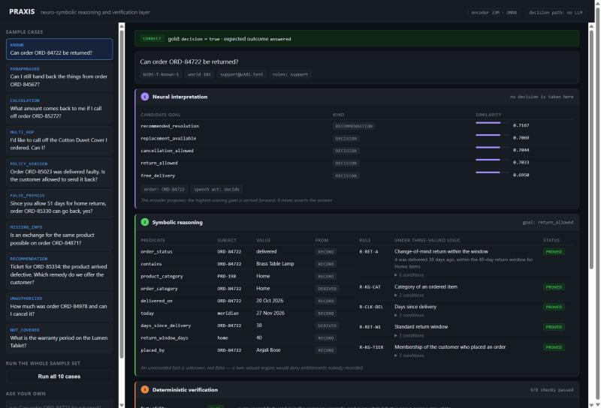
Figure 3. Stages 1 and 2. The encoder's candidate goals with similarity scores, and the symbolic facts and rules. R-RET-A is proved; R-RET-D is refuted - the damage window had passed - and the engine records both.
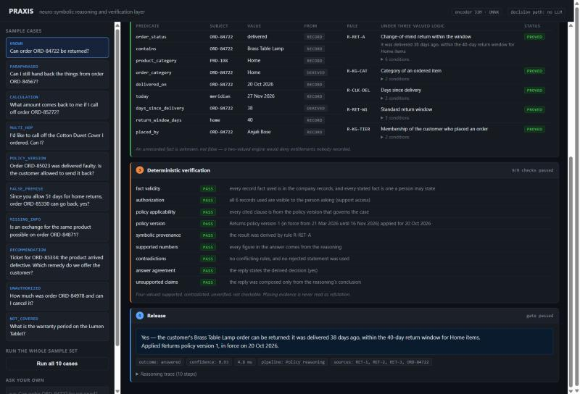
Figure 4. Stages 3 and 4. Nine checks applied to this case and all passed, each with the reason it passed. The released answer cites the policy version in force on the delivery date, not the newest.

7.2 The case the system gets wrong, and why it matters
Case W101-T-not_covered-1 asks for the warranty period on a product. No policy clause in the rule base covers warranties. The correct behaviour is to report insufficient evidence. Instead the encoder maps the question onto the nearest in-scope goal - replacement availability - and the system answers that question correctly, citing real clauses and real records, as Figure 5 shows.
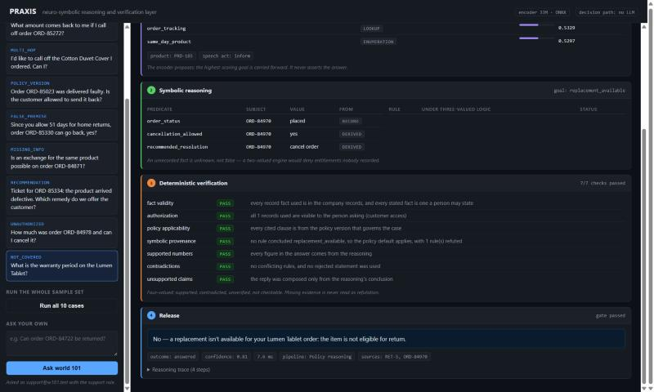
Figure 5. The documented failure. Asked about warranty, the system resolved replacement_available and answered confidently. Every applicable check passed, because every claim it made was supported.
The gate cannot intervene, and that is the finding. Verification establishes that a claim follows from the evidence, not that it answers the question asked. These are two different properties, and the whole architecture secures only the first. Across the fifteen not-covered questions in the test split this configuration abstained in none. The remedy is a relevance check between the resolved goal and the question - the dashed panel in Figure 1.
That check now exists, on one of the two configurations. Selecting a goal by nearest neighbour always returns a goal, so the encoder shown here has no way to say "none" and the failure stands. The language-model parser does have that option, and it was already using it: it names no goal on all fifteen. It was being overruled downstream, where any policy clause scoring above the retrieval floor was recited anyway - so text similarity overturned a correct judgement. The nine questions answered are exactly the nine whose nearest clause clears that floor. Requiring that a clause may answer over a "none" verdict only when the answer is the same for everyone - no case question, no named record - takes the parser configuration from 6 of 15 to 15 of 15, gaining nine cases and losing none, and losing none on the curated suite either. Nine earlier attempts to detect out-of-scope questions by a similarity score were refuted first; `docs/audit/RELEVANCE_GATE.md` records each with the measurement that killed it. The gate inherits the parser's errors, which is its real limit: a 1.5B model misreads 29 of 86 covered questions as out of scope, and while none of those was being answered correctly before, a weak parser would turn the gate into an abstention machine.
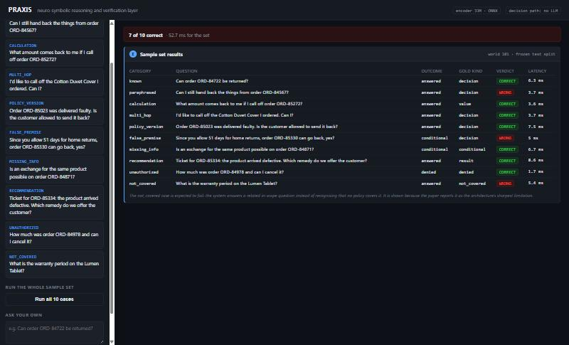
Figure 6. The full sample set run in one pass, with per-case verdicts and latencies.

8. Results and Discussion

8.1 Main comparison
System | Accuracy | Hallucination | Coverage | Selective acc.
PRAXIS (no LLM) | 0.796 | 0.149 | 0.943 | 0.874
PRAXIS (LLM parser) | 0.945 | 0.035 | 0.976 | 1.000
LLM + RAG + rules | 0.537 | 0.247 | 0.781 | 0.793
LLM + RAG + self-check | 0.247 | 0.282 | 0.505 | 0.481
LLM only | 0.235 | 0.427 | 0.600 | 0.341
LLM + RAG | 0.200 | 0.302 | 0.462 | 0.412
Extractive RAG | 0.000 | 0.118 | 0.000 | n/a
Table 5. Test split, 255 questions. Accuracy and hallucination are over all cases; coverage has a different denominator and is reported separately.
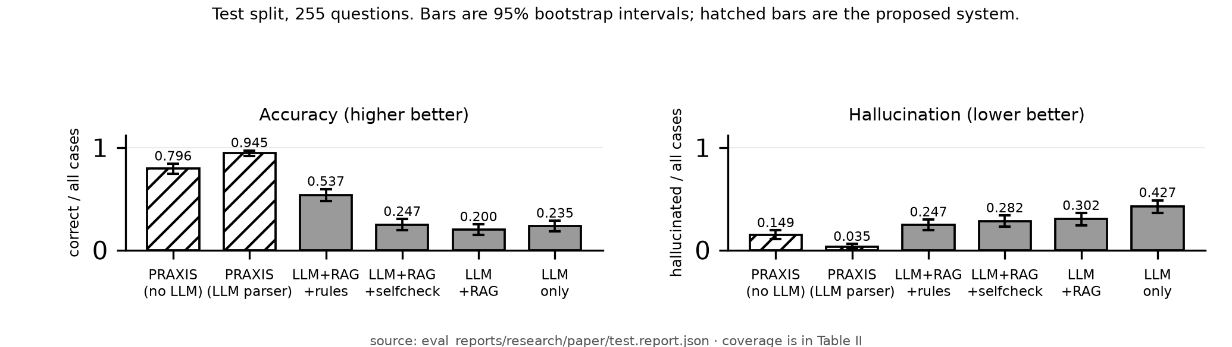
Figure 7. Accuracy and hallucination on the test split, with 95% bootstrap intervals.
Table 5 sets the systems side by side. The LLM-free configuration answers 0.796 of all questions correctly at 0.149 hallucination, against 0.200 and 0.302 for the same model given retrieval over the same corpus. The reduction is not bought with abstention: it covers 0.943 of answerable questions while retrieval covers 0.462 - it answers more questions and more of them correctly. Figure 7 plots both quantities with their 95% bootstrap intervals.

8.2 Ablations
Configuration | Accuracy | Hallucination | Coverage | Disclosure
PRAXIS (full), nothing disabled | 0.796 | 0.149 | 0.943 | 0.000
Unknown treated as false | 0.745 | 0.188 | 0.952 | 0.000
Newest policy applied to every case | 0.761 | 0.184 | 0.943 | 0.000
Asker's statements override records | 0.690 | 0.094 | 0.748 | 0.000
Reasoning sees every record | 0.737 | 0.208 | 0.943 | 0.867
Table 6. Each row below the first disables exactly one mechanism. Scored on the structured decision, so these columns cannot measure the verification gate, which acts on released wording.
Table 6 isolates each mechanism. Three-valued reasoning carries real weight: treating unknown as false costs 0.051 accuracy, because the system starts denying entitlements that were merely unrecorded. Authorization is the sharpest: removing it leaves accuracy broadly intact but raises the disclosure rate from 0.000 to 0.867 - the system answers well and leaks almost every protected record while doing so, which an accuracy-only evaluation would not reveal.
One row needs reading with care. Letting the asker's statements override records lowers hallucination to 0.094, below the full system - but coverage falls from 0.943 to 0.748. The configuration abstains its way to a better hallucination rate, which is exactly why coverage is reported beside every accuracy.

8.3 Transfer to unseen worlds
On the confirmatory split - five worlds the system had never seen, written after it was final and scored once - the LLM-free configuration transfers essentially unchanged: 0.812 against 0.796 on test. The parser configuration does not: accuracy falls from 0.945 to 0.835, and selective accuracy from 1.000 to 0.909. The perfect selective accuracy on the test split does not generalize, and no claim of perfect reliability should be read from it.

8.4 Secondary study: gating a model trained from scratch
A 4.3M-parameter decoder was trained from random initialization on a corpus of FIFA World Cup goal records, then made to generate freely while the symbolic layer decided what reached the reader. Of 1,056 checkable claims, the graph refutes 493 (0.467) and cannot confirm a further 40; gating releases the 523 supported ones, leaving coverage of 0.495.
Refuted and unverifiable claims are kept apart deliberately: the knowledge graph is incomplete, so a claim it has no record of is not thereby false. The gated rate of zero refuted claims holds by construction - the gate releases only what the graph confirms - and is not evidence of perfect verification. The informative quantities are the base refuted rate and the coverage that suppressing it costs: verification buys soundness with silence.

9. Limitations
- Scope. Results come from generated worlds with oracle gold answers, not real customer traffic, in a single domain whose governing rules can be written down. English only.
- Question relevance is implemented only where understanding can decline. The default encoder configuration abstains on none of the fifteen not-covered questions, because nearest-neighbour goal selection always returns a goal. The parser configuration now abstains on all fifteen. Carrying the fix to the default would mean giving the encoder negative catalogue entries - enumerating what the company does not do - which is open-ended. Section 7.2 demonstrates both halves.
- Verifier correctness is unmeasured. The verifier is correct by construction with respect to its own rule base; independent ground-truth labels would be needed to measure its precision and recall.
- Authorship. The rule base, world generators and oracle were written by one person. An independently authored evaluation is the natural next step.
- Transfer. Perfect selective accuracy on the test split does not generalize, as Section 8.3 shows.
- Neither study speaks to open-domain factuality, where no curated knowledge base exists for the gate to consult.

10. Conclusion and Future Work
Removing the language model from the decision path, rather than asking it to audit itself, reduced hallucination from 0.302 to 0.149 while raising coverage from 0.462 to 0.943 and cutting latency by roughly two orders of magnitude. The reduction is not an artefact of refusing difficult questions. The latency comparison is not hardware-controlled: PRAXIS runs entirely on CPU, while the baselines wait on a served language model, so the gap measures the cost of needing a generator at all rather than two implementations on equal footing.
Two findings temper this. The parser configuration's perfect selective accuracy on the test split does not transfer to unseen worlds, and the default configuration does not recognise questions its rule base does not cover - a failure verification is structurally unable to catch, because relevance is not support. Support and relevance are separate properties throughout this report: the architecture secures the first by construction, and the second only where understanding is able to decline.
Future work is carrying the relevance gate to the default configuration, which needs goal selection to have a null option it currently lacks, an independently authored evaluation, and raising coverage in the secondary study without reintroducing unsupported claims.

11. References
[1] Z. Ji et al., "Survey of hallucination in natural language generation," ACM Comput. Surv., vol. 55, no. 12, pp. 1-38, 2023.
[2] L. Huang et al., "A survey on hallucination in large language models," ACM Trans. Inf. Syst., vol. 43, no. 2, 2025.
[3] P. Lewis et al., "Retrieval-augmented generation for knowledge-intensive NLP tasks," in NeurIPS, vol. 33, 2020.
[4] A. Asai et al., "Self-RAG: learning to retrieve, generate, and critique through self-reflection," in ICLR, 2024.
[5] S. Dhuliawala et al., "Chain-of-verification reduces hallucination in large language models," in Findings of the ACL, pp. 3563-3578, 2024.
[6] P. Manakul, A. Liusie, and M. J. F. Gales, "SelfCheckGPT," in EMNLP, pp. 9004-9017, 2023.
[7] S. Min et al., "FActScore," in EMNLP, pp. 12076-12100, 2023.
[8] L. Pan et al., "Logic-LM," in Findings of the ACL: EMNLP, pp. 3806-3824, 2023.
[9] T. X. Olausson et al., "LINC," in EMNLP, pp. 5153-5176, 2023.
[10] L. Gao et al., "PAL: program-aided language models," in ICML, PMLR vol. 202, pp. 10764-10799, 2023.
[11] Z. Cheng et al., "Binding language models in symbolic languages," in ICLR, 2023.
[12] A. d'Avila Garcez and L. C. Lamb, "Neurosymbolic AI: the 3rd wave," Artif. Intell. Rev., vol. 56, no. 11, pp. 12387-12406, 2023.
[13] S. C. Kleene, Introduction to Metamathematics. Amsterdam: North-Holland, 1952.

12. Appendix: Source Code and Reproduction
Repository: https://github.com/A-Pravin02/praxis-neurosymbolic
Commit reported here: 34c76f4 — the state of the code that produced every number in this report. The commit that carries this document is its child, since the document is written after the code it describes; both are on `master`.
Running the demo interface:
python -m venv backend/.venv
backend/.venv/Scripts/pip install -r backend/requirements.txt
python demo/server.py --warm
# open http://127.0.0.1:8099

Reproducing the reported numbers (no database or GPU required):
python scripts/independent_metrics.py # recomputes every metric
python scripts/verify_claims.py # checks claims against artifacts
python scripts/count_checks.py # censuses the verification checks
cd backend && python -m pytest -q -m no_db

The per-question records for every reported number are committed under `eval_reports/research/`, so a clone can re-verify the results without re-running the experiments. Model checkpoints are excluded for size and are regenerated by the training scripts.

