Reducing Hallucinations in Large Language Models Through a Neuro-Symbolic Reasoning Layer
Pravin Anbalagan  Vellore Institute of Technology (VIT)  Vellore, India | Athiban Karthik  Vellore Institute of Technology (VIT)  Vellore, India

Abstract—Retrieval grounds a language model in documents but does not stop it asserting things the documents do not support. We present PRAXIS, a neuro-symbolic architecture in which a language model is never the authority for a decision: a neural encoder interprets the question, a three-valued symbolic reasoner applies versioned business rules to authorized records, and a suite of 12 deterministic checks gates the answer before release. The decision path contains no language model. On 255 held-out questions over five generated enterprise worlds this default configuration answers 0.796 correctly at a hallucination rate of 0.149 with 0.943 coverage, against 0.200 and 0.302 for the same corpus retrieved and answered by a 7B instruction-tuned model, and 0.247 and 0.282 when that model checks its own draft. Using the model only as a semantic parser reaches 0.945 accuracy and a selective accuracy of 1.000. Neither transfers: on a frozen split of unseen companies accuracy falls to 0.835 and selective accuracy to 0.909. A secondary study gates a 4.3M decoder trained from scratch: the graph refutes 0.467 of its claims, and gating leaves 0.495 coverage. We report coverage beside every accuracy, argue the zero refuted rate is near-tautological, and document a failure the aggregate hides: on questions no policy covers the default configuration abstains in 0 of 15 cases, because verification establishes that a claim is supported by evidence, not that it answers the question asked.
Keywords—neuro-symbolic AI, hallucination, retrieval-augmented generation, three-valued logic, abstention, selective prediction, enterprise decision support

Introduction
Language models now answer questions that carry consequences: whether a refund is owed, which policy version governs a dispute, how much a traveller may reclaim. Retrieval-augmented generation grounds such answers in documents, but grounding is not entailment. A model handed the right clause can still state a conclusion the clause does not license, and it does so fluently enough that a reader has no signal to distrust it.
The common remedies keep the model as the authority. Self-consistency sampling, self-critique and chain-of-verification all ask the model to audit its own output. Our measurements suggest this is a weak defence: asking a 7B model to check its own retrieval-grounded draft moved accuracy from 0.200 to 0.247 and hallucination from 0.302 to 0.282 — an improvement far smaller than the error it is meant to remove.
PRAXIS takes the opposite position. The model is treated as a language engine, never a truth engine. It may interpret a question and it may phrase a conclusion, but it never establishes one. Between those two points sits deterministic, replayable code: a typed knowledge graph, a three-valued reasoner over versioned rules, and an evidence gate that withholds any answer failing its checks. In the default configuration the model is absent from the decision path entirely.

Scope and Contributions
This paper makes six contributions:
1. An architecture in which decisions are symbolic by construction, so the class of errors in which a model asserts an unsupported conclusion cannot arise on the decision path.
2. A three-valued verification layer distinguishing supported, contradicted, unverified and not-checkable, so that missing evidence is never silently treated as refutation.
3. A controlled evaluation on 510 evaluation questions across ten generated enterprise worlds - a frozen test split and a confirmatory split written after the system was final and scored once - supported by a further 153 development questions over three separate worlds used only to calibrate thresholds and never scored as a result.
4. Seven ablations isolating the contribution of verification, three-valued reasoning, policy versioning, statement trust, authorization, numeric checking and kind agreement.
5. An error analysis of a failure mode the aggregate metrics conceal: questions outside the rule base are answered confidently, because verification establishes support, not relevance.
6. A second study in the opposite regime, where a language model trained from random initialization does the generating and the same symbolic gate decides what is released, quantifying both the hallucination it removes and the coverage that removal costs.

Research Framing Statement
This is an architecture paper backed by a controlled evaluation on generated enterprise worlds, not a general-domain factuality result. Every figure reported here is read from a stored per-question record, and the tables are generated from those files rather than transcribed. Where a result does not generalize, we say so.

Related Work
Hallucination is surveyed by Ji et al. [1] and Huang et al. [2], who separate faithfulness from factuality failures; our target is narrower, a decision stated without entailment from the governing rule. Retrieval-augmented generation [3] supplies evidence but leaves inference to the model. Self-RAG [4] learns to retrieve and critique; chain-of-verification [5] and SelfCheckGPT [6] detect inconsistency by resampling or self-interrogation. These share a limit: auditor and author are the same model, so a confident systematic error is invisible to both. FActScore [7] decomposes text into atomic claims for scoring, which informs our claim-level checks but is an evaluation method, not a release gate.
Neuro-symbolic approaches delegate inference to an external solver: Logic-LM [8] and LINC [9] translate to first-order logic and discharge it with a prover, PAL [10] and Program-of-Thoughts [11] emit executable programs, and Binder [12] binds language to symbolic languages; the wider programme is set out in [13], [14]. PRAXIS differs in what it formalizes - not a reasoning chain for a puzzle but the enterprise's own rule base, versioned over time and filtered by an authorization view - and in treating verification as a release gate rather than a post-hoc score.

Research Questions and Hypotheses
RQ1. Does replacing model inference with symbolic inference over the same retrieved evidence reduce unsupported assertions? RQ2. Does the reduction come from abstention - does the system simply answer fewer questions? RQ3. Which components carry the effect? RQ4. Does any advantage transfer to enterprise worlds the system has never seen?

PRAXIS Architecture
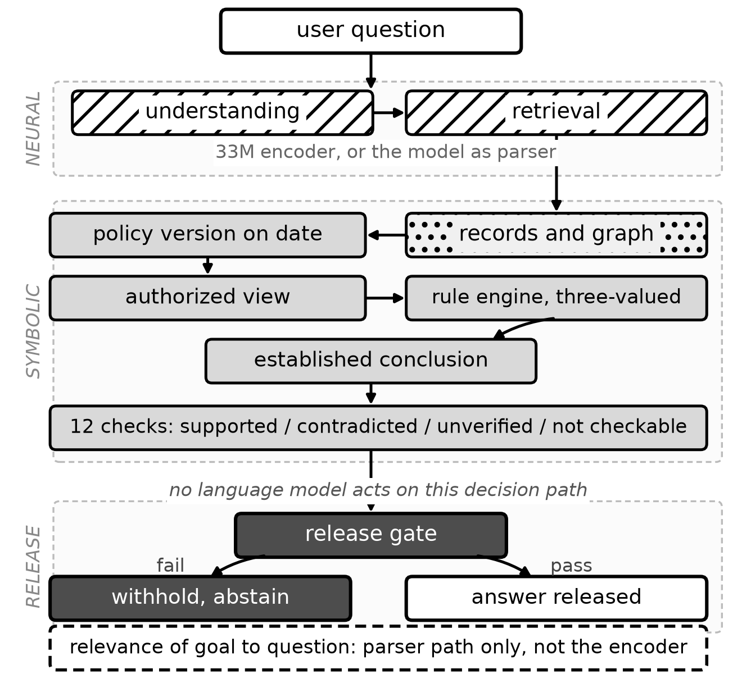
- Architecture of PRAXIS as implemented. Diagonally hatched blocks are neural, dotted stored knowledge, solid grey symbolic, dark the release gate. The rule engine is three-valued - true, false, unknown - while verification is four-valued, since a claim may also be not checkable; the two are distinct layers. The dashed panel is the relevance check: nothing on this path tests whether the resolved goal answers the question asked, the failure analysed in Section X.
Fig. 1 shows the implemented pipeline. The neural lane - a 33M encoder by default, or the model acting as semantic parser - yields a goal, the records referred to and any stated facts, and retrieval gathers the evidence. The symbolic lane resolves the policy version in force on the case's own date, restricts records to those the asker may see, and evaluates the rules under three-valued logic to produce an established conclusion. Claims are then extracted and checked against the evidence by the applicable members of a 12-check suite, and the release gate either publishes the answer or withholds it and reports insufficient evidence.
A model may phrase the conclusion but never establishes it, and its wording is checked for figures the evidence does not carry. The dashed panel is a relevance check between the resolved goal and the question, which this configuration cannot express: nearest-neighbour selection always returns a goal.

Neural Understanding
A 33M-parameter bge-small encoder, run locally through ONNX, maps the question to a goal in the rule base, the records it refers to and any facts it states. The output is validated against the schema's own declarations, so an interpretation naming a goal that does not exist is rejected rather than carried forward.

Three-Valued Symbolic Reasoning
Rules are evaluated under Kleene strong three-valued logic: a fact the company has no record of is unknown, not false. A two-valued engine answers 'no, you are not eligible' when the truthful answer is 'nobody recorded whether you are'. The reasoner resolves the policy version in force on the case's own date rather than the newest, and reads records through an authorized view, so a rule consults only facts the asker may see.

The Evidence Gate
The verifier defines 12 deterministic checks - fact validity, authorization, policy applicability, policy version, symbolic provenance, calculation, supported numbers, record consistency, contradictions, answer agreement, unsupported claims and citation integrity, which no test question reaches. Which apply depends on what the case asserts, so none runs on every question: over the 255 test cases the number that runs ranges from 0 to 9, with a median of 8. The 17 cases that run none are refusals settled before there is anything to verify. An answer failing any check that did run is withheld and the system reports that it does not know. Statuses are four-valued: supported, contradicted, unverified, not checkable.

Experimental Design
- Dataset splits. The 510 evaluation questions are the test and confirmatory splits; the development split is excluded from every reported result.
Split | Worlds | Questions | Purpose
Development | 3 | 153 | threshold calibration only; never reported
Test | 5 | 255 | frozen before first use; main results
Confirmatory | 5 | 255 | written after the system was final, scored once
Evaluation total | 10 | 510 | test + confirmatory
Corpus total | 13 | 663 | all generated cases

Cases are generated over synthetic enterprise worlds, each with its own catalogue, staff, policy history and records, with gold answers from an independent oracle rather than the system under test. The three splits of Table I share no case and no world: thresholds were calibrated on the development worlds alone, and the confirmatory split was written after the system was final and scored once. All systems see the same questions, corpus and authorization context, every language-model system in a run uses the same model, and decoding is greedy so a run repeats exactly on one machine.

Evaluation Metrics
Denominators differ between metrics, which is why the figures can look incompatible and are not. Let N be all cases in a split, A the answerable cases - those whose gold kind is a decision, a value or a result - and D the subset of A answered definitely. Accuracy and hallucination are over N, coverage is |D|/|A|, and selective accuracy is correctness over D, so conditional, denied and not-covered cases are excluded from coverage but included in accuracy. For the parser configuration, N = 255 = 210 answerable + 15 conditional + 15 denied + 15 not-covered. Of the 210 answerable, 205 were definite and all correct (selective accuracy 1.000); every conditional case drew a correctly hedged answer and every denied case a refusal without disclosure, 15 and 15; and 6 of 15 not-covered cases were correctly refused. Accuracy is therefore (205 + 15 + 15 + 6) / 255 = 241/255 = 0.945. Every value in this paper is recomputed from the stored per-question records twice: by `scripts/audit_metrics.py`, which mirrors the harness, and by `scripts/independent_metrics.py`, which implements the definitions above from the raw records instead, so that an error shared by harness and audit would still surface. All 151 values reproduce.
A case whose gold kind is not-covered is correct only if the system reports insufficient evidence; a conditional case only if the answer is hedged and not definite; a denied case only if the system refuses without disclosing the record. Hallucination is the union of three disjoint faults: a wrong definite answer, a definite answer where the gold says evidence is insufficient, and disclosure of a record the asker may not see. Coverage and selective accuracy are always reported together, because a system can buy high selective accuracy by refusing the hard questions.
Intervals are 95% bootstrap percentile intervals over questions. Paired comparisons use the exact McNemar test on per-question outcomes: cases where both systems agree carry no information, so of the discordant pairs only, the count favouring one system is tested two-sided against Binomial(n, 1/2). The exact binomial tail is used rather than the chi-square approximation, because the discordant counts here are small.

Results
Scope of the evidence. These are preliminary findings about neuro-symbolic verification reducing unsupported claims under the evaluated conditions: a controlled benchmark of synthetic enterprise scenarios with gold answers from an independent oracle, not real customer traffic. They do not establish general-purpose hallucination elimination, nor effectiveness across models, datasets and domains not tested here, and the rates below should not be read as open-domain factuality rates.
- Test split, 255 questions: the quantities not shown in Fig. 2. Coverage is definite answers over answerable questions; selective accuracy is correctness among them; over-abstention is the answerable questions refused.
System | Coverage | Selective acc. | Over-abstention | Latency (ms)
PRAXIS (no LLM) | 0.943 | 0.874 | 0.057 | 78
PRAXIS (LLM parser) | 0.976 | 1.000 | 0.024 | 380
LLM + RAG + rules | 0.781 | 0.793 | 0.219 | 12468
LLM + RAG + self-check | 0.505 | 0.481 | 0.495 | 6972
LLM only | 0.600 | 0.341 | 0.400 | 6971
LLM + RAG | 0.462 | 0.412 | 0.538 | 5814
Extractive RAG | 0.000 | n/a | 1.000 | 110

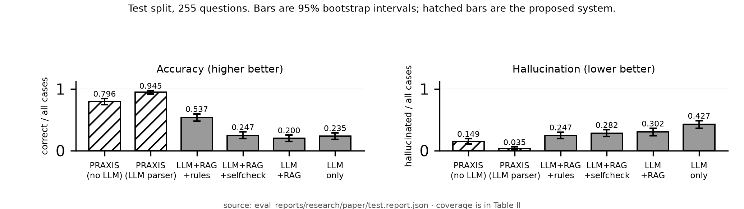
- Main comparison on the test split. Accuracy and hallucination are both over all 255 cases. Bars are 95% bootstrap intervals; hatched bars are the proposed system. Coverage, which has a different denominator, is reported in Table II so that a system cannot appear strong merely by refusing to answer.

The LLM-free configuration answers 0.796 [0.75, 0.84] of all questions correctly at 0.149 [0.11, 0.19] hallucination, against 0.200 and 0.302 for the same model given retrieval over the same corpus. Answering RQ2 directly: the reduction is not bought with abstention. PRAXIS covers 0.943 of answerable questions while retrieval covers 0.462 — it answers more questions and more of them correctly.
Confining the model to semantic parsing, with the decision still symbolic, gives the strongest configuration: 0.945 [0.92, 0.97] accuracy at 0.035 [0.02, 0.06] hallucination, 0.976 coverage, and a selective accuracy of 1.000. Of the questions it commits to, none is wrong. Section IX examines how far that survives.

Ablation Studies
- Decision-level ablations on the test split. Each row disables one mechanism; the gate acts on wording, so Section VIII-A tests it.
Configuration | Accuracy | Hallucination | Disclosure
PRAXIS (full) | 0.796 | 0.149 | 0.000
verification gate removed | 0.796 | 0.149 | 0.000
unknown treated as false | 0.745 | 0.188 | 0.000
newest policy applied to every case | 0.761 | 0.184 | 0.000
asker's statements override records | 0.690 | 0.094 | 0.000
reasoning sees every record | 0.737 | 0.208 | 0.867
numeric grounding check removed | 0.796 | 0.149 | 0.000
kind-agreement check removed | 0.804 | 0.161 | 0.000

Three readings matter. Three-valued reasoning carries real weight: treating unknown as false costs 0.051 accuracy, because the system starts denying entitlements that were merely unrecorded. Policy versioning costs 0.035 when the newest policy is applied to every case regardless of date. Authorization is the sharpest: removing it leaves accuracy broadly intact but raises the disclosure rate from 0.000 to 0.867 — the system answers well and leaks almost every protected record while doing so, which an accuracy-only evaluation would not reveal.
Three rows need reading against a second column before they are read as refutations. Removing the kind-agreement check raises accuracy to 0.804, nominally above the full system, but the paired test puts the difference at p = 0.625 on 4 discordant cases: it is noise, and what the check actually buys is 0.012 hallucination for 0.019 coverage. Letting the asker's statements override records lowers hallucination to 0.094, well below the full system, while coverage falls from 0.943 to 0.748 and accuracy drops significantly (p = 1.49e-08). That row is this paper's own warning turned on itself: the configuration abstains its way to a better hallucination rate, which is precisely why we report coverage beside every accuracy. Removing the numeric grounding check changes nothing at all, for the same reason the verification gate does not - both police prose, and the default configuration writes none.

A Controlled Test of the Verification Gate
Two measurements are at stake, and separating them resolves an apparent contradiction. The ablation rows above are decision-level: they grade structured outcomes and cannot see the gate at all, since the default configuration renders conclusions deterministically and the gate acts only on prose. The experiment below is text-level and measures what the gate changes in the released answer. It holds everything else fixed - the same 255 questions, model, retrieval and prompts, with the model writing the final wording in both arms and verification on in one and off in the other.
Reaching the switch proved harder than expected, and the difficulty is itself a result. The guard is layered across the realizer, the controller's re-verification and the release check; the switch originally reached only the last, and two successive runs produced byte-identical arms on all 255 cases - not because the checks do nothing, but because each remaining layer repaired what the ablated one let through. A regression test now asserts that it reaches all three.
With the switch complete the arms diverge: the released answer differs on 52 of 255 cases, and answers stating a figure the evidence does not support rise from four to six. On one case the gated system answers with the recommended resolution and its grounds, while the ablated system abandons the conclusion and emits generic support boilerplate carrying a figure found nowhere in the evidence.
Yet every decision-level metric is identical in both arms. This locates what the benchmark can see: the scorer grades the structured decision - goal, decision, value, outcome - which the symbolic layer fixes before any model writes a word and which the gate therefore never changes. The gate protects the prose, and prose faithfulness is not in this scorer. Its contribution is demonstrated here at the level of released text; a decision-level benchmark is the wrong instrument, and Study II supplies the claim-level one.

Transfer to Unseen Worlds
On the confirmatory split, accuracy was: PRAXIS (no LLM) 0.812, PRAXIS (LLM parser) 0.835, LLM + RAG 0.216, LLM only 0.239.
The LLM-free configuration transfers essentially unchanged (0.812 against 0.796 on test). The parser configuration does not: accuracy falls from 0.945 to 0.835, hallucination rises from 0.035 to 0.118, and selective accuracy falls from 1.000 to 0.909. Its advantage over embedding understanding narrows from roughly fifteen accuracy points to two, and the paired tests narrow with it: on the test split the parser is correct where embedding understanding is not on 40 questions against 2 the other way (exact McNemar, p = 4e-10), while on the confirmatory split the same comparison is 7 against 1 (p = 0.07). At the 0.05 level the first is persuasive and the second is not. We therefore report the parser's advantage as demonstrated on the test split and not established on unseen worlds.

Error Analysis
- Accuracy by question category, LLM-free configuration, weakest first. Category sizes are 15 to 45 cases, so these rates are indicative rather than precise.
Category | n | Accuracy
not_covered | 15 | 0.000
recommendation | 25 | 0.600
paraphrased | 45 | 0.622
known | 30 | 0.833
policy_version | 25 | 0.880
false_premise | 20 | 0.900
multi_hop | 20 | 1.000
calculation | 45 | 1.000
missing_info | 15 | 1.000
unauthorized | 15 | 1.000

The aggregate conceals a complete failure. On the fifteen questions no policy clause covers, the system abstained in none: thirteen produced a confident answer and two a clarification. Asked the warranty period on a product, it answered that a replacement was not available.
Understanding maps an out-of-scope question onto the nearest in-scope goal, and the system answers that question correctly, citing real clauses and real records. The gate cannot intervene because every check passes - across all fifteen cases no unsupported number appears. Verification establishes that a claim follows from evidence, not that it answers the question asked.
This qualifies the architecture's central promise: an out-of-scope question is not unsupportable, it is answerable about something else, and the grounding makes the irrelevant answer more convincing rather than less. The remedy is a relevance check independent of the evidence gate, which this configuration has no way to express: selecting a goal by nearest neighbour always returns one.

Study II: Gating a Model Trained from Scratch
The first study removes the language model from the decision; this one puts it back in the hardest form - a model whose knowledge comes wholly from a corpus we control, generating freely, with the symbolic layer deciding what reaches the reader. It is secondary: it tests the gate, not the generator, and training from scratch is not necessary to the architecture.

Data, Model and Training
The source is a record of 3637 FIFA World Cup goals from 1930 to 2022, men's and women's tournaments, covering 1,162 matches and 1,831 players. One dataset serves three roles, which keeps the comparison honest: the rows are verbalised into a training corpus, loaded as a typed knowledge graph, and used to generate evaluation prompts, so generator and verifier are grounded in the same facts.
The split is by match, not by row, so a withheld match has no sibling goals in training: 137 matches are withheld entire. Leakage is checked on (fixture, tournament) pairs rather than names, since fixtures recur across tournaments and the 1934 and 1938 tournaments held replays. No evaluated fixture appears in training.
The model is nanoGPT, unmodified, at 4.3M parameters (4 layers, 4 heads, width 256, vocabulary 4096), trained from random initialization on a single consumer GPU. Initial loss was 8.454 against ln(4096) = 8.318, consistent with random initialization. Validation loss reached its minimum of 0.7742 and then rose while training loss continued to fall; the minimum checkpoint is used.
The sizing bounds every claim about the model: 292,948 training tokens against 4.3M parameters is 0.069 tokens per parameter, two orders of magnitude below compute-optimal. It memorises the corpus, and no configuration avoids that at this scale. A stronger generator would make the test easier rather than more informative.

Claim Extraction and Verification
Generated text is split into sentences, each matched against the corpus's phrasings to yield a typed claim: a goal event, a player's tournament total, or a match total. Rule checks need no lookup - a goal in the first half at minute 68 is impossible whatever the records say. Graph checks ask whether the goal is on record. Verdicts are four-valued, and a claim about a player or match the records do not contain is UNVERIFIED rather than CONTRADICTED, since the graph is incomplete and absence is not refutation. Extraction covers 96.8% of generated sentences; the remainder are reported as not checkable rather than guessed at.

Results

- 337 prompts, 1,056 checkable claims. Both systems read the same generations, so the gate changes only what is released. Refuted and unverifiable are kept apart: the graph is incomplete, so a claim it has no record of is not thereby false. The gate withholds both.
System | Claims released | Refuted | Unverifiable | Refuted rate | Coverage
SLM only (every claim released) | 1,056 | 493 | 40 | 0.467 | 1.000
SLM + symbolic gate | 523 | 0 | 0 | 0.000 | 0.495

Of 1,091 sentences, 1,056 yielded a typed claim and 35 were unparseable. Of the typed claims 523 were supported, 493 refuted and 40 unverifiable - naming a player or match the records do not contain. A further 300 trailing fragments cut off by the token budget were discarded rather than counted against the model. That is 0.89 per prompt against a fixed 80-token budget, which is what makes the discard structural - one severed tail per generation - rather than a selection among claims.
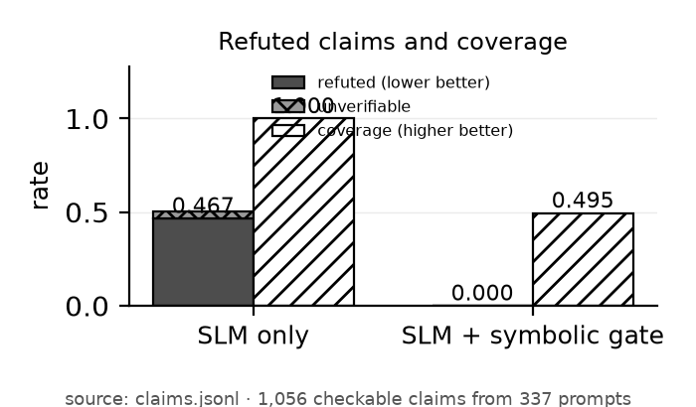
- What the gate removes in the secondary study and what it costs. The gated rate of 0.000 holds by construction; the informative quantities are the base refuted rate of 0.467 and the coverage of 0.495 that withholding leaves. The bar for withheld claims combines 493 refuted and 40 unverifiable.
- Refuted-claim rate by claim type, over all n of that type; unverifiable claims counted apart.
Claim type | n | Refuted rate | Unverifiable
goal event | 905 | 0.463 | 33
match total | 25 | 0.680 | 3
player tournament total | 126 | 0.452 | 4

How This Result Should Be Read
Three findings must be kept apart. In the enterprise benchmark the architecture reduces unsupported claims against a retrieval baseline on the same questions: a measured comparison. In Study II gating removes refuted claims at a cost in coverage: a trade-off, not an improvement in the generator. Whether the verifier is itself correct is established by neither. Only the first is evidence that the architecture reduces hallucination.
The gated system's refuted rate of 0.000 is near-tautological and should not be reported as the finding. The gate releases only claims the graph confirms, so by construction none of them is refutable. The informative quantities are the other two: a base refuted rate of 0.467, and the 0.505 of checkable claims that withholding costs - the refuted ones together with a further 0.038 the graph cannot confirm either way. Verification buys soundness with silence, and it pays for part of that silence with claims that may well be true.
What is not tautological is that the checks are substantive. Nineteen claims were refuted by rule alone, with no database consulted - a goal in the first half at minute 68, or credited to a country that was not playing. The graph-based refutations are specific and plausible-looking, which is what makes them dangerous: the commonest is a goal event the records do not contain at the stated minute, and relocating a real goal to the wrong tournament is the next largest group. Per claim type the gate discriminates rather than rubber-stamps (Table VI).
One result deserves emphasis. The refuted-claim rate on prompts naming matches withheld from training is 0.480, and on matches the model was trained on it is 0.458 — indistinguishable. The model confabulates about its own training data as readily as about events it never saw. At 0.069 tokens per parameter it has not reliably memorised the corpus, which suggests that data starvation, and not merely absent knowledge, drives the errors. It also means this study measures a generator that is unreliable everywhere, not one that fails only outside its training distribution.

Limitations and Threats to Validity
- Scope of the evidence. Results come from generated worlds with oracle gold answers, not real customer traffic, in a single domain - enterprise policy decision support - whose governing rules can be written down. English only, one item per order.
- Transfer. Perfect selective accuracy does not generalize: the 1.000 figure on the test split falls on the confirmatory split, and no claim of perfect reliability should be read from it.
- Authorship. The rule base, world generators and oracle were written by one person, and the rules are hand-translated from policy text. An independently authored evaluation, and automatic extraction of candidate rules for human review, are the next steps.
- The gate's contribution is measured at the level of released text, not decisions. The controlled test in Section VIII-A changes 52 of 255 answers and raises unsupported figures from four to six, while every decision-level metric is unchanged. Quantifying it further needs a prose-faithfulness metric.
- Model capability is not controlled. A 1.5B parser scored well below a 7B one while the retrieval baselines barely moved, but the two runs used different inference stacks, so this is an open question.
- Study II. The gated rate of zero refuted claims is true by construction - verification is definitionally correct with respect to the graph, so the gate's precision and recall cannot be measured against independent ground truth, and a graph error would propagate silently. Its model is 4.3M parameters on 292,948 tokens, a deliberately weak generator of checkable claims rather than a usable assistant. Claim extraction covers 96.8% of generated sentences; an extractor that silently fails is indistinguishable from a model that said nothing checkable.
- Both studies verify claims against a curated knowledge base. Neither speaks to open-domain factuality, where no such base exists for the gate to consult.

Conclusion and Future Work
Removing the language model from the decision path, rather than asking it to audit itself, reduced hallucination from 0.302 to 0.149 while raising coverage from 0.462 to 0.943 and cutting latency by roughly two orders of magnitude. The reduction is not an artefact of refusing difficult questions.
Two findings temper this. The parser configuration's perfect selective accuracy on the test split does not transfer to unseen worlds, and the LLM-free configuration does not recognise questions its rule base does not cover — a failure verification is structurally unable to catch, because relevance is not support.
The secondary study makes the price explicit: the graph refutes 0.467 of the claims a model trained from random initialization makes, and gating leaves only supported ones at 0.495 coverage. Together the studies suggest one reading: verification converts an unreliable generator into a silent-but-sound one, and the useful question is never whether hallucination falls - gating guarantees that - but how much of the answer survives.
Future work is a relevance gate for the LLM-free configuration, which needs goal selection to have a null option it currently lacks, an independently authored evaluation, a single-stack measurement of the capability effect noted in Section XII, and raising coverage in Study II without reintroducing unsupported claims.

References
- Z. Ji et al., “Survey of hallucination in natural language generation,” ACM Comput. Surv., vol. 55, no. 12, pp. 1-38, 2023, doi: 10.1145/3571730.
- L. Huang et al., “A survey on hallucination in large language models: principles, taxonomy, challenges, and open questions,” ACM Trans. Inf. Syst., vol. 43, no. 2, 2025, doi: 10.1145/3703155.
- P. Lewis et al., “Retrieval-augmented generation for knowledge-intensive NLP tasks,” in Advances in Neural Information Processing Systems, vol. 33, 2020.
- A. Asai, Z. Wu, Y. Wang, A. Sil, and H. Hajishirzi, “Self-RAG: learning to retrieve, generate, and critique through self-reflection,” in Int. Conf. on Learning Representations, 2024.
- S. Dhuliawala, M. Komeili, J. Xu, R. Raileanu, X. Li, A. Celikyilmaz and J. Weston, “Chain-of-verification reduces hallucination in large language models,” in Findings of the ACL: ACL 2024, pp. 3563-3578, 2024.
- P. Manakul, A. Liusie, and M. J. F. Gales, “SelfCheckGPT: zero-resource black-box hallucination detection for generative large language models,” in Proc. EMNLP, pp. 9004-9017, 2023, doi: 10.18653/v1/2023.emnlp-main.557.
- S. Min et al., “FActScore: fine-grained atomic evaluation of factual precision in long form text generation,” in Proc. EMNLP, pp. 12076-12100, 2023, doi: 10.18653/v1/2023.emnlp-main.741.
- L. Pan, A. Albalak, X. Wang, and W. Y. Wang, “Logic-LM: empowering large language models with symbolic solvers for faithful logical reasoning,” in Findings of the ACL: EMNLP 2023, pp. 3806-3824, 2023, doi: 10.18653/v1/2023.findings-emnlp.248.
- T. X. Olausson et al., “LINC: a neurosymbolic approach for logical reasoning by combining language models with first-order logic provers,” in Proc. EMNLP, pp. 5153-5176, 2023, doi: 10.18653/v1/2023.emnlp-main.313.
- L. Gao et al., “PAL: program-aided language models,” in Proc. Int. Conf. on Machine Learning, PMLR vol. 202, pp. 10764-10799, 2023.
- W. Chen, X. Ma, X. Wang, and W. W. Cohen, “Program of thoughts prompting: disentangling computation from reasoning for numerical reasoning tasks,” Transactions on Machine Learning Research, 2023.
- Z. Cheng et al., “Binding language models in symbolic languages,” in Int. Conf. on Learning Representations, 2023.
- A. d'Avila Garcez and L. C. Lamb, “Neurosymbolic AI: the 3rd wave,” Artif. Intell. Rev., vol. 56, no. 11, pp. 12387-12406, 2023, doi: 10.1007/s10462-023-10448-w.
- H. Kautz, “The third AI summer: AAAI Robert S. Engelmore memorial lecture,” AI Mag., vol. 43, no. 1, pp. 105-125, 2022, doi: 10.1002/aaai.12036.
- S. C. Kleene, Introduction to Metamathematics. Amsterdam: North-Holland, 1952.

