Reducing Hallucination with a Neuro-Symbolic Verification Layer
Project 1 — Praxis: Retrieval-Augmented Generation with Symbolic Proof and an Evidence Gate
Enterprise question answering over company policy, records and rules
Technical report prepared for review — 23 September 2026

1. The central idea
A language model is never what decides. It performs two jobs only: it understands what was asked, and it words the final answer. Every fact, number and yes/no in between is produced by document retrieval or by a symbolic rule engine. When a statement cannot be supported by evidence or derived from rules, the system withholds it rather than producing it.
This is the mechanism by which hallucination is reduced: not by instructing the model to be careful, and not by asking it whether it is confident — a model cannot be trusted to lower its own bar, and asking "are you sure?" measures nothing. The decision to answer is taken in ordinary code, from measurable quantities.

2. Pipeline architecture
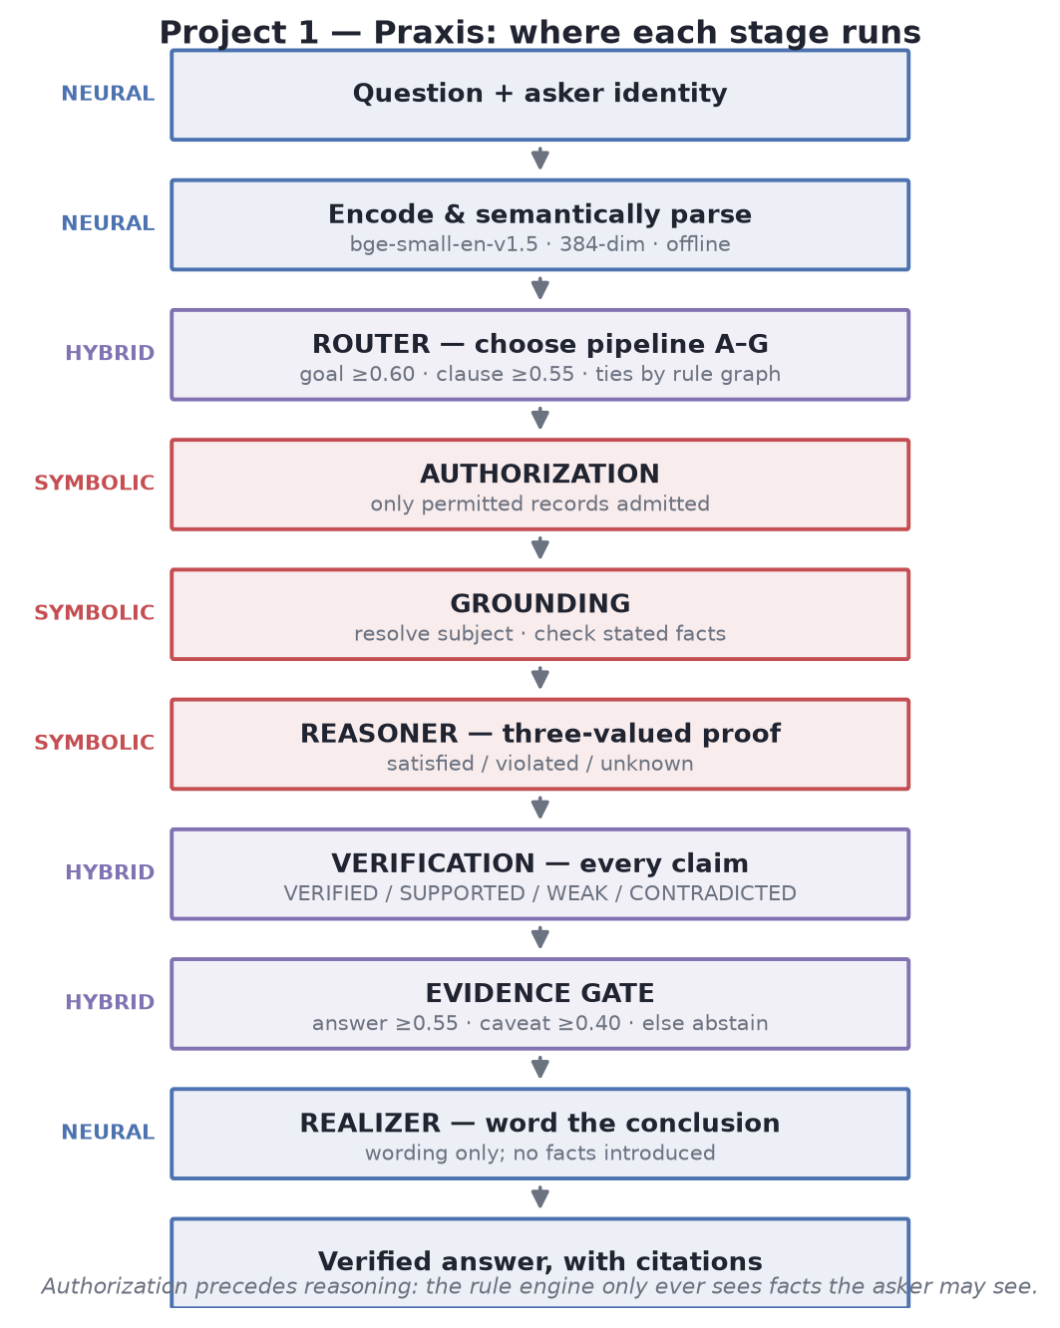
Figure 1 — The stages of Project 1, coloured by the layer that executes each one.
QUERY
| NEURAL encode the question (BAAI/bge-small-en-v1.5, ONNX, 384-dim, offline)
| NEURAL semantic parse into the closed schema (goal, inputs, clause)
| HYBRID ROUTER choose pipeline A-G -> section 4
| SYMBOLIC AUTHORIZATION admit only permitted records -> section 5
| SYMBOLIC GROUNDING resolve subject, check stated facts
| SYMBOLIC REASONER three-valued proof over rules-> section 6
| HYBRID VERIFICATION check each claim vs evidence -> section 7
| HYBRID EVIDENCE GATE answer / caveat / abstain -> section 8
| NEURAL REALIZER word the verified conclusion only
FINAL VERIFIED ANSWER
Why the order matters
Authorization runs BEFORE reasoning, so the symbolic engine only ever receives facts the asker is permitted to see. A system that reasoned first and filtered afterwards would leak restricted records through its own explanations.

3. Input and output
Input: a natural-language question together with the identity of the person asking (email and roles). Identity is not decoration — it determines which records may enter the reasoning at all.
Output is a structured object, not a string:
Field | What it carries
answer | the wording presented to the user
pipeline | which of the seven routes handled the question, and why
outcome | answered / insufficient / clarification / denied
citations | the clause identifiers and record identifiers the answer rests on
trace | every stage executed, labelled NEURAL, SYMBOLIC or HYBRID
confidence | a number computed in code, with its factor breakdown
verification | per-claim status: VERIFIED, SUPPORTED, WEAK or CONTRADICTED

4. Decision criteria — how a question is routed
The router chooses one of seven pipelines and records its reasoning:
 | Pipeline | Chosen when
A | Knowledge retrieval | the answer is a policy clause or a stored record
B | Policy reasoning | a yes/no decision that the rules determine
C | Multi-hop reasoning | an explanation following relations to a failed condition
D | Calculation | an amount computed by rule arithmetic
E | Clarification | cannot be pinned to one goal or one record
F | Insufficient knowledge | IS a company question, but nothing covers it
G | General conversation | NOT a company question at all

F and G are deliberately different failures. "What is the escalation window for a damaged laptop?" is a company question the knowledge pack does not cover; saying so is the honest answer, because guessing would invent policy. "Who won the 2018 World Cup?" is not a company question at all, so answering it from the company knowledge base would be a category error — the model answers it plainly, labelled as its own knowledge, carrying no citation and no verification.

4.1 Why the symbolic route is chosen, and when it is not
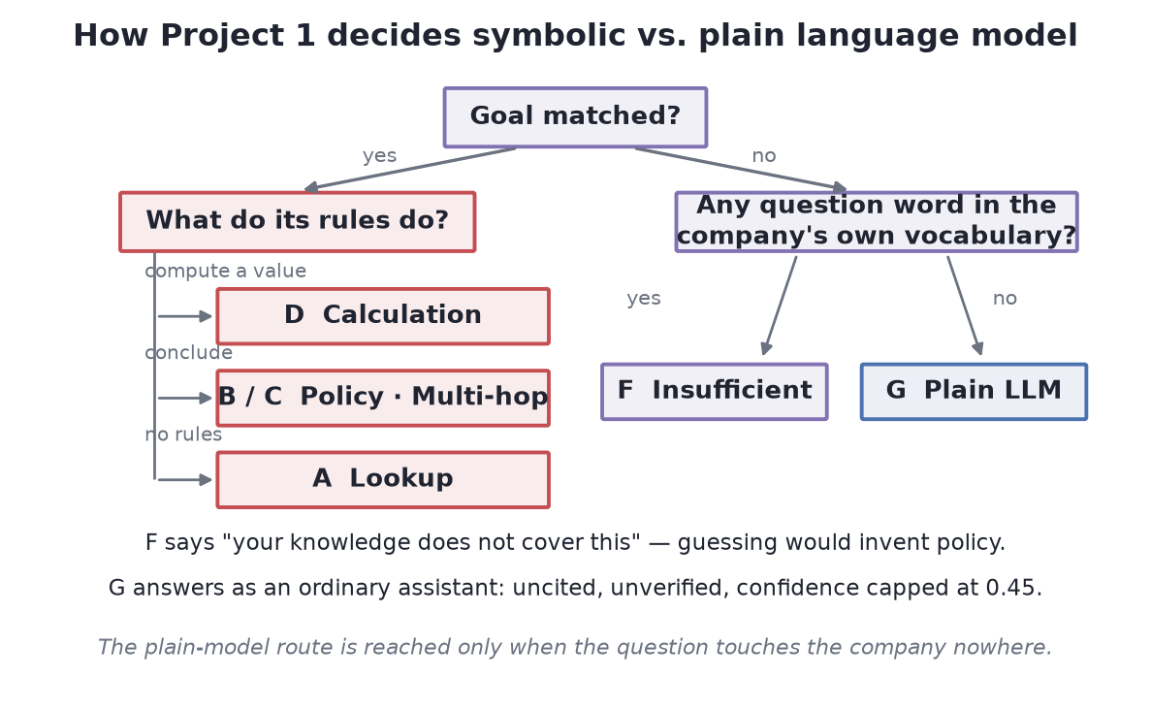
Figure 2 — The routing decision. The plain language model is reached only on the far right.
This is not a heuristic. It follows from the structure of the rule base for the matched goal:
- a goal whose rules compute a value → Calculation (D)
- a goal concluded by rules at all → symbolic evaluation (B or C)
- a goal with no rules → lookup (A)
- no goal matched, question is on-topic → insufficient knowledge (F)
- no goal matched, question is off-topic → plain language model (G)
The plain-model route is therefore reached only when the question has no connection to the company at all. That test compares the question's content words against the vocabulary of the knowledge pack itself — policy text, goal descriptions, schema predicate and entity-type names. A single shared content word keeps the question inside the company pipeline.
A subtle design point
Entity labels are deliberately excluded from that vocabulary. Whether a particular customer's name appears in the graph is a fact about the records, and topicality is decided before authorization has admitted anything. A test that consulted labels would answer differently for two people permitted to see different records.

4.2 Thresholds used
Constant | Value | Role
GOAL_ACCEPT | 0.60 | goal accepted on similarity alone
GOAL_SUPPORTED | 0.55 | accepted if stated inputs or mentions corroborate it
GOAL_SUGGEST | 0.45 | only good enough to offer as "did you mean"
RETRIEVAL_ACCEPT | 0.55 | clause relevant enough to answer an informational question
TIE_WINDOW | 0.03 | goals this close are resolved by the rule graph, not by score
KIND_WINDOW | 0.06 | a goal of the requested kind this close to the top is preferred
PARSED_CLAUSE_FLOOR | 0.40 | floor for a clause the semantic parser itself selected

4.3 Two symbolic checks applied to the neural interpretation
Content-word floor. A question containing no content word cannot select a goal, however close its embedding happens to be. The bare question "How much?" scored 0.60 against a delivery-charge goal.
Kind agreement. The goal's kind must match what was asked. "What is my reimbursement?" (an amount) and "does my trip qualify?" (a yes/no) sit a few hundredths apart in embedding space, and answering the wrong one produces a fluent, correctly cited answer to a question nobody asked.
Near-ties within 0.03 are broken by the rule graph — preferring the goal the question supplies evidence for, then the prerequisite over the goal that depends on it — never by a rounding difference in cosine similarity.

5. Retrieval (RAG) parameters
Parameter | Value | Note
chunk_target_tokens | 220 | target chunk size
chunk_overlap_tokens | 40 | overlap between adjacent chunks
embedding_dimension | 384
retrieval_top_k | 24 | first-pass recall
rerank_top_k | 8 | passed forward to verification
embedding_provider | semantic | was hashing - see below
encoder | BAAI/bge-small-en-v1.5 | ONNX Runtime, offline, ~130 MB

Retrieval is hybrid: pgvector cosine search combined with PostgreSQL full-text lexical search, fused and then reranked. Every span is authorization-filtered at the SQL level, and retrieved documents are treated as untrusted data — a span may be quarantined, and quarantined spans are excluded from the usable evidence count.
A defect found and corrected during this work
Retrieval was configured to use feature hashing - hashed word and character n-grams. That is lexical-semantic rather than a sentence encoder, so a paraphrase such as "can I give this back?" could not reach a passage about returning an item: the two share no term, and character n-grams do not bridge the gap. The right passage never entered the candidate set, which no amount of reranking recovers. Measured on that pair: 0.151 under hashing, 0.769 under the sentence encoder. Document retrieval now uses the same ONNX encoder the neural layer already ran. On the seeded corpus, "who do I contact if my laptop breaks" retrieves the IT helpdesk clause at 0.756 with no content word in common. Vectors from the two providers are not comparable, so an existing corpus must be re-embedded when the provider changes.

6. The symbolic layer — three-valued logic
Classical rule engines are two-valued: a condition holds or it does not, and a missing fact counts as false. That is precisely why rule-based assistants answer "no" to questions they ought to be able to answer. This reasoner keeps three outcomes apart:
Value | Meaning | What it enables
satisfied | the knowledge proves the condition
violated | the knowledge refutes the condition | why-not explanations
unknown | nobody has stated what it depends on | names the missing fact; conditional answers

Open and closed worlds. A company record is a closed world: if an order has no delivery date, it was not delivered. A hypothetical the user describes ("if I spent Rs 8,750") is an open world: anything unstated is unknown, not false. The reasoner is told which subjects are open.
Inference confidence. A derived fact takes confidence = min(premise confidences) × rule confidence, so it can never be more certain than the weakest premise it rests upon.
Contradictions. While a conflict is unresolved, neither value may be asserted — stating one and mentioning the disagreement afterwards would let the reader take the first number as the answer. A conflict resolved by version ordering permits the newer value and reports both.

7. Verification of every claim
Each claim in the drafted answer is assigned a status before the answer may be shown:
Status | Awarded when
VERIFIED | derived by the rule engine from verified premises; or from the user's own profile record; or a computed statistic whose figure matches the fact's value and appears in the retrieved evidence
SUPPORTED | corroborated by evidence, scored 0.35 × lexical + 0.65 × numeric agreement
WEAK | the derivation's premises are not fully evidence-backed
CONTRADICTED | sources disagree, or the value was superseded by a newer source

Evidence relevance is computed as 0.65 × best span score + 0.35 × mean of the top spans. A claim whose numbers do not appear in the supporting span has its score multiplied by 0.4 — this is the check that catches a fluent sentence carrying an invented figure.

8. The evidence gate — deciding to answer or abstain
Hard stops are applied in order: an unresolved contradiction reports the conflict; required evidence that is absent forces abstention; evidence relevance below 0.18 forces abstention; and no supported claim forces abstention.

8.1 Confidence formula
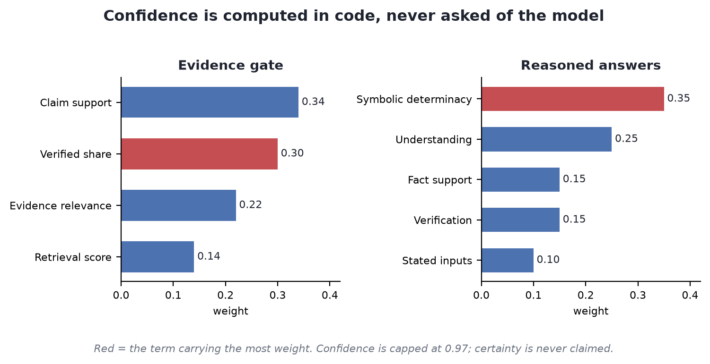
Figure 3 — The weights in each confidence blend. Determinacy of the proof dominates.
confidence = 0.34 * mean_support
+ 0.22 * evidence_relevance
+ 0.14 * min(1, best_retrieval_score)
+ 0.30 * verified_share
- 0.08 * min(unsupported_claims, 4)
if a symbolic conclusion exists and is verified: confidence = max(confidence, 0.82)
clamped to the range [0.00, 0.97]
Note the ceiling: 0.97, never 1.00. The system does not claim certainty. When the relevance floor is waived, the 0.22 relevance weight is redistributed proportionally across the remaining signals rather than dropped, so the result stays a weighted average and cannot be inflated.

8.2 Decision thresholds
Setting | Value | Effect
evidence_relevance_threshold | 0.18 | below this, abstain
claim_support_threshold | 0.40 | minimum for a claim to count as supported
answer_confidence_threshold | 0.55 | at or above this, ANSWER
caveat_confidence_threshold | 0.40 | at or above this, ANSWER WITH CAVEAT; below, ABSTAIN

An answer given from general knowledge (pipeline G) is capped at 0.45 and always labelled, so it can never be presented as grounded in company knowledge.

8.3 A second confidence, for reasoned answers
score = 0.25 * understanding (how well the goal was matched)
+ 0.10 * stated_inputs (confidence in facts the user supplied)
+ 0.35 * symbolic_determinacy (how decisively the rules concluded)
+ 0.15 * fact_support
+ 0.15 * verification
if the semantic encoder is unavailable: score = score * 0.8
Symbolic determinacy takes 1.00 when determined, 0.95 by default, 0.70 when conditional, 0.30 when unknown or absent, and 0.20 on conflict. It carries the largest weight in the blend, which states the design position outright: the determinacy of the proof matters more than similarity.

9. The system running, end to end
Each row below was run against the live stack on 23 September 2026, signed in as a customer of the demonstration workspace. Which pipeline a question reaches is the router's decision, not a setting.
Question | Pipeline | Conf. | Outcome
am I eligible for free delivery? | Policy reasoning | 1.00 | Verified, 8 checks. The rule is shown firing: membership = plus AND total 62,999 > 500
what happens if my item arrives damaged | Calculation | 0.98 | Computes her entitlement for her own order
how long do I have to cancel an order | Policy reasoning | 1.00 | Concludes the order can no longer be cancelled - already shipped
who do I contact if my laptop breaks | Knowledge retrieval | 0.56 | Cited. Shares no content word with the passage it found
what does the refund policy say | Knowledge retrieval | 0.82 | Answered from policy text, with citations
can I return order ORD-22003? | Access refused | - | The record belongs to another customer; the engine never receives it
can I give this back? | Clarification | - | Lists her actual orders and asks which one
who won the 2018 world cup | General conversation | - | Answered plainly, uncited, marked unverified

437 backend tests pass. The production frontend build succeeds.

10. Where hallucination is actually prevented
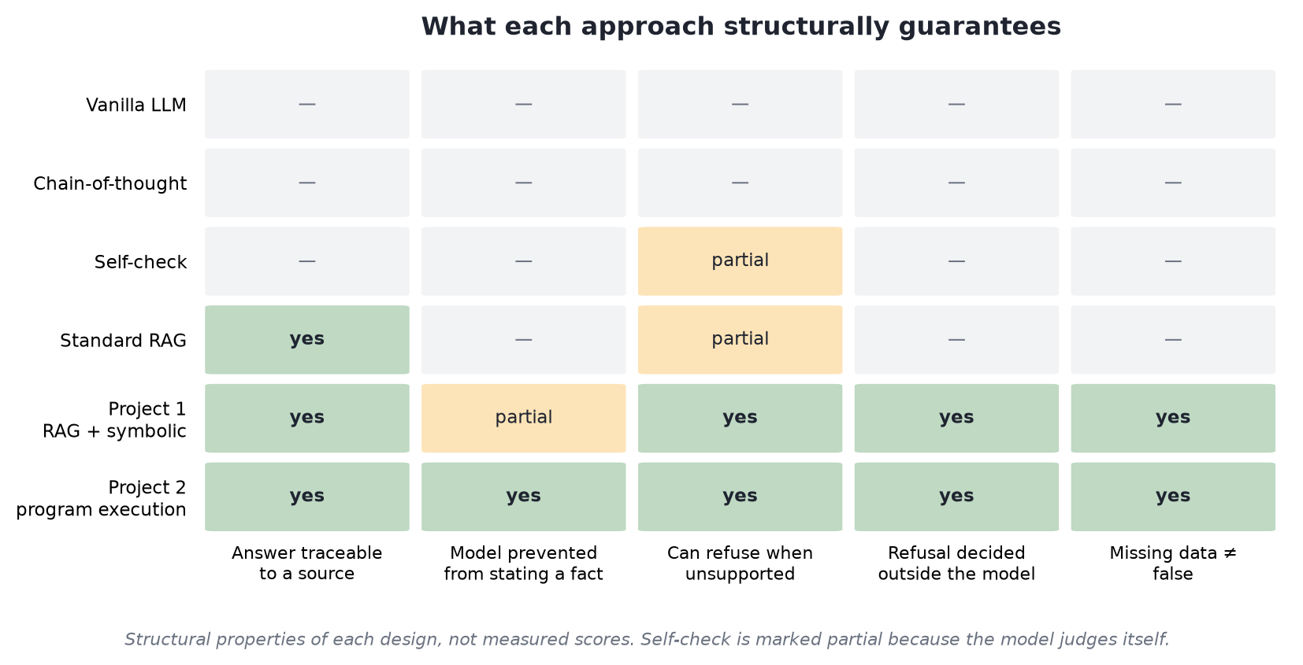
Figure 4 — Project 1 against existing approaches. These are structural properties of each design, not measured scores.
Failure mode | What prevents it
An invented number | the realizer only words the rule engine's computed value, and claim numbers must appear in the evidence
A fluent answer to the wrong question | kind-agreement check, and rule-graph tie-breaking
Policy invented for an uncovered topic | pipeline F states what is missing instead of guessing
A company answer to an off-topic question | pipeline G answers plainly, uncited, capped at 0.45
Asserting one of two conflicting values | an unresolved contradiction blocks both values
A stale policy value | version ordering; superseded values are marked CONTRADICTED
Leaking records through explanations | authorization precedes reasoning
A missing fact treated as false | three-valued logic returns unknown and names the gap

Scope of the claim
Hallucinations are reduced in enterprise question answering. They are not prevented, and they are not solved. This system does not claim otherwise, and no evaluation in this project reports a zero-hallucination result as a general property.

