
CAPS: LEARNING ADAPTIVE COMMUNICATION POLICIES
FOR EFFICIENT MULTI-AGENT LLM COLLABORATION
A Report submitted in partial fulfillment of the requirements
for the Degree of
Bachelor of Technology
in
COMPUTER SCIENCE AND ENGINEERING
by
Kallem Akshay Reddy 2311CS010285
Debasis Biswas 2311CS010164
Somagoud Vinay Kumar Goud 2311CS010627
Mathi Sudheer 2311CS010431
Under the guidance of
Dr. K. Asish Vardhan
Assistant Professor

Department of Computer Science and Engineering
School of Engineering
MALLA REDDY UNIVERSITY
Maisammaguda, Dulapally, Hyderabad, Telangana 500100
2026-2027
Department of Computer Science and Engineering
CERTIFICATE
This is to certify that the project report entitled “CAPS: Learning Adaptive Communication Policies for Efficient Multi-Agent LLM Collaboration”, submitted by Kallem Akshay Reddy (2311CS010285), Debasis Biswas (2311CS010164), Somagoud Vinay Kumar Goud (2311CS010627) and Mathi Sudheer (2311CS010431), towards the partial fulfillment of the requirements for the award of the degree of Bachelor of Technology in Computer Science and Engineering at Malla Reddy University, Hyderabad, is a record of work carried out under the supervision of Dr. K. Asish Vardhan, Assistant Professor.
The report presents the Phase-1 problem definition, feasibility analysis, literature survey and proposed methodology for the CAPS research project. Detailed implementation, experimental results and final conclusions are reserved for Major Project Phase-2.
The report is submitted to the Department of Computer Science and Engineering for academic evaluation during 2026-2027.

INTERNAL GUIDE | DEAN CSE
Dr. K. Asish Vardhan | Dr. Sudheer Babu

External Examiner

Department of Computer Science and Engineering
DECLARATION
We hereby declare that the project report entitled “CAPS: Learning Adaptive Communication Policies for Efficient Multi-Agent LLM Collaboration” has been prepared as part of our Major Project Phase-1 in the Department of Computer Science and Engineering, Malla Reddy University, Hyderabad, in partial fulfillment of the requirements for the award of the degree of Bachelor of Technology.
The report presents the problem definition, feasibility study, literature survey and proposed methodology. Sources, frameworks and prior research referred to in this report will be acknowledged through citations and references. Any implementation, experimental evidence or individual contribution included in subsequent project phases will be reported accurately and in accordance with institutional academic-integrity requirements.
Place: Hyderabad
Date: [DATE]

Kallem Akshay Reddy 2311CS010285
Debasis Biswas 2311CS010164
Somagoud Vinay Kumar Goud 2311CS010627
Mathi Sudheer 2311CS010431
ACKNOWLEDGEMENT
We express our sincere gratitude to CH.Malla Reddy, Chairman, and Dr,V.S.K Reddy, Vice Chancellor, Malla Reddy University, for providing the academic environment and institutional support necessary for this project.
We thank our project guide, Dr. K. Asish Vardhan, Assistant Professor, Department of Computer Science and Engineering, for guidance, constructive feedback and support in shaping the problem definition and research direction.
We acknowledge the Dean CSE, Dr.Sudheer Babu, and the faculty of the School of Engineering for their encouragement. We also acknowledge researchers and open-source contributors whose work on large language models, multi-agent systems, contextual bandits, information theory and software engineering benchmarks informs the proposed CAPS approach.
Finally, we thank our families, friends and peers for their encouragement. Any project-specific names, contributions and institutional acknowledgements should be reviewed and finalized by the project team before submission.
Kallem Akshay Reddy 2311CS010285
Debasis Biswas 2311CS010164
Somagoud Vinay Kumar Goud 2311CS010627
Mathi Sudheer 2311CS010431
ABSTRACT
Large language model (LLM) agents are increasingly organized into collaborative systems in which specialized agents plan, retrieve information, critique intermediate work and evaluate outputs. Communication supports coordination, but frequent or poorly targeted messages can increase token consumption, latency and context complexity. Existing multi-agent frameworks commonly provide mechanisms for routing and orchestration, while the decision of when, what and how much information to communicate is often specified through static rules or application-level heuristics.
This Phase-1 project proposes CAPS (Communication-Aware Policy Learning for Persistent Inter-Agent Collaboration), a research framework for learning adaptive communication policies in multi-agent LLM systems. The central idea is to represent candidate messages as contextual information units (CIUs), characterize the current collaboration state, and use a contextual decision policy to select whether information should be transmitted, summarized, deferred or withheld. A contextual bandit formulation, with LinUCB as an initial candidate, is proposed to estimate the value of communication relative to its cost. The policy objective balances task quality and collaboration efficiency while retaining sufficient information for downstream agents.
The planned evaluation compares adaptive communication against relevant baselines, including unrestricted communication, fixed-budget communication and heuristic policies. Candidate metrics include task success, communication-token usage, number of messages, latency, and quality-cost trade-offs. The project will use synthetic tasks for controlled analysis and, where feasible, a lightweight software-engineering benchmark. Phase-1 establishes the research motivation, requirements, feasibility, literature context and experimental protocol; it does not claim that the proposed method has already demonstrated an empirical improvement. Implementation, reproducible experiments and quantitative findings are planned for Phase-2.
Keywords: Multi-agent systems; large language models; adaptive communication; contextual bandits; information value; token efficiency; agent collaboration.

TABLE OF CONTENTS
Certificate II
Declaration III
Acknowledgement III
Abstract III
Table of Contents III
List of Figures III
List of Tables III
Abbreviations and Notation III
Chapter 1 Introduction 3
1.1 Introduction 3
1.2 Problem Statement 3
1.3 Objectives of the Project 3
1.4 Research Questions 3
1.5 Scope and Organization 3
Chapter 2 Problem Identification 3
2.1 Existing System 3
2.2 Limitations of Existing Approaches 3
2.3 Proposed System 3
2.4 Research Gap 3
Chapter 3 Literature Survey 3
3.1 Multi-Agent LLM Systems 3
3.2 Communication and Coordination 3
3.3 Contextual Bandits and Adaptive Policies 3
3.4 Evaluation of Agentic Systems 3
3.5 Comparative Summary 3
Chapter 4 Feasibility Study and Requirements 3
4.1 Technical Feasibility 3
4.2 Operational Feasibility 3
4.3 Economic Feasibility 3
4.4 Software Requirements 3
4.5 Hardware Requirements 3
4.6 Functional Requirements 3
4.7 Non-Functional Requirements 3
4.8 Risks and Mitigations 3
Chapter 5 Proposed Methodology 3
5.1 System Overview 3
5.2 Contextual Information Units 3
5.3 Context Representation 3
5.4 Communication Policy 3
5.5 Reward and Cost Model 3
5.6 Experimental Design 3
5.7 Evaluation Metrics 3
5.8 Validation and Reproducibility 3
5.9 Ethical and Research Considerations 3
Chapter 6 Expected Outcomes and Phase-1 Conclusion 3
6.1 Expected Outcomes 3
6.2 Deliverables and Milestones 3
6.3 Phase-1 Conclusion 3
6.4 Future Work for Phase-2 3
References 3
Appendix A Proposed Experiment Matrix 3
Appendix B Traceability and Submission Checklist 3

LIST OF FIGURES
Figure 2.1 Existing and proposed communication approaches 3
Figure 5.1 Proposed CAPS system architecture 3
Figure 5.2 End-to-end policy learning workflow 3
Figure 5.3 Proposed evaluation and feedback loop 3

LIST OF TABLES
Table 2.1 Comparison of communication strategies 3
Table 3.1 Summary of literature and relevance 3
Table 4.1 Software requirements 3
Table 4.2 Functional requirements 3
Table 4.3 Non-functional requirements 3
Table 4.4 Risk assessment and mitigation 3
Table 5.1 Contextual information unit schema 3
Table 5.2 Candidate policy actions 3
Table 5.3 Proposed evaluation metrics 3
Table 5.4 Experimental baseline matrix 3
Table 6.1 Phase-1 and Phase-2 deliverables 3
Table A.1 Proposed experiment matrix 3
ABBREVIATIONS AND NOTATION
Term | Meaning
LLM | Large Language Model
MAS | Multi-Agent System
CAPS | Communication-Aware Policy Learning for Persistent Inter-Agent Collaboration
CIU | Contextual Information Unit
UCB | Upper Confidence Bound
LinUCB | Linear Upper Confidence Bound contextual bandit
VOI | Value of Information
API | Application Programming Interface
SWE | Software Engineering
RAG | Retrieval-Augmented Generation
SUT | System Under Test
KPI | Key Performance Indicator
c_t | Communication cost at decision step t
r_t | Observed task or collaboration reward at step t
x_t | Context vector available to the communication policy
a_t | Selected communication action
T | Number of decision steps in an episode

CHAPTER 1
INTRODUCTION

1.1 Introduction
Large Language Models (LLMs) have significantly expanded the capabilities of software agents by enabling them to perform multi-step reasoning, interpret natural-language instructions, invoke external tools, retrieve information from diverse sources, and generate structured outputs. These capabilities have contributed to the emergence of agentic artificial intelligence systems, in which an LLM-based agent can plan actions, execute subtasks, observe intermediate results, and revise its behaviour according to the requirements of a given task. Such systems are increasingly relevant to applications involving software development, research assistance, data analysis, automated decision support, and complex workflow orchestration.
Although a single LLM agent can successfully handle many tasks, its effectiveness may be limited when a problem requires multiple forms of expertise, independent verification, parallel execution, or the integration of information from several sources. A single agent must maintain the relevant task context, perform different reasoning operations, and evaluate its own intermediate conclusions. As task complexity increases, this may lead to incomplete analysis, overlooked constraints, repeated reasoning, or insufficient verification of generated results.
Multi-agent Large Language Model systems address these limitations by distributing responsibilities among multiple specialized agents. Depending on the architecture, agents may be assigned roles such as planner, executor, researcher, critic, reviewer, and evaluator. The planner decomposes the original problem into manageable subtasks, the researcher gathers relevant information, the executor performs assigned operations, and the critic or evaluator examines intermediate and final results for correctness and completeness. By separating responsibilities, such systems can support parallel processing, specialized reasoning, cross-validation, and more structured problem-solving workflows.
However, distributing a task across multiple agents introduces an additional coordination requirement. Agents must exchange information about their observations, intermediate findings, decisions, constraints, and execution status. This coordination may occur through direct messages, shared memory, task hand-offs, tool outputs, or structured communication channels. The quality of this coordination can significantly influence the overall effectiveness of the system because individual agents may possess complementary information that is necessary for completing the task successfully.
Communication, therefore, is a fundamental design consideration in multi-agent LLM systems rather than a cost-free operation. Every message may introduce additional input and output tokens, increase inference time, require further processing, and enlarge the context that subsequent agents must interpret. When communication is poorly controlled, agents may repeatedly exchange information that is already available, transmit lengthy explanations when concise summaries would be sufficient, or generate messages that have little influence on subsequent decisions. These behaviours can increase computational expenditure without producing a corresponding improvement in task quality.
Excessive communication can also introduce indirect costs. Repeated messages may obscure important information, increase the difficulty of identifying relevant facts, and expose downstream agents to unnecessary context. When multiple agents independently reason about the same information, the resulting messages may contain duplicated conclusions or conflicting interpretations. In longer workflows, these effects can accumulate, making coordination increasingly expensive and potentially reducing the reliability of the overall process.
At the same time, reducing communication indiscriminately can be equally harmful. A message that appears redundant from a local perspective may contain a critical constraint, a correction to an earlier assumption, an exception to a general rule, or evidence required to validate a result. If an agent fails to transmit such information, another agent may make an incorrect decision, repeat an unsuccessful operation, or produce an incomplete final answer. Consequently, minimizing communication volume alone is not a sufficient objective. The system must distinguish between information that contributes meaningfully to task completion and information whose communication provides little additional value.
The central challenge is therefore to determine not only how much information should be exchanged, but also when it should be communicated, which information units should be selected, and what representation should be used to transmit them. These decisions depend on the current task state, the receiver's available knowledge, the relevance and novelty of the information, the confidence associated with the information, and the expected cost of communication.
The CAPS project, titled "CAPS: Learning Adaptive Communication Policies for Efficient Multi-Agent LLM Collaboration," investigates this challenge as a policy-learning problem. Rather than relying exclusively on a fixed communication schedule or a manually specified message rule, CAPS proposes a framework in which communication decisions are guided by contextual information and evaluated according to their contribution to task performance relative to their associated costs.
The proposed framework represents potentially useful information as structured Contextual Information Units (CIUs). A CIU is an identifiable piece of information that may be transmitted from one agent to another. Depending on the application, it may represent a discovered fact, an intermediate result, a task constraint, an uncertainty, a correction, a recommendation, or a summary of relevant observations. Each unit can be described using contextual attributes such as relevance, novelty, confidence, estimated information value, and communication cost. This representation is intended to make communication decisions more explicit, measurable, and reproducible.
CAPS formulates communication selection as a contextual decision problem. The policy observes a representation of the current collaboration context and selects an appropriate communication action. Depending on the system configuration, possible actions may include transmitting a selected information unit, sending a concise summary, communicating a full message, or suppressing a message when its expected value does not justify its cost. The action space can be extended to include routing decisions, recipient selection, and communication-budget allocation where these capabilities are supported by the underlying agent framework.
A contextual bandit approach is considered as an initial method for learning such decisions. In particular, Linear Upper Confidence Bound (LinUCB) provides a candidate mechanism for balancing the exploitation of communication actions that have performed well previously against the exploration of actions whose outcomes remain uncertain. The policy can use contextual features to estimate the expected reward associated with candidate actions and select an action based on its estimated benefit and uncertainty.
The use of a contextual bandit is motivated by the fact that communication decisions occur repeatedly during a collaborative task, while their usefulness varies with the context. However, the suitability of this approach depends on how the context is represented, how actions are defined, and how rewards are assigned. In addition, communication decisions may have delayed consequences: information transmitted early in a workflow may influence several later actions before its contribution to the final outcome becomes observable. The proposed methodology therefore treats reward design and delayed feedback as important research considerations rather than assuming that every communication action produces an immediately measurable benefit.
The effectiveness of CAPS must be assessed through a combination of task-quality and resource-efficiency measurements. Relevant measures include task success rate, communication-token consumption, total message count, execution latency, and the relationship between task quality and communication expenditure. An adaptive policy should not be considered successful merely because it sends fewer messages. Instead, it must demonstrate that communication resources are used more effectively while maintaining an acceptable level of task performance.
For this purpose, CAPS proposes comparisons against transparent baseline strategies, including unrestricted communication, fixed-budget communication, and heuristic communication policies. These baselines provide reference points for determining whether contextual adaptation offers measurable benefits beyond simpler coordination mechanisms. A reproducible experimental pipeline is also required to record policy decisions, contextual features, model configurations, task identifiers, random seeds, usage statistics, and evaluation outcomes.
The broader objective of CAPS is to investigate whether learned communication policies can make multi-agent LLM collaboration more efficient, controllable, and measurable. The project does not seek to train a new foundation model. Instead, it focuses on the decision-making mechanisms surrounding existing LLM agents and explores how communication can be adapted to the requirements of a task without requiring direct access to model weights.
The expected contribution is a systematic methodology for evaluating communication policies under explicit task-quality and resource constraints. By treating communication as a decision variable rather than a fixed property of an agent architecture, CAPS aims to provide a foundation for more efficient coordination in multi-agent LLM systems.

1.2 Problem Statement
Multi-agent LLM systems commonly employ predefined orchestration rules, role-specific instructions, fixed hand-off patterns, or repeated interaction cycles to coordinate the activities of participating agents. These mechanisms provide useful structure, improve workflow observability, and simplify implementation. Nevertheless, they do not necessarily adapt the frequency, content, or destination of messages to the changing requirements of a task.
In a conventional orchestration workflow, an agent may transmit its complete intermediate analysis even when the receiving agent requires only a conclusion and its supporting evidence. Similarly, an agent may communicate information that the receiver already possesses, repeat a previously transmitted result, or provide a lengthy explanation containing only a small number of decision-relevant facts. Such communication patterns can increase token usage and processing time without producing a proportional improvement in the final result.
Conversely, an excessively restrictive communication mechanism may suppress information that is essential for successful collaboration. An agent may fail to transmit a critical task constraint, an unexpected observation, an identified error, or evidence that invalidates a previous conclusion. This may cause downstream agents to proceed using incomplete or outdated information, thereby reducing task quality and increasing the likelihood of repeated work.
The problem is further complicated by the fact that the value of a message is context-dependent. The same information may be essential to one receiver and irrelevant to another. A message that is redundant at one stage of a task may become important after the task state changes. Likewise, the value of communication depends on whether the receiver already has access to the information through shared state, previous messages, or tool outputs.
A communication policy must therefore evaluate potential messages in relation to the current collaboration context. Relevant considerations include the information's expected usefulness, novelty, reliability, urgency, estimated token cost, and potential influence on subsequent decisions. The policy must also account for uncertainty because the eventual effect of a communication action may not be known when the decision is made.
The central problem addressed by CAPS is:
How can a contextual communication policy be learned to improve the efficiency of multi-agent LLM collaboration while maintaining acceptable task quality and explicitly accounting for communication costs and uncertainty?
To investigate this problem, the project proposes representing candidate information as structured Contextual Information Units and modelling communication selection as a contextual decision process. A candidate policy, initially based on LinUCB, will use contextual features to select among defined communication actions. The policy will be evaluated against baseline strategies under a controlled experimental protocol.
The research problem can be divided into the following subproblems:
- Information representation: How can information exchanged between agents be represented in a structured form that captures relevance, novelty, confidence, and estimated cost?
- Contextual decision-making: How can the current collaboration state be translated into features that help a policy estimate the expected value of alternative communication actions?
- Reward formulation: How can task-quality improvements and communication expenditure be combined into a reward signal without encouraging the policy to minimize messages at the expense of correctness?
- Policy learning: Can a contextual bandit approach adapt communication decisions from observed outcomes, and under what assumptions is such an approach appropriate?
- Evaluation and reproducibility: How can the effects of adaptive communication be measured reliably while controlling for model variability, task difficulty, evaluator noise, and differences in execution conditions?
- Generalization: Does a policy trained or calibrated in one collaboration setting remain useful when the task type, agent role, model configuration, or information distribution changes?
The problem is not simply to minimize the number of messages or tokens exchanged between agents. It is to identify communication strategies that achieve a favourable balance between collaboration quality and resource consumption. A reduction in communication cost is meaningful only when interpreted alongside task success, output quality, latency, and the reliability of the resulting decisions.
Accordingly, CAPS will evaluate communication efficiency as a multi-objective problem. The project will investigate whether adaptive communication can reduce resource expenditure for a comparable level of task quality, improve task quality within a fixed communication budget, or achieve a useful compromise between these outcomes. The magnitude and consistency of any such improvement must be established empirically.

1.3 Objectives of the Project
The primary objective of CAPS is to design and evaluate a reproducible framework for learning adaptive communication policies in multi-agent LLM systems. The framework aims to determine when information should be transmitted, what information should be shared, and how communication decisions should be evaluated in relation to task performance and resource expenditure.
The specific objectives are described below.
1. Define a structured representation for communicable information.
The project aims to develop a representation for Contextual Information Units that allows individual pieces of information to be evaluated independently of the full message in which they originate. Each unit may contain the information content, source agent, intended recipient, task identifier, relevance score, novelty estimate, confidence value, estimated communication cost, and associated context. This representation will support consistent communication decisions and facilitate the logging and analysis of individual information transfers.
The representation should also distinguish between directly observed information, inferred conclusions, uncertain claims, and corrective information where feasible. Such distinctions are important because a high-confidence correction to an incorrect assumption may have a different communication value from a speculative suggestion or a repeated summary.
2. Formulate communication selection as a contextual decision problem.
The project will model communication as a sequence of decisions in which the policy observes a contextual feature vector and selects an action from a predefined action space. Contextual features may include information relevance, novelty, confidence, estimated token cost, task stage, recipient role, and indicators of whether similar information has already been communicated.
The action space will initially remain sufficiently small to support controlled experimentation. Candidate actions may include transmitting an information unit, transmitting a concise representation, or suppressing a candidate message. More complex actions, such as recipient selection or multi-unit bundling, may be incorporated when supported by the implementation and experimental design.
3. Investigate a contextual bandit learning approach.
The project will investigate LinUCB as an initial candidate for selecting communication actions. The method will estimate the expected reward associated with candidate actions using contextual features and incorporate an uncertainty-dependent exploration term into action selection.
The objective is to determine whether this approach can learn useful communication preferences from repeated interactions and observed rewards. The investigation will also identify the limitations of a linear contextual model, particularly when communication value depends on complex interactions among features or on consequences that emerge only after several subsequent agent actions.
4. Establish transparent communication baselines.
To assess the contribution of the learned policy, the project will define baseline strategies that represent distinct communication behaviours. These will include unrestricted communication, fixed-budget communication, and heuristic communication based on predefined rules.
The unrestricted baseline will provide a reference for collaboration with relatively few policy-imposed communication restrictions. The fixed-budget baseline will examine communication under a predetermined resource limit. The heuristic baseline will use explicit rules, such as relevance or confidence thresholds, to decide whether a message should be transmitted.
Where practical, the evaluation will include matched-budget comparisons so that differences in task quality are not attributed solely to differences in communication expenditure.
5. Develop an evaluation protocol for task quality and communication efficiency.
The project will specify measurements for both collaboration outcomes and communication costs. Task-level measures will include task success rate and, where appropriate, output correctness, completeness, or rubric-based quality. Resource measures will include communication-token usage, message count, and execution latency.
The evaluation will distinguish communication-specific token expenditure from total model token usage. This distinction is necessary because reducing inter-agent messages does not automatically reduce the tokens consumed during agent reasoning, tool use, or final-answer generation.
The protocol will also examine quality-cost trade-offs rather than relying on a single aggregate metric. This will make it possible to determine whether a policy reduces communication expenditure while preserving task quality or whether any apparent efficiency gain is accompanied by a meaningful performance loss.
6. Design a reproducible experimental pipeline.
The project aims to establish an experimental workflow that records the information required to reproduce and audit communication-policy evaluations. Relevant records will include task identifiers, task seeds, agent roles, model configurations, policy parameters, candidate actions, selected actions, contextual features, reward observations, token usage, latency measurements, and task outcomes.
The pipeline should support repeated experiments, comparisons across policies, failure analysis, and the inspection of individual communication decisions. Where external LLM APIs are used, the implementation should also record relevant model identifiers, request outcomes, retries, and available usage metadata.
7. Investigate robustness, sensitivity, and generalization.
The project will examine how the observed results depend on reward weights, contextual feature selection, communication budgets, model choice, and task difficulty. It will also consider whether a learned policy transfers to different tasks, agent roles, or collaboration structures.
This objective is important because a policy that performs well only under one model configuration or one narrow task distribution may have limited practical usefulness. Evaluation should therefore distinguish between performance within the conditions used to develop a policy and performance under conditions that differ from those used during development.
8. Identify limitations and define the requirements for further development.
The project will document assumptions, confounding factors, implementation constraints, and threats to validity. Particular attention will be given to reward attribution, delayed communication effects, noisy task evaluators, stochastic LLM outputs, and the possibility that contextual features do not adequately capture the receiver's information state.
These findings will inform the design of subsequent experimental phases and establish the evidence required before making claims about improvements in efficiency, task quality, or generalization.

1.4 Research Questions
The project is guided by five research questions. Each question addresses a distinct aspect of adaptive communication in multi-agent LLM collaboration.
RQ1: Can contextual signals help a communication policy distinguish high-value information from low-value or redundant messages?
This question investigates whether information characteristics and collaboration-state features provide useful signals for communication selection. Potential features include relevance, novelty, confidence, estimated token cost, task stage, recipient role, and prior communication history.
The investigation will examine whether these signals enable the policy to select communication actions more effectively than simple fixed rules. It will also consider whether individual features contribute consistently across tasks or whether their usefulness depends on the application context.
Evidence for this question should include communication-selection behaviour, the characteristics of transmitted and suppressed information, and comparisons with heuristic baselines. Feature ablations may be used to determine whether particular contextual signals contribute meaningfully to policy performance.
RQ2: How does adaptive communication affect task success compared with unrestricted and fixed-budget communication?
This question evaluates whether a learned communication policy can preserve or improve task performance relative to established reference strategies. Unrestricted communication provides a reference for workflows in which messages are not selectively suppressed by the learned policy, while fixed-budget communication provides a reference for resource-constrained collaboration.
The comparison should account for differences in communication expenditure and task difficulty. Where feasible, policies should be evaluated on the same task instances, with comparable agent configurations and controlled execution conditions.
The results will help determine whether adaptive communication provides benefits beyond simply reducing the available communication budget. Both task-success differences and resource-consumption differences must be reported to support a balanced interpretation.
RQ3: What trade-off is observed between communication-token usage, latency, and task quality?
This question examines the relationship between communication expenditure and collaboration outcomes. A policy may reduce communication-token usage while increasing the number of reasoning steps required by individual agents. It may also reduce the number of messages without substantially reducing total execution latency if model inference or tool execution remains the dominant cost.
Consequently, the evaluation will separately measure communication tokens, total model tokens where available, message count, execution latency, and task quality. The analysis will examine whether different policies achieve comparable quality at different resource levels and whether some strategies offer a more favourable quality-cost trade-off.
Where sufficient observations are available, the results may be represented through quality-cost curves and Pareto comparisons. Such analyses can identify policies for which no alternative achieves better task quality with equal or lower communication expenditure, subject to the selected evaluation criteria.
RQ4: Does a learned policy generalize across task types, agent roles, and collaboration contexts?
This question investigates the extent to which communication policies remain effective beyond the conditions in which they were developed. A policy may learn useful general patterns, such as prioritizing novel and high-confidence information, but it may also overfit to specific task structures, message distributions, or agent configurations.
The project will therefore consider evaluation settings that vary task categories, agent roles, communication budgets, and model configurations where feasible. It will distinguish between evaluating a policy on familiar task distributions and testing it on held-out tasks or contexts.
Generalization will be assessed through differences in task quality, communication efficiency, and policy behaviour across evaluation settings. The investigation will also identify circumstances in which adaptation becomes less effective or requires recalibration.
RQ5: How sensitive are the findings to reward design, context representation, model choice, and evaluation noise?
This question addresses the reliability of the experimental conclusions. Communication policies depend on how the reward signal defines success and penalizes cost. If communication expenditure is penalized too strongly, the policy may suppress essential information. If task-quality improvements are rewarded without accounting for resource use, the policy may favour unnecessarily extensive communication.
The project will examine alternative reward formulations, contextual feature sets, and communication-cost weights. Where feasible, it will also compare model configurations and evaluate the effect of noisy or inconsistent task assessments.
Repeated trials, matched task instances, appropriate statistical summaries, and manual inspection of selected failures will be used to understand the stability of observed differences. This analysis is necessary to distinguish genuine policy improvements from random variation, evaluator bias, or experimental artefacts.
Taken together, these research questions provide a framework for investigating both the effectiveness of adaptive communication and the conditions under which it is likely to be useful. They also establish that the project must evaluate not only whether a policy reduces communication, but whether the reduction produces a measurable and reproducible improvement in the overall collaboration process.

1.5 Scope and Organization

1.5.1 Scope of the Project
The Phase-1 scope of CAPS is limited to problem formulation, feasibility analysis, literature survey, system requirements, proposed methodology, and the definition of an experimental evaluation framework. This phase establishes the conceptual and technical foundation required for subsequent implementation, experimentation, and result analysis.
The project focuses on communication decisions among LLM-based agents operating within an existing orchestration framework. It does not aim to develop a new foundation model, modify the internal parameters of an LLM, or replace the reasoning capabilities of the participating agents. Instead, it investigates the mechanisms through which information is selected, represented, routed, and transmitted during collaborative execution.
The proposed approach is intended to operate without direct access to model weights, provided that the underlying agent framework exposes the information needed to observe communication events and control message transmission. Depending on the implementation, this may include message content, sender and recipient identifiers, task metadata, available token-usage statistics, and execution timestamps.
The initial implementation will focus on a constrained communication-action space and a contextual policy-learning mechanism. LinUCB will be investigated as a candidate learning algorithm rather than assumed to be the optimal solution. The suitability of this method will depend on the structure of the communication problem, the availability of reward observations, and the degree to which contextual features can explain communication outcomes.
The project will investigate structured information representation through Contextual Information Units. These units are intended to provide a common representation for candidate messages and enable individual information items to be assessed according to their relevance, novelty, confidence, estimated cost, and expected contribution to a task.
The evaluation scope includes comparisons with unrestricted, fixed-budget, and heuristic communication strategies. Measurements will cover task success, communication-token usage, message count, latency, and other quality measures appropriate to the selected tasks. The exact benchmark selection, task count, model configurations, and evaluation budgets will be specified in the experimental design and reported alongside the results.
The project will also examine reproducibility and experimental validity. The proposed pipeline should retain sufficient metadata to trace policy decisions, reconstruct relevant execution conditions, and investigate failures. Where LLM outputs or automated evaluators are stochastic, repeated trials and explicit documentation of evaluation procedures will be used to reduce the risk of drawing conclusions from isolated observations.
The following areas define the principal boundaries of the Phase-1 investigation:
- Agent architecture: Existing LLM agents and orchestration frameworks are used as the execution environment; the project concentrates on communication-policy decisions.
- Information representation: Candidate communication content is represented using structured Contextual Information Units.
- Policy learning: Contextual decision-making is investigated using LinUCB as an initial candidate, with alternative approaches considered where justified.
- Communication control: The initial focus is on selecting, summarizing, or suppressing candidate information transfers within a defined action space.
- Evaluation: Task quality and communication expenditure are assessed together using explicit baselines and reproducible experiments.
- Implementation constraints: The approach should be compatible with accessible model interfaces and available usage metadata, while acknowledging the limitations of external API access.
- Research validity: Claims regarding efficiency, quality, and generalization must be supported by measured results rather than inferred from the design alone.
Several limitations are recognized at the outset. First, the estimated value of an information unit may not correspond to its actual contribution to a final result. Second, the consequences of a message may be delayed and distributed across multiple subsequent decisions. Third, automated evaluators may introduce bias or inconsistent judgments. Fourth, communication costs measured in tokens may not fully capture monetary expenditure, wall-clock latency, or the computational burden of the entire system.
In addition, suppressing a message at the communication layer does not necessarily eliminate the cost of generating its original content. If an agent has already generated a lengthy analysis before the policy decides whether to transmit it, the inference expenditure may already have occurred. Therefore, CAPS must clearly distinguish between savings achieved by reducing transmitted information and savings achieved by preventing unnecessary generation or processing.
The project does not assume that adaptive communication will outperform all existing approaches under every condition. Its purpose is to formulate the problem, develop an implementable method, define appropriate comparisons, and determine empirically whether contextual policy learning provides measurable benefits within the selected evaluation settings.

1.5.2 Organization of the Report
The report is organized into chapters that progress from the research problem and existing literature to system requirements, proposed methodology, and planned evaluation.
Chapter 1: Introduction
This chapter introduces the background of LLM-based multi-agent systems and explains why communication efficiency is an important design consideration. It presents the problem statement, project objectives, research questions, and scope. It also establishes the motivation for treating communication as an adaptive decision-making problem rather than relying exclusively on fixed orchestration rules.
Chapter 2: Existing System and Proposed System
This chapter examines conventional communication mechanisms used in multi-agent LLM workflows, including unrestricted message exchange, predefined hand-offs, fixed interaction schedules, and rule-based message filtering. Their advantages and limitations are discussed with respect to adaptability, communication overhead, information loss, and implementation complexity.
The chapter then presents the proposed CAPS framework and explains how contextual information representation, policy learning, communication control, and outcome evaluation fit together. The intended system components and their interactions are described to establish the basis for implementation.
Chapter 3: Literature Survey
This chapter reviews research relevant to multi-agent LLM collaboration, communication-efficient agent systems, contextual bandits, information selection, adaptive coordination, and evaluation methodology. It identifies concepts and methods that inform the proposed approach and examines the limitations of existing techniques in relation to the CAPS research questions.
The literature survey will also distinguish between established findings in prior research and hypotheses that remain to be tested within the proposed system. This distinction is necessary to ensure that the project's contribution is clearly defined and that claims of novelty are supported by an appropriate review of existing work.
Chapter 4: Feasibility Study and Requirements Analysis
This chapter assesses the technical, operational, and experimental feasibility of the project. It identifies the required software components, model interfaces, communication-control mechanisms, data-logging facilities, and evaluation resources.
Functional requirements will describe the expected behaviour of the system, including information-unit creation, contextual feature extraction, policy action selection, communication execution, reward collection, and experiment logging. Non-functional requirements will address reproducibility, reliability, traceability, extensibility, and the ability to operate within practical model-usage constraints.
The chapter will also document assumptions, resource limitations, and anticipated risks associated with external LLM services and automated evaluation.
Chapter 5: Proposed Methodology
This chapter describes the proposed CAPS architecture and the methodology used to formulate communication decisions. It explains the structure of Contextual Information Units, the contextual feature representation, the candidate action space, and the role of LinUCB in estimating action values.
The chapter also specifies the intended reward formulation, baseline strategies, communication-cost measurements, and experimental protocol. It describes how task outcomes and resource usage will be recorded and how the results will be analysed to assess communication efficiency and task quality.
The methodology will distinguish between design decisions established during Phase-1 and implementation choices that require validation during later experimental phases.
Chapter 6: Expected Outcomes and Future Work
This chapter outlines the anticipated contributions of the project and the milestones planned for subsequent phases. Expected outcomes include a structured communication representation, an implementable policy-learning mechanism, transparent baseline strategies, and an evaluation pipeline for measuring task quality and communication expenditure.
The chapter will also identify the experiments required to answer the research questions, the limitations that may affect interpretation, and the conditions under which further development would be justified. Any claims about actual performance improvements will be based on completed experiments rather than anticipated outcomes.
References
This section lists the academic publications, technical documentation, benchmark descriptions, and other sources used to support the research background, methodology, and experimental design. References will follow the citation style prescribed by the institution and will be traceable to the claims they support.
Appendices
The appendices will contain supplementary material needed to support reproducibility and documentation. Depending on the final implementation, this may include configuration details, Contextual Information Unit schemas, policy parameters, experiment settings, evaluation rubrics, supplementary tables, and additional implementation diagrams.
Overall, the report establishes the conceptual basis for CAPS and defines a structured path from problem formulation to empirical evaluation. Phase-1 provides the requirements and methodology necessary for implementation, while subsequent phases will determine whether the proposed adaptive communication approach produces reliable and practically meaningful improvements over the selected baselines.
CHAPTER 2
PROBLEM IDENTIFICATION

2.1 Existing System
Multi-agent LLM applications commonly coordinate agents through predefined workflows, directed graphs, supervisor patterns, shared memory or tool-mediated hand-offs. Frameworks such as AutoGen and LangGraph provide abstractions for defining agents, routing messages and controlling execution. These abstractions reduce implementation effort and make workflows easier to inspect. They do not, by themselves, guarantee that the communication policy is optimized for a particular task objective.
Three broad patterns are relevant. Unrestricted or conversational coordination permits agents to exchange messages whenever the workflow allows. Fixed-budget coordination limits the number of messages or tokens. Heuristic coordination uses rules such as role-based hand-offs, confidence thresholds or explicit supervisor approval. Each pattern is reasonable in some settings, but the best choice can depend on task difficulty, uncertainty, redundancy and the receiver's current knowledge.

2.2 Limitations of Existing Approaches

2.2.1 Static communication schedules
A static schedule treats similar workflow stages similarly even when their information needs differ. A simple subtask may require only one concise result, whereas an ambiguous task may need clarification and critique. Fixed routing can therefore overspend on easy tasks or undersupply difficult ones.

2.2.2 Redundant and low-value messages
Agents can repeat facts already present in shared context, provide verbose reasoning that does not alter the receiver's next action, or relay uncertain claims without useful provenance. Redundancy increases context length and may distract the receiver from decision-relevant information. The project will treat redundancy as a measurable property rather than assume that every message is useful.

2.2.3 Cost-quality trade-off
Minimizing tokens alone is not an adequate objective. A policy that sends no messages can be inexpensive but fail the task. Likewise, maximizing task success without considering resource use can make a collaborative system unnecessarily expensive. Evaluation must report quality and cost separately and then use a clearly stated utility or Pareto comparison.

2.2.4 Delayed and noisy feedback
The usefulness of a message may only become clear after later steps or final task evaluation. A message can be locally plausible yet not improve the final answer. Model outputs and automated judges can also be noisy. A policy-learning method must accommodate uncertain feedback and must not treat a single aggregate score as conclusive evidence.

2.3 Proposed System
CAPS proposes a communication layer that sits between agents or within an orchestration controller. At each eligible communication point, the layer constructs a context vector, represents candidate content as one or more CIUs, estimates the value and cost of possible actions, and selects an action. Candidate actions include sending the full message, sending a compressed summary, sending selected CIUs, deferring transmission, or suppressing a message when it is redundant and nonessential. The final action set will be constrained by the framework interface and experimental budget.
The policy receives feedback from task outcomes and communication measurements. A contextual bandit formulation is proposed because it supports incremental learning from context-action-reward observations without requiring a full transition model of the multi-agent environment. LinUCB is an initial candidate, not a pre-established best solution. Alternative policies may be added if time and compute permit.

2.4 Research Gap
Prior work provides orchestration frameworks, communication protocols, multi-agent reasoning patterns and methods for reducing LLM cost. The project focuses on the narrower question of learning a context-dependent communication policy and evaluating the policy under a common task and cost protocol. The intended gap is methodological: message value, communication action, observed reward and resource cost should be represented explicitly and compared against credible baselines.
Approach | Potential strength | Limitation motivating CAPS
Unrestricted communication | Simple to configure; preserves opportunities to share context | Can generate redundant messages and high token usage
Fixed message/token budget | Predictable upper bound on resource use | Does not adapt budget to task context or information value
Rule-based heuristic | Interpretable and inexpensive | Rules may not generalize across tasks and roles
Adaptive learned policy | Can use observed outcomes to adjust decisions | Requires careful reward design, sufficient observations and robust evaluation

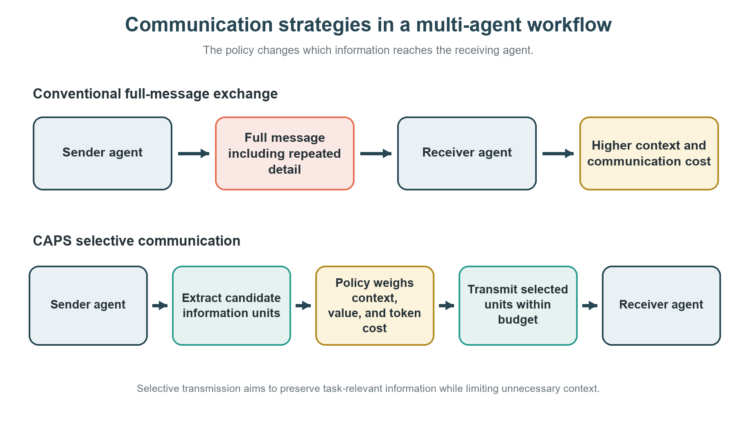
Figure 2.1. Existing and proposed communication approaches

CHAPTER 3
LITERATURE SURVEY

3.1 Multi-Agent LLM Systems
Research on LLM-based agents has explored role specialization, planning, tool use, memory, critique and iterative collaboration. Frameworks such as AutoGen describe conversations among agents and support configurable control flow. LangGraph emphasizes stateful orchestration through graph-based execution. These systems establish practical infrastructure for multi-agent applications. For CAPS, the key implication is that a policy can be implemented as a layer over orchestration rather than requiring a replacement for the underlying agent runtime.
Multi-agent systems introduce challenges that do not appear in isolated prompting: agents can hold inconsistent beliefs, duplicate work, propagate errors, and use different amounts of context. Communication protocols therefore influence both the quality of the final result and the resources consumed. A useful policy should account for the receiver's role and current state, not just the sender's desire to provide a complete response.

3.2 Communication and Coordination
Communication strategies in distributed systems often balance bandwidth, timeliness, redundancy and reliability. Although LLM agents communicate using natural-language messages rather than only fixed packets, the general principle remains relevant: the value of a message depends on what the receiver needs, what is already known, and what decision follows. Natural-language communication adds uncertainty because messages may be verbose, ambiguous or partially incorrect.
Debate, critique and reflection patterns use additional messages to improve reasoning or verification. These methods suggest that some communication has substantial value, especially when independent review can catch errors. However, more rounds do not necessarily imply better results. CAPS therefore treats communication volume as a variable to measure and optimize jointly with task performance, rather than assuming that either maximum or minimum communication is always preferable.

3.3 Contextual Bandits and Adaptive Policies
A contextual bandit observes context, selects an action and receives a reward. Unlike a full reinforcement-learning formulation, a basic contextual bandit does not model the entire sequence of environment transitions. This can make it a useful initial formulation when the decision of interest is a local communication choice and feedback can be assigned to that choice or to a short episode.
LinUCB estimates expected reward using a linear model over context features and uses an uncertainty term to balance exploitation and exploration. In CAPS, the action may correspond to a message handling strategy, and context features may describe novelty, estimated relevance, uncertainty, receiver role, task stage, token cost and prior communication. This formulation is a proposal requiring validation: natural-language agent interactions are non-stationary, rewards can be delayed, and feature estimates may be imperfect.
The reward design must avoid pathological behavior. A token-only reward encourages silence; a task-success-only reward may encourage unlimited communication. A combined reward can penalize communication cost while preserving a minimum emphasis on task quality. Results should additionally report each metric separately so the scalar reward cannot conceal a quality regression.

3.4 Evaluation of Agentic Systems
Evaluating agentic systems is difficult because outcomes depend on task sampling, model versions, prompts, tool availability, stopping criteria and judge reliability. A reproducible evaluation should record the exact task set, model identifier, system prompts, temperature or sampling settings, tool traces, token usage and error cases. When automated judges are used, their rubric and known limitations should be documented; a subset of examples should be reviewed manually where feasible.
For CAPS, evaluation should compare policies on the same tasks and, wherever possible, use matched seeds and model settings. Reporting only average task success is insufficient. The protocol should include communication tokens, message count, end-to-end latency and task success, together with variation across runs. Improvements should be described as empirical observations within the tested setting, not as universal guarantees.

3.5 Comparative Summary
Research area | Representative work or system | Relevance to CAPS | Boundary / open issue
Agent conversation frameworks | AutoGen [1] | Provides configurable multi-agent communication | Framework capability does not establish learned communication efficiency
Stateful orchestration | LangGraph documentation [2] | Provides graph/state-based execution patterns | Routing logic may remain manually specified
LLM agent reasoning | ReAct [3] | Interleaves reasoning and action | Does not directly optimize inter-agent message cost
Multi-agent debate | Du et al. [4] | Shows iterative communication can affect reasoning outcomes | Additional rounds may increase cost and are task-dependent
Contextual bandits | Li et al. [5] | Provides contextual action-selection foundation | Reward and feature assumptions need empirical validation
LLM evaluation | HELM [6] | Motivates multi-dimensional and transparent evaluation | CAPS requires task-specific metrics and traceability

The literature supports the feasibility of combining agent orchestration with adaptive decision-making, but it does not predetermine that a particular policy will improve outcomes. The proposed evaluation is intended to test this claim directly and transparently.

CHAPTER 4
FEASIBILITY STUDY AND REQUIREMENTS

4.1 Technical Feasibility
The project is technically feasible as a software research prototype because its primary functions—intercepting communication, extracting metadata, selecting an action, recording usage and computing evaluation metrics—can be implemented in Python around an existing LLM agent workflow. The proposed policy does not require training a foundation model. It does require a stable orchestration interface, access to message content or metadata, and a method for collecting usage and task outcome signals.
The initial prototype can use synthetic or deterministic tasks to validate policy logic before calling external models. This staged design separates software correctness from model cost. A small contextual bandit can be trained from logged episodes, while the policy interface can be tested with mocked agent responses. A real-LLM pilot can follow only after rate limits, costs and reproducibility controls are defined.

4.2 Operational Feasibility
The system is intended for research and evaluation rather than immediate production deployment. Its operation can be organized into independent modules: task runner, agent adapter, CIU extractor, context builder, policy selector, communication controller, reward logger and analysis scripts. Modular boundaries support debugging and permit baseline policies to share the same execution pipeline.
Operational risks include model API outages, rate limits, changing model behavior, incomplete token metadata and non-deterministic task outcomes. These risks can be managed through retry limits, structured logs, checkpointed runs, cached responses where methodologically appropriate, and clear separation of exploratory pilot results from the final evaluation.

4.3 Economic Feasibility
The main cost drivers are model API tokens, repeated evaluation episodes, storage and compute time. A free or low-cost tier may support early development but should not be assumed to support a complete large-scale study. The experiment matrix should therefore be staged: unit tests and synthetic tasks first, a small pilot second, and a bounded final evaluation only after resource consumption is measured.
Cost feasibility should be reported using actual input and output tokens, model pricing applicable at execution time, number of episodes and retries. If external API use is unavailable, the system can still validate structural behavior with mock agents, but such results must not be presented as evidence of real-LLM task performance.

4.4 Software Requirements
Component | Proposed requirement | Purpose
Language | Python 3.10+ (confirm environment at implementation) | Core prototype and experiment scripts
Agent framework | Adapter for selected framework, e.g. LangGraph or AutoGen | Orchestrate agents and intercept messages
LLM access | Provider API or locally available model; exact model to be recorded | Generate agent outputs
Policy module | NumPy or equivalent lightweight numerical implementation | Contextual policy and LinUCB calculations
Data handling | JSONL/CSV and SQLite where useful | Persist traces, rewards and configuration
Analysis | pandas, NumPy, matplotlib | Aggregate metrics and create plots
Testing | Python unittest/pytest, depending on selected environment | Unit tests and regression checks
Version control | Git | Track code and configuration revisions

4.5 Hardware Requirements
A standard development computer is sufficient for orchestration, policy computation, logging and analysis. If remote model APIs are used, local GPU hardware is not a strict requirement for inference. If a local model is selected, memory and accelerator requirements depend on model size and quantization. The final report should record the actual processor, memory, operating system, runtime, model deployment and network assumptions used in experiments.
Resource | Minimum planning assumption | Notes
CPU | Modern multi-core processor | Adequate for orchestration and lightweight policy updates
RAM | 8 GB or more recommended for development | Actual requirement depends on framework and log volume
Storage | Several GB available for logs, cached responses and artifacts | Retain raw traces and summarized metrics separately
Network | Stable connection for hosted model APIs | API latency and outages affect end-to-end measurements
GPU | Optional for API-hosted models | Required only if selected local model demands it

4.6 Functional Requirements
ID | Requirement
FR-01 | The system shall load a documented task set and execute a defined multi-agent workflow.
FR-02 | The system shall intercept eligible communication events and preserve sender, receiver, task stage and message metadata.
FR-03 | The system shall represent candidate message content using a documented CIU schema or equivalent structured representation.
FR-04 | The system shall construct context features using only information available at the time of the communication decision.
FR-05 | The system shall support baseline communication policies and the candidate adaptive policy through a common interface.
FR-06 | The system shall record selected actions, estimated costs, observed usage and task outcomes.
FR-07 | The system shall compute task success, token use, message count and latency from recorded traces where available.
FR-08 | The system shall export raw episode traces and aggregate summaries for reproducibility.
FR-09 | The system shall support configuration of seeds, model identifiers, policy parameters and experiment budgets.
FR-10 | The system shall distinguish missing measurements from zero-valued measurements.

4.7 Non-Functional Requirements
ID | Requirement
NFR-01 Reproducibility | Every run shall record configuration, code revision, model identifier, task identifiers and random seeds where applicable.
NFR-02 Observability | Each policy decision shall be traceable to its context, action and subsequent reward or outcome.
NFR-03 Fairness | Baselines shall use comparable tasks, prompts, model settings, stopping rules and evaluation criteria.
NFR-04 Efficiency | Policy computation and logging overhead shall be measured separately from model inference costs.
NFR-05 Robustness | The system shall handle API failures, malformed outputs, missing usage fields and retry exhaustion.
NFR-06 Modularity | Agent adapter, policy, reward computation and evaluation shall be separable components.
NFR-07 Integrity | The report shall distinguish planned work, completed implementation and experimentally supported claims.
NFR-08 Privacy | Sensitive inputs and credentials shall not be written to public logs or source control.

4.8 Risks and Mitigations
Risk | Potential effect | Mitigation
Noisy reward signal | Policy learns unstable communication choices | Use repeated episodes, explicit rubrics and separate metrics
Token metadata unavailable | Cost comparison becomes incomplete | Record provider usage where available and flag estimates
API rate limits or budget | Incomplete experiment matrix | Stage evaluation, cap retries and checkpoint runs
Policy overfits task set | Poor generalization | Separate development/validation/test tasks
Inconsistent baselines | Unfair comparison | Use shared runner and matched settings
Judge bias | Misleading task-success estimates | Document rubric and manually inspect a subset
Framework changes | Reproduction failures | Pin versions and record environment metadata
Information loss from compression | Task quality degrades | Compare full-send, summary and CIU-select actions

CHAPTER 5
PROPOSED METHODOLOGY

5.1 System Overview
CAPS is proposed as a policy layer between a message-producing agent and its recipient. The layer does not replace the agents' reasoning process; it decides how candidate information is delivered. A typical episode begins with a task specification, launches agents under a defined workflow, observes a candidate message, constructs CIUs and context features, selects a communication action, and records the subsequent outcome.
The conceptual architecture contains six components: (1) task and orchestration runner, (2) agent adapter, (3) CIU extraction and scoring, (4) context builder, (5) communication policy and controller, and (6) trace logger and evaluator. These components should expose stable interfaces so that baseline and adaptive policies can be compared without changing the rest of the workflow.
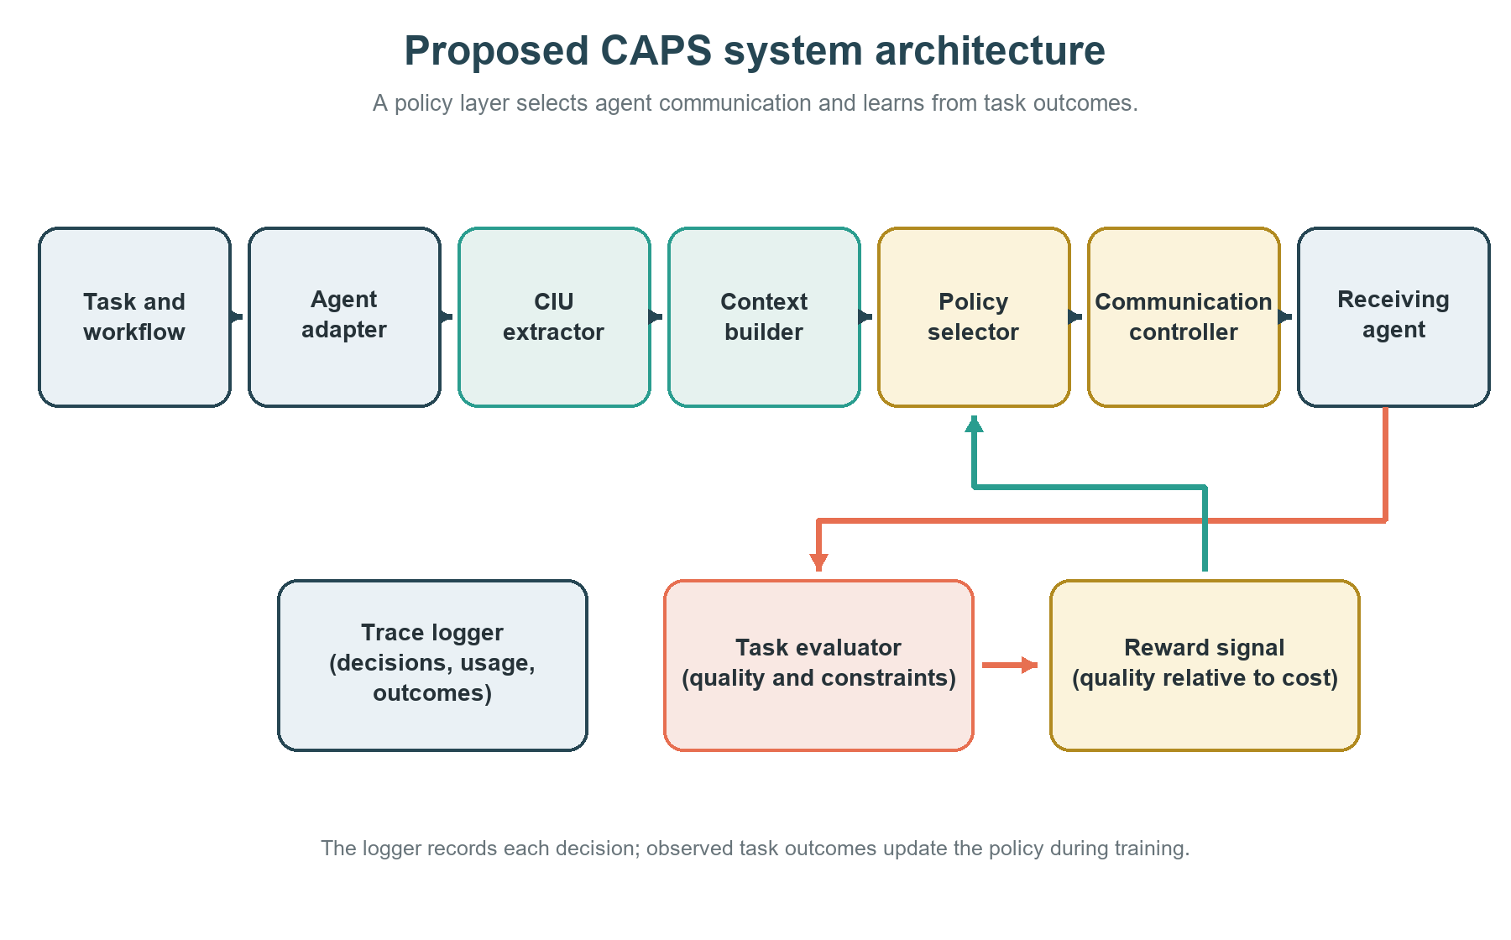
Figure 5.1. Proposed CAPS system architecture
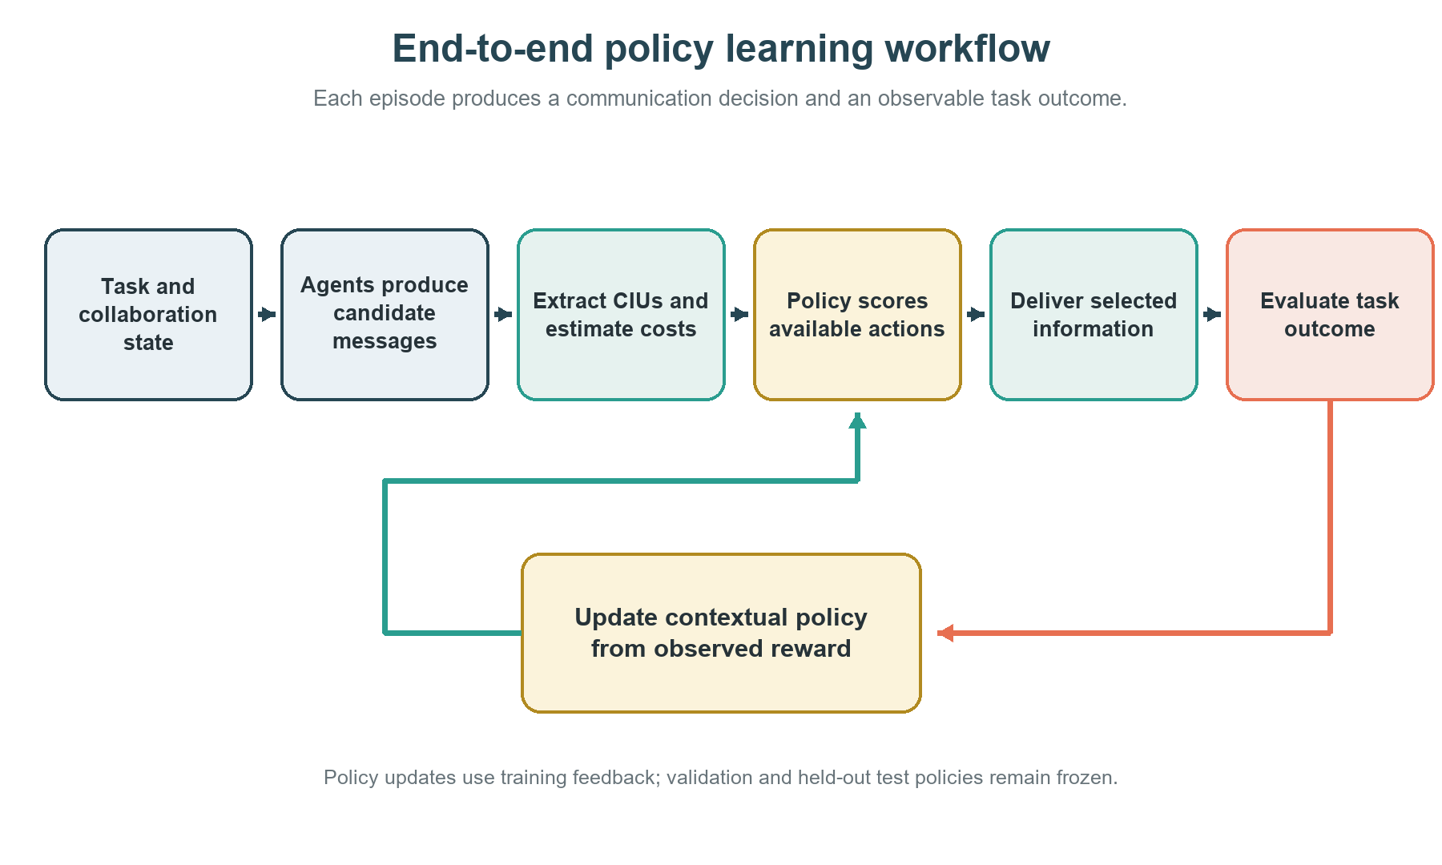
Figure 5.2. End-to-end policy learning workflow

5.2 Contextual Information Units
A contextual information unit is a candidate fact, constraint, result, decision, unresolved question or instruction that may affect the receiver's next action. CIUs are intended to make message selection more granular than sending or dropping an entire paragraph. In the initial prototype, CIUs may be extracted by deterministic rules, structured agent outputs or an LLM-based parser. The chosen extraction method must be fixed and recorded during comparative experiments.
Field | Description | Example
ciu_id | Stable identifier within an episode | task17_agentA_msg03_ciu02
content | Atomic information statement | The requested output must be valid JSON
source | Agent, tool or document that produced it | Planner agent
relevance | Estimated relation to receiver's current subtask | High / medium / low or numeric score
novelty | Whether the receiver already has equivalent information | New / repeated / uncertain
confidence | Confidence or evidence status | Observed / inferred / unverified
urgency | Whether delay could block the next action | Immediate / normal / deferrable
estimated_tokens | Estimated cost of transmitting the CIU | Token count if available
provenance | Reference to source trace or tool result | Message/tool event identifier

CIU extraction can introduce errors, including splitting a condition from its qualification or misclassifying a hypothesis as a fact. The prototype should preserve the original message and link each CIU back to its source. When extraction confidence is low, the policy may default to sending the full message or using a conservative action.

5.3 Context Representation
At decision step t, the policy observes a context vector x_t. Candidate features include sender and receiver roles, task stage, estimated relevance, novelty, confidence, urgency, message length, recent communication frequency, prior action outcomes and current budget remaining. Features must be available before the action is chosen; future information or the final task result must not leak into the decision context.
Categorical features may be encoded using one-hot vectors or compact integer mappings, while continuous features may be normalized using statistics computed from training or development episodes. Missing values should be explicitly represented. The initial feature set should remain small enough to inspect and debug. Feature ablations can later test whether relevance, novelty or cost estimates materially affect policy behavior.

5.4 Communication Policy
The initial policy candidate is LinUCB, which estimates the expected reward of each available action from contextual features and includes an uncertainty bonus. At each eligible event, the policy scores each action, selects an action under the configured exploration rule, and records both the score and selected action. A deterministic evaluation mode may choose the highest-scoring action after training; exploration settings must be reported.
Candidate actions are: A1 send the full message; A2 send a concise summary; A3 send only selected CIUs; A4 defer communication until a defined checkpoint; and A5 suppress transmission when content is redundant and nonessential. The action set is a design proposal and may be simplified if the selected framework cannot safely support all actions. Safety-critical constraints, explicit task requirements and required tool outputs must override cost-minimizing suppression.
Action | Communication behavior
A1 Full message | Transmit the complete candidate message.
A2 Summary | Transmit a concise summary of the candidate message.
A3 Selected CIUs | Transmit only the selected contextual information units.
A4 Defer | Hold communication until a defined checkpoint.
A5 Suppress | Withhold a candidate message when it is redundant and nonessential.
Table 5.2 Candidate policy actions
For a linear contextual bandit, the estimated reward for action a may be represented as a linear function of the context features. The upper-confidence score combines the estimated mean with an uncertainty term. The implementation should document feature construction, regularization, exploration coefficient, update timing and reward attribution. The method should be treated as a candidate to test, not as a guaranteed optimum.
score(a, x) = estimated_reward(a, x) + exploration_bonus(a, x)

5.5 Reward and Cost Model
The reward should represent the value of collaboration while accounting for resource consumption. One candidate formulation is a weighted utility combining task outcome and normalized communication cost. Let Q denote task quality, C the communication cost and λ the cost weight. A candidate episode reward is R = Q − λC, with Q and C normalized and defined before final testing. The exact formulation and λ must be selected on development data, documented in configuration, and accompanied by separate reporting of Q and C.
R = Q − λC
Communication cost may include input/output tokens attributable to inter-agent messages, message count and communication-related latency. These measures should not be conflated: token counts are a resource proxy, message count reflects interaction frequency, and wall-clock latency includes model service and orchestration effects. When provider token usage is unavailable, estimates should be labeled as estimates.
Reward attribution is a central methodological issue. If only a final task score is available, multiple earlier communication decisions may contribute to the same outcome. The first version should use episode-level feedback with a clearly stated attribution rule and analyze sensitivity to that choice. If feasible, intermediate receiver judgments or controlled ablations can provide additional evidence, but should not be mistaken for objective ground truth.

5.6 Experimental Design
The evaluation will proceed in stages. Stage 1 validates CIU parsing, action execution and logging on synthetic tasks. Stage 2 compares communication baselines on a small pilot set to estimate API cost, failure rate and runtime. Stage 3 trains or updates the adaptive policy using development episodes. Stage 4 evaluates frozen policies on held-out tasks and reports metrics with uncertainty estimates. Stage 5 performs ablations and qualitative error analysis if resources permit.
Baseline / method | Communication behavior | Purpose
B1 Unrestricted | Send messages according to the original workflow without CAPS filtering | Reference for task quality and upper-end communication usage
B2 Fixed budget | Apply a fixed message or token budget | Tests predictable resource limitation
B3 Heuristic | Use predefined relevance/novelty thresholds or role rules | Tests a transparent non-learning policy
B4 Random constrained | Choose among eligible actions under the same budget | Sanity-checks whether learned choices beat arbitrary selection
M1 CAPS-LinUCB | Select action using contextual estimates and exploration | Candidate adaptive policy
Ablation 1 | CAPS without selected context features | Tests contribution of feature groups
Ablation 2 | Alternative reward weights or cost normalization | Tests sensitivity to utility design

Tasks should be split into development/validation and held-out evaluation sets. Hyperparameters must not be selected using the final test outcomes. Where feasible, all methods should run on the same task instances and matched seeds. Any deviations caused by API failures, model availability or budget limits must be logged and disclosed.
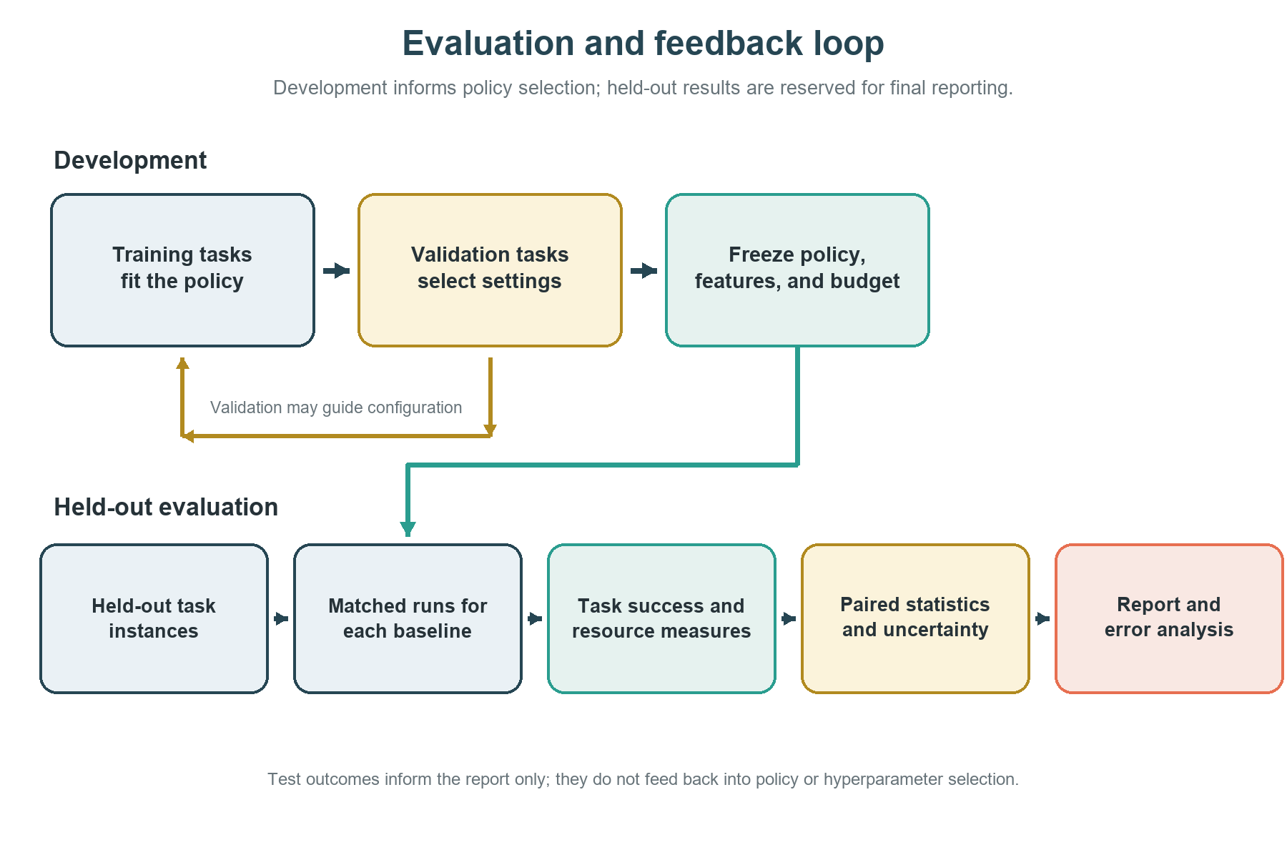
Figure 5.3. Proposed evaluation and feedback loop

5.7 Evaluation Metrics
Metric | Definition / reporting rule | Interpretation
Task success | Fraction of tasks meeting a predefined success criterion | Primary quality measure
Task quality score | Rubric-based score, if binary success is insufficient | Captures partial correctness; report rubric
Communication tokens | Input/output tokens attributable to inter-agent messages | Direct resource proxy when provider data exists
Message count | Number of inter-agent message events | Measures interaction frequency
End-to-end latency | Elapsed time from task start to final result | Includes model service and orchestration
Success per 1,000 tokens | Task successes normalized by communication token use | Efficiency view; report with raw metrics
Failure rate | Fraction of episodes failing due to task or infrastructure errors | Separates system reliability from task quality
Policy action distribution | Frequency of full-send, summary, CIU-select, defer and suppress | Shows learned behavior and possible collapse
Uncertainty | Confidence intervals or variation across repeated runs | Avoids overinterpreting small differences

5.8 Validation and Reproducibility
- Record repository revision, package versions, model identifiers, prompts, decoding settings, task IDs and random seeds.
- Persist raw messages or appropriately redacted traces, action decisions, token usage, reward values and final outcomes.
- Validate that no future or test-only information enters policy features.
- Run unit tests for each action, including full-send fallback, empty CIU output, malformed metadata and API failure.
- Use the same evaluator rubric across baselines and report missing data explicitly.
- Keep exploratory pilots separate from the frozen final evaluation and document all exclusions.
- Where a model-based judge is used, retain judge prompt/version and manually inspect a sample of decisions and disagreements.

5.9 Ethical and Research Considerations
The project should use authorized datasets and comply with provider terms. API keys must be stored outside source control. Logs should avoid retaining personal or confidential information unless there is a clear authorization and research need. The policy must not suppress required safety instructions, critical warnings or task constraints merely to reduce cost. In reporting, the team should distinguish empirical observations from hypotheses and avoid claiming universal efficiency or reliability based on a narrow benchmark.
Reproducibility also requires reporting negative and inconclusive findings. If CAPS reduces token use but lowers task success, both outcomes should be presented. If the policy fails to outperform a heuristic baseline, that is a valid experimental result and should guide future policy design.

CHAPTER 6
EXPECTED OUTCOMES AND PHASE-1 CONCLUSION

6.1 Expected Outcomes
The expected outcome of Phase-1 is a well-specified research plan for learning adaptive communication policies in multi-agent LLM collaboration. The design is expected to produce a modular prototype in Phase-2, but no empirical performance improvement is claimed in this Phase-1 document.
- A formal problem definition for communication decisions under quality and resource constraints.
- A CIU schema and context feature specification that preserve message provenance.
- A baseline suite covering unrestricted, fixed-budget and heuristic communication.
- A contextual bandit policy interface, with LinUCB as the initial candidate.
- A reproducible experiment runner with trace-level logging and configurable budgets.
- An evaluation report comparing task quality, token use, message count, latency and uncertainty.
- A documented account of limitations, failure cases and future extensions.

6.2 Deliverables and Milestones
Phase / milestone | Deliverable | Acceptance evidence
Phase-1: Problem definition | Problem statement, objectives and research questions | Approved report sections
Phase-1: Literature and feasibility | Survey, requirements, risks and resource plan | Cited literature and documented assumptions
Phase-1: Methodology | CIU schema, action space, reward proposal and evaluation protocol | Methodology review by project guide
Phase-2: Prototype | Agent adapter, policy module, logger and baseline runner | Unit tests and sample traces
Phase-2: Pilot | Small-scale feasibility runs | Cost, runtime and failure summary
Phase-2: Final evaluation | Held-out experiments and ablations | Reproducible raw data and analysis
Phase-2: Final reporting | Results, limitations, conclusion and paper submission | Guide-reviewed thesis and conference submission evidence

6.3 Phase-1 Conclusion
This report has defined CAPS as a proposed approach to adapt communication decisions in multi-agent LLM systems. The project is motivated by the tension between information sharing, task quality and communication cost. The proposed methodology represents messages as contextual information units, uses context-dependent action selection and evaluates performance against common communication baselines.
The feasibility study indicates that the research can be pursued as a modular software prototype using existing agent orchestration and model interfaces. The principal risks are noisy reward attribution, API cost, policy overfitting, incomplete usage metadata and unfair baseline comparisons. These risks are addressed through staged experiments, held-out evaluation, transparent metrics and traceable logs. The central research question remains empirical and will be answered only after the Phase-2 implementation and evaluation.

6.4 Future Work for Phase-2
Phase-2 should implement the minimum viable pipeline first, validate it with synthetic tasks and then conduct a small real-model pilot. The team should freeze the feature schema and baseline definitions before final evaluation, choose policy hyperparameters without using held-out test outcomes, and retain per-episode traces. Future extensions may compare LinUCB with other contextual policies, investigate delayed reward assignment, incorporate receiver-state estimates, and evaluate generalization across models and task domains.

REFERENCES
[1] Q. Wu et al., “AutoGen: Enabling Next-Gen LLM Applications via Multi-Agent Conversation,” arXiv:2308.08155, 2023. https://arxiv.org/abs/2308.08155
[2] LangChain, “LangGraph Documentation,” official documentation. https://docs.langchain.com/oss/python/langgraph/ (accessed [ACCESS DATE]).
[3] S. Yao et al., “ReAct: Synergizing Reasoning and Acting in Language Models,” International Conference on Learning Representations (ICLR), 2023. https://arxiv.org/abs/2210.03629
[4] Y. Du et al., “Improving Factuality and Reasoning in Language Models through Multiagent Debate,” arXiv:2305.14325, 2023. https://arxiv.org/abs/2305.14325
[5] L. Li, W. Chu, J. Langford and R. E. Schapire, “A Contextual-Bandit Approach to Personalized News Article Recommendation,” Proceedings of the 19th International Conference on World Wide Web, pp. 661–670, 2010. https://doi.org/10.1145/1772690.1772758
[6] P. Liang et al., “Holistic Evaluation of Language Models,” Transactions on Machine Learning Research, 2023. https://arxiv.org/abs/2211.09110
[7] OpenAI, “A Practical Guide to Building Agents,” official resource, [publication/access date to verify]. https://openai.com/business/guides-and-resources/a-practical-guide-to-building-ai-agents/
[8] A. Vaswani et al., “Attention Is All You Need,” Advances in Neural Information Processing Systems, vol. 30, 2017. https://arxiv.org/abs/1706.03762
[9] S. Russell and P. Norvig, Artificial Intelligence: A Modern Approach, 4th ed., Pearson, 2021.
[10] Additional papers on communication-efficient multi-agent LLM systems, information value estimation and contextual policy learning should be added after the final literature search and verified before submission.

APPENDIX A
PROPOSED EXPERIMENT MATRIX
The following matrix is a planning artifact for Phase-2. The number of tasks, repeats, model choices and budgets must be finalized after the pilot and approved by the project guide. It must not be represented as completed experimental work.
Experiment | Policy | Task split | Primary purpose | Status
E1 | Unrestricted | Pilot | Establish baseline quality and cost | Planned
E2 | Fixed budget | Pilot | Measure quality under constrained communication | Planned
E3 | Heuristic | Pilot/development | Establish interpretable baseline | Planned
E4 | CAPS-LinUCB | Development | Train/update policy from contextual feedback | Planned
E5 | Frozen CAPS-LinUCB | Held-out test | Estimate generalization and trade-off | Planned
E6 | Feature ablation | Held-out test | Assess value of context feature groups | Planned
E7 | Reward sensitivity | Validation/test protocol defined in advance | Assess effect of cost weight λ | Planned
E8 | Error analysis | Sample of successes and failures | Identify communication failures and policy pathologies | Planned

A.1 Run-level metadata
- Run identifier and timestamp
- Code revision and dependency versions
- Model provider and exact model identifier
- Prompt and decoding configuration
- Task identifier, split and seed
- Policy name, parameters and action history
- Input/output token usage and latency
- Task outcome, judge rubric and error status
- Excluded episodes and reason for exclusion

APPENDIX B
TRACEABILITY AND SUBMISSION CHECKLIST

B.1 Research traceability
Claim or artifact | Evidence required in Phase-2 | Status in this report
CAPS policy implementation | Source code, unit tests and configuration | Proposed
CIU extraction | Schema, source-linked examples and error analysis | Proposed
Adaptive policy learning | Decision traces and update logs | Proposed
Task success comparison | Per-task outcomes and evaluation rubric | Not yet measured
Communication efficiency | Provider token records or labeled estimates | Not yet measured
Latency comparison | Timestamped run traces under documented conditions | Not yet measured
Generalization | Held-out tasks and repeated runs | Not yet measured
Statistical uncertainty | Confidence intervals or repeated-run variation | Not yet measured

