**Artificial Intelligence:**

AI is a branch of computer science interested in developing intelligent machines that can think and act like humans. Data scientists feed AI machines large sets of data to help train them to identify patterns and work through logical reasoning to mimic human capabilities.   
  
There are 3 proposed stages when it comes to machine learning:

1. Artificial Narrow Intelligence
2. Artificial General Intelligence
3. Artificial Super Intelligence

1**. Artificial Narrow Intelligence: (ANI)**

Machines with ANI have a very limited range in what they can do. They are designed for maybe one or two specific tasks, and they cannot operate outside of their specialized field. This type of AI is also known as ‘weak AI’ – not because they are weak in its capabilities, but because it cannot progress any further than what it was first programmed to do.

Examples of ANI include:

* Self-driving cars and the automation of transport
* Virtual assistants such as Amazon’s Alexa or Apple’s Siri
* [Sybil](https://news.mit.edu/2023/ai-model-can-detect-future-lung-cancer-0120) – a lung cancer detection AI developed by the Massachusetts Institute of Technology
* Chatbots
* Board-game bots like AlphaGo (which beat one of the best Go players in the world in 2016)

**2. Artificial General Intelligence:(AGI)**

The goal for this second of the stages of AI is to solve problems it has not been trained to and work through logical reasoning in rule-based systems to accomplish a task, as a human would. For this reason, AGI is also known as strong AI, as it has uses across multiple areas.

### ****3.** **Artificial Super Intelligence** **(ASI)****

The proposed final stage of evolution hypothesized by AI researchers is the moment when AI becomes self-aware and surpasses the boundaries of human intelligence.

In this moment, which is known as singularity and transcendence, we will either not be able to tell the difference between humans and AI in any way, or we will be completely dependent on machine intelligence to provide direction and prediction.

**Expert Systems:**

An expert system is a computer program that is designed to solve complex problems and to provide decision-making ability like a human expert. It performs this by extracting knowledge from its knowledge base using the reasoning and inference rules according to the user queries.

It is called so because it contains the expert knowledge of a specific domain and can solve any complex problem of that particular domain. These systems are designed for a specific domain, such as **medicine, science,** etc.

The performance of an expert system is based on the expert's knowledge stored in its knowledge base. The more knowledge stored in the KB, the more that system improves its performance.

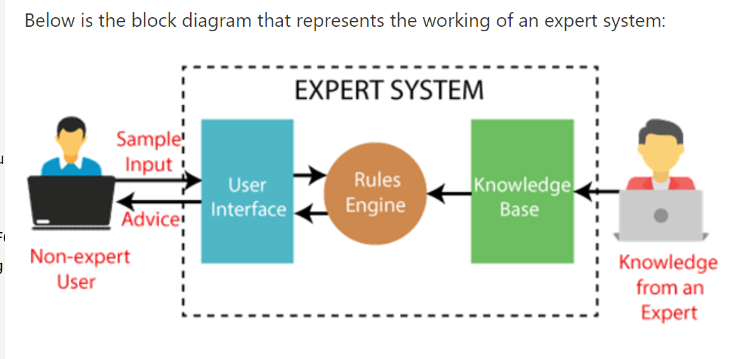

**Below are some popular examples of the Expert System:**

* **DENDRAL:** It was an artificial intelligence project that was made as a chemical analysis expert system. It was used in organic chemistry to detect unknown organic molecules with the help of their mass spectra and knowledge base of chemistry.
* **MYCIN:** It was one of the earliest backward chaining expert systems that was designed to find the bacteria causing infections like bacteraemia and meningitis.
* **PXDES:** It is an expert system that is used to determine the type and level of lung cancer.
* **CaDeT:** The CaDet expert system is a diagnostic support system that can detect cancer at early stages.

**Characteristics of Expert System**

* **High Performance:** The expert system provides high performance for solving any type of complex problem of a specific domain with high efficiency and accuracy.
* **Understandable:** It responds in a way that can be easily understandable by the user. It can take input in human language and provides the output in the same way.
* **Reliable:** It is much reliable for generating an efficient and accurate output.
* **Highly responsive:** ES provides the result for any complex query within a very short period of time.

## Components of Expert System

An expert system mainly consists of three components:

* **User Interface**
* **Inference Engine**
* **Knowledge Base**

**1. **User Interface: I**t is an interface that helps a non-expert user to communicate with the expert system to find a solution.**

****2. Inference Engine:****

**The inference engine is known as the brain of the expert system as it is the main processing unit of the system. It applies inference rules to the knowledge base to derive a conclusion or deduce new information. It helps in deriving an error-free solution of queries asked by the user.**

**There are two types of inference engine:**

**Deterministic Inference engine: The conclusions drawn from this type of inference engine are assumed to be true. It is based on facts and rules.**

**Probabilistic Inference engine:** This type of inference engine contains uncertainty in conclusions, and based on the probability.

Inference engine uses the below modes to derive the solutions:

**Forward Chaining:** It starts from the known facts and rules, and applies the inference rules to add their conclusion to the known facts.

**Backward Chaining:** It is a backward reasoning method that starts from the goal and works backward to prove the known facts.

3. **Knowledge Base** :

The knowledge base is a type of storage that stores knowledge acquired from the different experts of the particular domain. It is considered as big storage of knowledge. The more the knowledge base, the more precise will be the Expert System.

**Components of Knowledge Base**

* **Factual Knowledge:** The knowledge which is based on facts and accepted by knowledge engineers comes under factual knowledge.
* **Heuristic Knowledge:** This knowledge is based on practice, the ability to guess, evaluation, and experiences.

**Knowledge Representation:** It is used to formalize the knowledge stored in the knowledge base using the If-else rules.

**Knowledge Acquisitions:** It is the process of extracting, organizing, and structuring the domain knowledge, specifying the rules to acquire the knowledge from various experts, and store that knowledge into the knowledge base.

**Why Expert Systems: ( NHENCH)**

**1.No memory Limitations:**

1. **High Efficiency:**
2. **Expertise in a domain:**
3. **Not affected by emotions:**
4. **High security:**
5. **Considers all the facts:**

**6. Regular updates improve the performance:**

**Machine Learning**

https://www.ibm.com/topics/machine-learning

****Difference:****

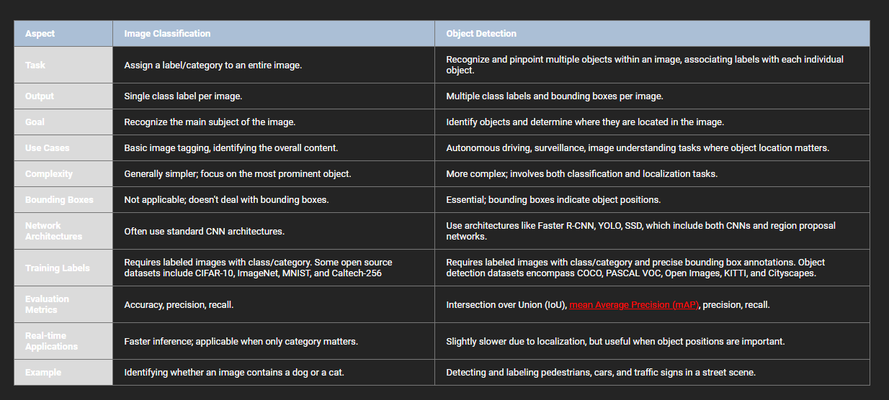

****Similarities :****

