## *Experiment No: 08*

## *Experiment Name:*

## First-Come-First-Served (FCFS) Scheduling Algorithm.

## *Discussion:*

## In this lab we are going to learn about First-Come-First-Served (FCFS) Scheduling Algorithm and we are going to execute its code in c language.

***First-Come-First-Served (FCFS) Scheduling Algorithm:***

First-Come-First-Served algorithm is the simplest scheduling algorithm. Processes are dispatched according to their arrival time on the ready queue. Being a non-preemptive discipline, once a process has a CPU, it runs to completion. The FCFS scheduling is fair in the formal sense or human sense of fairness but it is unfair in the sense that long jobs make short jobs wait and unimportant jobs make important jobs wait. FCFS is more predictable than most of other schemes since it offers time.

***Algorithm:***

1. Start the process

2. Declare the array size

3. Get the number of processes to be inserted

4. Get the value

5. Start with the first process from it’s initial position let other process to be in queue

6. Calculate the total number of burst time

7. Display the values

8. Stop the process

***Source Code:***

#include<stdio.h>

void main()

{

int n,a[10],b[10],t[10],w[10],g[10],i,m;

float att=0,awt=0;

for(i=0; i<10; i++)

{

a[i]=0;

b[i]=0;

w[i]=0;

g[i]=0;

}

printf("Enter the Total number of processes: ");

scanf("%d",&n);

printf("Enter the burst times: ");

for(i=0; i<n; i++)

scanf("%d",&b[i]);

printf("\nEnter the arrival times: ");

for(i=0; i<n; i++)

scanf("%d",&a[i]);

g[0]=0;

for(i=0; i<10; i++)

g[i+1]=g[i]+b[i];

for(i=0; i<n; i++)

{

w[i]=g[i]-a[i];

t[i]=g[i+1]-a[i];

awt=awt+w[i];

att=att+t[i];

}

awt =awt/n;

att=att/n;

printf("\n\tProcess\tWaiting time\tTurn arround time\n");

for(i=0; i<n; i++)

{

printf("\tp%d\t\t%d\t\t%d\n",i,w[i],t[i]);

}

printf("The average waiting time is %f\n",awt);

printf("The average turn around time is %f\n",att);

}

***Output:***

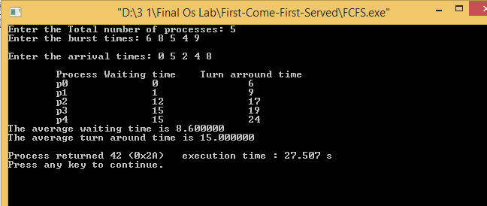

***Discussion:***

FCFS scheme is not useful in scheduling interactive users because it cannot guarantee good response time. One of the major drawback of this scheme is that the average time is often quite long. The First-Come-First-Served algorithm is rarely used as a master scheme in modern operating systems but it is often embedded within other schemes.