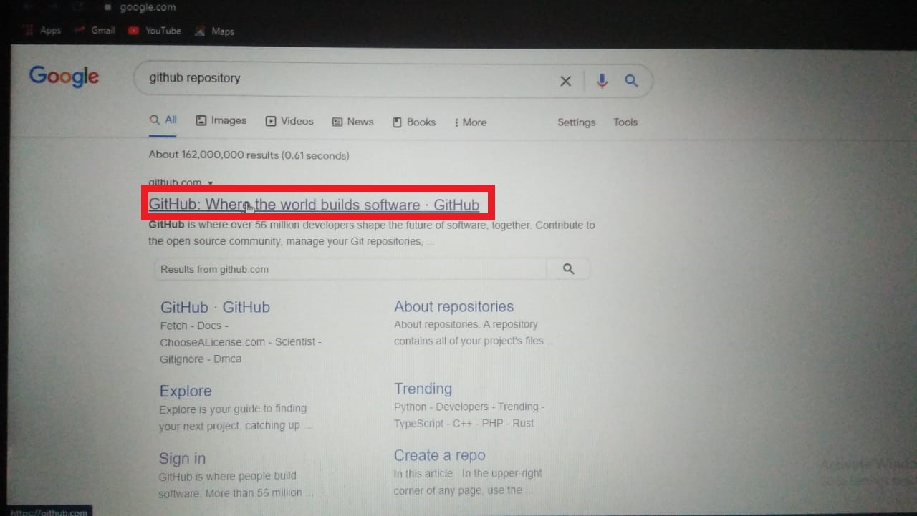

* Create a new Repository on Github.

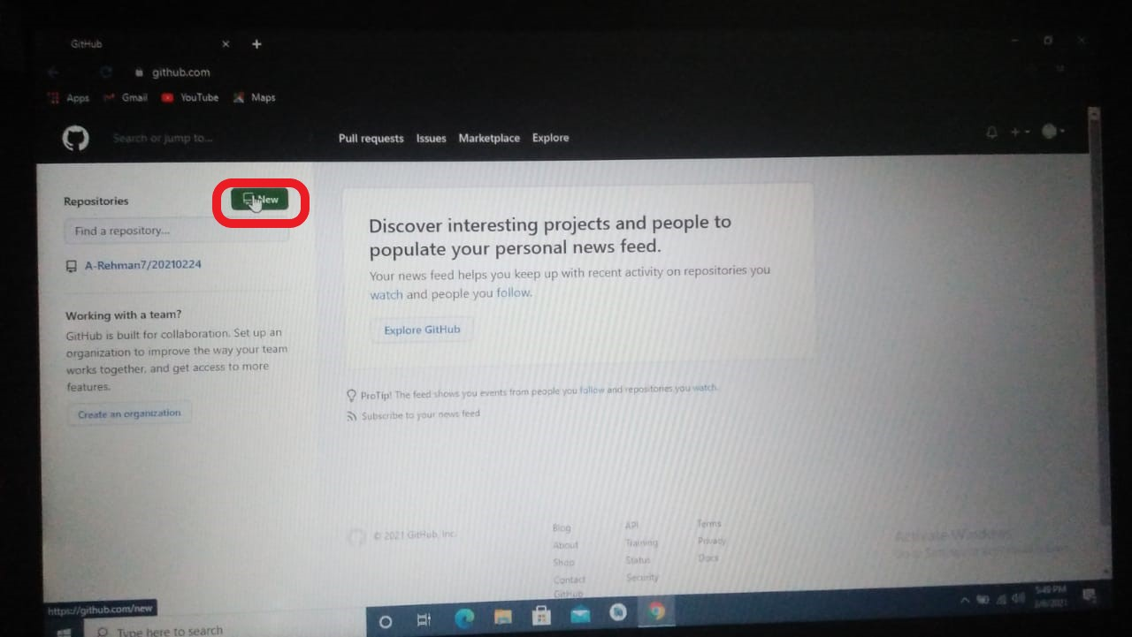

* First of all Open account on Github and click on new to get a new repository.

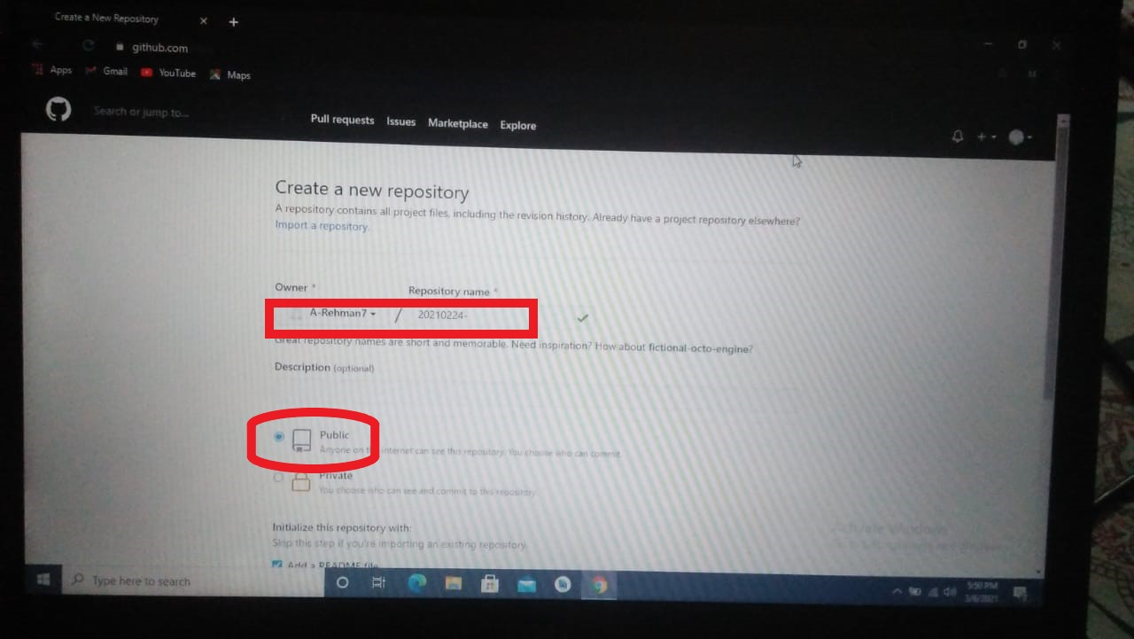

* Enter repository name in the highlighted place
* Click on Public button if you want that your repository is accessed by anyone.

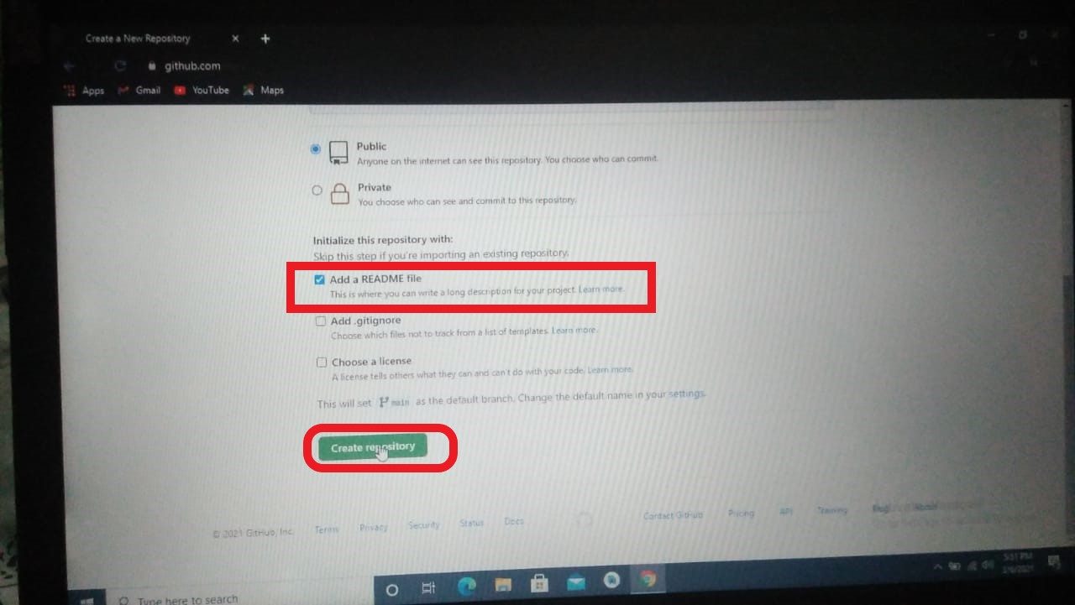

* Check a box of **Add a README file**
* Click on **create repository** button.

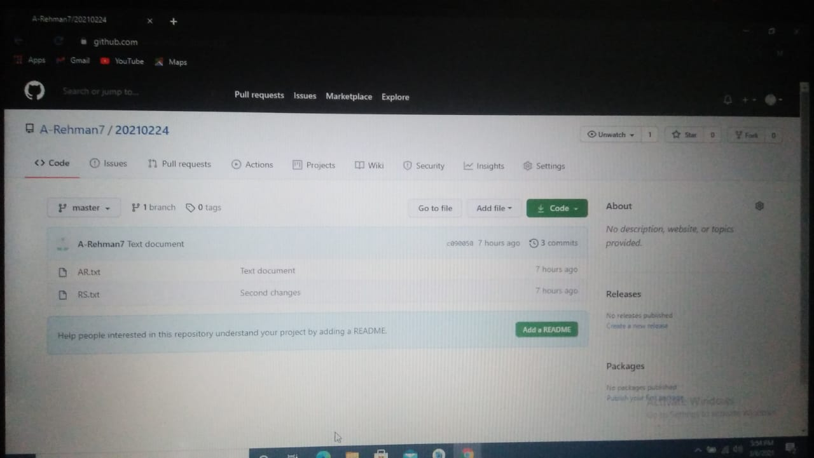

* New repository is created .

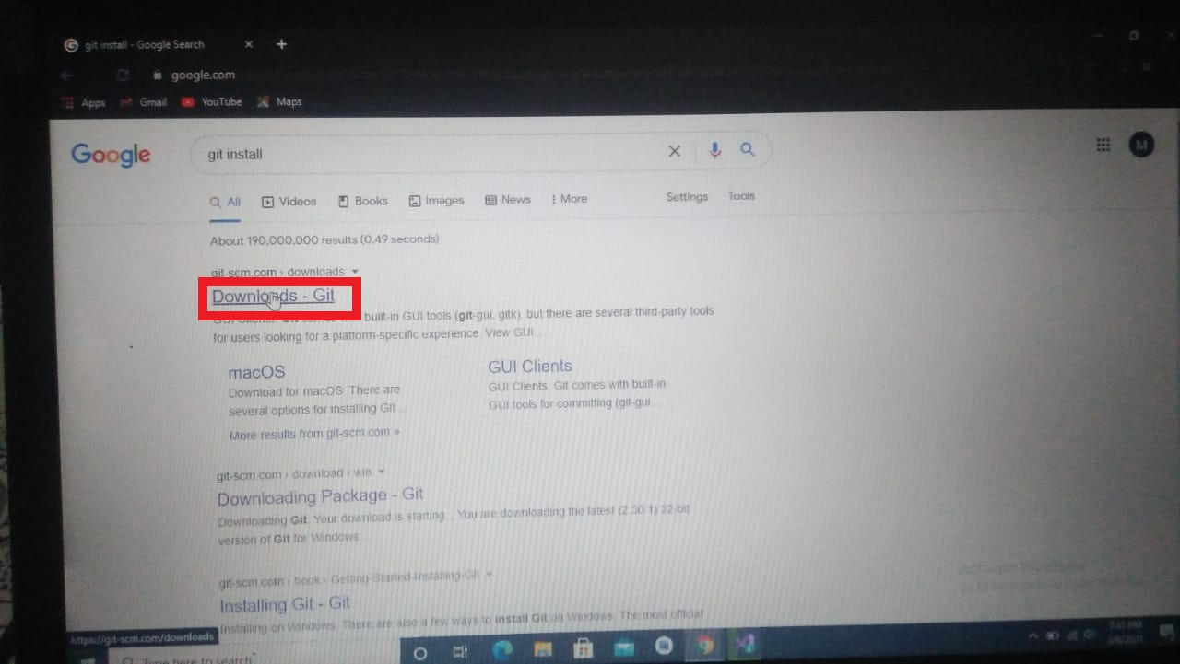

* To install git, type on google git install
* Click on **Downloads-Git** site

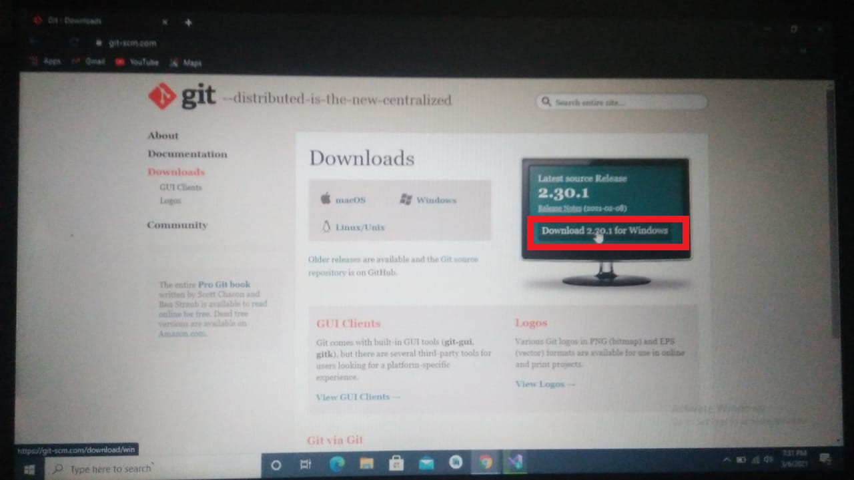

* Click on download button to download latest version of git
* Git installed when you click on download button

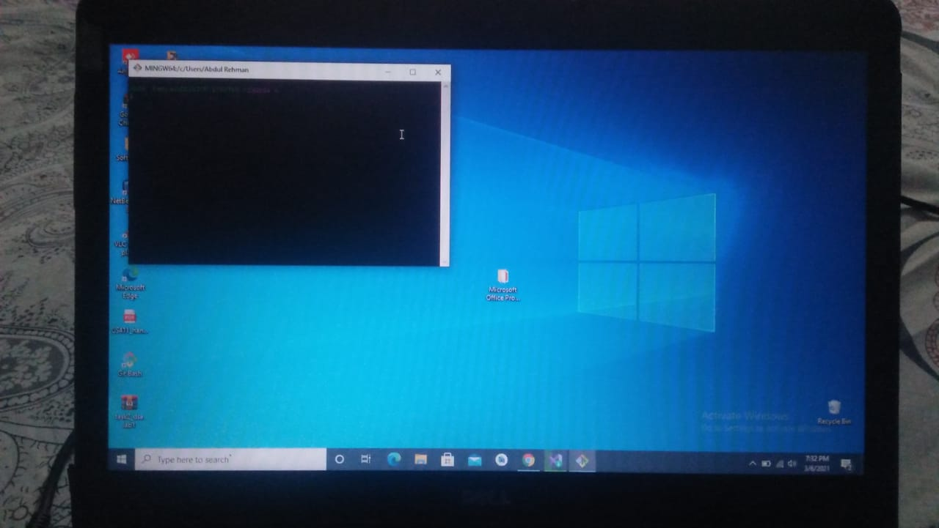

* Git is installed

**DOWNLOAD ANDROID STUDIO**

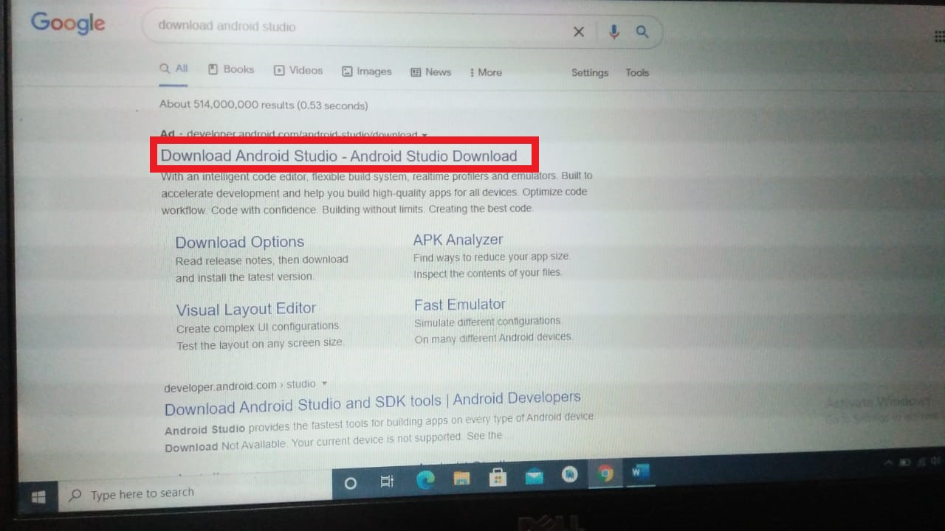

* Click on download android studio latest version

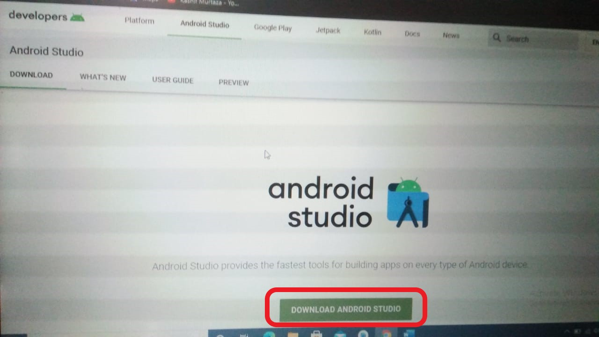

* This window appear and then again click on download android studio

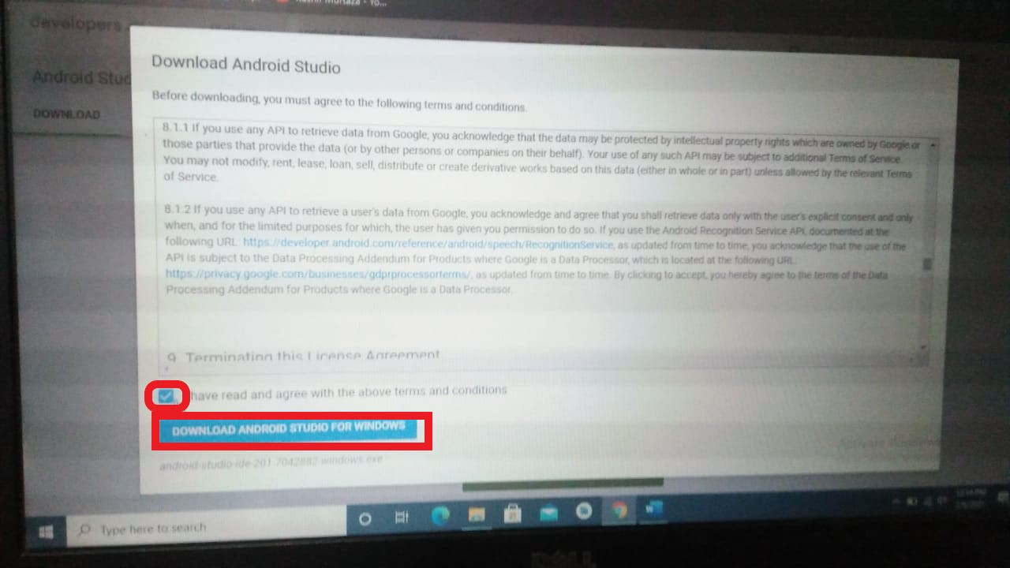

* Check the box that you have agree with the terms and conditions
* Click on download android studio for windows

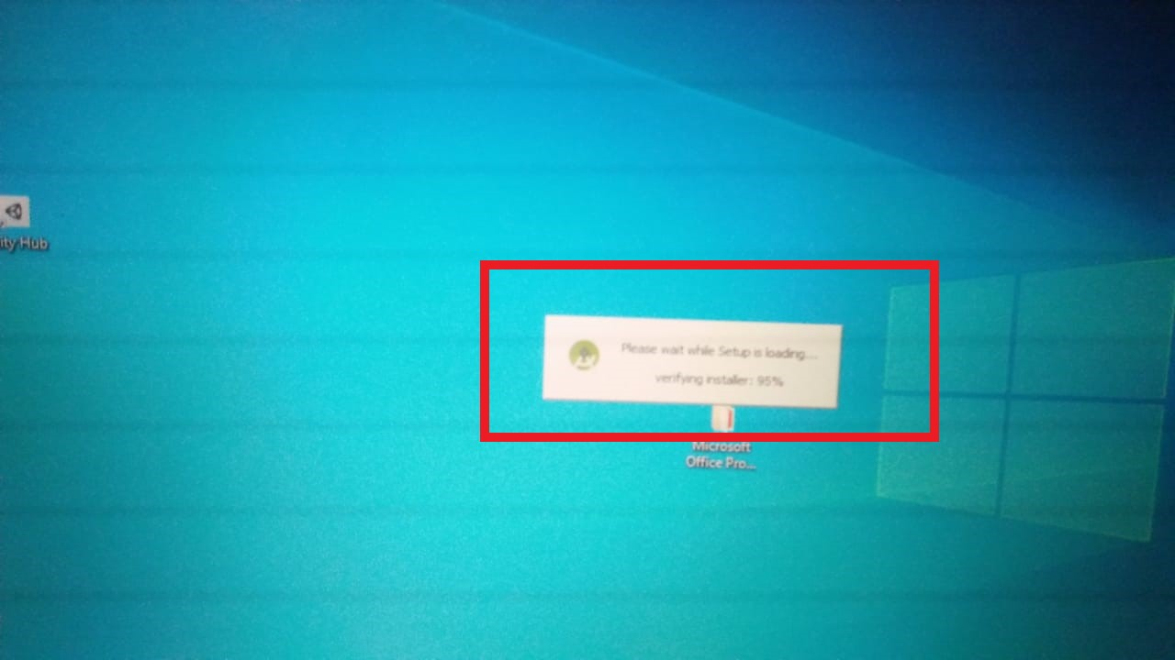

* Setup is starting for installing

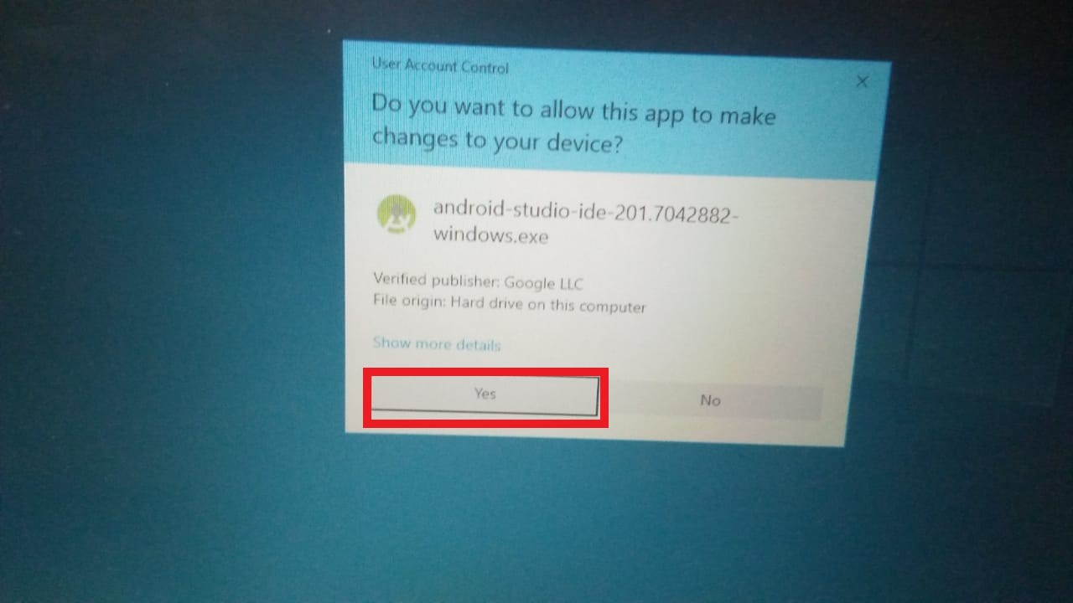

* Click on yes for successfully installing android studio

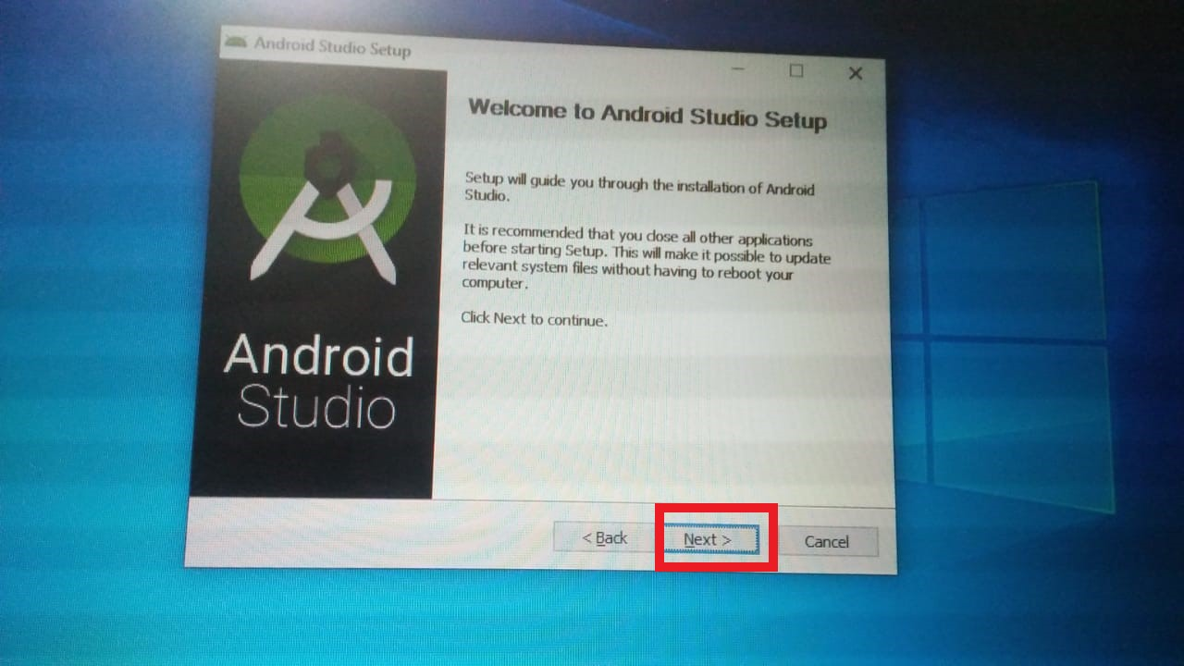

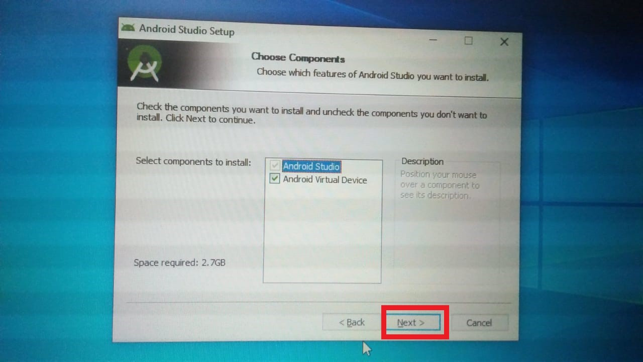

* Click on Next

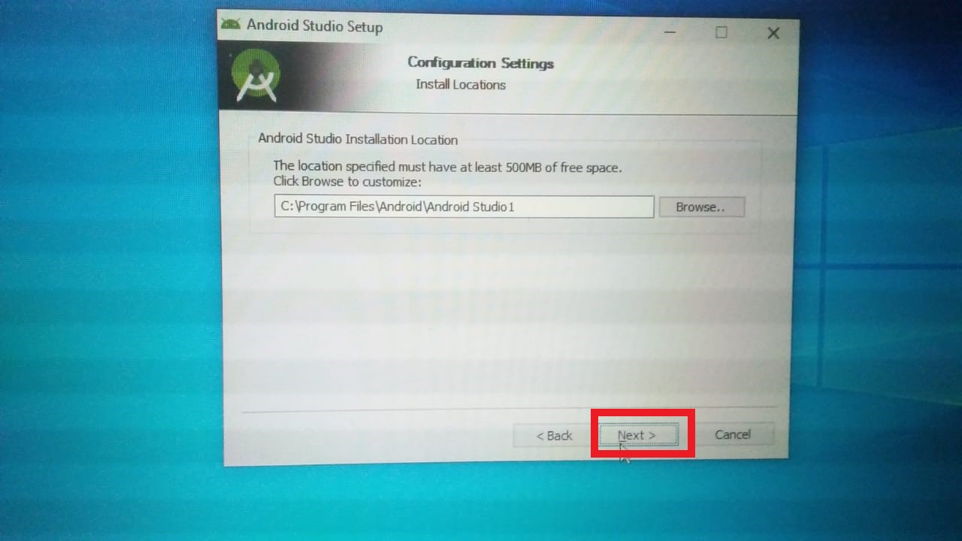

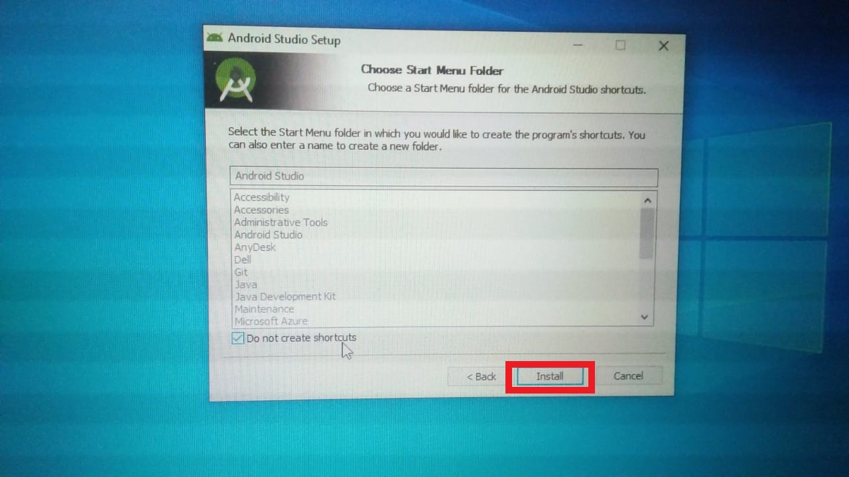

* Click on Install

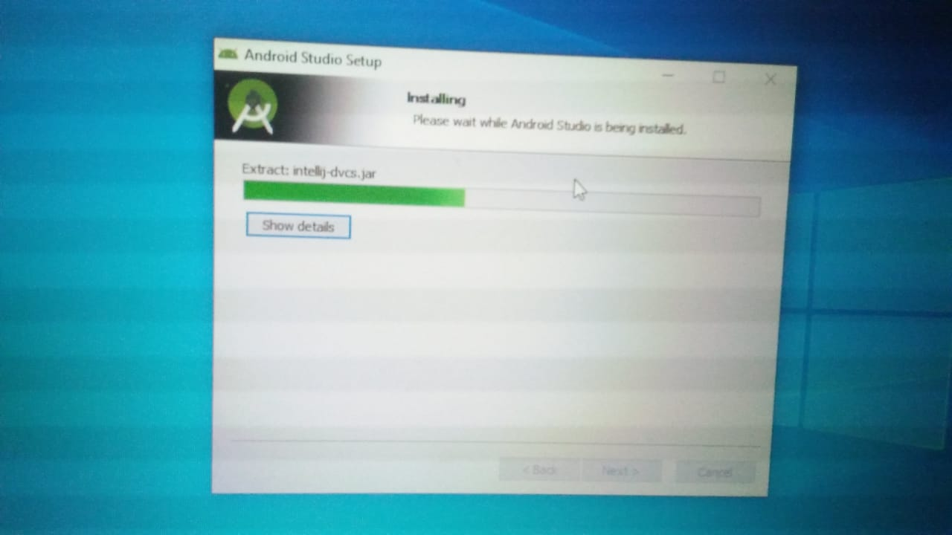

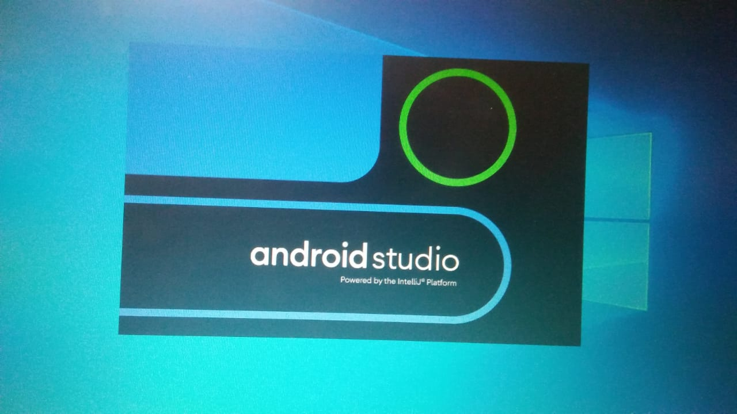

* Android Studio for windows is installed successfully.

Project 1:

**Draw a screen layout of login screen**

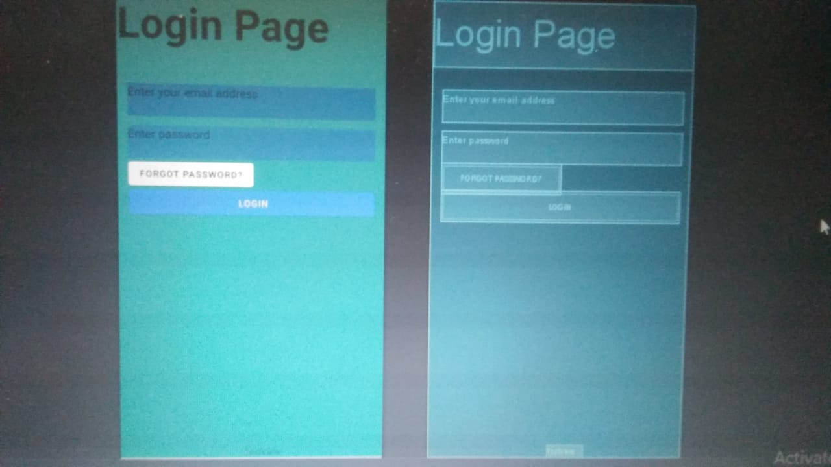

* Take four text boxes
* First text box rewrite from **Login** **Page** and width 410sp and height 70sp and set to top of the screen
* Second text box rewrite from **Enter your email address** and set below the login box having width 370sp and height 70sp
* Third text box rewrite from **Enter your password** and set below the second box having width 370sp and height 70sp
* Fourth text box rewrite from **Forgot Password** and set below the third text box having white background color
* Paste one button on screen and change its text from Login having skyblue background

**Second Screen**

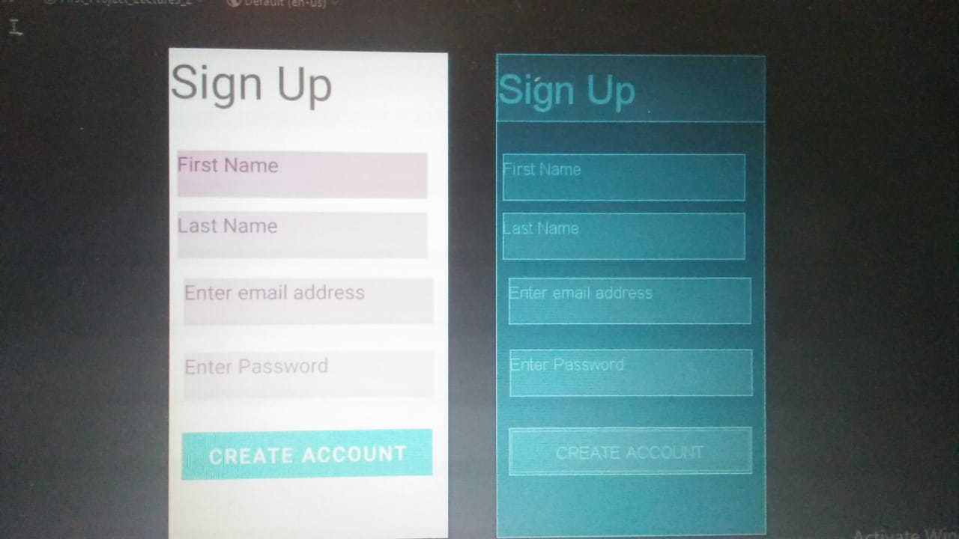

* Take five text boxes
* First text box rewrite from **Sign Up** and width 410sp and height 70sp and set to top of the screen
* Second text box rewrite from **First Name** and set below the signup box having width 370sp and height 70sp
* Third text box rewrite from **Last Name** and set below the second box having width 370sp and height 70sp
* Fourth text box rewrite from **Enter your email address** and set below the third text box having width 370sp and height 70sp
* Fifth text box rewrite from **Enter your password** and set below the fourth text box having width 370sp and height 70sp
* Paste one button on screen and change its text from **CREATE ACCOUNT** having sky blue background

**Third Screen**

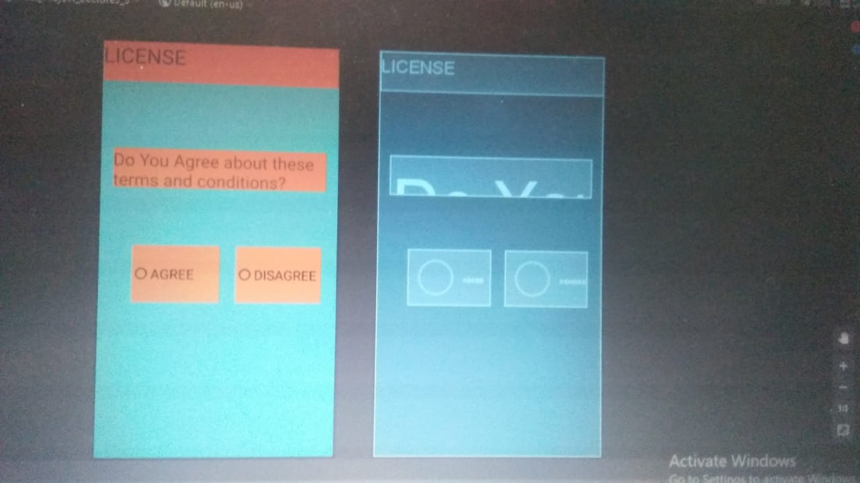

* Take two text boxes
* First text box rewrite from **LICENSE** and width 410sp and height 70sp and set to top of the screen having color number FFAA6C2A
* Second text box rewrite from **Do you agree about these terms and conditions** and set below the license box having width 370sp and height 70sp having color number FFAA6C2A
* Take two radio buttons which set to the parallel of each other with names of **AGREE** and **DISAGREE** having color number FFAA6C2A