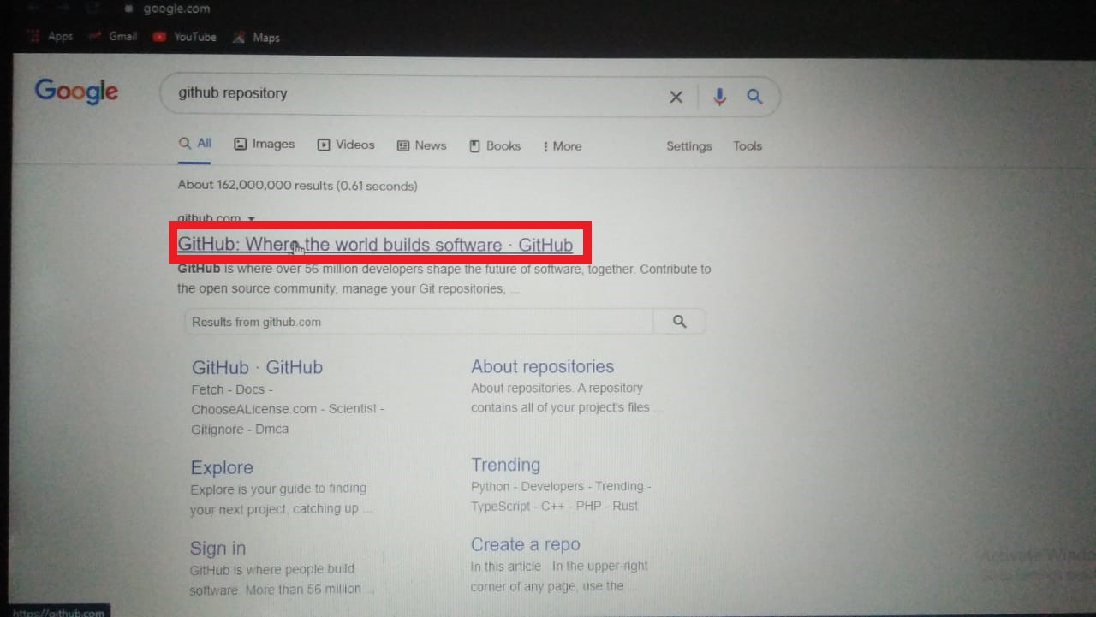

* Create a new Repository on Github.

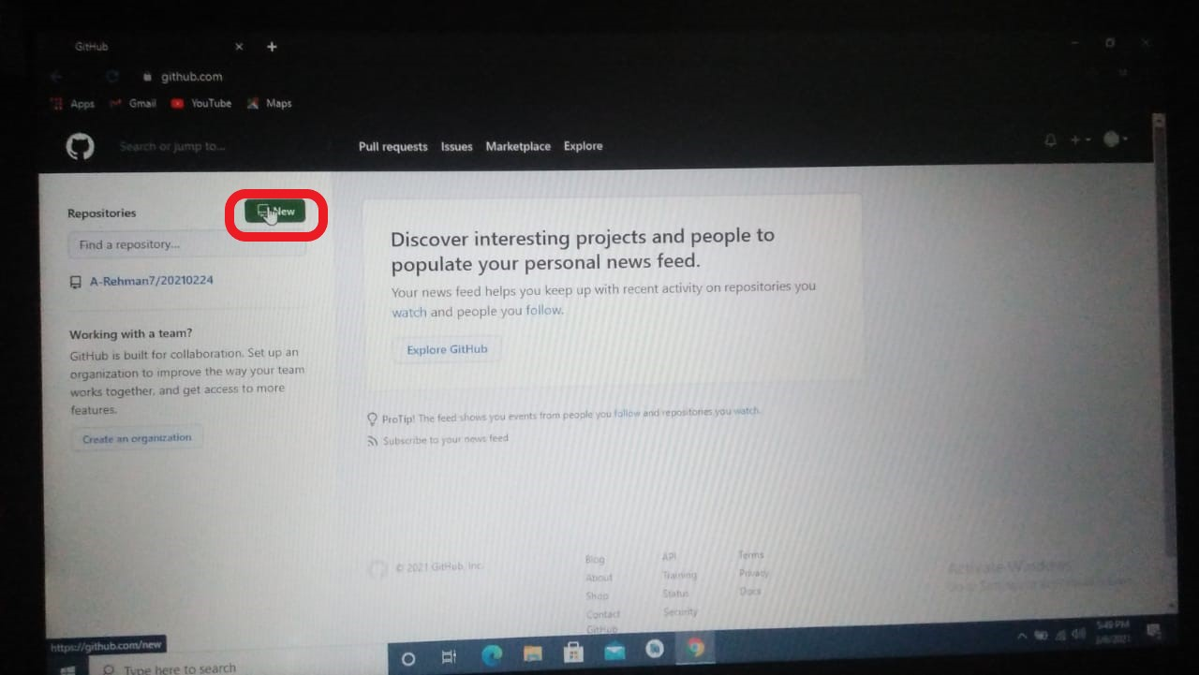

* First of all Open account on Github and click on new to get a new repository.

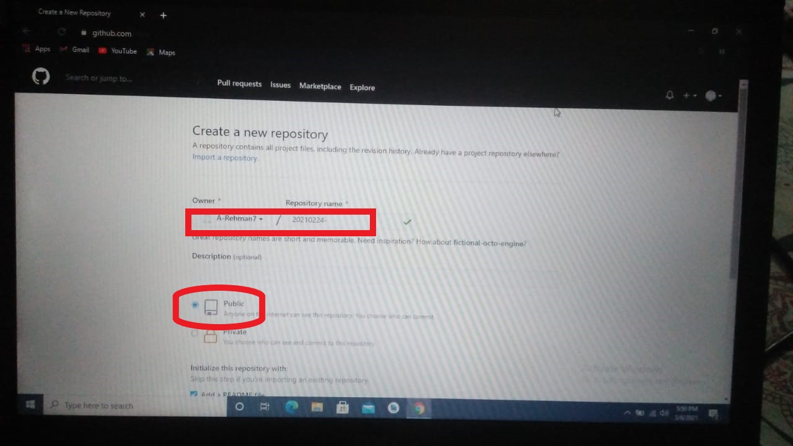

* Enter repository name in the highlighted place
* Click on Public button if you want that your repository is accessed by anyone.

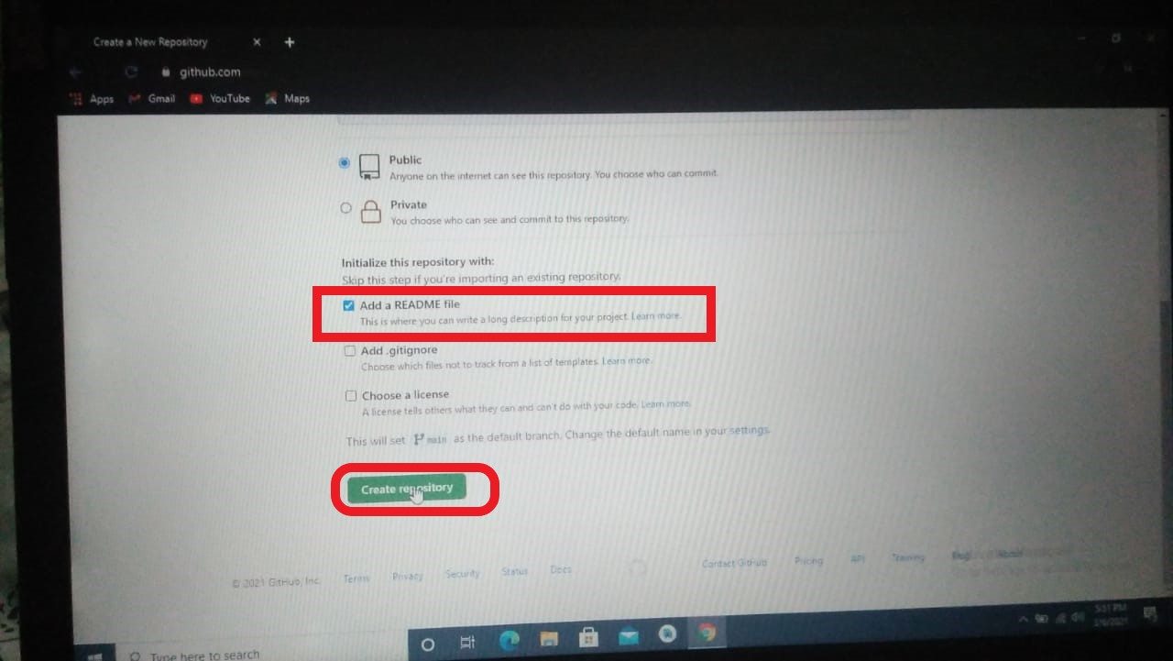

* Check a box of **Add a README file**
* Click on **create repository** button.

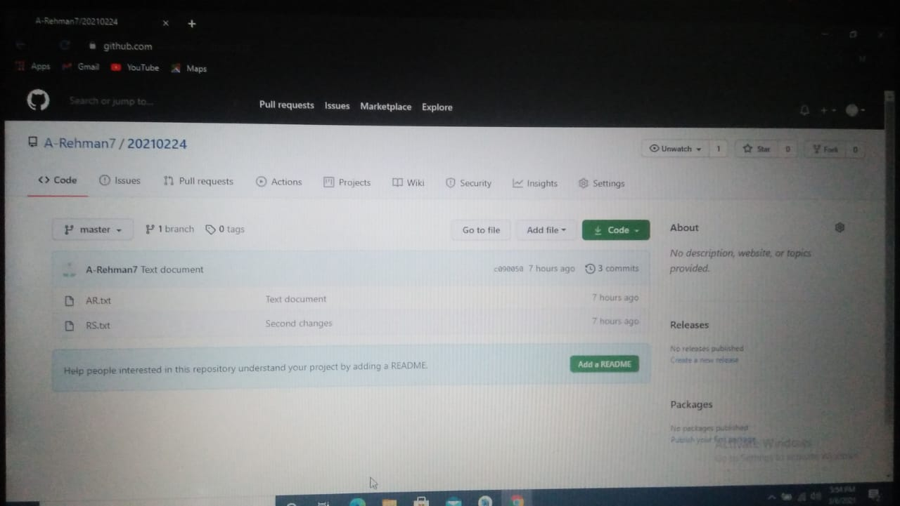

* New repository is created .

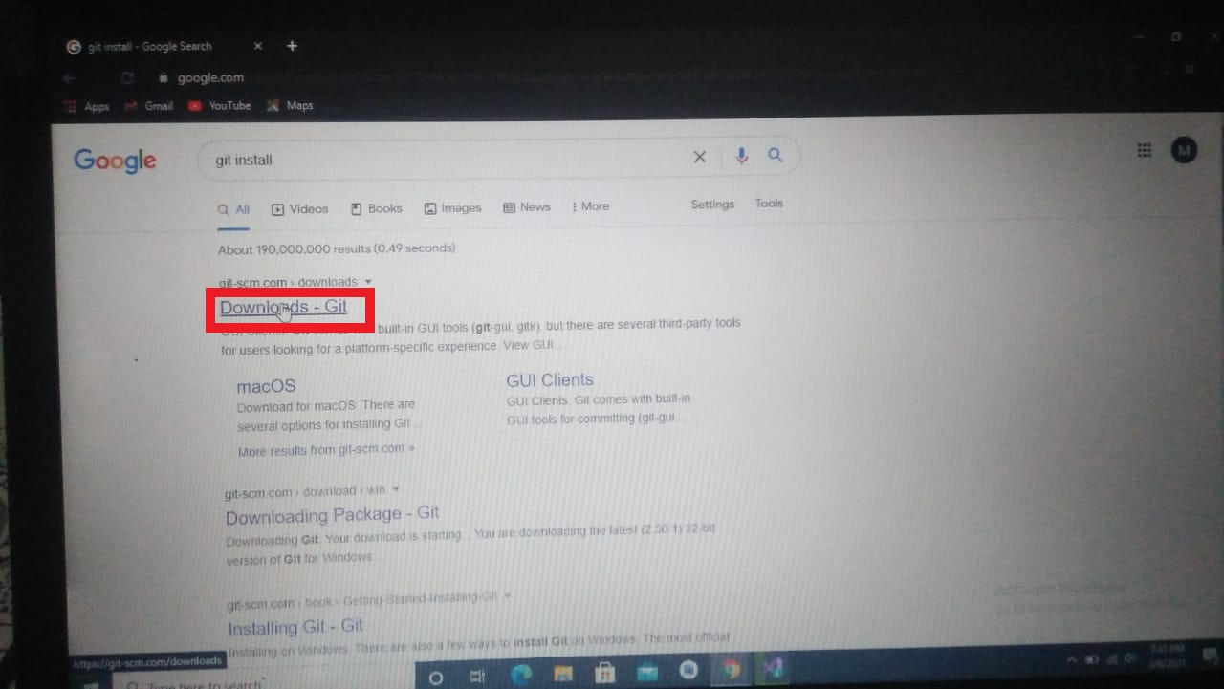

* To install git, type on google git install
* Click on **Downloads-Git** site

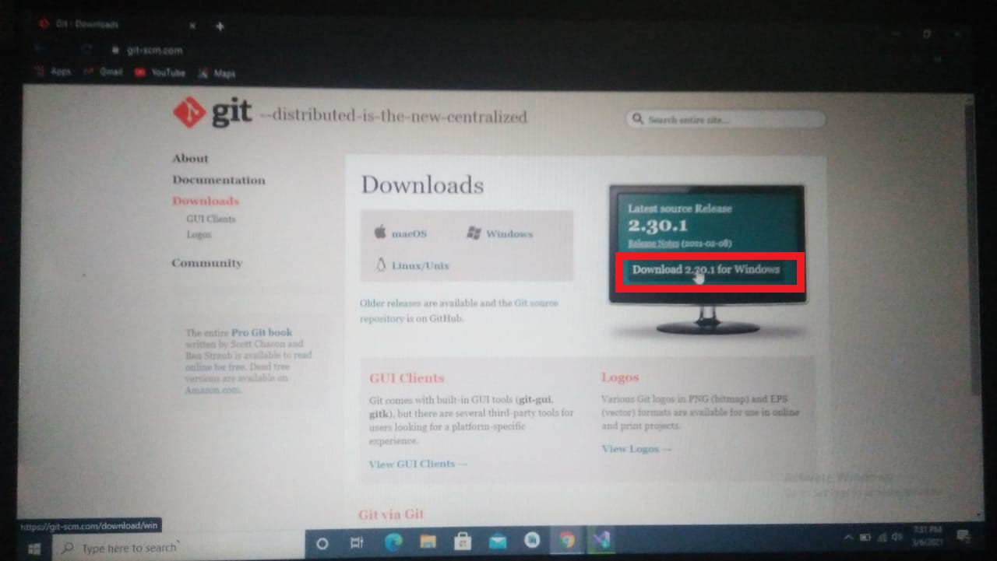

* Click on download button to download latest version of git
* Git installed when you click on download button

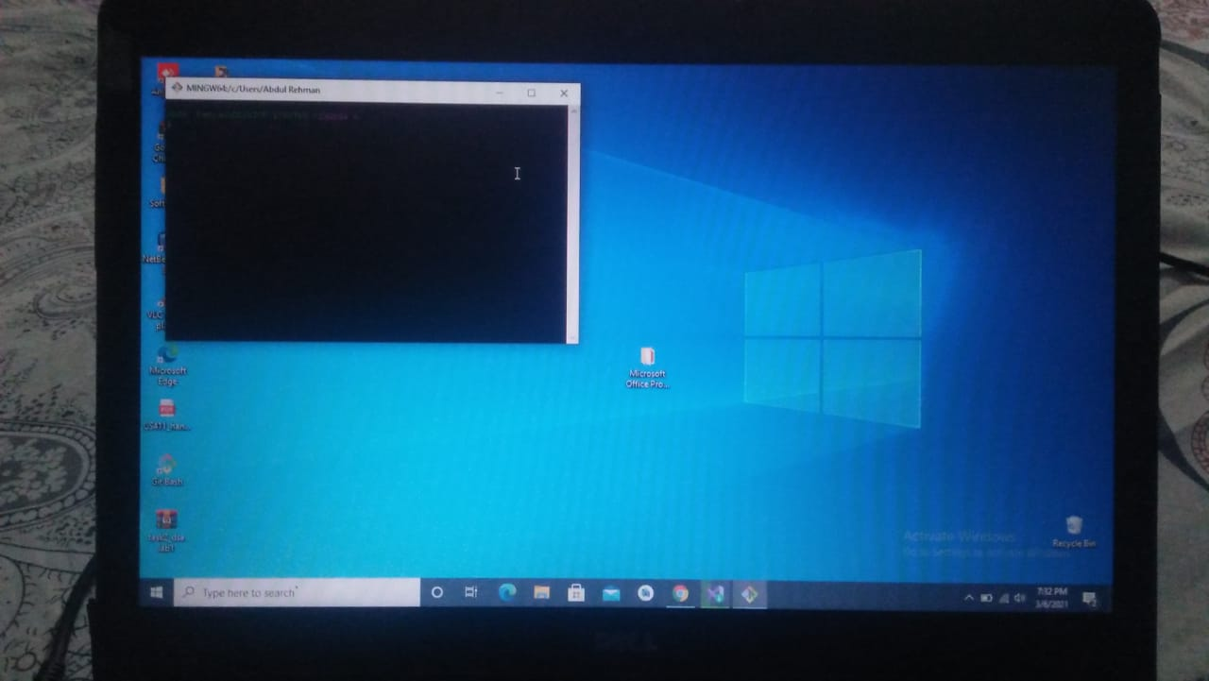

* Git is installed

**DOWNLOAD ANDROID STUDIO**

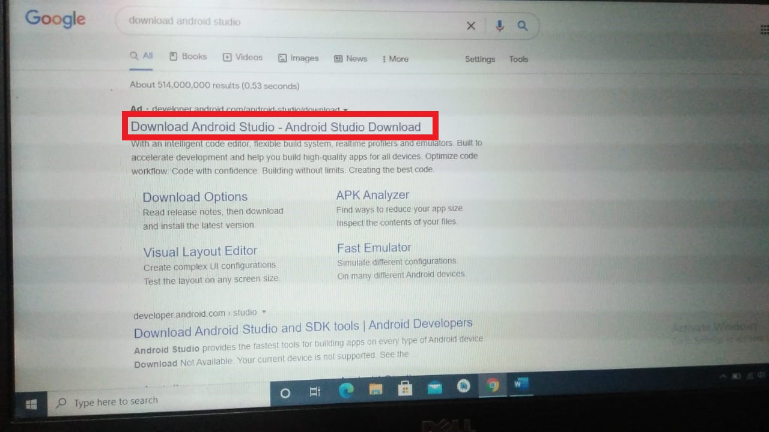

* Click on download android studio latest version

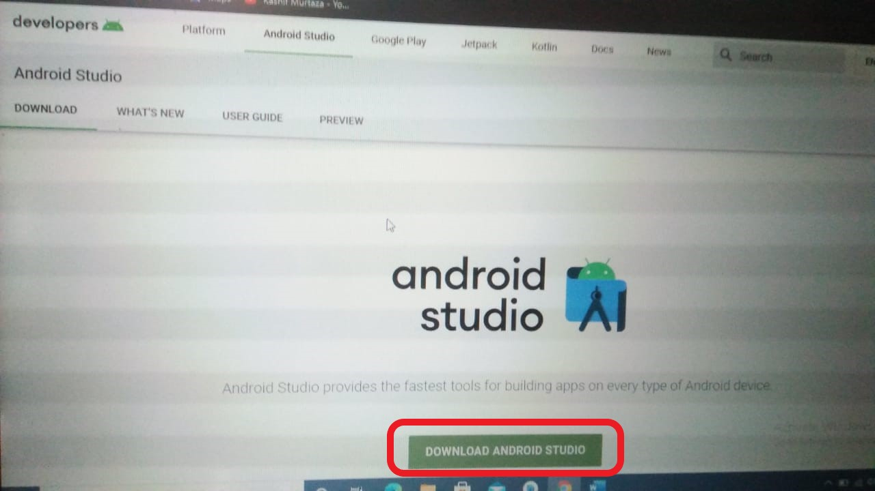

* This window appear and then again click on download android studio

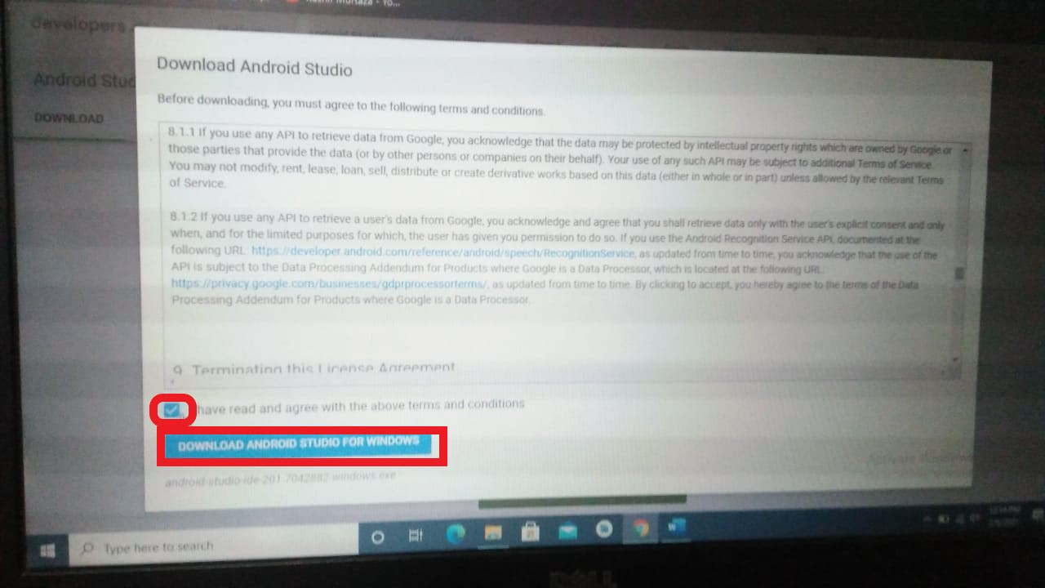

* Check the box that you have agree with the terms and conditions
* Click on download android studio for windows

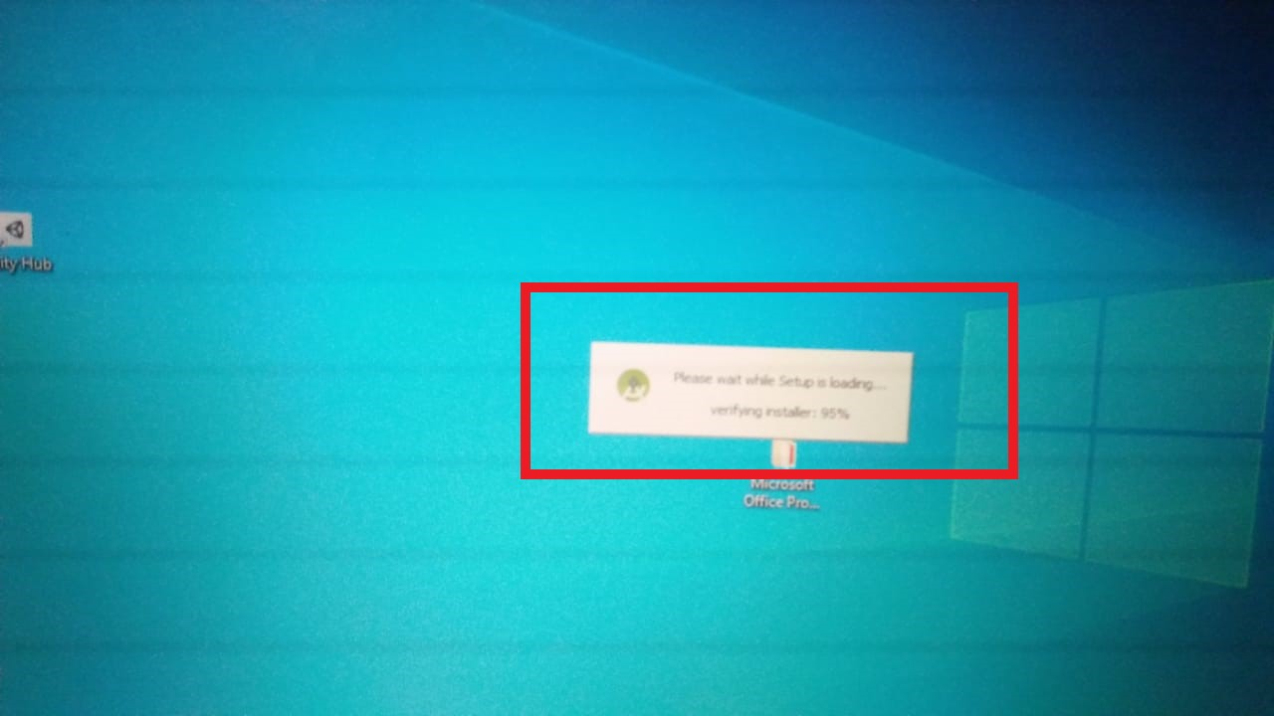

* Setup is starting for installing

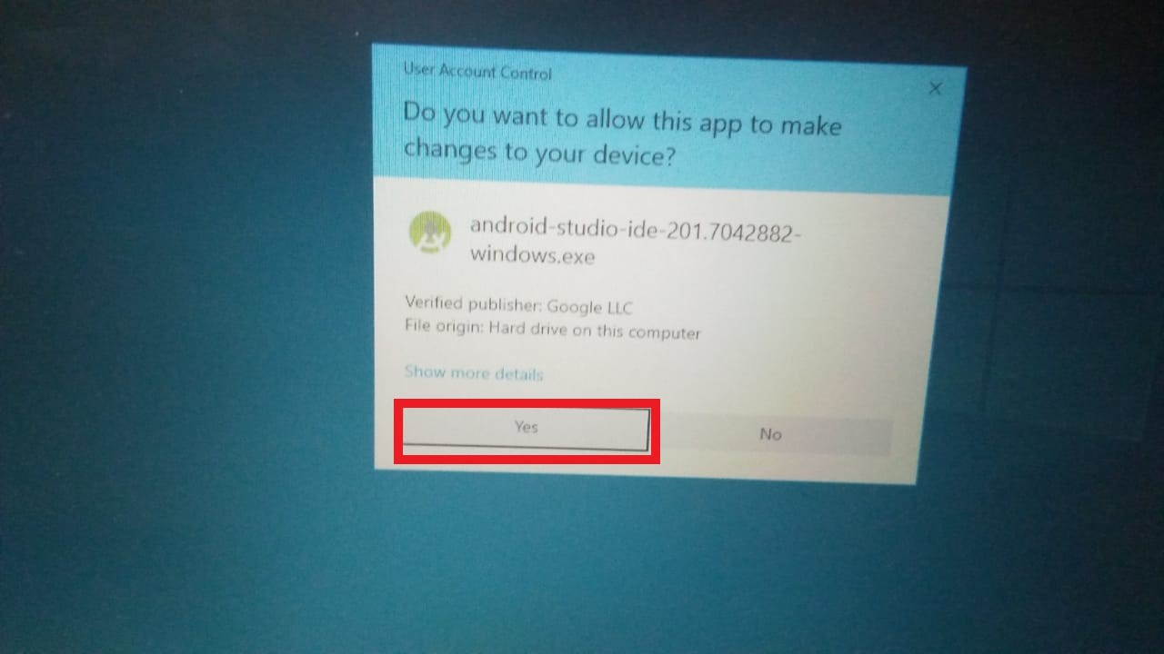

* Click on yes for successfully installing android studio

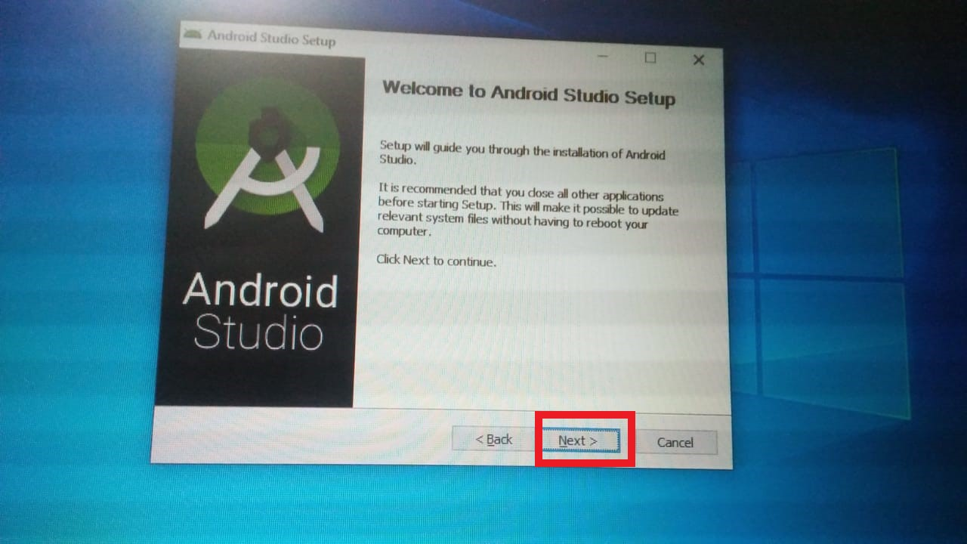

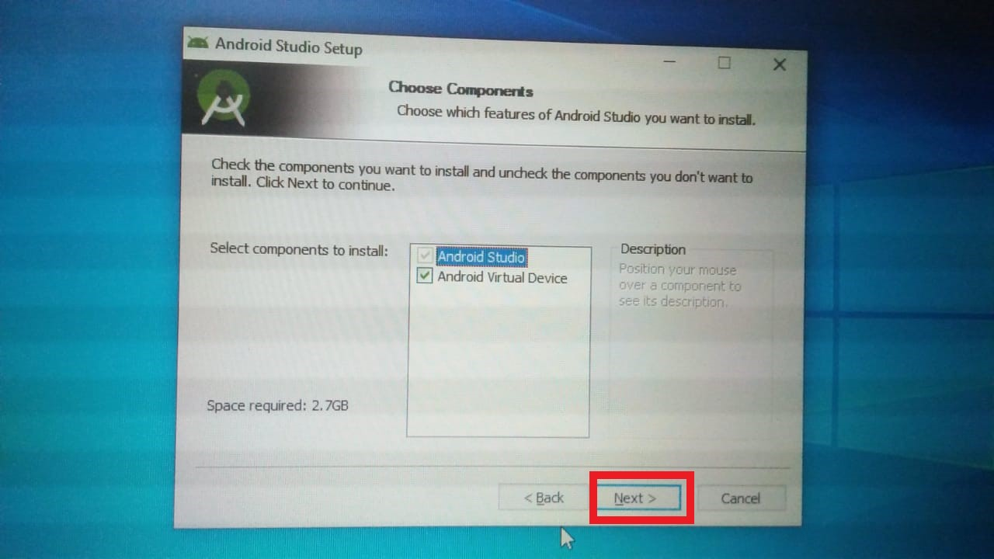

* Click on Next

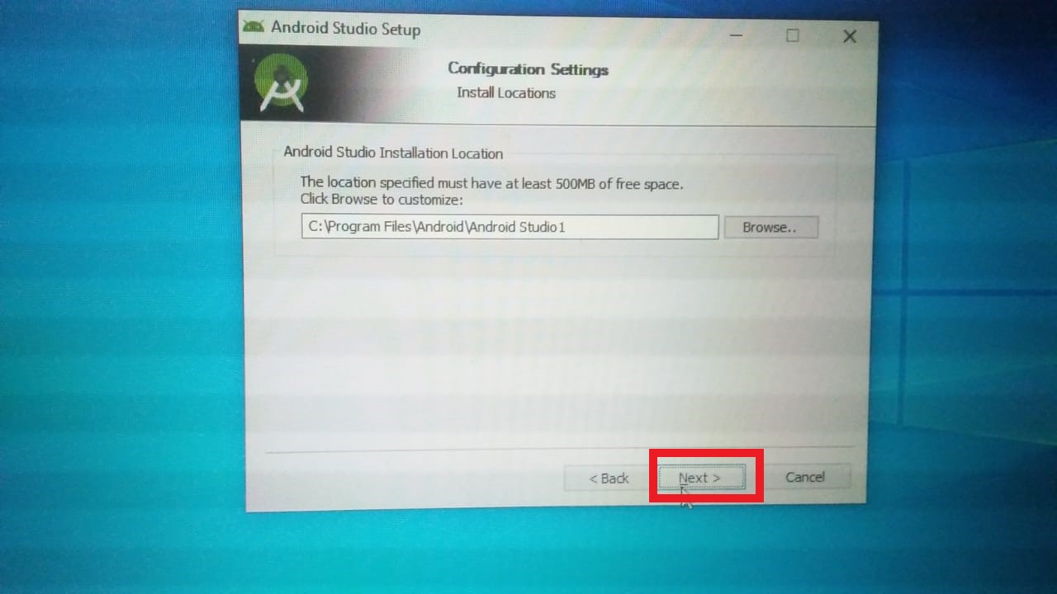

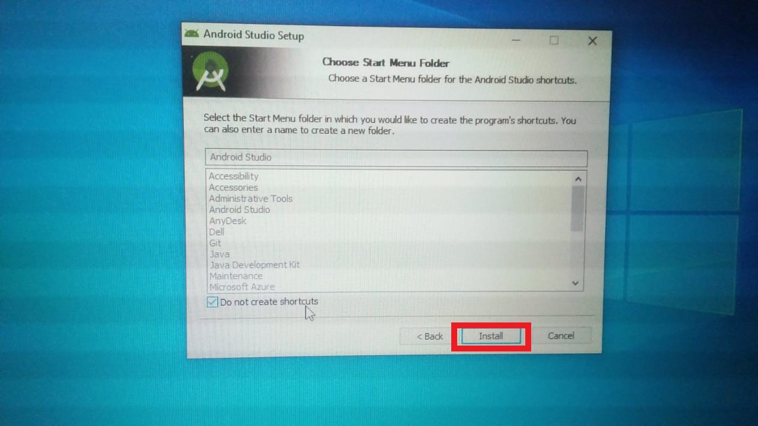

* Click on Install

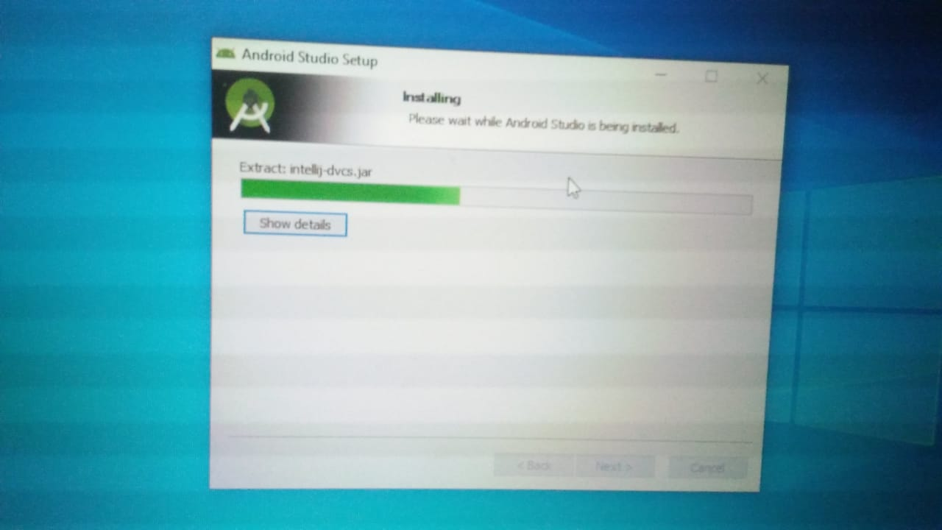

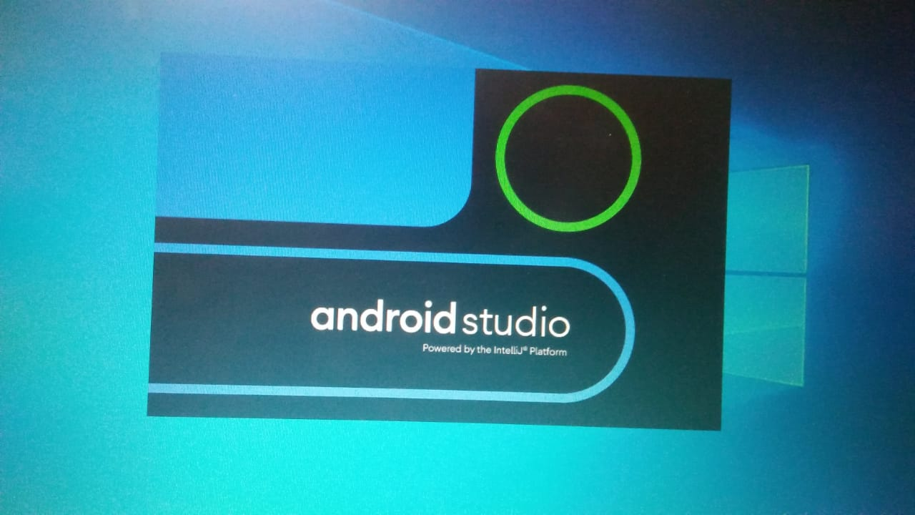

* Android Studio for windows is installed successfully.