JOURNAL RINGING & MIGRATION

Using ringing data to inform a geolocator study: when and which birds to equip?

Raphaël Nussbaumera,b,[1] (ORCID: [0000-0002-8185-1020](https://orcid.org/0000-0002-8185-1020) ; twitter: [@rafnuss](https://twitter.com/rafnuss)) and Colin Jacksona  
aA Rocha Kenya, Watamu, Kenya, bSwiss Ornithological Institute, Sempach, Switzerland

# Abstract

# Introduction

Geolocators are a well-established technology used to study bird migration which have become popular due to their relatively low cost and light weight, making them the only tool available to study migration patterns of smaller birds (Bridge et al., 2011). These small tracking devices have helped advance our understanding of bird migration on a number of levels: identifying migration routes and wintering locations (Salewski et al., 2013; Smith et al., 2014; Kralj et al., 2020), revealing migration strategies (Adamík et al., 2016; Briedis et al., 2019; Hahn et al., 2020) and migration connectivity (Finch et al., 2015; Procházka et al., 2017; McKinnon & Love, 2018), among others.

This technology bears strong potential to uncover some long-distance Afro-tropical migration patterns, many of which are still largely unknown to this date (Benson, 1982; Bennun, 2000; Cox et al., 2011; Bussière et al., 2015; Nwaogu & Cresswell, 2016). As habitat destruction and climate change accelerate and adversely affect migrant birds, it is becoming urgent to better understand these patterns in order to effectively protect these migratory bird populations (Simmons et al., 2004; Sekercioglu, 2010; Şekercioĝlu et al., 2012; Vickery et al., 2014). Geolocators are instrumental in helping us gain this fine scale understanding of migration routes, timing, triggers and variability, as well as identifying breeding, wintering and stopover sites to protect.

However, geolocators are not without constraints. Indeed, the tags must be retrieved to recover data, harnesses can fail, bird survival might be impacted, latitudinal precision can be relatively poor, and finally analysis can be difficult and prone to errors. With the increasing number of studies using geolocators, these challenges have been partially addressed. Increased experience with this technology has helped improve survival rates through minimum relative load and non-elastic harness technology (Streby et al., 2015; Weiser et al., 2015; Brlík et al., 2020). The analysis of data has also become easier and more accurate (Lisovski & Hahn, 2012; Lisovski et al., 2019) and pitfalls discussed (Fudickar et al., 2012; Lisovski et al., 2012; Lisovski et al., 2018). Finally, technological developments have led to additional measurements being captured by geolocators, such as temperature, air pressure and accelerometer, providing further research opportunities (Meier et al., 2018; Liechti et al., 2018; Dhanjal-Adams et al., 2018; Sjöberg et al., 2018; Jiguet et al., 2019; Briedis et al., 2020).

Despite this progress, geolocator studies still need to be carefully planned (in terms of field time, research questions, sample size etc.) to improve the recapture of birds from one season to the next. In this study, we present an example of geolocator study carried out on two Afro-tropical migrants in Kenya. This study will demonstrate how pre-deployment analysis using an existing ringing database can help optimize the deployment of geolocators, answering two questions in particular: 1) how can we accurately estimate how many birds can be equipped during one season, to avoid wasting geolocators or not maximizing equipping rates, and 2) when should we equip, and which bird should we equip (with regards to sex, age, and weight) to maximize the recapture rate and consequently data retrieval?

# Materials and methods

## Ringing site and database

A Rocha Kenya Conservation centre (3°22'36.3"S, 39°59'16.9"E) is located on the coast of Kenya and in the middle of the Northern Zanzibar-Inhambane Coastal Forest Mosaic ecoregion, recognized for its high biodiversity value (Marris, 2010) and threatened with high habitat fragmentation incurred by population growth as well as the expansion of agriculture and charcoal burning (Burgess & Clarke, 2000). Located near the Equator (400km south), several migrant strategies overlap in this area (Turpie, 1996): palearctic passage (e.g. Sedge Warbler) and wintering (e.g. Spotted Flycatcher), and several types of intra-African migration: wintering (e.g. Pygmy Kingfisher), passage (e.g. White-throated Bee-eater), and summering (e.g. ), and finally predictable and erratic rain-related movements (e.g.).

More locally, the study centre is located on a residential coastal scrub/forest that has benefitted from limited habitat change over the last 50 years (Alemayehu, 2016), in the effort to preserve the ecosystems for tourism purposes. The ringing nets are placed in a nature trail that runs through a small patch of forest, managed by the field study centre.

In this study, we use the ringing dataset from ringing sessions conducted regularly from 2002 to this date. Up to early 2019, the dataset consists of 3’372 entries of 2’532 rings covering 96 species and collected during 317 sessions. The ringing effort presents some temporal variability, as well as variability in the metadata recorded (see SM1). In general (see Figure 7 in SM1), sessions start at sunrise (M=06.12am; SD=00:14) and last until bird activity slows down (session duration M=04:08; SD=01:01). On average, a total of 154m (SD= 51) of nets were used. Descriptive notes on weather conditions were also included, and later classified according to their expected influence on the capture rate (none, little, large). We manually checked extreme values in the dataset and removed outliers.

In addition, we also present the ringing data of 2020, when the geolocators were deployed. We did not include this data in the fitting of the models but rather used it for comparison and discussion purposes.

In this case study, geolocators were placed on Red-capped Robin-chats (RCRC), a terrestrial thrush wintering in the area from April to October, in order to uncover their summering site and migration routes (Nussbaumer & Jackson, 2020). The migratory patterns for this Afro-tropical migrant have proven difficult to understand, as there appears to be several migratory populations, as well as resident populations.

## How many geolocators to order?

In the planification stage, it is important to accurately estimate the number of individuals that can realistically be captured during a ringing season, and thus the number of geolocators to request. Indeed, geolocators are configured to collect data for a single year, and therefore cannot be kept for future studies. Overestimating the individuals captured would thus result in wasting devices. This estimation will directly influence the ringing effort planned (i.e. number of sessions, duration of session, number of nets etc). To address this question, we followed a three-step process described below.

In the first step, we modelled the number of RCRC captured per session using a generalized additive model (GAM), assuming the number of captures follows a Poisson distribution. The predictor variables tested in the model are (1) year (2) day-of-year (or Julian day), (3) duration of the session, (4) total length of nets, (5) starting time and (6) weather conditions. To overcome the lack of sufficient data for the duration, start time and length of nets, we used multiple imputation methods by chained equations (Azur et al., 2011) to generate 30 sets of data without any missing value. For each of these sets, a GAM model was fitted.

In the second step, we address the problem that RCRC can only be equipped once a year. A first approach tested was to model the count of new birds (i.e., birds that have not yet been captured in the same year) rather than the total number of birds. However, this count depends on how many RCRC have already been equipped earlier in the year. Instead, we preferred to model the probability that a bird captured was not already captured in the same year. This probability is modelled with a Generalized Linear Model (GLM) using a binomial family and a single explanatory variable consisting of the total number of RCRC captured in the year.

In the third step, we used the two models above to predict the number of RCRC that can be captured over one year. This number is estimated from the prediction of the models under various ringing scenarios. The default scenario for our ringing season of 2020 is to ring every week for 4 hours using 156m of nets. Using the first model and this information, we can estimate the number of RCRC that will be captured along the season. Knowing how many birds have been captured, we used the second model to predict how many unique RCRC can be equipped along the year by multiplying the number of captures by the probability of each individual being a new bird. Finally, assuming that the sessions are independent conditional to the model, we estimate the total number with a cumulative sum along the year. The standard error estimate is computed with basic variance calculus assuming independence of the variables.

This approach was performed under different scenarios where we modify the number of ringing sessions, total length of nets and duration of ringing session. The default scenario includes 4hr-ringing sessions every 10 days with 156m of nets. We tested the influence of increasing the duration of ringing session to 6hrs and the length of nets to 225m. In addition, we tested an optimized ringing schedule where more ringing sessions are held during the peak passage. Finally, we also compared the actual number of RCRC captured in 2020 with the prediction of our model using the exact sessions’ duration and length of nets.

## Improve the recapture rate

Data collected by geolocators can only be retrieved if the equipped bird is recaptured in the following years. Consequently, to optimize the study, it is essential to equip those birds that are most likely to be recaptured. Here too, the ringing database can inform this decision, in this case by providing the recapture rate of a bird as a function of the date of equipping but also the sex, age or weight of the bird. Using this information, the ringer can make an informed decision about whether or not to equip a captured bird. This decision should also account for the total number of geolocators available and the number of sessions left.

In this study, we look at two parameters: the time of year and the age class (adult or juvenile). The recapture probability is estimated by modelling the binomial response of whether a captured bird will be recaptured in the following years: we consider that an individual is recaptured if the bird has been recaptured at least once in any of the following years, and this independently from whether it was already captured in the past.

We modelled the count of adults and juveniles per session separately to reveal the influence of age on recapture rates. The weight of the bird was left out of the model as it showed little to no effect on the recapture rate (see Figure 10 in SM3).

The expected number of retrieved geolocators can be computed as the product of the initial geolocator count and estimated recapture rate.

All computation was performed on R (Team & others, 2013), using the MCGV package (Wood, 2017) for GAM and Mice Package (Buuren & Groothuis-Oudshoorn, 2011) for the imputation.

# Results

## How many captures are possible?

A GAM model was fitted to the data in order to model the number of RCRC captured for each session. After testing several parametrizations of the model (see SM2), the retained model was `Count ~s(Julian) + s(Year) + NetsDuration + s(NetsLength)'. The fitted model for the default case (156m of nets and 4hr of duration) together with the raw counts data is illustrated in Figure 1. The model fits a typical migrant phenology curve, with a steep increase in the numbers in May, peaking in early June with almost 3 RCRC per session. The second peak of returning birds in mid-September is much smaller with only 1.5 birds/session. The counts of 2020 show an early arrival of birds (peak in second half of May), but overall, within the range of typical years.

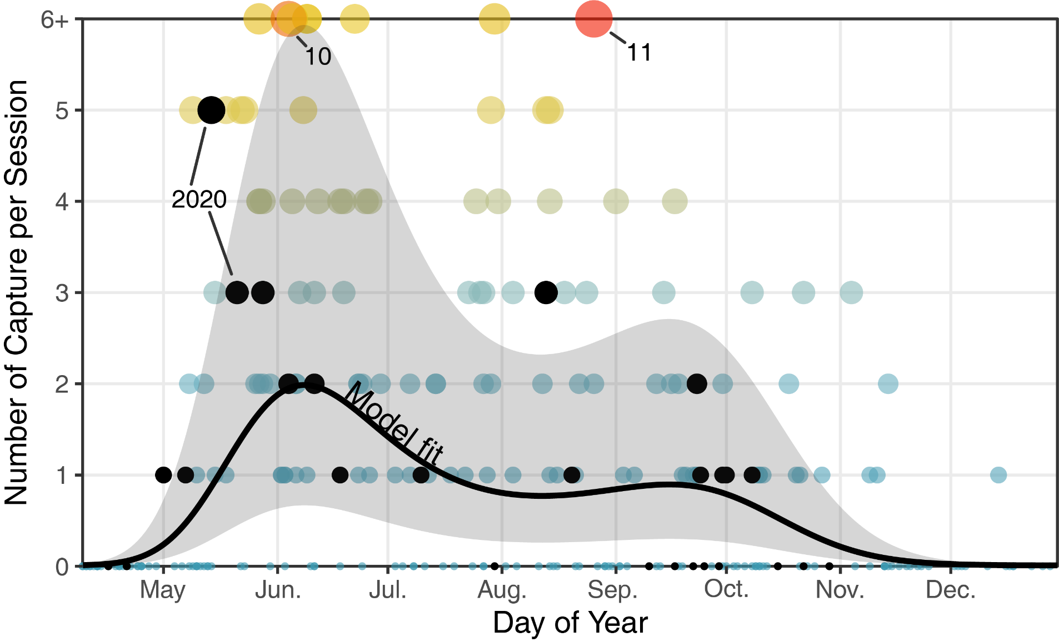

Figure 1: Seasonal variation in the number of captured RCRC per session. Points represent actual data points while the black line is the model estimate for the default/average case (156m, 4hr) with its corresponding uncertainty illustrated as shaded area. Sessions with 6 or more RCRC are illustrated on the “6+” line but with proportionate size and color. Black points correspond to the 2020 data, when the geolocators were equipped.

We modelled the probability of recapture within a year in order to extract the number of unique birds captured during a single year (Figure 2). As the cumulative number of RCRC captured increases, the recapture rate also increases and consequently, the probability of being a new bird decreases from around 100% for the first bird to 60-70% after 40 RCRC have been captured in the year. Note that this approach can only reliably estimate the probability up to a maximum of around 40 RCRC captured in a year.

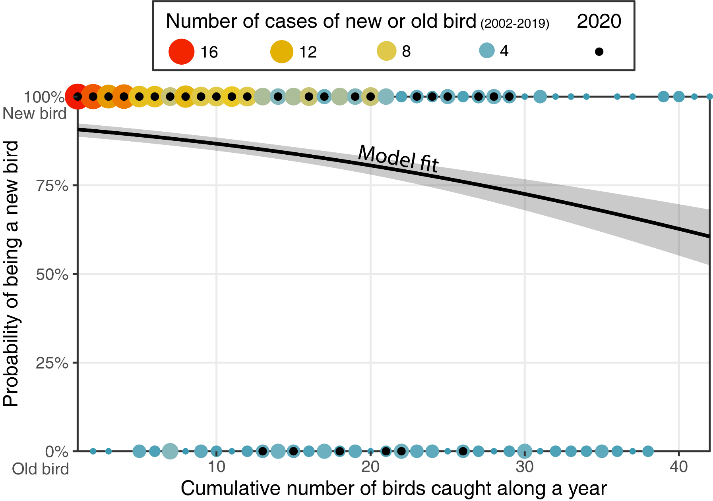

Figure 2: The colour and size of the points indicate the number of occurrences in the dataset that the nth bird caught in a year had already been caught during the year (bottom, old bird, 0%) or the first time it was caught this year (top, new bird, 100%). The line shows the fitted model of the probability that a bird is a new bird as a function of its rank of capture. The probability of capturing a new bird (i.e., a bird not yet captured this year) decreases as the number of RCRC capture increases.

Five different scenarios of ringing were modelled to estimate the total number of unique RCRC captured along the year in Figure 3. Compared with the total number of birds caught at the end of year with the default scenario (16), increasing the duration of ringing sessions by 2hr (‘6hr’) or adding 44m of additional nets (‘200m’) results in only 3 more birds caught (19). However, the optimized scenario yields many more birds, with a total of 22 birds captured in fewer number of sessions (31 instead of 37). In 2020, the total number of RCRC captured as of 1 November was 23, against 20 predicted by the model.

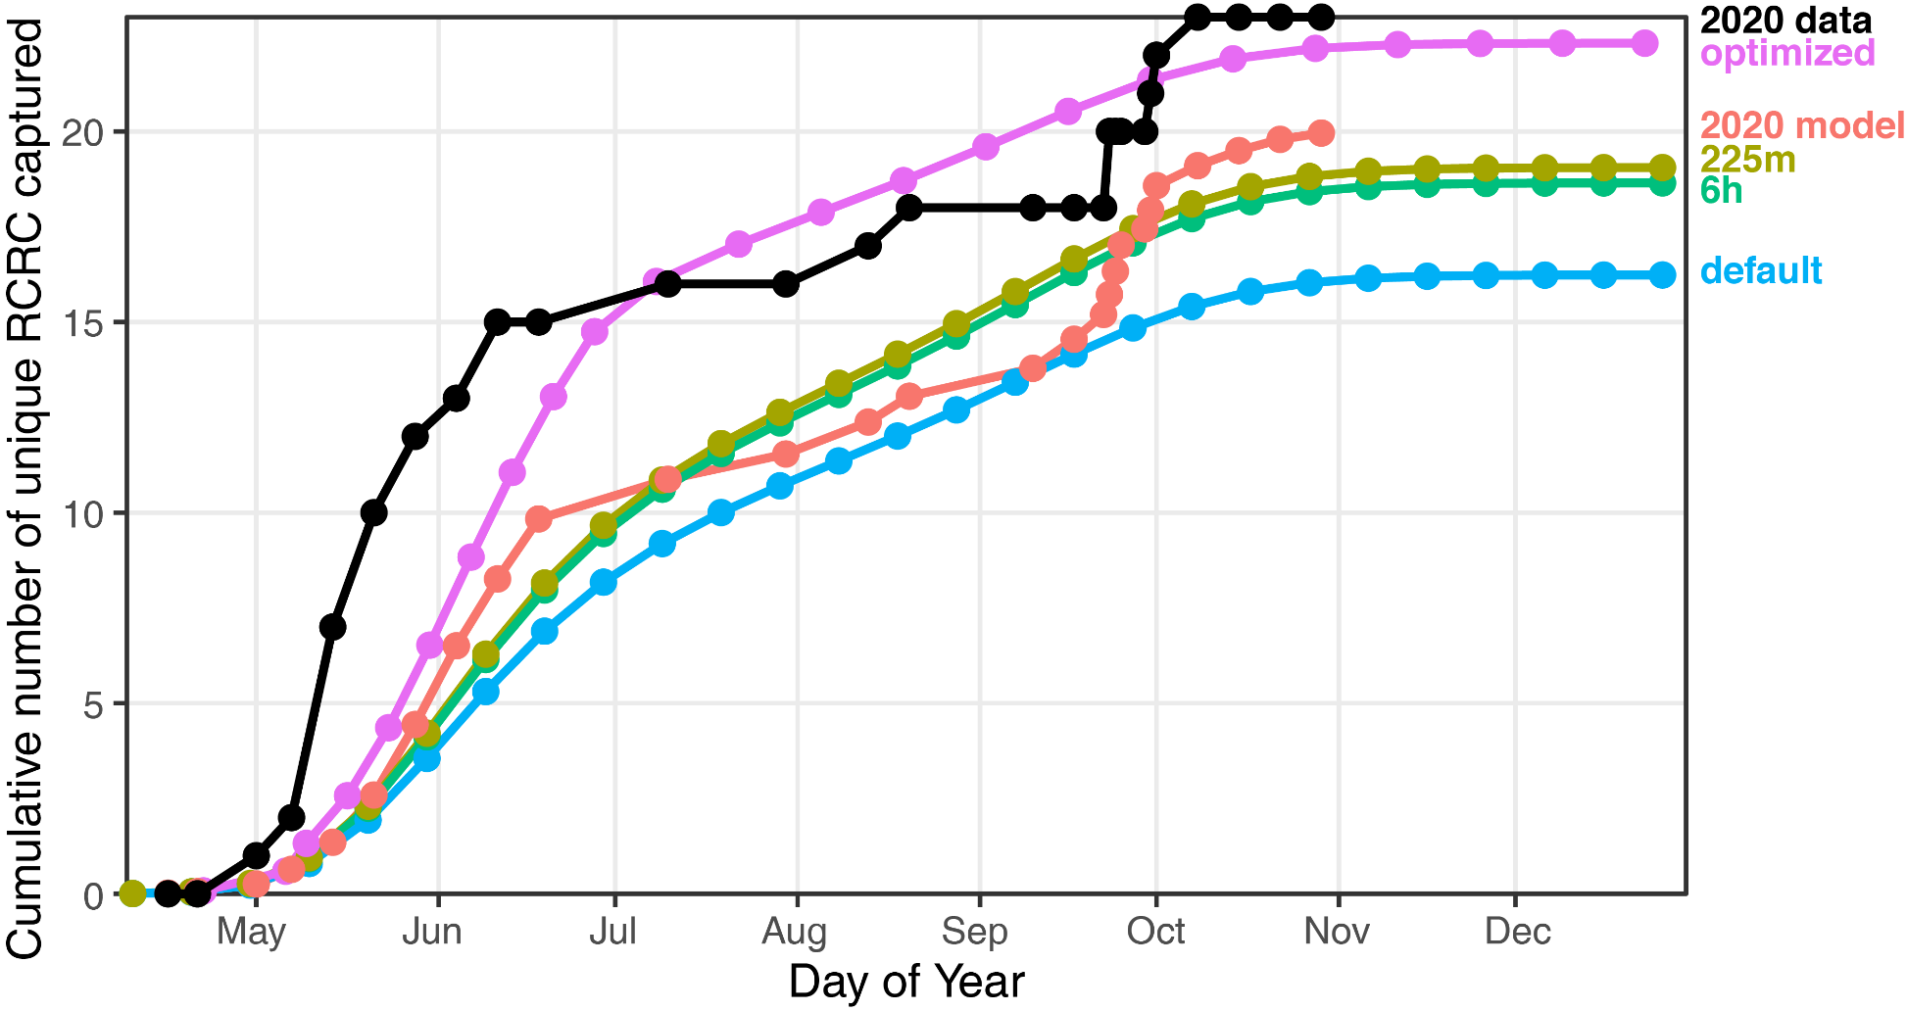

Figure 3: Model predictions of the total unique RCRC caught along a year following different scenarios. The default scenario consists of 4hr ringing sessions using 156m of nets every 10 days. ‘6h’ and ‘225m’ are modifications of the default scenario, and ‘optimized’ increases the number of sessions (every week) during the peak passage (mid-May – July) and decreases them (every 2 weeks) during the rest of the year. Finally, using the exact date, duration, net length used in 2020, the model prediction ‘2020 model’ can be compared to the actual data (‘2020 data’).

## Improve the recapture rate

Over the 161 unique RCRC individuals captured in the dataset, 67 (42%) were recaptured at least once and 39 (24%) were recapture at least once in the following year. Assuming each capture-recapture is independent from whether the bird had already been captured earlier, the recapture rate increases to 47% and 30% for subsequent year. In genral, juveniles and adults show similar recapture rates (46% vs 47% respectively) but when considering only subsequent year, adults show a much higher recapture rate (34%) than juveniles (27%).

When modelled over the day of year (Figure 4a), the recapture rate shows an increase along the year from 25% to almost 50% at the end of year. Separating adults from juveniles allows us to identify further trends. The increase in juveniles’ recapture rate is not significant. By contrast, adults show a clear increase from May to August, before stabilising from September to October. Modelling the number of captures of adults and juveniles (Figure 4b), we observe an earlier arrival of juveniles (late May vs early June for adults) and earlier departure in August, while adults show a second peak early October.

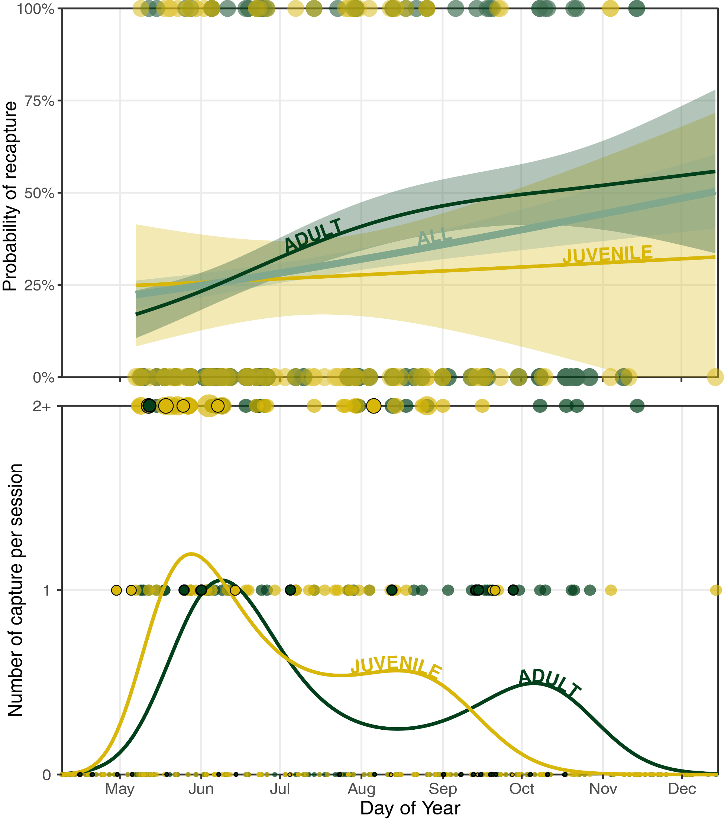

Figure 4: Comparison of adult (green) and juvenile (yellow) trend in (a) recapture rate and (b) number of captures per session along the year.

# Discussion

[Recall of objective]

In this paper, we provide an example of how a ringing dataset can inform the design and planning of a geolocator study.

[Model learning]

The model of capture per session provides practical information to plan ringing sessions in order to maximize the number of Red-capped Robin-chat captured. Increasing the duration of ringing sessions from 4h to 6h and increasing the number of nets only slightly improves the total number of RCRC captured. This is explained by the fact that RCRC are mostly active in the first hours of the day, and that additional nets are no longer located in optimal habitat. By contrast, increasing the number of sessions as well as choosing the right time of year significantly increases the number of captures.

In 2020, the initial plan was to ring at least every 2 weeks, and every week during peak passage (from May to early June and from late August to October). Following an earlier and simpler count model (not accounting for annual trend nor recapture rate), we expected to capture a total of 30. Because of uncertainties surrounding the first deployment year, we conservatively requested 15 geolocators, also allowing for flexibility to learn how to equip, choose which bird to equip and when along the year.

[Recapture rate]   
The slight increase in recapture rate as the season progresses seems to indicate that we should equip birds later in the year, however, this trend should be balanced with the number of RCRC captured per session, which decreases at the same time. Striking a balance between improving the recapture rate and still capturing enough birds is key.

For the purpose of our study, we had to equip 15 RCRC. While waiting for July/August seemed preferable in order to increase the recapture rate, the number of birds captured decreases, and we were more likely to catch the same bird again (resident).

Comparing the number of captures of juveniles and adults also informs our hypotheses on birds’ movements. Indeed, the ringing data suggests an earlier arrival of juveniles in Spring and an earlier departure in Autumn. The increase in the recapture of adults captured later in the year seems to point toward adults holding territories on site. To learn more about the age difference patterns observed in the ringing data and confirm the hypothesis of variable departure/arrival time based on age, we decided to start equipping some birds already end of June and wait later in the season to equip the remaining adult residents, who had a higher recapture probability.

[How to understand this year data?]  
We can loosely compare/validate the model results with the actual data collected in 2020, though caution is needed as this represents only a single year. The number of RCRC captured in 2020 is comparable to the model estimate, albeit slightly higher. The arrival date proved to be earlier than the average and the numbers appeared to be higher than average at the beginning of the season. This could be due to a particularly good breeding season (many juveniles caught during this period) or affected by the playback used near the nets. Later in the year, we captured more adults by targeting singing birds holding territory, as was predicted by the model.

[Extend this model to others]  
Although the model and results of this study are tailored for the specific case of RCRC on coastal Kenya, the application of this methodology can be extended to other situations where ringing are available exist for the study site. RCRC were equipped during wintering period, which is rather unusual in geolocator studies. Indeed, most studies focus on breeding (capture is then done directly on nest) sites because the return rates to the nest are higher. However, birds similarly hold territory on their wintering sites and show site fidelity (ref), thus making them ideal candidate for geolocator study.

Targeting bird on nest : different approach?

Intra- longer distant migrant?

and application Only limited to intra-african? Wintering site? Ringing database???  
 MK study

# Conclusion

# Acknowledgments

This work was supported by the Swiss Ornithological Institute and A Rocha Kenya.

# References

Adamík, P., Emmenegger, T., Briedis, M., Gustafsson, L., Henshaw, I., Krist, M., … Hahn, S. (2016). Barrier crossing in small avian migrants: Individual tracking reveals prolonged nocturnal flights into the day as a common migratory strategy. *Scientific Reports*, *6*(February), 1–9. https://doi.org/10.1038/srep21560

Alemayehu, F. (2016). Land Use and Land Cover Change in the Coastal Area of Watamu Mida Creek, Kenya. *Open Journal of Forestry*, *06*(04), 230–242. https://doi.org/10.4236/ojf.2016.64019

Azur, M. J., Stuart, E. A., Frangakis, C., & Leaf, P. J. (2011). Multiple imputation by chained equations: what is it and how does it work? *International Journal of Methods in Psychiatric Research*, *20*(1), 40–49. https://doi.org/10.1002/mpr.329

Bennun, L. (2000). Assessing and monitoring bird populations in Africa: an overview. *Ostrich*, *71*(1–2), 214–215. https://doi.org/10.1080/00306525.2000.9639915

Benson, C. W. (1982). Migrants in the Afrotropical Region South of the Equator. *Ostrich*, *53*(1), 31–49. https://doi.org/10.1080/00306525.1982.9634723

Bridge, E. S., Thorup, K., Bowlin, M. S., Chilson, P. B., Diehl, R. H., Fléron, R. W., … Wikelski, M. (2011). Technology on the Move: Recent and Forthcoming Innovations for Tracking Migratory Birds. *BioScience*, *61*(9), 689–698. https://doi.org/10.1525/bio.2011.61.9.7

Briedis, M., Bauer, S., Adamík, P., Alves, J. A., Costa, J. S., Emmenegger, T., … Hahn, S. (2019). A full annual perspective on sex-biased migration timing in long-distance migratory birds. *Proceedings of the Royal Society B: Biological Sciences*, *286*(1897). https://doi.org/10.1098/rspb.2018.2821

Briedis, M., Beran, V., Adamík, P., & Hahn, S. (2020). Integrating light-level geolocation with activity tracking reveals unexpected nocturnal migration patterns of the tawny pipit. *Journal of Avian Biology*, *51*(9), 1–10. https://doi.org/10.1111/jav.02546

Brlík, V., Koleček, J., Burgess, M., Hahn, S., Humple, D., Krist, M., … Procházka, P. (2020). Weak effects of geolocators on small birds: A meta-analysis controlled for phylogeny and publication bias. *Journal of Animal Ecology*, *89*(1), 207–220. https://doi.org/10.1111/1365-2656.12962

Burgess, N., & Clarke, G. (2000). Coastal forests of eastern Africa.

Bussière, E. M. S., Underhill, L. G., & Altwegg, R. (2015). Patterns of bird migration phenology in South Africa suggest northern hemisphere climate as the most consistent driver of change. *Global Change Biology*, *21*(6), 2179–2190. https://doi.org/10.1111/gcb.12857

Buuren, S. van, & Groothuis-Oudshoorn, K. (2011). mice : Multivariate Imputation by Chained Equations in R. *Journal of Statistical Software*, *45*(3), 1–67. https://doi.org/10.18637/jss.v045.i03

Cox, D., Brandt, M., Mcgregor, R., Ottosson, U., Stevens, M., & Cresswell, W. (2011). Patterns of seasonal and yearly mass variation in West African tropical savannah birds. *Ibis*, *153*(4), 672–683. https://doi.org/10.1111/j.1474-919X.2011.01150.x

Dhanjal-Adams, K. L., Bauer, S., Emmenegger, T., Hahn, S., Lisovski, S., & Liechti, F. (2018). Spatiotemporal Group Dynamics in a Long-Distance Migratory Bird. *Current Biology*, *28*(17), 2824-2830.e3. https://doi.org/10.1016/j.cub.2018.06.054

Finch, T., Saunders, P., Avilés, J. M., Bermejo, A., Catry, I., de la Puente, J., … Butler, S. J. (2015). A pan-European, multipopulation assessment of migratory connectivity in a near-threatened migrant bird. *Diversity and Distributions*, *21*(9), 1051–1062. https://doi.org/10.1111/ddi.12345

Fudickar, A. M., Wikelski, M., & Partecke, J. (2012). Tracking migratory songbirds: accuracy of light-level loggers (geolocators) in forest habitats. *Methods in Ecology and Evolution*, *3*(1), 47–52. https://doi.org/10.1111/j.2041-210X.2011.00136.x

Hahn, S., Alves, J. A., Bedev, K., Costa, J. S., Emmenegger, T., Schulze, M., … Dhanjal-Adams, K. L. (2020). Range-wide migration corridors and non-breeding areas of a northward expanding Afro-Palaearctic migrant, the European Bee-eater Merops apiaster. *Ibis*, *162*(2), 345–355. https://doi.org/10.1111/ibi.12752

Jiguet, F., Burgess, M., Thorup, K., Conway, G., Arroyo Matos, J. L., Barber, L., … Hewson, C. (2019). Desert crossing strategies of migrant songbirds vary between and within species. *Scientific Reports*, *9*(1), 1–12. https://doi.org/10.1038/s41598-019-56677-4

Kralj, J., Martinović, M., Jurinović, L., Szinai, P., Süto, S., & Preiszner, B. (2020). Geolocator study reveals east African migration route of Central European Common Terns. *Avian Research*, *11*(1), 1–11. https://doi.org/10.1186/s40657-020-00191-z

Liechti, F., Bauer, S., Dhanjal-Adams, K. L., Emmenegger, T., Zehtindjiev, P., & Hahn, S. (2018). Miniaturized multi-sensor loggers provide new insight into year-round flight behaviour of small trans-Sahara avian migrants. *Movement Ecology*, *6*(1), 1–10. https://doi.org/10.1186/s40462-018-0137-1

Lisovski, S., Bauer, S., Briedis, M., Davidson, S. C., Dhanjal-Adams, K. L., Hallworth, M. T., … Bridge, E. S. (2019). Light‐level geolocator analyses: A user’s guide. *Journal of Animal Ecology*, *89*(1), 1–16. https://doi.org/10.1111/1365-2656.13036

Lisovski, S., & Hahn, S. (2012). GeoLight - processing and analysing light-based geolocator data in R. *Methods in Ecology and Evolution*, *3*(6), 1055–1059. https://doi.org/10.1111/j.2041-210X.2012.00248.x

Lisovski, S., Hewson, C. M., Klaassen, R. H. G., Korner-Nievergelt, F., Kristensen, M. W., & Hahn, S. (2012). Geolocation by light: Accuracy and precision affected by environmental factors. *Methods in Ecology and Evolution*, *3*(3), 603–612. https://doi.org/10.1111/j.2041-210X.2012.00185.x

Lisovski, S., Schmaljohann, H., Bridge, E. S., Bauer, S., Farnsworth, A., Gauthreaux, S. A., … Wunder, M. B. (2018). Inherent limits of light-level geolocation may lead to over-interpretation. *Current Biology*, *28*(3), R99–R100. https://doi.org/10.1016/j.cub.2017.11.072

Marris, E. (2010). Conservation: Biodiversity as a bonus prize. *Nature*, *468*(7326), 895. https://doi.org/10.1038/468895a

McKinnon, E. A., & Love, O. P. (2018). Ten years tracking the migrations of small landbirds: Lessons learned in the golden age of bio-logging. *The Auk*, *135*(4), 834–856. https://doi.org/10.1642/auk-17-202.1

Meier, C. M., Karaardıç, H., Aymí, R., Peev, S. G., Bächler, E., Weber, R., … Liechti, F. (2018). What makes Alpine swift ascend at twilight? Novel geolocators reveal year-round flight behaviour. *Behavioral Ecology and Sociobiology*, *72*(3), 45. https://doi.org/10.1007/s00265-017-2438-6

Nussbaumer, R., & Jackson, C. (2020). *Using geolocators to unravel intra-African migrant strategies*. Watamu. https://doi.org/10.13140/RG.2.2.34477.10721

Nwaogu, C. J., & Cresswell, W. (2016). Body reserves in intra-African migrants. *Journal of Ornithology*, *157*(1), 125–135. https://doi.org/10.1007/s10336-015-1259-5

Procházka, P., Hahn, S., Rolland, S., van der Jeugd, H., Csörgő, T., Jiguet, F., … Korner-Nievergelt, F. (2017). Delineating large-scale migratory connectivity of reed warblers using integrated multistate models. *Diversity and Distributions*, *23*(1), 27–40. https://doi.org/10.1111/ddi.12502

Salewski, V., Flade, M., Poluda, A., Kiljan, G., Liechti, F., Lisovski, S., & Hahn, S. (2013). An unknown migration route of the “globally threatened” Aquatic Warbler revealed by geolocators. *Journal of Ornithology*, *154*(2), 549–552. https://doi.org/10.1007/s10336-012-0912-5

Şekercioĝlu, çaĝan H., Primack, R. B., & Wormworth, J. (2012). The effects of climate change on tropical birds. *Biological Conservation*, *148*(1), 1–18. https://doi.org/10.1016/j.biocon.2011.10.019

Sekercioglu, C. H. (2010). IN FOCUS: Partial migration in tropical birds: the frontier of movement ecology. *Journal of Animal Ecology*, *79*(5), 933–936. https://doi.org/10.1111/j.1365-2656.2010.01739.x

Simmons, R. E., Barnard, P., Dean, W. R. J., Midgley, G. F., Thuiller, W., & Hughes, G. (2004). Climate change and birds: Perspectives and prospects from southern Africa. *Ostrich*, *75*(4), 295–308. https://doi.org/10.2989/00306520409485458

Sjöberg, S., Pedersen, L., Malmiga, G., Alerstam, T., Hansson, B., Hasselquist, D., … Bäckman, J. (2018). Barometer logging reveals new dimensions of individual songbird migration. *Journal of Avian Biology*, *49*(9). https://doi.org/10.1111/jav.01821

Smith, M., Bolton, M., Okill, D. J., Summers, R. W., Ellis, P., Liechti, F., & Wilson, J. D. (2014). Geolocator tagging reveals Pacific migration of Red-necked Phalarope Phalaropus lobatus breeding in Scotland. *Ibis*, *156*(4), 870–873. https://doi.org/10.1111/ibi.12196

Streby, H. M., McAllister, T. L., Peterson, S. M., Kramer, G. R., Lehman, J. A., & Andersen, D. E. (2015). Minimizing marker mass and handling time when attaching radio-transmitters and geolocators to small songbirds. *The Condor*, *117*(2), 249–255. https://doi.org/10.1650/condor-14-182.1

Team, R. C., & others. (2013). R: A language and environment for statistical computing. Vienna, Austria.

Turpie, J. K. (1996). Superpilots Bird migration in Africa. *Africa Birds and Birding*, 61–67.

Vickery, J. A., Ewing, S. R., Smith, K. W., Pain, D. J., Bairlein, F., Škorpilová, J., & Gregory, R. D. (2014). The decline of Afro-Palaearctic migrants and an assessment of potential causes. *Ibis*, *156*(1), 1–22. https://doi.org/10.1111/ibi.12118

Weiser, E. L., Lanctot, R. B., Brown, S. C., Alves, J. A., Battley, P. F., Bentzen, R., … Sandercock, B. K. (2015). Effects of geolocators on hatching success, return rates, breeding movements, and change in body mass in 16 species of Arctic-breeding shorebirds. *Movement Ecology*, *4*(1). https://doi.org/10.1186/s40462-016-0077-6

Wood, S. N. (2017). *Generalized additive models: an introduction with R*. CRC press.

# Supplementary Material

1. Data extent

The ringing sessions are relatively well-spread throughout the years (y-axis in Figure 6), although with a slightly higher intensity in March-April than June-July or December-January. Over the years, there is a more heterogeneous distribution (x-axis in Figure 6): very good coverage between 2003 and 2007, variable from 2008 to 2012, and relatively correct since then.

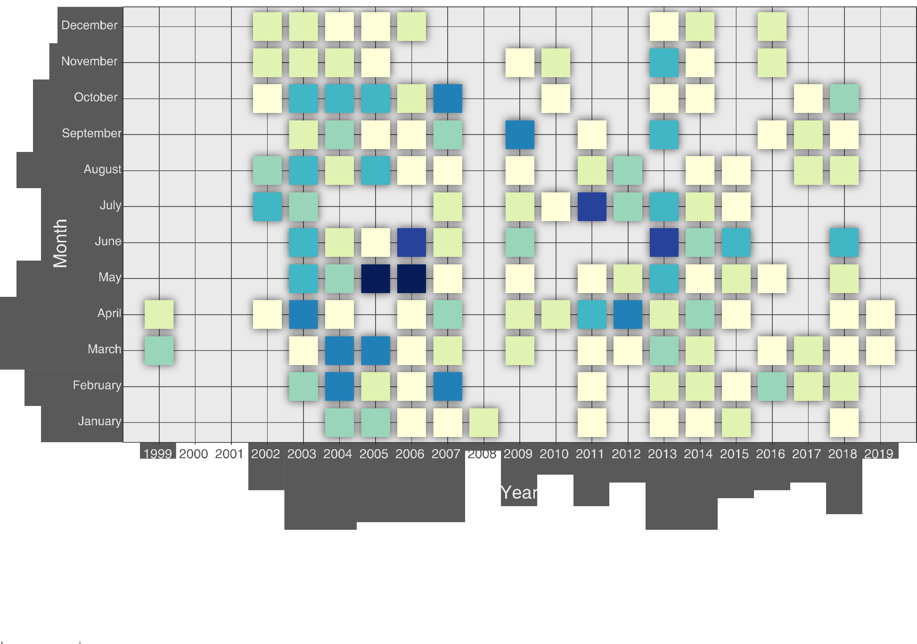

Figure 6: Distribution of the ringing sessions according to year and month. Colo scale indicates the number of ringing sessions.

Additional information for each session were available for some session: starting time (data available for 74% of the sessions), closing time (39%), sum of net lengths (23%), weather condition (45%).

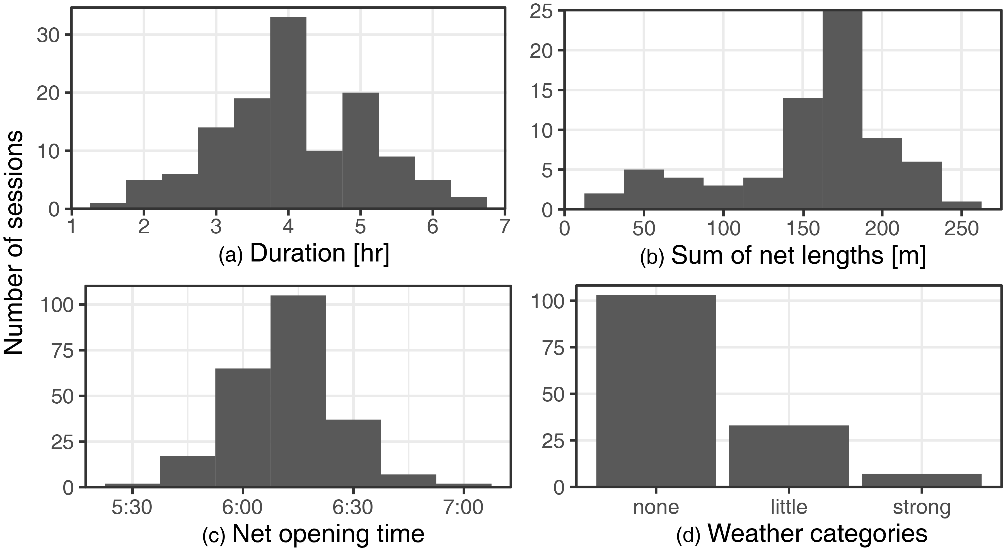

Figure 7: Histograms of the metadata collected for each ringing sessions (N=317) of (a) the total length of nets (N=73), (b) the duration of ringing session (N=124), (c) Weather category (N=143) and (d) hour when session started (N=235).

1. Count Model

The GAM of the count (i.e. number of RCRC captured per session) was tested with (1) year (2) day-of-year (or Julian day), (3) duration of the sessions and (4) starting time, (5) total length of nets and and (6) weather. We first tested a GAM smoothing for each variable separately to analyse its effect (Figure 8).

1. **Year** (Figure 8a). A general decline in overall number of birds is observed over the 20 years of the dataset. It was included as a smoothing term.
2. **Julian** (Figure 8b). Julian days has a strong influence on the number of capture and varies non-linearly. This variable is thus included in a model as a smoothing term.
3. **Duration** (Figure 8c). The duration of the session computed as the difference between closing time and opening time shows an positive correlation with the number of capture. It is thus included in the model as a linear term.
4. **Net opening time** (Figure 8d). The fit of the opening time seems to indicate a higher capture rate for session starting later. This relationship is contrary to knowledge and considered non-meaningful. It is thus not retained for the model.
5. **Sum of net lengths** (Figure 8e). Between 50 and 200m, the fit shows an increase of capture as the total length of the nets increase. Yet, above 200m, the fit shows a stabilisation of the count. This is explain by the fact that the nets added above 200m are located in habitat which are not ideal for RCRC and thus don’t contribute to an increase in capture. This term is included as a smoothing term.
6. **Weather** **categories** (Figure 8f). The weather categories don’t chose a clear pattern and are thus not included in the model.

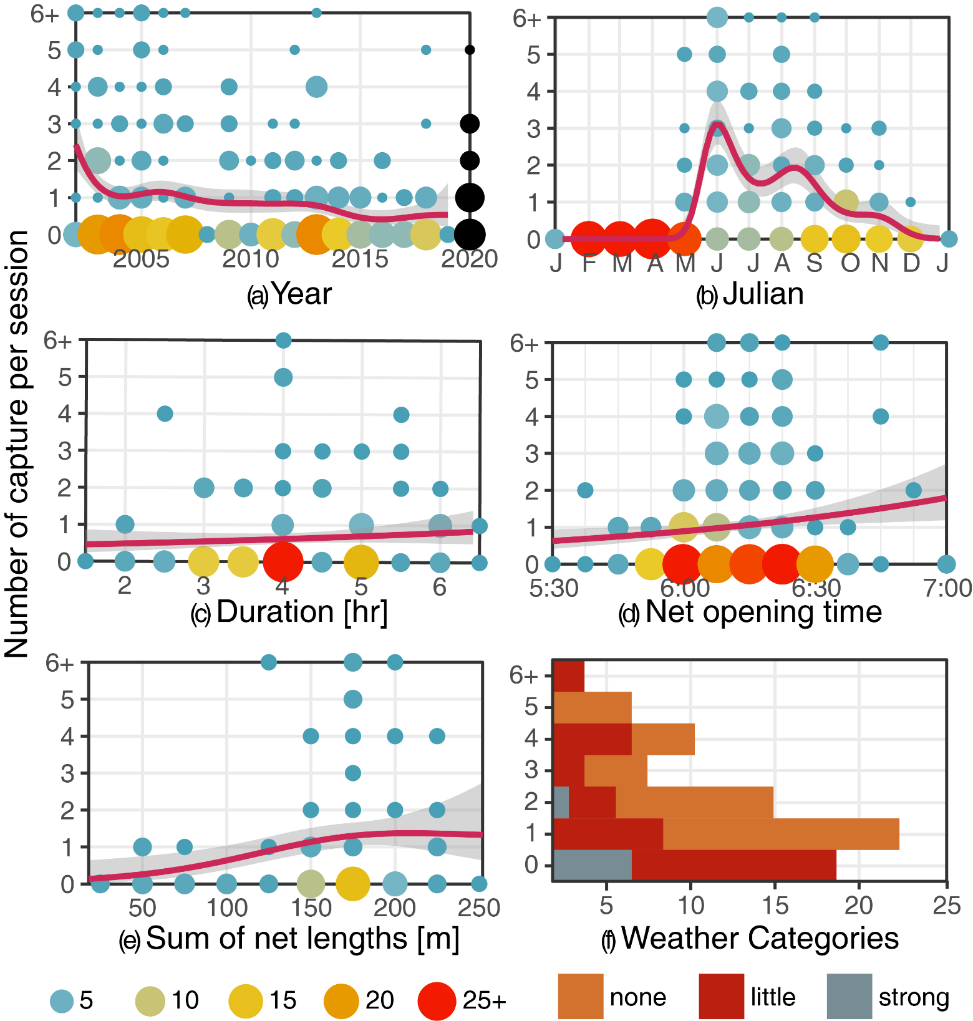

Figure 8: Number of RCRC captured by session as a function of (a) the total length of nets, (b) the duration of ringing session, (c) Weather category and (d) Hour when session started. The blue line with shaded area is a smothed curved fitted on the data (GAM or G

1. Recapture Model

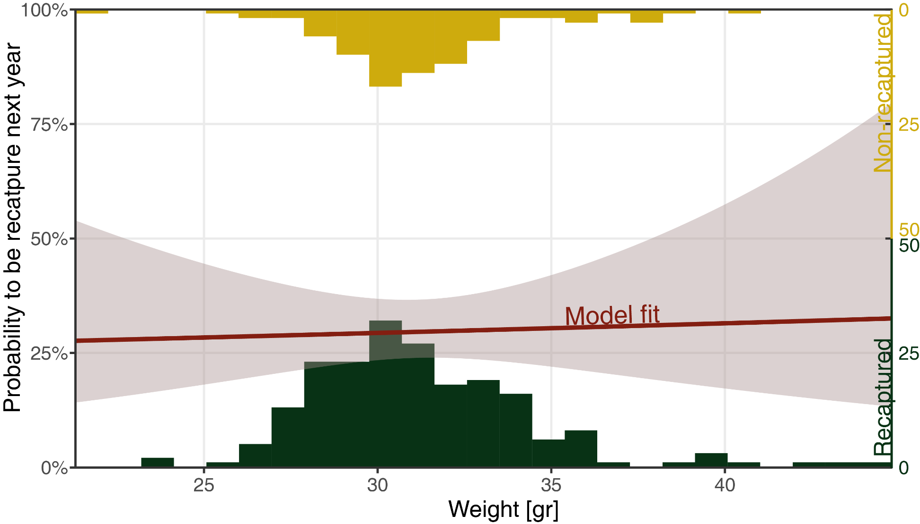

Figure 10: Histograms of the weight for RCRC recaptured in a following year and those not recapture together with the model fit. The uncertainty of the model shows that weight has unclear influence on the recatpure rate.

1. corresponding author: [raphael.nussbaumer@arocha.org](mailto:raphael.nussbaumer@arocha.org)