**Report:6**

**Date: 30th March to 5th April 2025**

**Group-1**

**Project Title: Hard stop and momentary stop using vehicle trajectory dataset**

**Target: Plotted graphs of Instantaneous Velocity vs Time Frame, Acceleration vs Time Frame and Jerk vs Time Frame**

**Team Members:**

| Aarsha shah | AU2240163 |
| --- | --- |
| Hetav shah | AU2240253 |
| Ved Savalia | AU2240242 |
| Parshwa shah | AU2240249 |
| Dev Gorakhiya | AU2240087 |

## **Introduction**

This report details the progress made in Week 6 of our project. In this report, we have focused on enhancing the preprocessed dataset by plotting graphs of Instantaneous Velocity, Acceleration and Jerk. For every vehicle that was tracked (given its unique trackID), we employed scatter plots and line graphs to show changes in motion as a function of time.

This visualization method gives a clear insight into how the motion of the vehicle develops, enabling us to determine when a vehicle is decelerating, temporarily stopping, or coming to a permanent stop. Based on this observation we can analyze the classification of the momentary stop vehicles.

**Graphs**

1. **Instantaneous Velocity vs Time Frame**

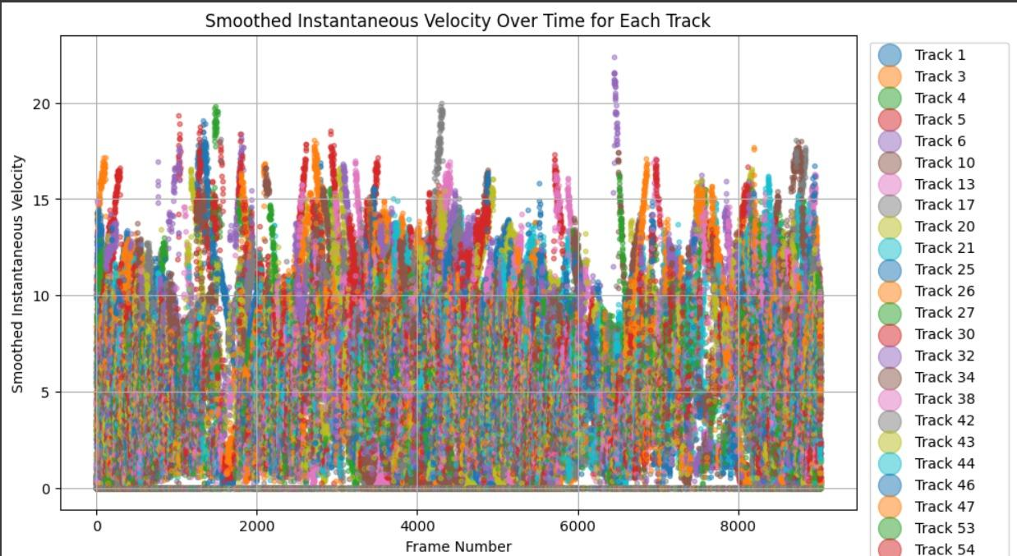

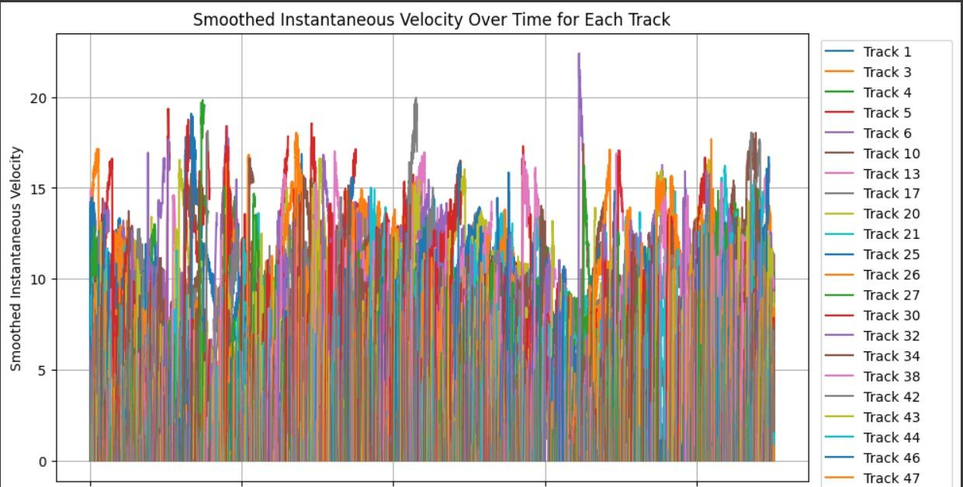

Here as we can see that the plot is varying sinusoidally, i.e first decreasing then increasing, and then again decreasing and so on.

1. **Acceleration vs Time Frame**

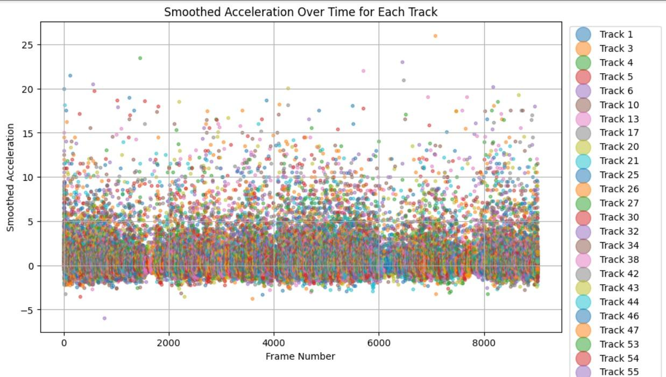

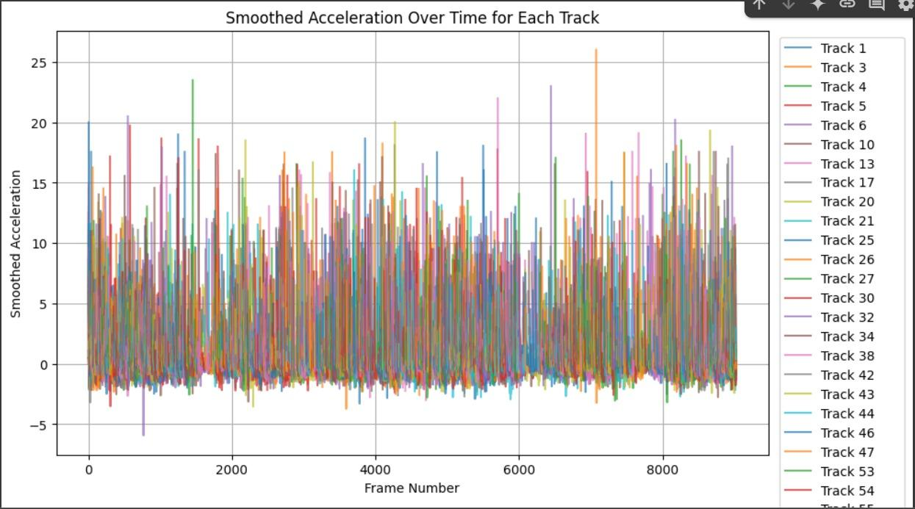

Similarly we can see with the acceleration v/s time graph.

1. **Jerk vs Time Frame**



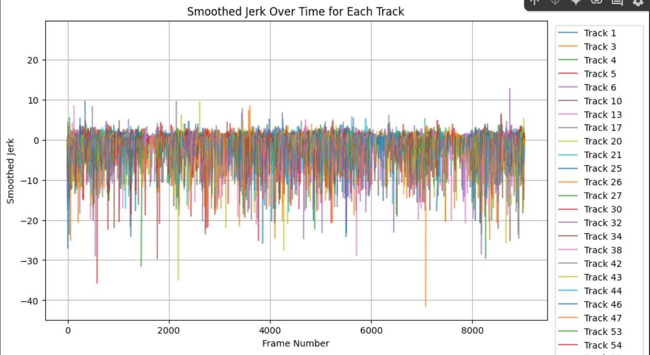

And same with the Jerk v/s time graph

**Future Work**

1. Currently, we are facing some issues with the superimpose part. In which we planned to plot the vehicle’s position(especially the momentary stop classified based on the average velocity value) on each frame and combine to form a single video. Now we have planned to complete it by Tuesday.

2. Alongside we will do research to classify the momentary stop and the hard stop on the video so created in first step directly by using unsupervised clustering algorithms such as k means or DBSCAN, in which we will set some velocity as parameter and based on that the algorithm will make clusters throughout the frame.