Desk Robot
Design, Components List & Build Guide
Palm-height USB desk robot with camera, microphone, speaker and OLED eyes · 14 October 2026

1. Overview
A small, non-moving desk robot that connects to a computer with a single USB cable. It has a USB camera and microphone in the head, a speaker in the body, and a 0.96" OLED that shows animated eyes. Everything inside runs through a small USB hub, so the computer sees a normal webcam, microphone, speaker and a serial device for the eyes.
Key figure | Value
Overall height | 164 mm (within an average palm length)
Footprint (body) | 72 × 58 mm
Connection to PC | 1 × USB cable (USB 2.0)
3D-printed parts | 7 parts, about 165 g PLA, no supports
Target budget | ₹1,500 – 2,000 including 3D printing
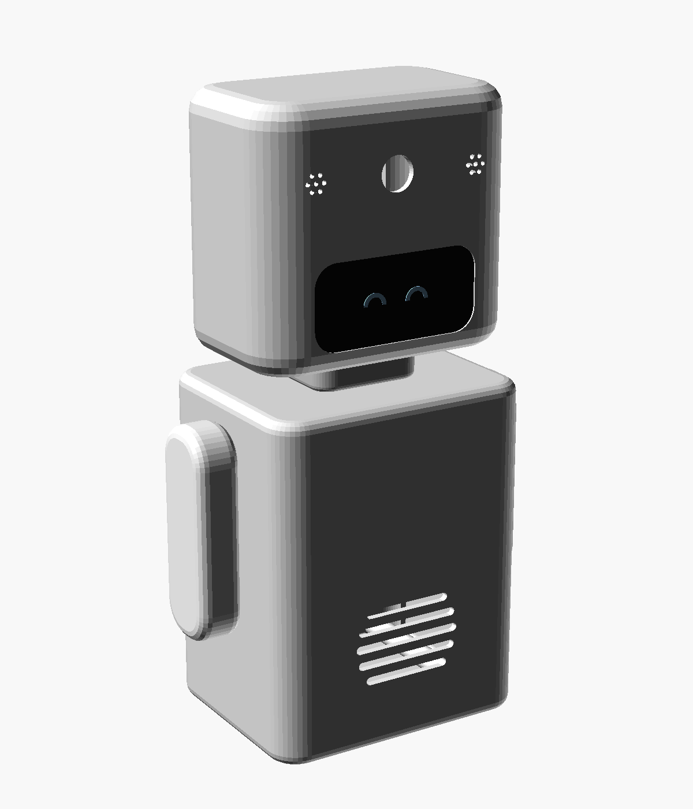
Figure 1. Assembled robot (rendered preview)

2. Enclosure Design

2.1 Construction
- Head and body: rounded box shells, open at the back and printed face-down so the front comes out smooth without supports.
- Back covers: shallow rounded caps with a locating lip, each held by 4 × M2 × 10 self-tapping screws into full-depth bosses.
- Neck: separate hollow tube glued into the head and body. All head wiring runs through its 18 × 12 mm channel.
- Arms: separate, fixed. Each has 2 pegs that glue into holes in the body sides.

2.2 Dimensions
Part | Size W × D × H (mm) | Notes
Body | 72 × 58 × 90 | 8 mm corner radius, speaker grille on the front
Neck (visible) | 30 × 24 × 8 | Hollow wire channel
Head | 72 × 46 × 66 | 12 mm corners, 6 mm rounded edges
Arms (× 2) | 12 × 20 × 56 | Pill-shaped, fixed with pegs
Overall | 164 mm tall

2.3 Features
- Head front: OLED window inside a shallow "visor" recess, camera lens hole above it, and a 7-hole mic grille on each side.
- Head inside: 4 locating pegs for the OLED, 4 camera standoffs, and holder rings for mic capsules.
- Body front: 5-slot speaker grille with a ring that locates a 40 mm speaker.
- Body back cover: pedestal for the controller board, 3 zip-tie anchors for the hub and cable, and a U-notch for the USB cable.
- Body sides and bottom: peg holes for the arms and 4 recesses for optional rubber feet.
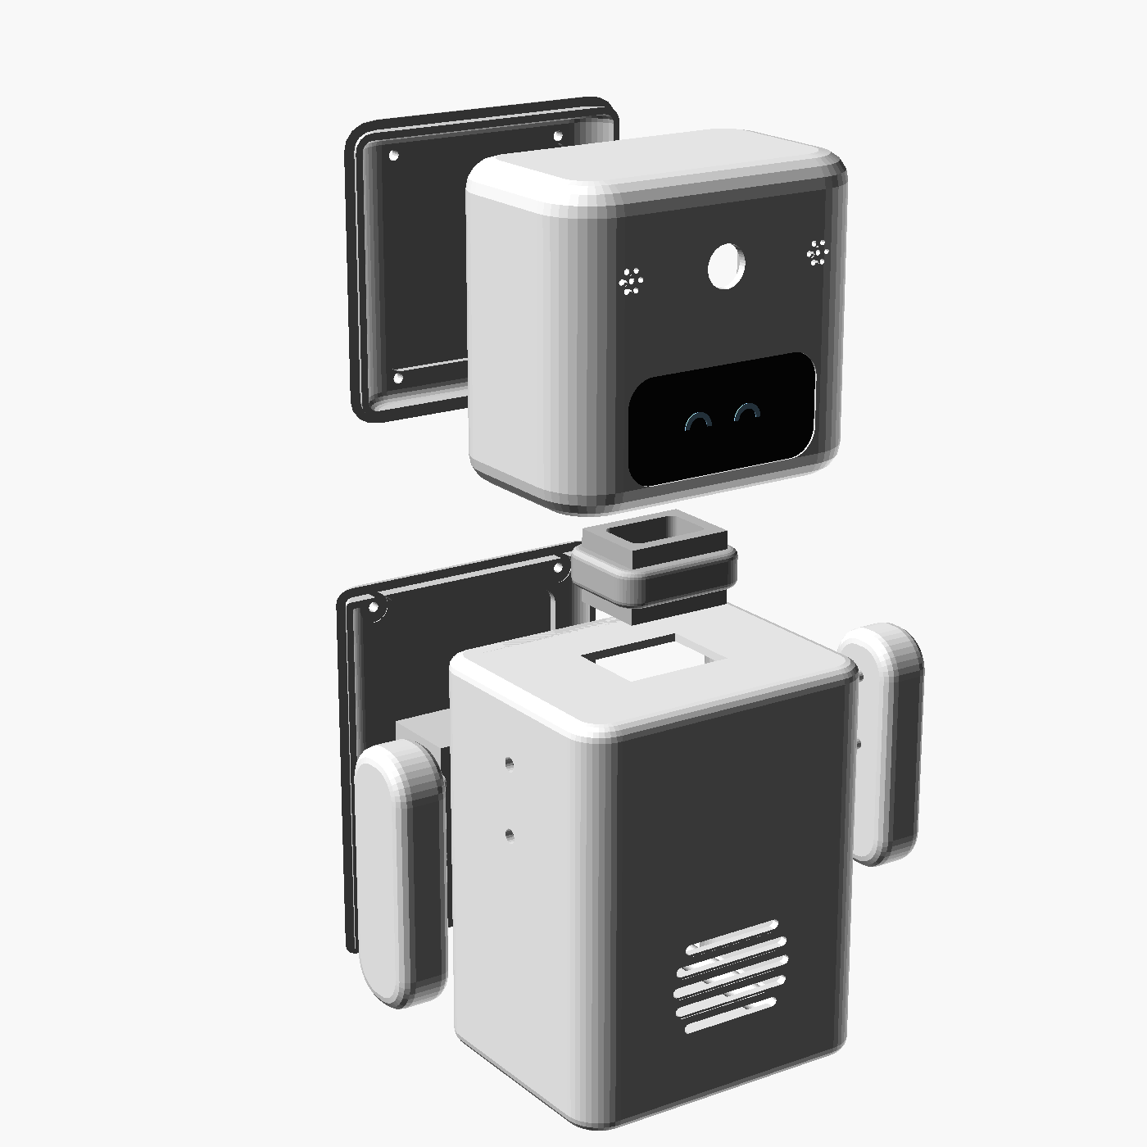  Figure 2. Exploded view | 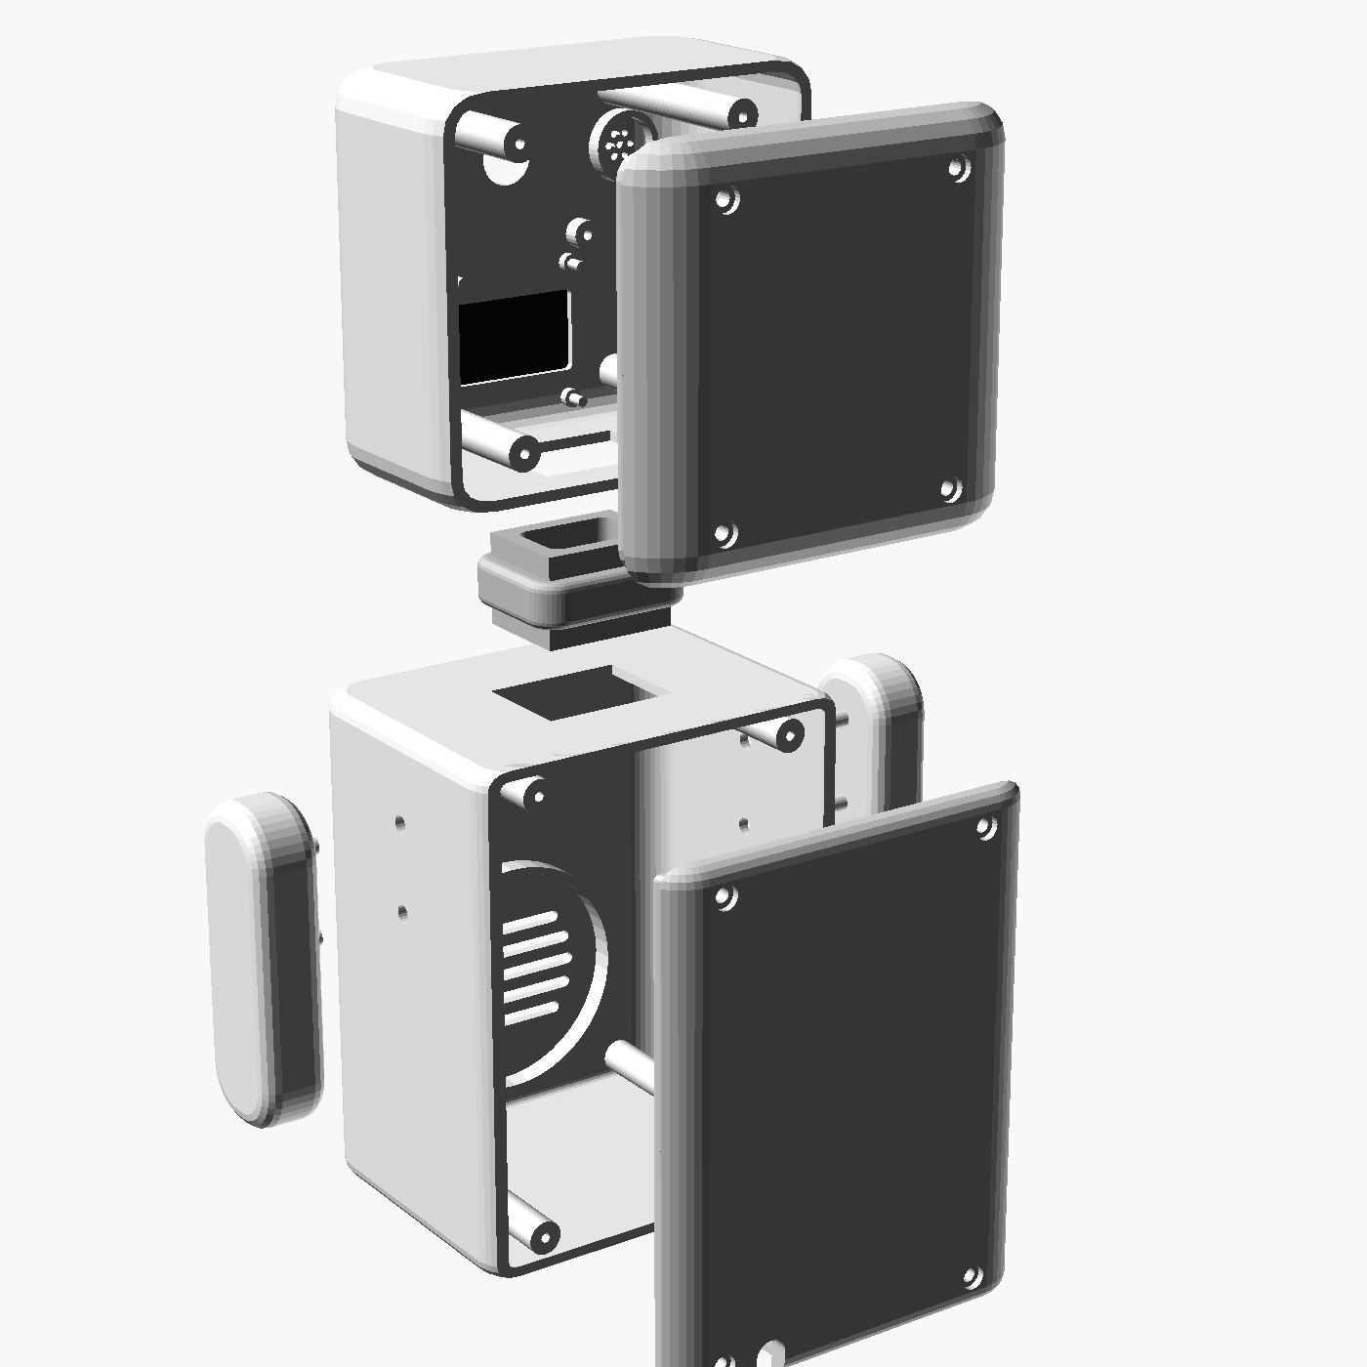  Figure 3. Rear view: bosses and back covers

3. Components List (Budget Build)
Prices are approximate ranges for Robu.in, Robocraze, Amazon.in or a local electronics market. Check the live prices before ordering.

3.1 Electronics
# | Component | Specification to ask for | Qty | Approx. ₹
1 | Arduino Nano clone | ATmega328P, CH340, with USB cable | 1 | 200 – 260
2 | 0.96" OLED display | SSD1306 128×64, I2C 4-pin | 1 | 160 – 200
3 | USB webcam with mic | Cheapest 480p/720p generic, case removed | 1 | 350 – 550
4 | USB sound card | "USB 7.1 / 3D sound" dongle | 1 | 150 – 190
5 | Speaker | 40 mm round, 8 Ω, 0.5 – 1 W | 1 | 25 – 40
6 | USB 2.0 hub | Cheapest 4-port, case removed, with PC cable | 1 | 120 – 180
7 | 3.5 mm plug | Cut from old earphones or aux cable | 1 | 0
8 | Jumper wires | Female-to-female (Nano → OLED) | 4 | 10 – 20

3.2 Hardware and 3D Printing
# | Item | Qty | Approx. ₹
9 | M2 × 10 self-tapping screws | 8 | 30 – 50
10 | Zip ties, double-sided foam tape, Fevikwik / hot glue | — | 40 – 70
11a | PLA ~165 g on your own or a college printer (₹1,000 – 1,300/kg) | 165 g | 170 – 230
11b | or a print service at ₹3 – 5 per gram | 165 g | 500 – 830

3.3 Total Cost
Scenario | Total
Own / college 3D printer | ₹1,250 – 1,800
3D-print service (low-end picks) | ₹1,600 – 2,000
Optional: PAM8403 amp for louder sound | + ₹40 – 60
Optional: rubber feet | + ₹30

3.4 How the Budget Was Reached
Change | Saves | Trade-off
Arduino Nano clone instead of a NodeMCU ESP32 | ₹150 – 200 | Same OLED wiring. Keep the ESP32 if you already own one.
Cheapest webcam with a built-in mic | ₹100 – 300 | One part gives camera and mic. The head mount is adjusted after measuring the board.
No PAM8403 amplifier | ₹40 – 80 | Quieter but fine for a desk. Also uses less USB power. Can be added later.
Lighter model (1.8 mm walls, recessed covers) | ~35 g PLA | None for a desk robot.
No rubber feet, minimal jumper wires | ₹50 – 90 | Use hot-glue dots as feet.

3.5 Buying Tips
- Webcam: buy from a local market if you can and look at the board inside. It should fit in about a 32 × 32 mm space.
- Print service: ask for "PLA, 0.2 mm layers, 15 % infill, no supports" and quote the weight (~165 g), not print hours.
- College lab: using a college 3D-printing lab is the biggest single saving.

4. Wiring and Power

4.1 Connections
From | To | Notes
PC USB port | USB hub (upstream cable) | The only cable leaving the robot
Hub port 1 | USB webcam | Camera + built-in microphone
Hub port 2 | USB sound card | Headphone out (L + GND) → speaker
Hub port 3 | Arduino Nano | Drives the OLED eyes
Nano 5V / GND | OLED VCC / GND | OLED modules accept 3.3 – 5 V
Nano A4 / A5 | OLED SDA / SCL | I2C bus

4.2 USB Power Budget
A USB 2.0 port supplies 500 mA. The budget build uses roughly 300 – 400 mA, which leaves a safe margin.
Device | Typical current
Webcam | 150 – 250 mA
Arduino Nano + OLED | ≈ 30 mA
Sound card + speaker (no amp) | 50 – 100 mA
Total | ≈ 300 – 400 mA
If you add the PAM8403 amp, keep the volume moderate or use a USB 3.0 (blue) port, which supplies 900 mA.

5. 3D Printing
Settings: PLA, 0.2 mm layers, 4 perimeters (walls are 1.8 mm), 15 % infill, no supports. All parts fit together on one 220 × 220 mm bed (plate_all_parts.stl).
Part (STL file) | Print orientation | Qty | Approx. PLA
body_shell.stl | Face down | 1 | 56 g
body_back.stl | Outer face down | 1 | 26 g
head_shell.stl | Face down | 1 | 33 g
head_back.stl | Outer face down | 1 | 17 g
neck.stl | Upright | 1 | 4 g
arm_left.stl / arm_right.stl | Outer face down, pegs up | 2 | 8 g each
Total (incl. ~10 % waste) |  | 7 parts | ≈ 165 g
Visor tip: pause at 0.6 mm and switch to black filament for the first layers of the head to get a black visor around the eyes. Otherwise paint the recess.

6. Assembly
- Route the head wires through the neck, then glue the neck into the body top and the head bottom.
- Glue the arm pegs into the holes on the body sides.
- Head: press the OLED onto its 4 pegs (glass against the window) and fix it with a dab of hot glue. Screw or glue the webcam board to its standoffs with the lens in the lens hole.
- Body: hot-glue the speaker into its ring. Fix the Arduino Nano to the pedestal on the back cover with foam tape, USB end up. Zip-tie the hub to the anchors and tape the sound card inside.
- Wire everything as in section 4.1.
- Lay the PC cable in the U-notch and zip-tie it to the lowest anchor for strain relief. Then screw on both back covers.
- Upload the eye-animation code to the Nano (Arduino IDE with the Adafruit SSD1306 or U8g2 library).

7. Before You Print: Measure Your Parts
The model uses typical sizes. Measure your actual parts, set these values at the top of desk_robot.scad, and re-export the STLs (or ask for the model to be updated).
Parameter | What to measure
cam_pcb, cam_hole_spacing | Webcam board size and its mounting-hole spacing
cam_lens_hole_d, cam_standoff_h | Lens diameter, and how far the lens sticks out of the board
mic_x | Position of the webcam's built-in mic (move the grille to it)
oled_hole_dx, oled_hole_dz, oled_view_dz | OLED hole spacing and where the glass sits on the board
spk_d | Speaker diameter (default 40 mm)
head_h / body_* | Increase if the webcam board is larger than about 32 mm

8. Files in This Package
File / folder | Contents
Desk_Robot_Design_and_Components.docx | This document
robot/desk_robot.scad | Adjustable OpenSCAD source (OpenSCAD 2021.01+)
robot/stl/ | 7 print-ready STL files plus plate_all_parts.stl
robot/renders/ | Preview images (assembly, exploded, back, internals, print plate)
robot/BOM.md | Components list (Markdown)
robot/README.md | Print and assembly quick guide
docs/…/desk-robot-enclosure-design.md | Design record

