Desk Robot
ESP32-CAM Build: Design, Components List & Build Guide
Palm-height desk robot with camera, microphone, speaker and OLED eyes · 15 October 2026

1. Overview
A small, non-moving desk robot built around an ESP32-CAM, which acts as both the camera and the controller. An INMP441 microphone, a small speaker with a PAM8403 amplifier, and a 0.96" OLED showing animated eyes are wired to it. One USB cable links the robot to the computer through an ESP32-CAM-MB USB board.
Key figure | Value
Overall height | 159 mm (within an average palm length)
Head / body | 72 × 46 × 71 mm / 72 × 50 × 80 mm
Connection to PC | 1 × micro-USB cable (power + serial). Wi-Fi is optional for faster video.
3D-printed parts | 7 parts, about 155 g PLA, no supports
Budget | ₹1,050 – 1,550 with your own printer (₹1,350 – 2,100 with a print service)
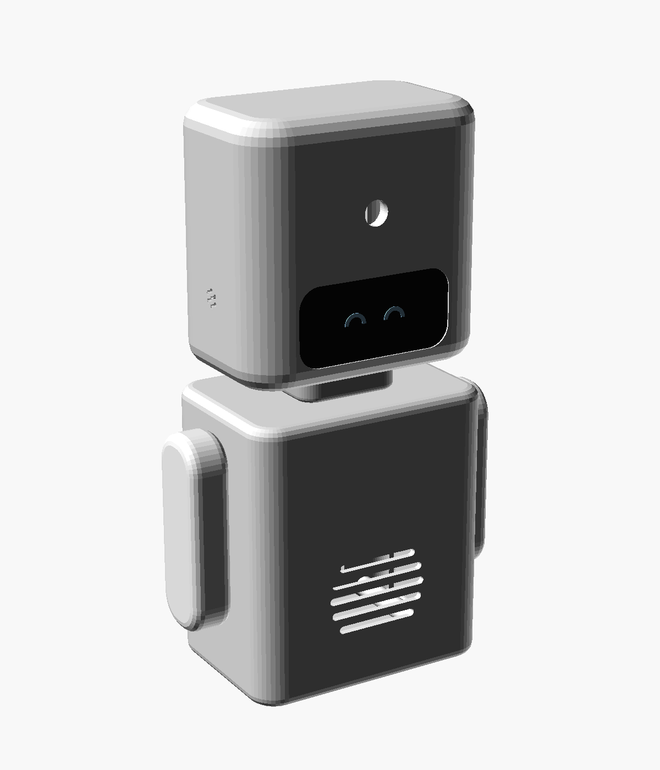
Figure 1. Assembled robot (rendered preview)

2. Enclosure Design

2.1 Construction
- Head and body: rounded box shells, open at the back and printed face-down so the front comes out smooth without supports.
- Back covers: shallow rounded caps with a locating lip, each held by 4 × M2 × 10 self-tapping screws.
- Neck: hollow tube glued into the head and body. All head wiring runs through its 18 × 12 mm channel.
- Arms: fixed, each glued in with 2 pegs.

2.2 What Goes Where
Location | Part | How it is held
Head front, upper | ESP32-CAM, mounted sideways | Lens sits in a printed collar behind the lens hole. Board ends are hot-glued to 2 posts.
Head front, lower | 0.96" OLED (eyes) | 4 locating pegs, with the glass against the visor window
Head sides | INMP441 mic ("ears") | Square pocket behind a 7-hole grille on each side; use either one
Body front | 40 mm speaker | Locating ring behind the 5-slot grille, hot glue
Body back cover | ESP32-CAM-MB USB board | Pedestal and foam tape, micro-USB end down
Body back cover | PAM8403 amplifier | Foam tape near the zip-tie anchors
Body bottom (back) | USB cable | U-notch in the back cover

Why the camera is sideways: the ESP32-CAM board (40.5 mm) and the OLED (27.8 mm) do not fit one above the other in a palm-sized head. Mounting the board sideways keeps the head small. The camera image therefore comes out rotated 90°, which one line of code fixes on the PC (for example, cv2.rotate).
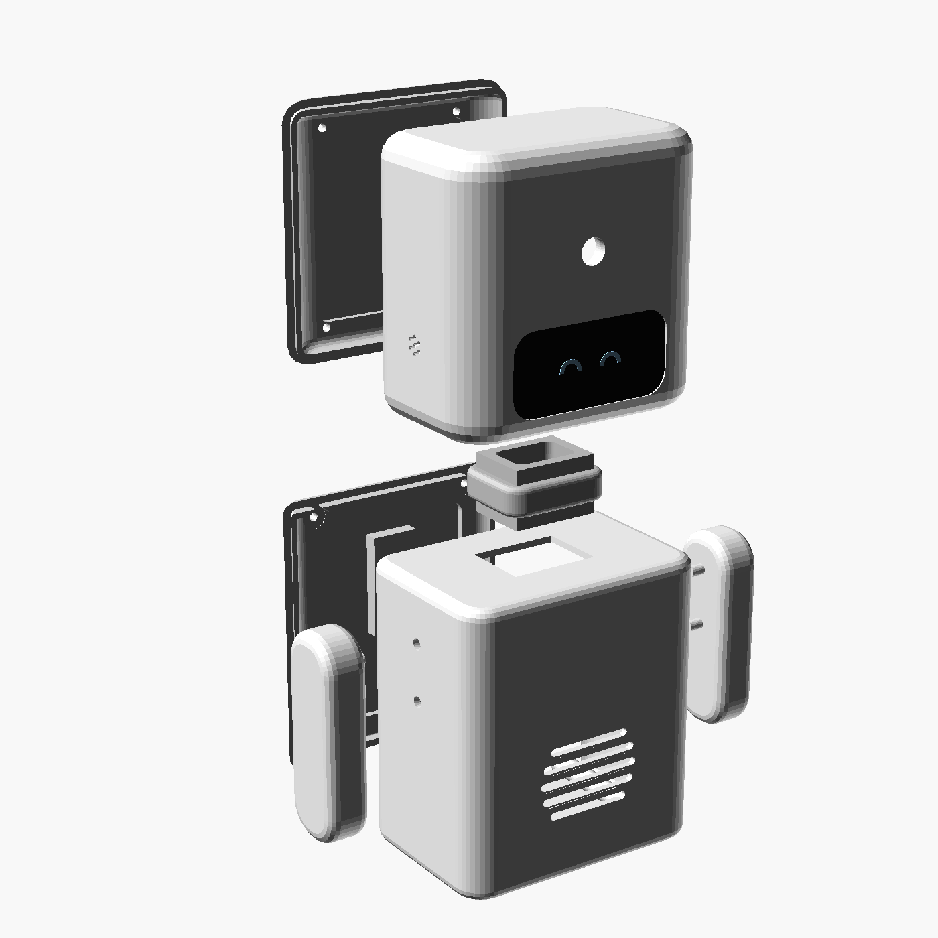  Figure 2. Exploded view | 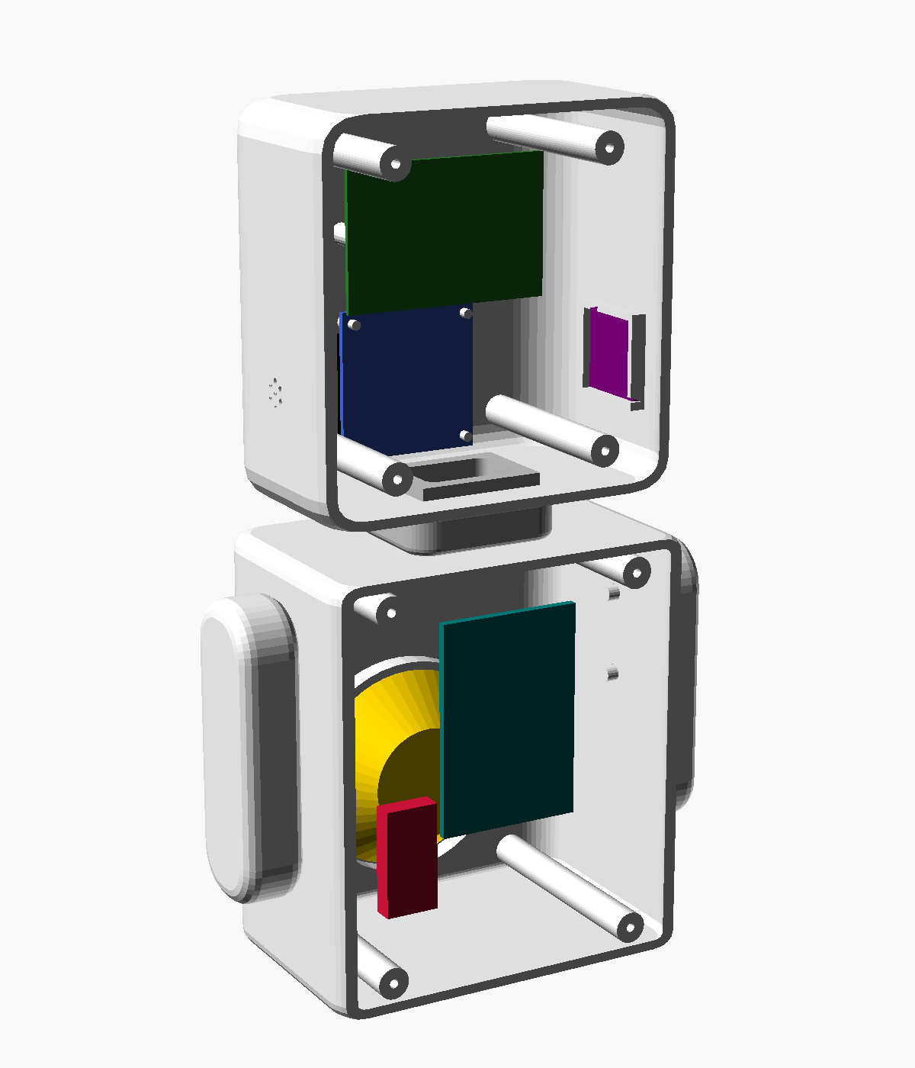  Figure 3. Inside view (covers off)

3. Components List (Budget Build)
Prices are approximate ranges for Robu.in, Robocraze, Amazon.in or a local electronics market. Check the live prices before ordering.

3.1 Electronics
# | Component | Specification to ask for | Qty | Approx. ₹
1 | ESP32-CAM + ESP32-CAM-MB | AI-Thinker, OV2640 camera, MB USB board (CH340). Buy as a combo. | 1 set | 450 – 600
2 | INMP441 microphone | I2S MEMS mic breakout (6-pin) | 1 | 130 – 180
3 | Speaker | 40 mm round, 8 Ω, 0.5 – 1 W | 1 | 20 – 40
4 | PAM8403 amplifier | Mini 5 V module | 1 | 35 – 60
5 | 0.96" OLED (optional) | SSD1306 128×64, I2C 4-pin | 1 | 160 – 200
6 | Micro-USB cable | Must be a data cable (a phone cable works) | 1 | 0 – 80
7 | Jumper wires | ~10 male-to-female + ~6 female-to-female | ~16 | 30 – 50
8 | Capacitors and resistor | 470 µF / 10 V capacitor, 1 kΩ resistor, 100 nF capacitor | 1 each | 10 – 15

3.2 Hardware and 3D Printing
# | Item | Qty | Approx. ₹
9 | M2 × 10 self-tapping screws | 8 | 30 – 50
10 | Zip ties, double-sided foam tape, Fevikwik / hot glue | — | 40 – 70
11a | PLA ~155 g on your own or a college printer | 155 g | 155 – 200
11b | or a print service at ₹3 – 5 per gram | 155 g | 470 – 780

3.3 Total Cost
Scenario | Total
Own / college 3D printer | ₹1,050 – 1,550
3D-print service | ₹1,350 – 2,100
Skip the OLED (print or paint the eyes) | − ₹160 – 200

3.4 Parts the ESP32-CAM Replaces
Removed part | Was ₹ | Replaced by
USB webcam | 350 – 550 | ESP32-CAM camera
Arduino Nano | 200 – 260 | ESP32-CAM
USB hub | 120 – 180 | Not needed: one USB device
USB sound card | 150 – 190 | INMP441 mic + PAM8403, driven by the ESP32-CAM

4. Wiring and Power

4.1 Pin Connections
ESP32-CAM pin | Connects to | Notes
5V, GND | MB board 5V, GND | Power from USB. Fit the 470 µF capacitor across 5V and GND.
U0T, U0R | MB board U0R, U0T | USB serial link to the PC (crossed)
IO0 | MB board IO0 | Needed for flashing
IO13, IO15 | OLED SDA, SCL | OLED VCC to 3V3
IO14 | INMP441 SCK | I2S bit clock
IO4 | INMP441 WS | Shared with the flash LED: remove or cover the LED
IO2 | INMP441 SD | Mic L/R to GND, VDD to 3V3
IO12 | 1 kΩ → PAM8403 IN (100 nF to GND) | PWM audio. The filter keeps IO12 low at boot.
MB 5V, GND | PAM8403 power | PAM8403 output to the speaker

4.2 Power and Data
- Power: the ESP32-CAM draws about 120 – 300 mA (more with Wi-Fi on), plus the amplifier. That is within the 500 mA a USB 2.0 port supplies at moderate volume.
- Wired data: video over the USB serial link is limited to about 5 – 10 fps at 320×240.
- Wi-Fi data: smooth video at about 15 – 25 fps, with the USB cable used for power and control. The hardware is the same; only the code differs.

5. 3D Printing
Settings: PLA, 0.2 mm layers, 4 perimeters (walls are 1.8 mm), 15 % infill, no supports. All parts fit together on one 220 × 220 mm bed (plate_all_parts.stl).
Part (STL file) | Print orientation | Qty | Approx. PLA
body_shell.stl | Face down | 1 | 46 g
body_back.stl | Outer face down | 1 | 21 g
head_shell.stl | Face down | 1 | 36 g
head_back.stl | Outer face down | 1 | 18 g
neck.stl | Upright | 1 | 4 g
arm_left.stl / arm_right.stl | Outer face down, pegs up | 2 | 8 g each
Total (incl. ~10 % waste) |  | 7 parts | ≈ 155 g
Visor tip: pause at 0.6 mm and switch to black filament for the first layers of the head to get a black visor around the eyes. Otherwise paint the recess.

6. Assembly
- Prepare the ESP32-CAM: remove or cover the flash LED, and solder the 470 µF capacitor across 5V and GND.
- Route the head wires through the neck, then glue the neck into the body top and the head bottom. Glue the arm pegs into the body sides.
- Head: press the OLED onto its pegs (glass against the window). Seat the camera lens in the collar and hot-glue the board ends to the two posts. Glue the INMP441 into a side pocket, sound hole facing the grille.
- Body: hot-glue the speaker into its ring. Foam-tape the ESP32-CAM-MB onto the back-cover pedestal, micro-USB end down. Tape the PAM8403 near the anchors.
- Wire everything as in section 4.1.
- Plug the USB cable into the MB board, lay it in the U-notch, and screw on both back covers.
- Flash the firmware from the Arduino IDE (board: AI Thinker ESP32-CAM) and rotate the camera image 90° on the PC.

7. Before You Print: Measure Your Parts
The model uses typical sizes. Measure your actual parts, set these values at the top of desk_robot.scad, and re-export the STLs.
Parameter | What to measure
cam_lens_d | Camera lens barrel diameter (default 8 mm)
cam_lens_dx | How far the lens is from the board centre along its length (default 5 mm)
cam_front_gap | How far the lens sticks out from the board (default 7.5 mm)
oled_hole_dx, oled_hole_dz, oled_view_dz | OLED hole spacing and where the glass sits on the board
mic_board | INMP441 breakout size (default 15 × 15 mm)
mb_board, spk_d | ESP32-CAM-MB size and speaker diameter

8. Files in This Package
File / folder | Contents
Desk_Robot_ESP32-CAM_Design.docx | This document
robot/desk_robot.scad | Adjustable OpenSCAD source (OpenSCAD 2021.01+)
robot/stl/ | 7 print-ready STL files plus plate_all_parts.stl
robot/renders/ | Preview images (assembly, exploded, back, internals, print plate)
robot/BOM.md | Components list and pin wiring (Markdown)
robot/README.md | Print and assembly quick guide
docs/…/desk-robot-enclosure-design.md | Design record

