A lot of analysis

## Read in the data

Due to the inconsistent column naming covention, we manually convert the cx column to cX in an effort to reduce obfuscation.

# Read in the data  
data <- read.csv('Greatest_Aussie_Groceries_sales_data.csv', header=TRUE, sep=",")  
# Change column name of cx to match style of capital X and Y  
colnames(data)[colnames(data)=="cx"] <- "cX"

### Reformatting Data

# Organic X  
dataR <- data %>% filter(class=="organic") %>% select(STORE, WEEK, Hval_150, pX, cX, oz_X, deal_X, feat_X)  
dataR$brand <- "X"  
dataR$class <- "organic"  
colnames(dataR) <- c("STORE", "WEEK", "Hval", "p", "c", "oz", "deal", "feat", "brand", "class")  
data.ref <- dataR  
# Organic Y  
dataR <- data %>% filter(class=="organic") %>% select(STORE, WEEK, Hval_150, pY, cY, oz_Y, deal_Y, feat_Y)  
dataR$brand <- "Y"  
dataR$class <- "organic"  
colnames(dataR) <- c("STORE", "WEEK", "Hval", "p", "c", "oz", "deal", "feat", "brand", "class")  
data.ref <- rbind(data.ref, dataR)  
# NonOrganic X  
dataR <- data %>% filter(class=="nonorganic") %>% select(STORE, WEEK, Hval_150, pX, cX, oz_X, deal_X, feat_X)  
dataR$brand <- "X"  
dataR$class <- "nonorganic"  
colnames(dataR) <- c("STORE", "WEEK", "Hval", "p", "c", "oz", "deal", "feat", "brand", "class")  
data.ref <- rbind(data.ref, dataR)  
# NonOrganic Y  
dataR <- data %>% filter(class=="nonorganic") %>% select(STORE, WEEK, Hval_150, pY, cY, oz_Y, deal_Y, feat_Y)  
dataR$brand <- "Y"  
dataR$class <- "nonorganic"  
colnames(dataR) <- c("STORE", "WEEK", "Hval", "p", "c", "oz", "deal", "feat", "brand", "class")  
data.ref <- rbind(data.ref, dataR)

## Mutate Data

We mutate the data to include columns for deal_feat (an indictator for both deal and features), revenue, and profit.

# Append a deal_feat column for X and Y  
data <- mutate(data, deal_feat_Y = deal_Y*10 + feat_Y, deal_feat_X = deal_X*10 + feat_X)  
# Append a revenue column for X and Y   
data <- mutate(data, rev_X = oz_X * pX, rev_Y = oz_Y * pY)  
# Append a profit column for X and Y   
data <- mutate(data, profit_X = rev_X - cX * pX, profit_Y = rev_Y - cY * pY)

## Summary Plots

Lets start by just plotting the profit over the 52 weeks for each store.

plotStore <- function(store_ID) {  
# The palette with black:  
cbbPalette <- c("red4", "orange1", "blue4", "skyblue1", "green4", "chartreuse1", "darkorchid4", "mediumorchid1")  
# Pull data into temp results dataframe  
results <- data.frame(WEEK=c(1:52))  
results[,c("profit_X_org","profit_Y_org")] <- data %>% filter(.,STORE==store_ID, class=="organic") %>% select(.,profit_X, profit_Y)  
results[,c("profit_X_non","profit_Y_non")] <- data %>% filter(.,STORE==store_ID, class=="nonorganic") %>% select(.,profit_X, profit_Y)  
results[,c("profit_X_org_col","profit_Y_org_col")] <- data %>% filter(.,STORE==store_ID, class=="organic") %>% select(.,deal_X, deal_Y)  
results[,c("profit_X_non_col","profit_Y_non_col")] <- data %>% filter(.,STORE==store_ID, class=="nonorganic") %>% select(.,deal_X, deal_Y)  
# Assign legend name to categorical data  
results$profit_X_org_col[results$profit_X_org_col == 0] <- "X organic w/o deal"  
results$profit_X_org_col[results$profit_X_org_col == 1] <- "X organic w/ deal"  
results$profit_Y_org_col[results$profit_Y_org_col == 0] <- "Y organic w/o deal"  
results$profit_Y_org_col[results$profit_Y_org_col == 1] <- "Y organic w deal"  
results$profit_X_non_col[results$profit_X_non_col == 0] <- "X nonorganic w/o deal"  
results$profit_X_non_col[results$profit_X_non_col == 1] <- "X nonorganic w deal"  
results$profit_Y_non_col[results$profit_Y_non_col == 0] <- "Y nonorganic w/o deal"  
results$profit_Y_non_col[results$profit_Y_non_col == 1] <- "Y nonorganic w deal"  
# Plot results  
ggplot(results, aes(x=WEEK)) +   
 geom_point(aes(y=profit_X_org, colour=profit_X_org_col)) +  
 geom_point(aes(y=profit_Y_org, colour=profit_Y_org_col)) +   
 geom_point(aes(y=profit_X_non, colour=profit_X_non_col)) +  
 geom_point(aes(y=profit_Y_non, colour=profit_Y_non_col)) +   
 scale_colour_manual(values=cbbPalette) +  
 labs(x = "Week", y = "Profit", title = paste("Profit for Store",store_ID))   
}  
  
# Plot the data  
plotStore(1)

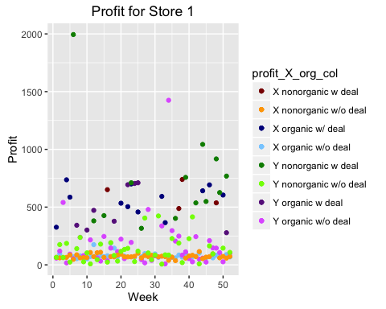

plotStore(2)

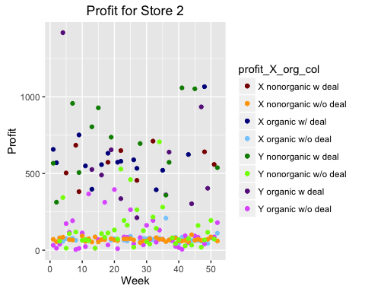

plotStore(3)

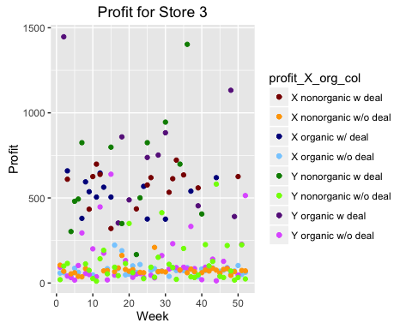

plotStore(4)

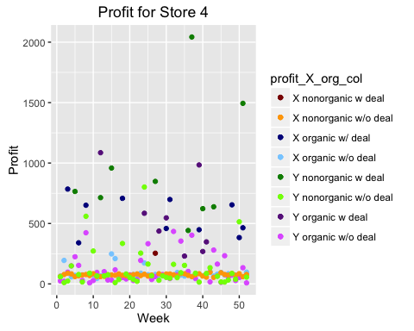

plotStore(5)

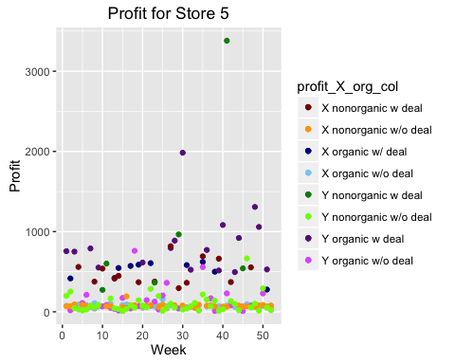

plotStore(6)

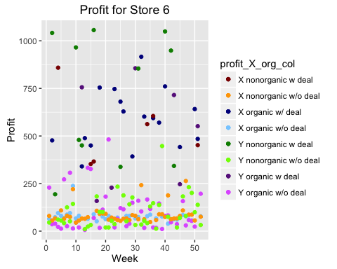

plotStore(7)

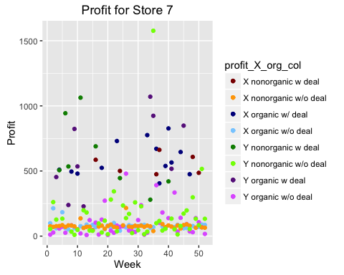

## General Scatter Plot  
cbbPalette <- c("red4", "orange1", "blue4", "skyblue1", "green4", "chartreuse1", "darkorchid4", "mediumorchid1")  
generalScatterResults <- data.ref %>% select(WEEK, p, c, oz, deal, class, brand)  
generalScatterResults$deal[generalScatterResults$deal == 1] = "w deal"  
generalScatterResults$deal[generalScatterResults$deal == 0] = "w/o deal"  
generalScatterResults <- generalScatterResults %>% mutate(profit=oz*(p-c))  
generalScatterResults <- generalScatterResults %>% mutate(type=paste(brand,class,deal,sep=" "))  
ggplot(generalScatterResults, aes(x=WEEK)) +   
 geom_point(aes(y=profit, colour=type)) +  
 scale_colour_manual(values=cbbPalette) +  
 labs(x = "Week", y = "Profit", title = "Profit for products across all stores")

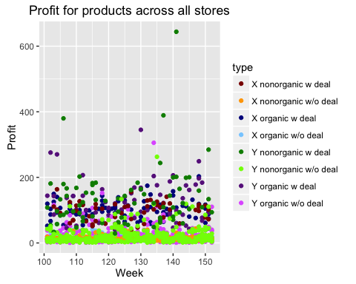

# Box plots of profit for the different products

This is just a simple box plot analysis

# Function to retreve data from dataframe and composite into factor  
retrieveData <- function(data, deal, CLASS, xy) {  
 names <- c("STORE", "PROFIT")  
 if (xy == "x")  
 temp <- data %>% filter(deal_X==deal, class==CLASS) %>% select(STORE, profit_X)  
 else  
 temp <- data %>% filter(deal_Y==deal, class==CLASS) %>% select(STORE, profit_Y)  
 colnames(temp) <- names  
 name <- if (xy == "x") "X" else "Y"  
 name <- if (CLASS == "organic") paste(name,"O",sep="") else paste(name,"I",sep="")   
 name <- if (deal == 1) paste(name,"deal",sep="_") else paste(name,"no_deal",sep="_")   
 return(data.frame(type=rep(name,nrow(temp)),temp))  
}  
  
boxplot_data <- retrieveData(data, deal=0, CLASS="organic", xy="x")  
boxplot_data <- rbind(boxplot_data,retrieveData(data, deal=0, CLASS="nonorganic", xy="x"))  
boxplot_data <- rbind(boxplot_data,retrieveData(data, deal=0, CLASS="organic", xy="y"))  
boxplot_data <- rbind(boxplot_data,retrieveData(data, deal=0, CLASS="nonorganic", xy="y"))  
boxplot_data <- rbind(boxplot_data,retrieveData(data, deal=1, CLASS="organic", xy="x"))  
boxplot_data <- rbind(boxplot_data,retrieveData(data, deal=1, CLASS="nonorganic", xy="x"))  
boxplot_data <- rbind(boxplot_data,retrieveData(data, deal=1, CLASS="organic", xy="y"))  
boxplot_data <- rbind(boxplot_data,retrieveData(data, deal=1, CLASS="nonorganic", xy="y"))  
  
ggplot(boxplot_data, aes(x=type, y=PROFIT)) + geom_boxplot() + labs(title="Boxplots of profit for different products", x="Product", y = "Profit")

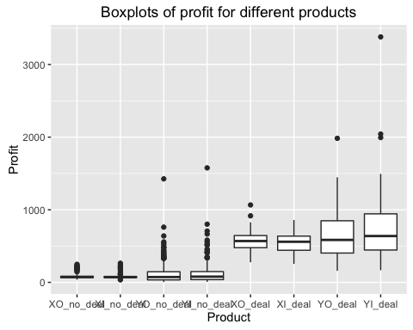

Given the massive spread between no deal and deal data, let's take a log10() scale transform of the y-axis

boxplot_data <- mutate(boxplot_data, log10PROFIT=log10(PROFIT))  
ggplot(boxplot_data, aes(x=type, y=log10PROFIT)) + geom_boxplot() + labs(title="Boxplots of log10(profit) for different products", x="Product", y = "log10(Profit)")

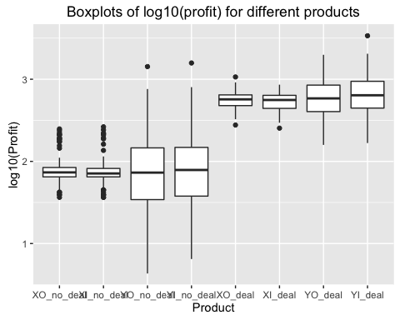

It is clear from these boxplots that the median values for X and Y products are approximately equal. The spread of profit for Y is much larger than X. Profit increases dramatically when a deal is going on.

Just as an additional spam of figures, lets look at the box plots for each product seperated by store (again with a log10 scaling)

boxplot_data %>% filter(type=="XO_no_deal") %>% ggplot(., aes(x=STORE, y=PROFIT)) + geom_boxplot(aes(group = cut_width(STORE, 1))) + labs(title=paste("Profit of", "XO_no_deal" ,"for different stores"), x="Store", y = "Profit")

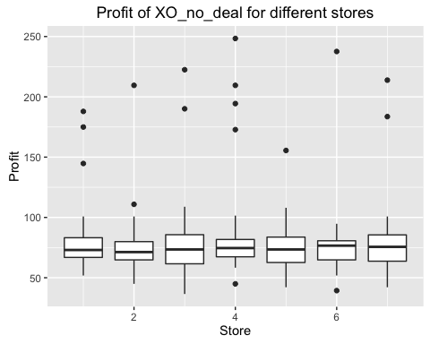

boxplot_data %>% filter(type=="XI_no_deal") %>% ggplot(., aes(x=STORE, y=PROFIT)) + geom_boxplot(aes(group = cut_width(STORE, 1))) + labs(title=paste("Profit of", "XI_no_deal" ,"for different stores"), x="Store", y = "Profit")

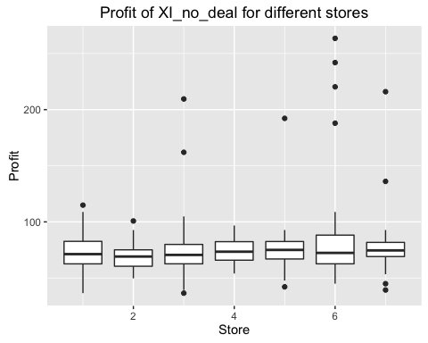

boxplot_data %>% filter(type=="YO_no_deal") %>% ggplot(., aes(x=STORE, y=PROFIT)) + geom_boxplot(aes(group = cut_width(STORE, 1))) + labs(title=paste("Profit of", "YO_no_deal" ,"for different stores"), x="Store", y = "Profit")

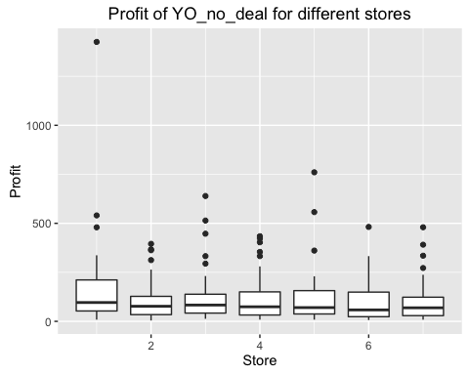

boxplot_data %>% filter(type=="YI_no_deal") %>% ggplot(., aes(x=STORE, y=PROFIT)) + geom_boxplot(aes(group = cut_width(STORE, 1))) + labs(title=paste("Profit of", "YI_no_deal" ,"for different stores"), x="Store", y = "Profit")

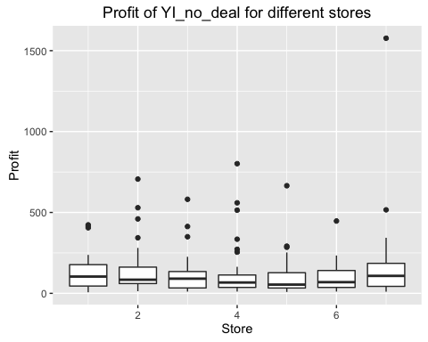

boxplot_data %>% filter(type=="XO_deal") %>% ggplot(., aes(x=STORE, y=PROFIT)) + geom_boxplot(aes(group = cut_width(STORE, 1))) + labs(title=paste("Profit of", "XO_deal" ,"for different stores"), x="Store", y = "Profit")

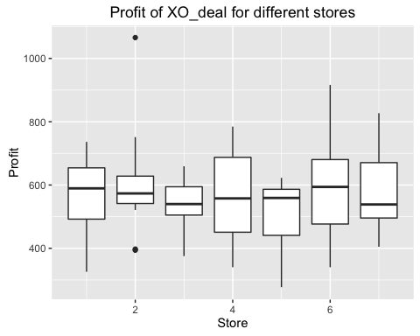

boxplot_data %>% filter(type=="XI_deal") %>% ggplot(., aes(x=STORE, y=PROFIT)) + geom_boxplot(aes(group = cut_width(STORE, 1))) + labs(title=paste("Profit of", "XI_deal" ,"for different stores"), x="Store", y = "Profit")

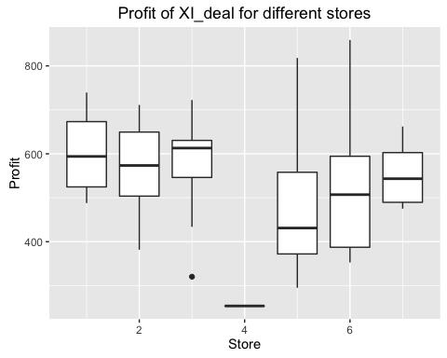

boxplot_data %>% filter(type=="YO_deal") %>% ggplot(., aes(x=STORE, y=PROFIT)) + geom_boxplot(aes(group = cut_width(STORE, 1))) + labs(title=paste("Profit of", "YO_deal" ,"for different stores"), x="Store", y = "Profit")

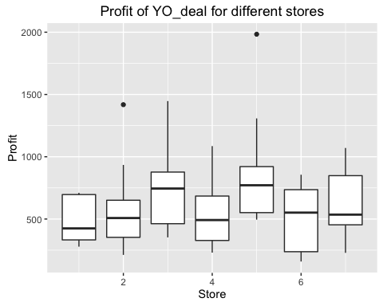

boxplot_data %>% filter(type=="YI_deal") %>% ggplot(., aes(x=STORE, y=PROFIT)) + geom_boxplot(aes(group = cut_width(STORE, 1))) + labs(title=paste("Profit of", "YI_deal" ,"for different stores"), x="Store", y = "Profit")

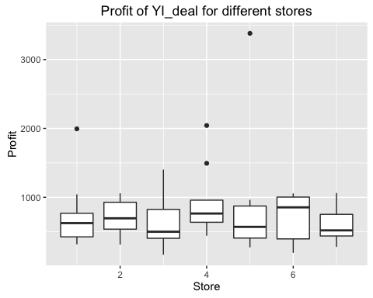

## Regression

# Function that pulls out the data  
retrieveDataLM <- function(data, CLASS, xy) {  
 names <- c("STORE", "oz", "p", "deal")  
 if (xy == "x")  
 temp <- data %>% filter(.,class==CLASS) %>% select(.,STORE, oz_X, pX, deal_X)  
 else  
 temp <- data %>% filter(class==CLASS) %>% select(STORE, oz_Y, pY, deal_Y)  
 colnames(temp) <- names  
 name <- if (xy == "x") "X" else "Y"  
 name <- if (CLASS == "organic") paste(name,"O",sep="") else paste(name,"I",sep="")   
 return(data.frame(type=rep(name,nrow(temp)),temp))  
}  
  
# Function that plots the loglog and actual curves  
filteredLM <- function(data, TYPE, log=FALSE, include_Deal=FALSE) {  
 response <- data %>% filter(type==TYPE) %>% select(oz) %>% {if (log) log(.) else (.)} %>% as.matrix()  
 elasticity <- data %>% filter(type==TYPE) %>% select(p) %>% {if (log) log(.) else (.)} %>% as.matrix()  
 deal <- data %>% filter(type==TYPE) %>% select(deal) %>% {if (include_Deal) (.) else (.)*0} %>% as.matrix()  
 return(lm(response~elasticity+deal))  
}  
  
# Function to plot Prediction with actual data  
plotStatsLogLog <- function(lm, type="loglog", title="") {  
 results <- data.frame(p=lm$model$elasticity, oz=lm$model$response, resid=resid(lm))  
 results <- mutate(results, loglogSol=lm$coefficients[1] + lm$coefficients[2]*p + if (is.na(lm$coefficients[3])) 0 else lm$coefficients[3]*lm$model$deal)  
 results$sol <- exp(results$loglogSol)  
 if (type == "loglog")  
 ggplot(results) + geom_point(aes(x=p, y=oz)) + geom_line(aes(x=p, y=loglogSol)) + labs(x="log(price)", y="log(oz)", title=title) + coord_flip()  
 else  
 ggplot(results) + geom_point(aes(x=exp(p), y=exp(oz))) + geom_line(aes(x=exp(p), y=sol)) + labs(x="price", y="oz", title=title) + coord_flip()  
}  
  
# Function that generates the inear model  
lm_data <- retrieveDataLM(data, CLASS="organic", xy="x")  
lm_data <- rbind(lm_data,retrieveDataLM(data, CLASS="nonorganic", xy="x"))  
lm_data <- rbind(lm_data,retrieveDataLM(data, CLASS="organic", xy="y"))  
lm_data <- rbind(lm_data,retrieveDataLM(data, CLASS="nonorganic", xy="y"))

### Log Regression for Organic X without deal dummy variable

Linear regression for

# Linear Model Summary for Organic X product without including the deal dummy variable  
XO_lm_without_deal <- filteredLM(lm_data, TYPE="XO", log=TRUE, include_Deal=FALSE)  
summary(XO_lm_without_deal)

##   
## Call:  
## lm(formula = response ~ elasticity + deal)  
##   
## Residuals:  
## Min 1Q Median 3Q Max   
## -0.65001 -0.23331 -0.06901 0.14514 1.17942   
##   
## Coefficients: (1 not defined because of singularities)  
## Estimate Std. Error t value Pr(>|t|)   
## (Intercept) -16.8432 0.5183 -32.49 <2e-16 ***  
## elasticity -7.0398 0.1445 -48.73 <2e-16 ***  
## deal NA NA NA NA   
## ---  
## Signif. codes: 0 '***' 0.001 '**' 0.01 '*' 0.05 '.' 0.1 ' ' 1  
##   
## Residual standard error: 0.3749 on 362 degrees of freedom  
## Multiple R-squared: 0.8677, Adjusted R-squared: 0.8674   
## F-statistic: 2375 on 1 and 362 DF, p-value: < 2.2e-16

plotStatsLogLog(XO_lm_without_deal, "loglog", "loglog PED for Organic X without deal")

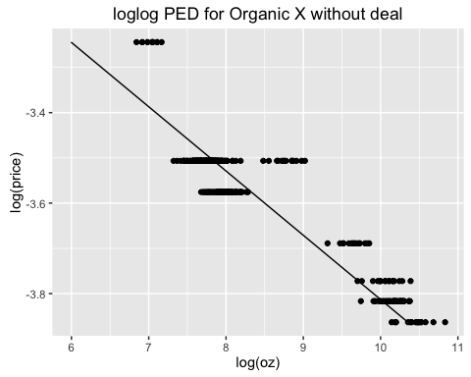

plotStatsLogLog(XO_lm_without_deal, "normal", "PED for Organic X without deal")

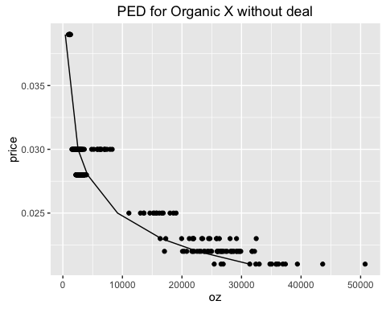

### Log Regression for Organic X with deal dummy variable

Linear regression for

# Linear Model Summary for Organic X product including deal dummy variable  
XO_lm_with_deal <- filteredLM(lm_data, TYPE="XO", log=TRUE, include_Deal=TRUE)  
summary(XO_lm_with_deal)

##   
## Call:  
## lm(formula = response ~ elasticity + deal)  
##   
## Residuals:  
## Min 1Q Median 3Q Max   
## -0.48496 -0.12887 -0.03184 0.08066 1.21545   
##   
## Coefficients:  
## Estimate Std. Error t value Pr(>|t|)   
## (Intercept) -3.16811 0.71250 -4.446 1.16e-05 ***  
## elasticity -3.12964 0.20256 -15.450 < 2e-16 ***  
## deal 1.39566 0.06387 21.851 < 2e-16 ***  
## ---  
## Signif. codes: 0 '***' 0.001 '**' 0.01 '*' 0.05 '.' 0.1 ' ' 1  
##   
## Residual standard error: 0.2463 on 361 degrees of freedom  
## Multiple R-squared: 0.9431, Adjusted R-squared: 0.9427   
## F-statistic: 2989 on 2 and 361 DF, p-value: < 2.2e-16

plotStatsLogLog(XO_lm_with_deal, "loglog", "loglog PED for Organic X with deal")

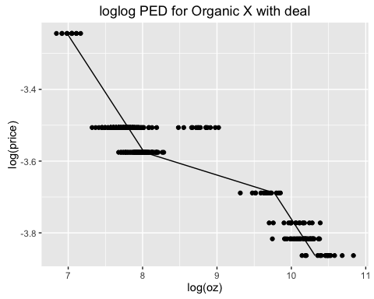

plotStatsLogLog(XO_lm_with_deal, "normal", "PED for Organic X with deal")

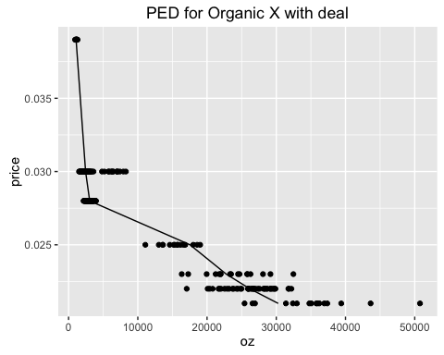

### Log Regression for Organic Y without deal dummy variable

Linear regression for

# Linear Model Summary for Organic Y product without including the deal dummy variable  
YO_lm_without_deal <- filteredLM(lm_data, TYPE="YO", log=TRUE, include_Deal=FALSE)  
summary(YO_lm_without_deal)

##   
## Call:  
## lm(formula = response ~ elasticity + deal)  
##   
## Residuals:  
## Min 1Q Median 3Q Max   
## -2.85175 -0.65452 0.03862 0.62843 2.76432   
##   
## Coefficients: (1 not defined because of singularities)  
## Estimate Std. Error t value Pr(>|t|)   
## (Intercept) -15.7803 1.2829 -12.30 <2e-16 ***  
## elasticity -6.7308 0.3595 -18.72 <2e-16 ***  
## deal NA NA NA NA   
## ---  
## Signif. codes: 0 '***' 0.001 '**' 0.01 '*' 0.05 '.' 0.1 ' ' 1  
##   
## Residual standard error: 0.9754 on 362 degrees of freedom  
## Multiple R-squared: 0.4919, Adjusted R-squared: 0.4905   
## F-statistic: 350.5 on 1 and 362 DF, p-value: < 2.2e-16

plotStatsLogLog(YO_lm_without_deal, "loglog", "loglog PED for Organic Y without deal")

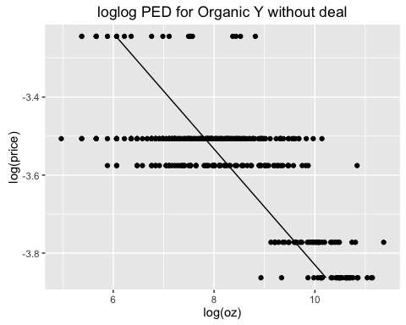

plotStatsLogLog(YO_lm_without_deal, "normal", "PED for Organic Y without deal")

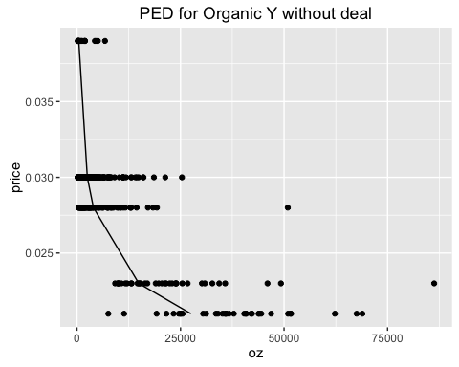

### Log Regression for Organic Y with deal dummy variable

Linear regression for

# Linear Model Summary for Organic Y product including deal dummy variable  
YO_lm_with_deal <- filteredLM(lm_data, TYPE="YO", log=TRUE, include_Deal=TRUE)  
summary(YO_lm_with_deal)

##   
## Call:  
## lm(formula = response ~ elasticity + deal)  
##   
## Residuals:  
## Min 1Q Median 3Q Max   
## -2.79111 -0.65105 0.03551 0.60161 2.80730   
##   
## Coefficients:  
## Estimate Std. Error t value Pr(>|t|)   
## (Intercept) -5.9350 2.3642 -2.510 0.0125 *   
## elasticity -3.9058 0.6740 -5.795 1.49e-08 ***  
## deal 1.1975 0.2445 4.897 1.47e-06 ***  
## ---  
## Signif. codes: 0 '***' 0.001 '**' 0.01 '*' 0.05 '.' 0.1 ' ' 1  
##   
## Residual standard error: 0.9458 on 361 degrees of freedom  
## Multiple R-squared: 0.5236, Adjusted R-squared: 0.5209   
## F-statistic: 198.4 on 2 and 361 DF, p-value: < 2.2e-16

plotStatsLogLog(YO_lm_with_deal, "loglog", "loglog PED for Organic Y with deal")

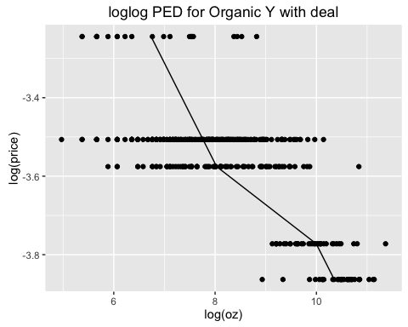

plotStatsLogLog(YO_lm_with_deal, "normal", "PED for Organic Y with deal")

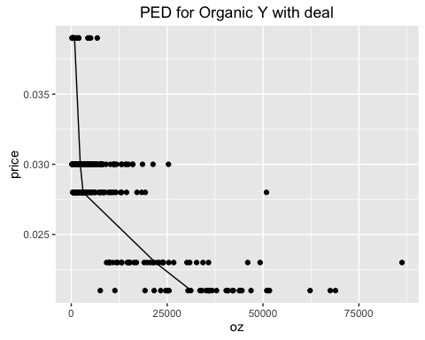

### Log Regression for Nonorganic X without deal dummy variable

Linear regression for

# Linear Model Summary for Nonorganic X product without including the deal dummy variable  
XI_lm_without_deal <- filteredLM(lm_data, TYPE="XI", log=TRUE, include_Deal=FALSE)  
summary(XI_lm_without_deal)

##   
## Call:  
## lm(formula = response ~ elasticity + deal)  
##   
## Residuals:  
## Min 1Q Median 3Q Max   
## -0.62446 -0.23014 -0.09199 0.08494 1.27804   
##   
## Coefficients: (1 not defined because of singularities)  
## Estimate Std. Error t value Pr(>|t|)   
## (Intercept) -15.8704 0.5801 -27.36 <2e-16 ***  
## elasticity -6.7511 0.1630 -41.43 <2e-16 ***  
## deal NA NA NA NA   
## ---  
## Signif. codes: 0 '***' 0.001 '**' 0.01 '*' 0.05 '.' 0.1 ' ' 1  
##   
## Residual standard error: 0.3569 on 362 degrees of freedom  
## Multiple R-squared: 0.8258, Adjusted R-squared: 0.8253   
## F-statistic: 1716 on 1 and 362 DF, p-value: < 2.2e-16

plotStatsLogLog(XI_lm_without_deal, "loglog", "loglog PED for Nonorganic X without deal")

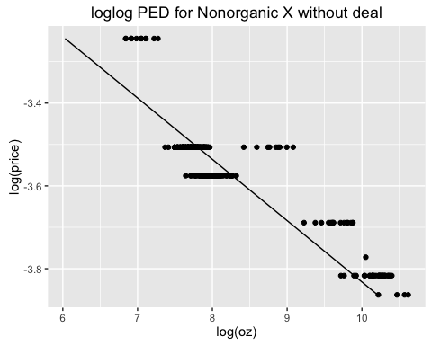

plotStatsLogLog(XI_lm_without_deal, "normal", "PED for Nonrganic X without deal")

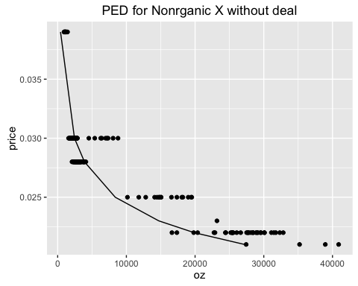

### Log Regression for Nonorganic X with deal dummy variable

Linear regression for

# Linear Model Summary for Nonorganic X product including deal dummy variable  
XI_lm_with_deal <- filteredLM(lm_data, TYPE="XI", log=TRUE, include_Deal=TRUE)  
summary(XI_lm_with_deal)

##   
## Call:  
## lm(formula = response ~ elasticity + deal)  
##   
## Residuals:  
## Min 1Q Median 3Q Max   
## -0.52573 -0.10589 -0.00324 0.06946 1.30459   
##   
## Coefficients:  
## Estimate Std. Error t value Pr(>|t|)   
## (Intercept) -3.27234 0.60919 -5.372 1.4e-07 ***  
## elasticity -3.15079 0.17312 -18.200 < 2e-16 ***  
## deal 1.40060 0.05548 25.243 < 2e-16 ***  
## ---  
## Signif. codes: 0 '***' 0.001 '**' 0.01 '*' 0.05 '.' 0.1 ' ' 1  
##   
## Residual standard error: 0.2149 on 361 degrees of freedom  
## Multiple R-squared: 0.937, Adjusted R-squared: 0.9367   
## F-statistic: 2685 on 2 and 361 DF, p-value: < 2.2e-16

plotStatsLogLog(XI_lm_with_deal, "loglog", "loglog PED for Nonorganic X with deal")

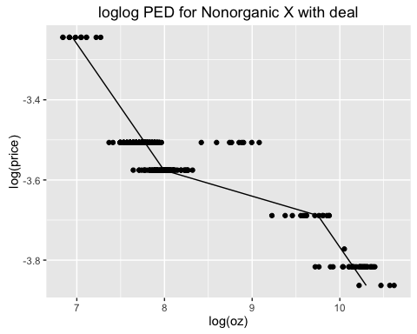

plotStatsLogLog(XI_lm_with_deal, "normal", "PED for Nonorganic X with deal")

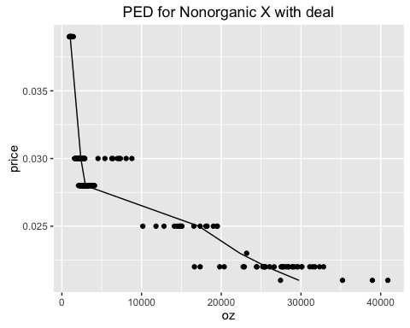

### Log Regression for Nonorganic Y without deal dummy variable

Linear regression for

# Linear Model Summary for Nonorganic Y product without including the deal dummy variable  
YI_lm_without_deal <- filteredLM(lm_data, TYPE="YI", log=TRUE, include_Deal=FALSE)  
summary(YI_lm_without_deal)

##   
## Call:  
## lm(formula = response ~ elasticity + deal)  
##   
## Residuals:  
## Min 1Q Median 3Q Max   
## -2.5546 -0.6087 0.0357 0.6109 3.4261   
##   
## Coefficients: (1 not defined because of singularities)  
## Estimate Std. Error t value Pr(>|t|)   
## (Intercept) -15.4133 1.2595 -12.24 <2e-16 ***  
## elasticity -6.6570 0.3529 -18.86 <2e-16 ***  
## deal NA NA NA NA   
## ---  
## Signif. codes: 0 '***' 0.001 '**' 0.01 '*' 0.05 '.' 0.1 ' ' 1  
##   
## Residual standard error: 0.9586 on 362 degrees of freedom  
## Multiple R-squared: 0.4957, Adjusted R-squared: 0.4943   
## F-statistic: 355.8 on 1 and 362 DF, p-value: < 2.2e-16

plotStatsLogLog(YI_lm_without_deal, "loglog", "loglog PED for Nonorganic Y without deal")

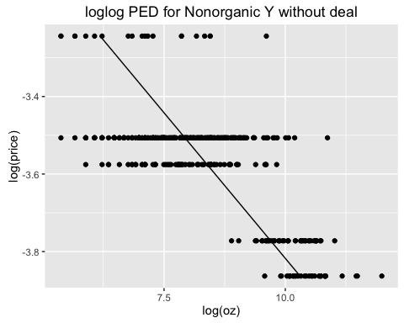

plotStatsLogLog(YI_lm_without_deal, "normal", "PED for Nonorganic Y without deal")

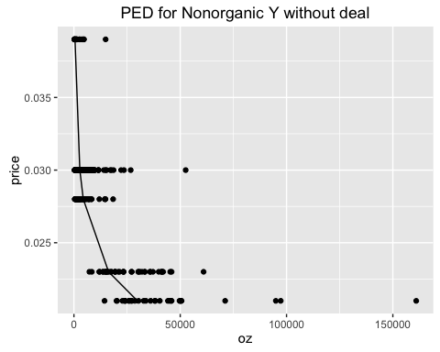

### Log Regression for Nonorganic Y with deal dummy variable

Linear regression for

# Linear Model Summary for Nonorganic Y product including deal dummy variable  
YI_lm_with_deal <- filteredLM(lm_data, TYPE="YI", log=TRUE, include_Deal=TRUE)  
summary(YI_lm_with_deal)

##   
## Call:  
## lm(formula = response ~ elasticity + deal)  
##   
## Residuals:  
## Min 1Q Median 3Q Max   
## -2.46784 -0.56287 0.02177 0.56931 3.02660   
##   
## Coefficients:  
## Estimate Std. Error t value Pr(>|t|)   
## (Intercept) -2.3106 2.3526 -0.982 0.327   
## elasticity -2.8956 0.6712 -4.314 2.07e-05 ***  
## deal 1.5425 0.2386 6.464 3.31e-10 ***  
## ---  
## Signif. codes: 0 '***' 0.001 '**' 0.01 '*' 0.05 '.' 0.1 ' ' 1  
##   
## Residual standard error: 0.9087 on 361 degrees of freedom  
## Multiple R-squared: 0.548, Adjusted R-squared: 0.5455   
## F-statistic: 218.8 on 2 and 361 DF, p-value: < 2.2e-16

plotStatsLogLog(YI_lm_with_deal, "loglog", "loglog PED for Nonorganic Y with deal")

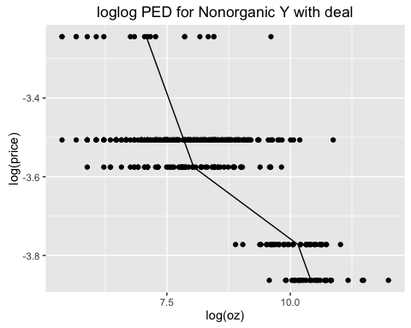

plotStatsLogLog(YI_lm_with_deal, "normal", "PED for Nonorganic Y with deal")

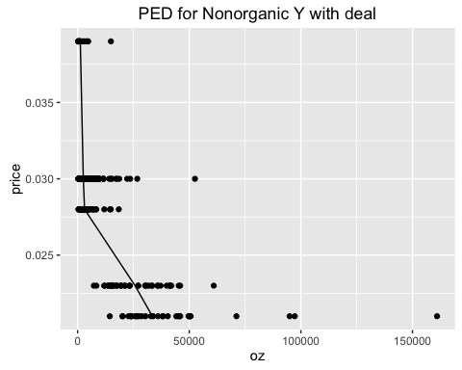

## Cross Elasticity of demand

# Function that pulls out the data  
retrieveDataCPED <- function(data, Q_class, Q_brand) {  
tempQ <- data %>% filter(., class==Q_class) %>% select(., STORE, matches(paste("oz",Q_brand,sep="_")))  
colnames(tempQ) <- c("STORE", "oz")  
tempP_Org <- data %>% filter(., class=="organic") %>% select(., pX, pY)  
colnames(tempP_Org) <- c("p_X_org", "p_Y_org")  
tempP_NonOrg <- data %>% filter(., class=="nonorganic") %>% select(., pX, pY)  
colnames(tempP_NonOrg) <- c("p_X_nonorg", "p_Y_nonorg")  
return(data.frame(tempQ, tempP_Org, tempP_NonOrg))  
}  
  
# Function that plots the loglog and actual curves  
crossPEDLinearReg <- function(data, TYPES, log=TRUE) {  
 Q <- data %>% select(oz) %>% {if (log) log(.) else (.)} %>% as.matrix()  
 pXOrg <- data %>% select(p_X_org) %>% {if (log) log(.) else (.)} %>% {if ("xOrg" %in% TYPES) (.) else (.)*0} %>% as.matrix()  
 pYOrg <- data %>% select(p_Y_org) %>% {if (log) log(.) else (.)} %>% {if ("yOrg" %in% TYPES) (.) else (.)*0} %>% as.matrix()  
 pXNonOrg <- data %>% select(p_X_nonorg) %>% {if (log) log(.) else (.)} %>% {if ("xNonOrg" %in% TYPES) (.) else (.)*0} %>% as.matrix()  
 pYNonOrg <- data %>% select(p_Y_nonorg) %>% {if (log) log(.) else (.)} %>% {if ("yNonOrg" %in% TYPES) (.) else (.)*0} %>% as.matrix()  
 return(lm(Q~pXOrg+pYOrg+pXNonOrg+pYNonOrg))  
}  
  
  
crossXOrg <- retrieveDataCPED(data, "organic", "X")  
crossYOrg <- retrieveDataCPED(data, "organic", "Y")  
crossXNonOrg <- retrieveDataCPED(data, "nonorganic", "X")  
crossYNonOrg <- retrieveDataCPED(data, "nonorganic", "Y")  
  
lmXOrg <- crossPEDLinearReg(crossXOrg, c("xOrg"))  
summary(lmXOrg)

##   
## Call:  
## lm(formula = Q ~ pXOrg + pYOrg + pXNonOrg + pYNonOrg)  
##   
## Residuals:  
## Min 1Q Median 3Q Max   
## -0.65001 -0.23331 -0.06901 0.14514 1.17942   
##   
## Coefficients: (3 not defined because of singularities)  
## Estimate Std. Error t value Pr(>|t|)   
## (Intercept) -16.8432 0.5183 -32.49 <2e-16 ***  
## pXOrg -7.0398 0.1445 -48.73 <2e-16 ***  
## pYOrg NA NA NA NA   
## pXNonOrg NA NA NA NA   
## pYNonOrg NA NA NA NA   
## ---  
## Signif. codes: 0 '***' 0.001 '**' 0.01 '*' 0.05 '.' 0.1 ' ' 1  
##   
## Residual standard error: 0.3749 on 362 degrees of freedom  
## Multiple R-squared: 0.8677, Adjusted R-squared: 0.8674   
## F-statistic: 2375 on 1 and 362 DF, p-value: < 2.2e-16

lmXOrg <- crossPEDLinearReg(crossXOrg, c("yOrg"))  
summary(lmXOrg)

##   
## Call:  
## lm(formula = Q ~ pXOrg + pYOrg + pXNonOrg + pYNonOrg)  
##   
## Residuals:  
## Min 1Q Median 3Q Max   
## -1.5019 -0.6540 -0.5033 0.5381 2.4173   
##   
## Coefficients: (3 not defined because of singularities)  
## Estimate Std. Error t value Pr(>|t|)   
## (Intercept) 9.5488 1.3545 7.05 9.14e-12 ***  
## pXOrg NA NA NA NA   
## pYOrg 0.3226 0.3796 0.85 0.396   
## pXNonOrg NA NA NA NA   
## pYNonOrg NA NA NA NA   
## ---  
## Signif. codes: 0 '***' 0.001 '**' 0.01 '*' 0.05 '.' 0.1 ' ' 1  
##   
## Residual standard error: 1.03 on 362 degrees of freedom  
## Multiple R-squared: 0.001991, Adjusted R-squared: -0.0007657   
## F-statistic: 0.7223 on 1 and 362 DF, p-value: 0.396

lmXOrg <- crossPEDLinearReg(crossXOrg, c("xNonOrg"))  
summary(lmXOrg)

##   
## Call:  
## lm(formula = Q ~ pXOrg + pYOrg + pXNonOrg + pYNonOrg)  
##   
## Residuals:  
## Min 1Q Median 3Q Max   
## -1.7368 -0.6850 -0.4753 0.6117 2.3207   
##   
## Coefficients: (3 not defined because of singularities)  
## Estimate Std. Error t value Pr(>|t|)   
## (Intercept) 5.9253 1.6707 3.547 0.000442 ***  
## pXOrg NA NA NA NA   
## pYOrg NA NA NA NA   
## pXNonOrg -0.6951 0.4693 -1.481 0.139438   
## pYNonOrg NA NA NA NA   
## ---  
## Signif. codes: 0 '***' 0.001 '**' 0.01 '*' 0.05 '.' 0.1 ' ' 1  
##   
## Residual standard error: 1.028 on 362 degrees of freedom  
## Multiple R-squared: 0.006024, Adjusted R-squared: 0.003278   
## F-statistic: 2.194 on 1 and 362 DF, p-value: 0.1394

lmXOrg <- crossPEDLinearReg(crossXOrg, c("yNonOrg"))  
summary(lmXOrg)

##   
## Call:  
## lm(formula = Q ~ pXOrg + pYOrg + pXNonOrg + pYNonOrg)  
##   
## Residuals:  
## Min 1Q Median 3Q Max   
## -1.5608 -0.6622 -0.4882 0.5950 2.4324   
##   
## Coefficients: (3 not defined because of singularities)  
## Estimate Std. Error t value Pr(>|t|)   
## (Intercept) 8.63069 1.35446 6.372 5.67e-10 ***  
## pXOrg NA NA NA NA   
## pYOrg NA NA NA NA   
## pXNonOrg NA NA NA NA   
## pYNonOrg 0.06509 0.37955 0.171 0.864   
## ---  
## Signif. codes: 0 '***' 0.001 '**' 0.01 '*' 0.05 '.' 0.1 ' ' 1  
##   
## Residual standard error: 1.031 on 362 degrees of freedom  
## Multiple R-squared: 8.123e-05, Adjusted R-squared: -0.002681   
## F-statistic: 0.02941 on 1 and 362 DF, p-value: 0.8639

### Profit versus Price for the four products

XOrg.Qcoef = c(-16.8432,-7.0398)  
YOrg.Qcoef = c(-15.7803,-6.7308)  
XNonOrg.Qcoef = c(-15.8704,-6.7511)  
YNonOrg.Qcoef = c(-15.4133,-6.657)  
  
XOrg.Ccoef = c(-0.0006,0.8491)  
YOrg.Ccoef = c(0.0003,0.8042)  
XNonOrg.Ccoef = c(-0.0004,0.8434)  
YNonOrg.Ccoef = c(0.0003,0.804)  
  
profit <- function(price, Qcoef, Ccoef) {  
 quantity <- exp(Qcoef[1]) * price^Qcoef[2]  
 cost <- Ccoef[1] + Ccoef[2]*price  
 return(quantity*(price-cost))  
}  
Xorg.Profit.func <- function(price) {  
 return(profit(price,XOrg.Qcoef,XOrg.Ccoef))  
}  
Yorg.Profit.func <- function(price) {  
 return(profit(price,YOrg.Qcoef,YOrg.Ccoef))  
}  
Xnonorg.Profit.func <- function(price) {  
 return(profit(price,XNonOrg.Qcoef,XNonOrg.Ccoef))  
}  
Ynonorg.Profit.func <- function(price) {  
 return(profit(price,YNonOrg.Qcoef,YNonOrg.Ccoef))  
}  
ggplot(data.frame(price = c(0.018, 0.035)), aes(price)) +   
 stat_function(fun = Xorg.Profit.func, aes(colour = "organic X")) +   
 stat_function(fun = Yorg.Profit.func, aes(colour = "organic Y")) +   
 stat_function(fun = Xnonorg.Profit.func, aes(colour = "inorganic X")) +   
 stat_function(fun = Ynonorg.Profit.func, aes(colour = "inorganic Y")) +  
 scale_colour_manual("Lgend title", values = c("red", "blue", "green", "orange")) +  
 labs(x = "price/oz", y = "profit/wk", title = "Profit per week versus price for each product")

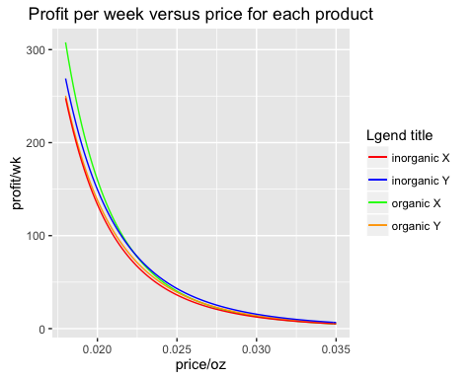

### Marginal Cost = Marginal Revenue

# Linear Model for C(q)  
costQuantityLM <- function(data, CLASS, BRAND) {  
 cost <- data %>% filter(class==CLASS, brand==BRAND) %>% select(c) %>% log() %>% as.matrix()  
 quantity <- data %>% filter(class==CLASS, brand==BRAND) %>% select(oz) %>% log() %>% as.matrix()  
 return(lm(cost~quantity))  
}  
  
# Linear Model for R(q)  
revenueQuantityLM <- function(data, CLASS, BRAND) {  
 revenue <- data %>% filter(class==CLASS, brand==BRAND) %>% select(p) %>% log() %>% as.matrix()  
 quantity <- data %>% filter(class==CLASS, brand==BRAND) %>% select(oz) %>% log() %>% as.matrix()  
 return(lm(revenue~quantity))  
}  
  
marginalValue <- function(point, coef) {  
 return(exp(coef[1])*point^coef[2] + coef[2]*exp(coef[1])*point^(coef[2]-1)*point)  
}  
  
cQ_X_org <- costQuantityLM(data.ref, "organic", "X")  
cQ_X_org$coefficients[1] <- cQ_X_org$coefficients[1]  
cQ_X_org$coefficients[2] <- cQ_X_org$coefficients[2]/1.15  
cQ_Y_org <- costQuantityLM(data.ref, "organic", "Y")  
cQ_X_nonorg <- costQuantityLM(data.ref, "nonorganic", "X")  
cQ_Y_nonorg <- costQuantityLM(data.ref, "nonorganic", "Y")  
  
rQ_X_org <- revenueQuantityLM(data.ref, "organic", "X")  
rQ_Y_org <- revenueQuantityLM(data.ref, "organic", "Y")  
rQ_X_nonorg <- revenueQuantityLM(data.ref, "nonorganic", "X")  
rQ_Y_nonorg <- revenueQuantityLM(data.ref, "nonorganic", "Y")  
  
cQ_XO_Curve <- function(quantity) return(marginalValue(quantity,cQ_X_org$coefficients))  
rQ_XO_Curve <- function(quantity) return(marginalValue(quantity,rQ_X_org$coefficients))  
  
cQ_YO_Curve <- function(quantity) return(marginalValue(quantity,cQ_Y_org$coefficients))  
rQ_YO_Curve <- function(quantity) return(marginalValue(quantity,rQ_Y_org$coefficients))  
  
cQ_XI_Curve <- function(quantity) return(marginalValue(quantity,cQ_X_nonorg$coefficients))  
rQ_XI_Curve <- function(quantity) return(marginalValue(quantity,rQ_X_nonorg$coefficients))  
  
cQ_YI_Curve <- function(quantity) return(marginalValue(quantity,cQ_Y_nonorg$coefficients))  
rQ_YI_Curve <- function(quantity) return(marginalValue(quantity,rQ_Y_nonorg$coefficients))  
  
quantity.range = c(10, 100000)  
ggplot(data.frame(quantity = quantity.range ), aes(quantity)) +   
 stat_function(fun = cQ_XO_Curve, aes(colour = "MC XO")) +   
 stat_function(fun = rQ_XO_Curve, aes(colour = "MR XO")) +   
 labs(y = "price/cost (per oz)", x="Quantity", title = "MC and MR for Organic X")

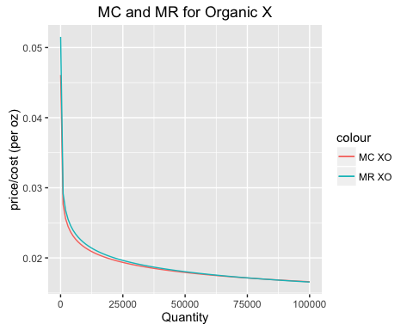

ggplot(data.frame(quantity = quantity.range ), aes(quantity)) +   
 stat_function(fun = cQ_YO_Curve, aes(colour = "MC YO")) +   
 stat_function(fun = rQ_YO_Curve, aes(colour = "MR YO")) +   
 labs(y = "price/cost (per oz)", x="Quantity", title = "MC and MR for Organic Y")

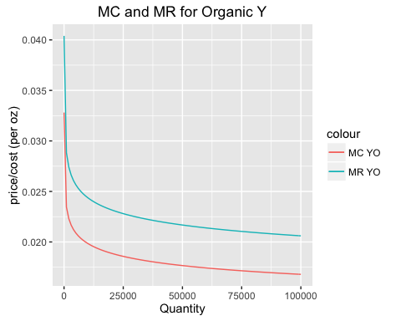

ggplot(data.frame(quantity = quantity.range ), aes(quantity)) +   
 stat_function(fun = cQ_XI_Curve, aes(colour = "MC XI")) +   
 stat_function(fun = rQ_XI_Curve, aes(colour = "MR XI")) +   
 labs(y = "price/cost (per oz)", x="Quantity", title = "MC and MR for NonOrganic X")

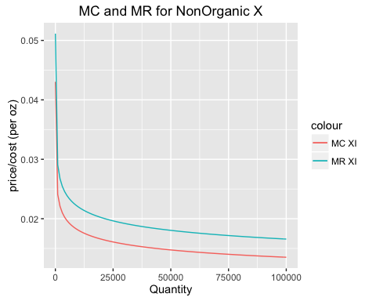

ggplot(data.frame(quantity = quantity.range ), aes(quantity)) +   
 stat_function(fun = cQ_YI_Curve, aes(colour = "MC YI")) +   
 stat_function(fun = rQ_YI_Curve, aes(colour = "MR YI")) +   
 labs(y = "price/cost (per oz)", x="Quantity", title = "MC and MR for NonOrganic Y")

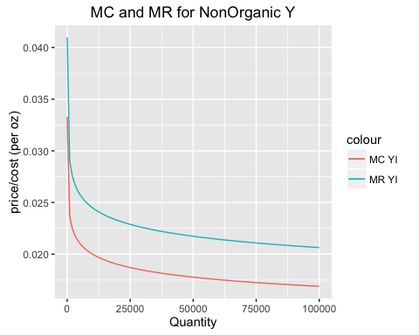

### MC = MR fake data

Reduced cost/oz response to an increase in quantity by 15% to reflect a greater fixed cost.

cQ_X_org <- costQuantityLM(data.ref, "organic", "X")  
cQ_X_org$coefficients[1] <- cQ_X_org$coefficients[1]  
cQ_X_org$coefficients[2] <- cQ_X_org$coefficients[2]/1.15  
cQ_XO_Curve <- function(quantity) return(marginalValue(quantity,cQ_X_org$coefficients))  
rQ_XO_Curve <- function(quantity) return(marginalValue(quantity,rQ_X_org$coefficients))  
quantity.range = c(10, 100000)  
ggplot(data.frame(quantity = quantity.range ), aes(quantity)) +   
 stat_function(fun = cQ_XO_Curve, aes(colour = "MC XO")) +   
 stat_function(fun = rQ_XO_Curve, aes(colour = "MR XO")) +   
 labs(y = "price/cost (per oz)", x="Quantity", title = "MC and MR for Organic X (with improved c curve)")

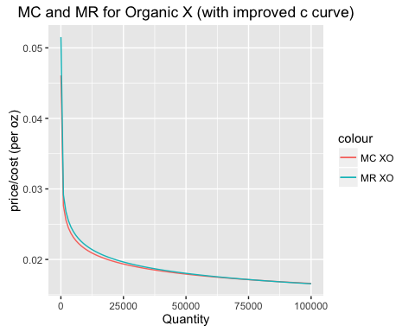

ggplot(data.frame(quantity = quantity.range ), aes(quantity)) +   
 stat_function(fun = cQ_XO_Curve, aes(colour = "MC XO")) +   
 stat_function(fun = rQ_XO_Curve, aes(colour = "MR XO")) +   
 labs(y = "log10 price/cost (per oz)", x="log 10 Quantity", title = "MC and MR for Organic X (with improved c curve)") +  
 scale_x_log10()

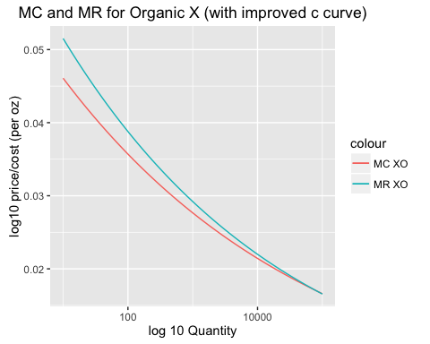

### Multivariate cross-PED

crossPEDLM <- function(data.ref, BRAND="X", CLASS="organic") {  
 quantity <- data.ref %>% filter(brand==BRAND, class==CLASS) %>% select(oz) %>% log() %>% as.matrix()  
 hVal <- data.ref %>% filter(brand==BRAND, class==CLASS) %>% select(Hval) %>% log() %>% as.matrix()  
 XO_org_price <- data.ref %>% filter(brand=="X", class=="organic") %>% select(p) %>% log() %>% as.matrix()  
 YO_org_price <- data.ref %>% filter(brand=="Y", class=="organic") %>% select(p) %>% log() %>% as.matrix()  
 XI_org_price <- data.ref %>% filter(brand=="X", class=="nonorganic") %>% select(p) %>% log() %>% as.matrix()  
 YI_org_price <- data.ref %>% filter(brand=="Y", class=="nonorganic") %>% select(p) %>% log() %>% as.matrix()  
 XO_org_deal <- data.ref %>% filter(brand=="X", class=="organic") %>% select(deal) %>% as.matrix()  
 YO_org_deal <- data.ref %>% filter(brand=="Y", class=="organic") %>% select(deal) %>% as.matrix()  
 XI_org_deal <- data.ref %>% filter(brand=="X", class=="nonorganic") %>% select(deal) %>% as.matrix()  
 YI_org_deal <- data.ref %>% filter(brand=="Y", class=="nonorganic") %>% select(deal) %>% as.matrix()  
   
 lm.crossPED <- lm(quantity~hVal + XO_org_price + YO_org_price + XI_org_price + YI_org_price + XO_org_deal + YO_org_deal + XI_org_deal + YI_org_deal)  
}

### Multivariate cross-PED for XO

crossPEDLMXO <- function(data.ref, BRAND="X", CLASS="organic") {  
 quantity <- data.ref %>% filter(brand==BRAND, class==CLASS) %>% select(oz) %>% log() %>% as.matrix()  
 hVal <- data.ref %>% filter(brand==BRAND, class==CLASS) %>% select(Hval) %>% log() %>% as.matrix()  
 XO_org_price <- data.ref %>% filter(brand=="X", class=="organic") %>% select(p) %>% log() %>% as.matrix()  
 YO_org_price <- data.ref %>% filter(brand=="Y", class=="organic") %>% select(p) %>% log() %>% as.matrix()  
 XI_org_price <- data.ref %>% filter(brand=="X", class=="nonorganic") %>% select(p) %>% log() %>% as.matrix()  
 YI_org_price <- data.ref %>% filter(brand=="Y", class=="nonorganic") %>% select(p) %>% log() %>% as.matrix()  
 XO_org_deal <- data.ref %>% filter(brand=="X", class=="organic") %>% select(deal) %>% as.matrix()  
 YO_org_deal <- data.ref %>% filter(brand=="Y", class=="organic") %>% select(deal) %>% as.matrix()  
 XI_org_deal <- data.ref %>% filter(brand=="X", class=="nonorganic") %>% select(deal) %>% as.matrix()  
 YI_org_deal <- data.ref %>% filter(brand=="Y", class=="nonorganic") %>% select(deal) %>% as.matrix()  
   
 lm.crossPED <- lm(quantity~XO_org_price + XO_org_deal + YO_org_deal)  
}  
XO_cross_PED <- crossPEDLM(data.ref, "X", "organic")  
summary(XO_cross_PED)

##   
## Call:  
## lm(formula = quantity ~ hVal + XO_org_price + YO_org_price +   
## XI_org_price + YI_org_price + XO_org_deal + YO_org_deal +   
## XI_org_deal + YI_org_deal)  
##   
## Residuals:  
## Min 1Q Median 3Q Max   
## -0.35984 -0.11885 -0.03342 0.05692 1.16674   
##   
## Coefficients:  
## Estimate Std. Error t value Pr(>|t|)   
## (Intercept) -0.12343 1.31244 -0.094 0.925128   
## hVal 0.01133 0.02571 0.441 0.659719   
## XO_org_price -3.05819 0.19334 -15.818 < 2e-16 ***  
## YO_org_price 0.66601 0.17098 3.895 0.000117 ***  
## XI_org_price -0.12149 0.18959 -0.641 0.522066   
## YI_org_price 0.23843 0.17355 1.374 0.170350   
## XO_org_deal 1.43078 0.06176 23.166 < 2e-16 ***  
## YO_org_deal 0.02100 0.06157 0.341 0.733207   
## XI_org_deal -0.04871 0.06125 -0.795 0.426987   
## YI_org_deal 0.08843 0.06172 1.433 0.152804   
## ---  
## Signif. codes: 0 '***' 0.001 '**' 0.01 '*' 0.05 '.' 0.1 ' ' 1  
##   
## Residual standard error: 0.2322 on 354 degrees of freedom  
## Multiple R-squared: 0.9504, Adjusted R-squared: 0.9491   
## F-statistic: 753.3 on 9 and 354 DF, p-value: < 2.2e-16

XO_cross_PED <- crossPEDLMXO(data.ref, "X", "organic")  
summary(XO_cross_PED)

##   
## Call:  
## lm(formula = quantity ~ XO_org_price + XO_org_deal + YO_org_deal)  
##   
## Residuals:  
## Min 1Q Median 3Q Max   
## -0.34544 -0.13032 -0.03795 0.05013 1.18062   
##   
## Coefficients:  
## Estimate Std. Error t value Pr(>|t|)   
## (Intercept) -3.16105 0.68321 -4.627 5.19e-06 ***  
## XO_org_price -3.13756 0.19424 -16.153 < 2e-16 ***  
## XO_org_deal 1.39063 0.06125 22.704 < 2e-16 ***  
## YO_org_deal -0.18046 0.03159 -5.712 2.34e-08 ***  
## ---  
## Signif. codes: 0 '***' 0.001 '**' 0.01 '*' 0.05 '.' 0.1 ' ' 1  
##   
## Residual standard error: 0.2362 on 360 degrees of freedom  
## Multiple R-squared: 0.9478, Adjusted R-squared: 0.9473   
## F-statistic: 2178 on 3 and 360 DF, p-value: < 2.2e-16

### Multivariate cross-PED for YO

crossPEDLMYO <- function(data.ref, BRAND="Y", CLASS="organic") {  
 quantity <- data.ref %>% filter(brand==BRAND, class==CLASS) %>% select(oz) %>% log() %>% as.matrix()  
 hVal <- data.ref %>% filter(brand==BRAND, class==CLASS) %>% select(Hval) %>% log() %>% as.matrix()  
 XO_org_price <- data.ref %>% filter(brand=="X", class=="organic") %>% select(p) %>% log() %>% as.matrix()  
 YO_org_price <- data.ref %>% filter(brand=="Y", class=="organic") %>% select(p) %>% log() %>% as.matrix()  
 XI_org_price <- data.ref %>% filter(brand=="X", class=="nonorganic") %>% select(p) %>% log() %>% as.matrix()  
 YI_org_price <- data.ref %>% filter(brand=="Y", class=="nonorganic") %>% select(p) %>% log() %>% as.matrix()  
 XO_org_deal <- data.ref %>% filter(brand=="X", class=="organic") %>% select(deal) %>% as.matrix()  
 YO_org_deal <- data.ref %>% filter(brand=="Y", class=="organic") %>% select(deal) %>% as.matrix()  
 XI_org_deal <- data.ref %>% filter(brand=="X", class=="nonorganic") %>% select(deal) %>% as.matrix()  
 YI_org_deal <- data.ref %>% filter(brand=="Y", class=="nonorganic") %>% select(deal) %>% as.matrix()  
   
 lm.crossPED <- lm(quantity~XO_org_price + YO_org_price + YO_org_deal)  
}  
YO_cross_PED <- crossPEDLM(data.ref, "Y", "organic")  
summary(YO_cross_PED)

##   
## Call:  
## lm(formula = quantity ~ hVal + XO_org_price + YO_org_price +   
## XI_org_price + YI_org_price + XO_org_deal + YO_org_deal +   
## XI_org_deal + YI_org_deal)  
##   
## Residuals:  
## Min 1Q Median 3Q Max   
## -2.94464 -0.64035 0.00247 0.59479 2.31866   
##   
## Coefficients:  
## Estimate Std. Error t value Pr(>|t|)   
## (Intercept) 1.366189 5.332936 0.256 0.7980   
## hVal -0.079762 0.104471 -0.763 0.4457   
## XO_org_price 0.557819 0.785592 0.710 0.4781   
## YO_org_price -3.954382 0.694750 -5.692 2.64e-08 ***  
## XI_org_price 1.372694 0.770372 1.782 0.0756 .   
## YI_org_price 0.215070 0.705186 0.305 0.7606   
## XO_org_deal -0.092792 0.250961 -0.370 0.7118   
## YO_org_deal 1.176298 0.250179 4.702 3.70e-06 ***  
## XI_org_deal 0.455553 0.248870 1.830 0.0680 .   
## YI_org_deal 0.005135 0.250776 0.020 0.9837   
## ---  
## Signif. codes: 0 '***' 0.001 '**' 0.01 '*' 0.05 '.' 0.1 ' ' 1  
##   
## Residual standard error: 0.9436 on 354 degrees of freedom  
## Multiple R-squared: 0.535, Adjusted R-squared: 0.5232   
## F-statistic: 45.26 on 9 and 354 DF, p-value: < 2.2e-16

YO_cross_PED <- crossPEDLMYO(data.ref, "Y", "organic")  
summary(YO_cross_PED)

##   
## Call:  
## lm(formula = quantity ~ XO_org_price + YO_org_price + YO_org_deal)  
##   
## Residuals:  
## Min 1Q Median 3Q Max   
## -2.8533 -0.6560 0.0318 0.5870 2.7387   
##   
## Coefficients:  
## Estimate Std. Error t value Pr(>|t|)   
## (Intercept) -3.4693 2.6189 -1.325 0.1861   
## XO_org_price 0.7786 0.3634 2.143 0.0328 *   
## YO_org_price -3.9990 0.6721 -5.950 6.36e-09 ***  
## YO_org_deal 1.1654 0.2438 4.780 2.56e-06 ***  
## ---  
## Signif. codes: 0 '***' 0.001 '**' 0.01 '*' 0.05 '.' 0.1 ' ' 1  
##   
## Residual standard error: 0.9412 on 360 degrees of freedom  
## Multiple R-squared: 0.5296, Adjusted R-squared: 0.5256   
## F-statistic: 135.1 on 3 and 360 DF, p-value: < 2.2e-16

### Multivariate cross-PED for XI

crossPEDLMXI <- function(data.ref, BRAND="X", CLASS="nonorganic") {  
 quantity <- data.ref %>% filter(brand==BRAND, class==CLASS) %>% select(oz) %>% log() %>% as.matrix()  
 hVal <- data.ref %>% filter(brand==BRAND, class==CLASS) %>% select(Hval) %>% log() %>% as.matrix()  
 XO_org_price <- data.ref %>% filter(brand=="X", class=="organic") %>% select(p) %>% log() %>% as.matrix()  
 YO_org_price <- data.ref %>% filter(brand=="Y", class=="organic") %>% select(p) %>% log() %>% as.matrix()  
 XI_org_price <- data.ref %>% filter(brand=="X", class=="nonorganic") %>% select(p) %>% log() %>% as.matrix()  
 YI_org_price <- data.ref %>% filter(brand=="Y", class=="nonorganic") %>% select(p) %>% log() %>% as.matrix()  
 XO_org_deal <- data.ref %>% filter(brand=="X", class=="organic") %>% select(deal) %>% as.matrix()  
 YO_org_deal <- data.ref %>% filter(brand=="Y", class=="organic") %>% select(deal) %>% as.matrix()  
 XI_org_deal <- data.ref %>% filter(brand=="X", class=="nonorganic") %>% select(deal) %>% as.matrix()  
 YI_org_deal <- data.ref %>% filter(brand=="Y", class=="nonorganic") %>% select(deal) %>% as.matrix()  
   
 lm.crossPED <- lm(quantity~XI_org_price + YI_org_price + XI_org_deal)  
}  
XI_cross_PED <- crossPEDLM(data.ref, "X", "nonorganic")  
summary(XI_cross_PED)

##   
## Call:  
## lm(formula = quantity ~ hVal + XO_org_price + YO_org_price +   
## XI_org_price + YI_org_price + XO_org_deal + YO_org_deal +   
## XI_org_deal + YI_org_deal)  
##   
## Residuals:  
## Min 1Q Median 3Q Max   
## -0.40513 -0.09481 -0.01748 0.05342 1.27001   
##   
## Coefficients:  
## Estimate Std. Error t value Pr(>|t|)   
## (Intercept) -0.80247 1.14292 -0.702 0.48307   
## hVal 0.01148 0.02239 0.513 0.60838   
## XO_org_price -0.05371 0.16836 -0.319 0.74991   
## YO_org_price 0.15148 0.14889 1.017 0.30968   
## XI_org_price -3.01591 0.16510 -18.267 < 2e-16 ***  
## YI_org_price 0.45680 0.15113 3.023 0.00269 **   
## XO_org_deal -0.03101 0.05378 -0.577 0.56463   
## YO_org_deal 0.05907 0.05362 1.102 0.27136   
## XI_org_deal 1.45074 0.05334 27.200 < 2e-16 ***  
## YI_org_deal -0.02728 0.05374 -0.508 0.61209   
## ---  
## Signif. codes: 0 '***' 0.001 '**' 0.01 '*' 0.05 '.' 0.1 ' ' 1  
##   
## Residual standard error: 0.2022 on 354 degrees of freedom  
## Multiple R-squared: 0.9453, Adjusted R-squared: 0.9439   
## F-statistic: 679.8 on 9 and 354 DF, p-value: < 2.2e-16

XI_cross_PED <- crossPEDLMXI(data.ref, "X", "nonorganic")  
summary(XI_cross_PED)

##   
## Call:  
## lm(formula = quantity ~ XI_org_price + YI_org_price + XI_org_deal)  
##   
## Residuals:  
## Min 1Q Median 3Q Max   
## -0.38903 -0.09652 -0.02595 0.05932 1.27352   
##   
## Coefficients:  
## Estimate Std. Error t value Pr(>|t|)   
## (Intercept) -0.94038 0.65699 -1.431 0.153   
## XI_org_price -3.02961 0.16307 -18.579 < 2e-16 ***  
## YI_org_price 0.53499 0.07467 7.165 4.44e-12 ***  
## XI_org_deal 1.44573 0.05236 27.612 < 2e-16 ***  
## ---  
## Signif. codes: 0 '***' 0.001 '**' 0.01 '*' 0.05 '.' 0.1 ' ' 1  
##   
## Residual standard error: 0.2013 on 360 degrees of freedom  
## Multiple R-squared: 0.9449, Adjusted R-squared: 0.9444   
## F-statistic: 2057 on 3 and 360 DF, p-value: < 2.2e-16

### Multivariate cross-PED for YI

crossPEDLMYI <- function(data.ref, BRAND="Y", CLASS="nonorganic") {  
 quantity <- data.ref %>% filter(brand==BRAND, class==CLASS) %>% select(oz) %>% log() %>% as.matrix()  
 hVal <- data.ref %>% filter(brand==BRAND, class==CLASS) %>% select(Hval) %>% log() %>% as.matrix()  
 XO_org_price <- data.ref %>% filter(brand=="X", class=="organic") %>% select(p) %>% log() %>% as.matrix()  
 YO_org_price <- data.ref %>% filter(brand=="Y", class=="organic") %>% select(p) %>% log() %>% as.matrix()  
 XI_org_price <- data.ref %>% filter(brand=="X", class=="nonorganic") %>% select(p) %>% log() %>% as.matrix()  
 YI_org_price <- data.ref %>% filter(brand=="Y", class=="nonorganic") %>% select(p) %>% log() %>% as.matrix()  
 XO_org_deal <- data.ref %>% filter(brand=="X", class=="organic") %>% select(deal) %>% as.matrix()  
 YO_org_deal <- data.ref %>% filter(brand=="Y", class=="organic") %>% select(deal) %>% as.matrix()  
 XI_org_deal <- data.ref %>% filter(brand=="X", class=="nonorganic") %>% select(deal) %>% as.matrix()  
 YI_org_deal <- data.ref %>% filter(brand=="Y", class=="nonorganic") %>% select(deal) %>% as.matrix()  
   
 lm.crossPED <- lm(quantity~XI_org_price + YI_org_price + YI_org_deal)  
}  
YI_cross_PED <- crossPEDLM(data.ref, "Y", "nonorganic")  
summary(YI_cross_PED)

##   
## Call:  
## lm(formula = quantity ~ hVal + XO_org_price + YO_org_price +   
## XI_org_price + YI_org_price + XO_org_deal + YO_org_deal +   
## XI_org_deal + YI_org_deal)  
##   
## Residuals:  
## Min 1Q Median 3Q Max   
## -2.57701 -0.56374 0.00957 0.54617 2.74225   
##   
## Coefficients:  
## Estimate Std. Error t value Pr(>|t|)   
## (Intercept) -1.3969129 5.1438843 -0.272 0.786   
## hVal -0.1313873 0.1007674 -1.304 0.193   
## XO_org_price -0.5463521 0.7577431 -0.721 0.471   
## YO_org_price -0.1401418 0.6701215 -0.209 0.834   
## XI_org_price 1.0388633 0.7430626 1.398 0.163   
## YI_org_price -2.9248065 0.6801875 -4.300 2.21e-05 ***  
## XO_org_deal -0.0610505 0.2420646 -0.252 0.801   
## YO_org_deal 0.0006412 0.2413103 0.003 0.998   
## XI_org_deal 0.1519458 0.2400471 0.633 0.527   
## YI_org_deal 1.5008699 0.2418856 6.205 1.53e-09 ***  
## ---  
## Signif. codes: 0 '***' 0.001 '**' 0.01 '*' 0.05 '.' 0.1 ' ' 1  
##   
## Residual standard error: 0.9101 on 354 degrees of freedom  
## Multiple R-squared: 0.5554, Adjusted R-squared: 0.5441   
## F-statistic: 49.13 on 9 and 354 DF, p-value: < 2.2e-16

YI_cross_PED <- crossPEDLMYI(data.ref, "Y", "nonorganic")  
summary(YI_cross_PED)

##   
## Call:  
## lm(formula = quantity ~ XI_org_price + YI_org_price + YI_org_deal)  
##   
## Residuals:  
## Min 1Q Median 3Q Max   
## -2.4585 -0.5614 0.0186 0.5795 2.8311   
##   
## Coefficients:  
## Estimate Std. Error t value Pr(>|t|)   
## (Intercept) -0.2907 2.7120 -0.107 0.915   
## XI_org_price 0.6184 0.4151 1.490 0.137   
## YI_org_price -2.9475 0.6710 -4.393 1.47e-05 ***  
## YI_org_deal 1.5197 0.2387 6.366 5.92e-10 ***  
## ---  
## Signif. codes: 0 '***' 0.001 '**' 0.01 '*' 0.05 '.' 0.1 ' ' 1  
##   
## Residual standard error: 0.9072 on 360 degrees of freedom  
## Multiple R-squared: 0.5507, Adjusted R-squared: 0.547   
## F-statistic: 147.1 on 3 and 360 DF, p-value: < 2.2e-16

summary_XO <- data.ref %>% filter(brand=="X", class=="organic") %>% select(oz, p, c, deal, feat)  
summary_XO <- mutate(summary_XO, profit=oz*(p-c))  
summary_XO$deal[summary_XO$deal == 0] <- "Without"  
summary_XO$deal[summary_XO$deal == 1] <- "With"  
summary_XO$feat[summary_XO$feat == 0] <- "Without"  
summary_XO$feat[summary_XO$feat == 1] <- "With"  
ggplot(summary_XO, aes(x=deal, y=profit)) + geom_boxplot() + labs(title="XO profit with and without a deal", x="Deal", y = "Profit")

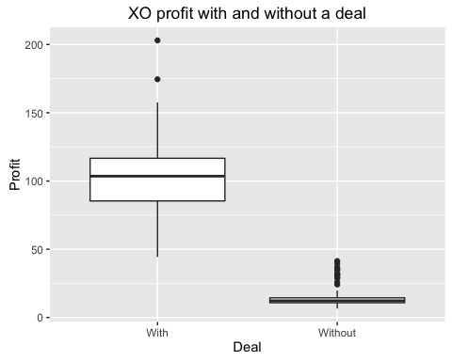

ggplot(summary_XO, aes(x=deal, y=oz)) + geom_boxplot() + labs(title="XO oz sold with and without a deal", x="Deal", y = "Oz")

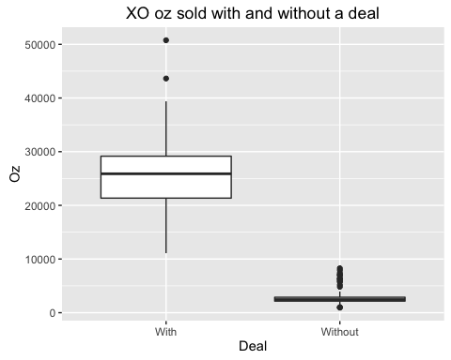

ggplot(summary_XO, aes(x=feat, y=profit)) + geom_boxplot() + labs(title="XO profit with and without a feature", x="Feature", y = "Profit")

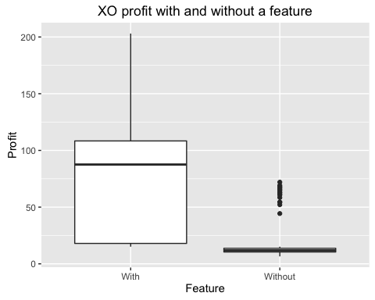

ggplot(summary_XO, aes(x=feat, y=oz)) + geom_boxplot() + labs(title="XO oz sold with and without a feature", x="Feature", y = "Oz")

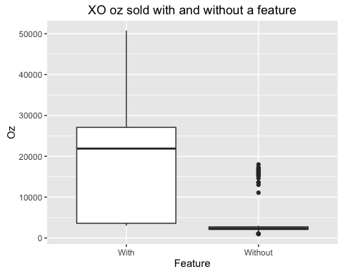

summary_YO <- data.ref %>% filter(brand=="Y", class=="organic") %>% select(oz, p, c, deal, feat)  
summary_YO <- mutate(summary_YO, profit=oz*(p-c))  
summary_YO$deal[summary_YO$deal == 0] <- "Without"  
summary_YO$deal[summary_YO$deal == 1] <- "With"  
summary_YO$feat[summary_XO$feat == 0] <- "Without"  
summary_YO$feat[summary_XO$feat == 1] <- "With"  
ggplot(summary_YO, aes(x=deal, y=profit)) + geom_boxplot() + labs(title="YO profit with and without a deal", x="Deal", y = "Profit")

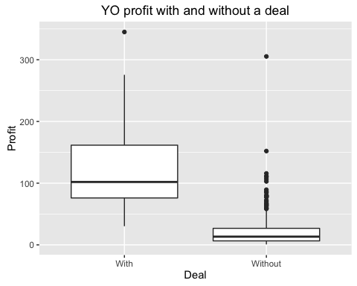

ggplot(summary_YO, aes(x=deal, y=oz)) + geom_boxplot() + labs(title="YO oz sold with and without a deal", x="Deal", y = "Oz")

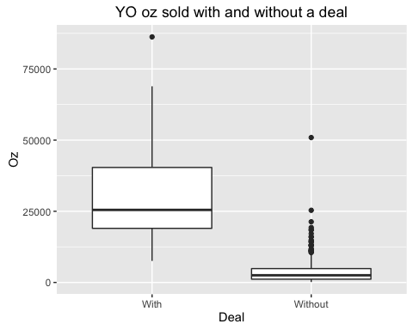

ggplot(summary_YO, aes(x=feat, y=profit)) + geom_boxplot() + labs(title="YO profit with and without a feature", x="Feature", y = "Profit")

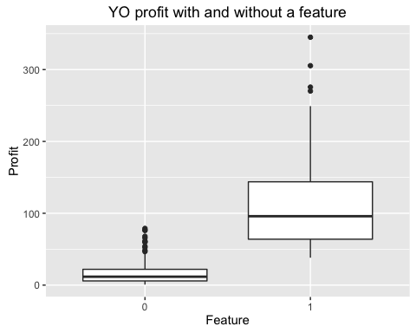

ggplot(summary_YO, aes(x=feat, y=oz)) + geom_boxplot() + labs(title="YO oz sold with and without a feature", x="Feature", y = "Oz")

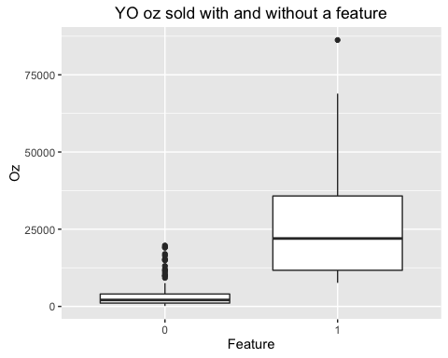

summary_XI <- data.ref %>% filter(brand=="X", class=="nonorganic") %>% select(oz, p, c, deal, feat)  
summary_XI <- mutate(summary_XI, profit=oz*(p-c))  
summary_XI$deal[summary_XI$deal == 0] <- "Without"  
summary_XI$deal[summary_XI$deal == 1] <- "With"  
summary_XI$feat[summary_XI$feat == 0] <- "Without"  
summary_XI$feat[summary_XI$feat == 1] <- "With"  
ggplot(summary_XI, aes(x=deal, y=profit)) + geom_boxplot() + labs(title="XI profit with and without a deal", x="Deal", y = "Profit")

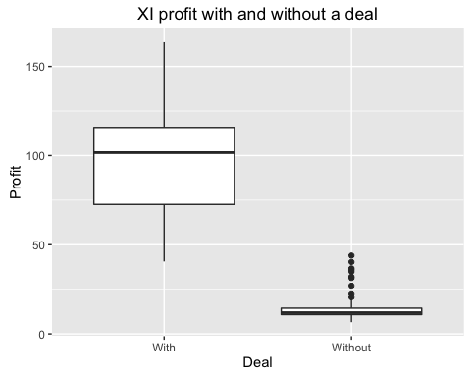

ggplot(summary_XI, aes(x=deal, y=oz)) + geom_boxplot() + labs(title="XI oz sold with and without a deal", x="Deal", y = "Oz")

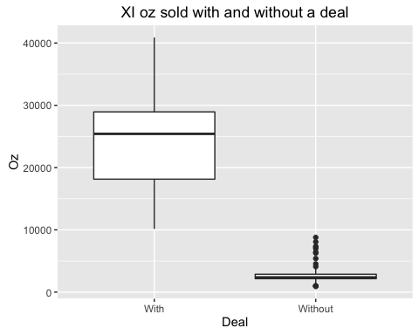

ggplot(summary_XI, aes(x=feat, y=profit)) + geom_boxplot() + labs(title="XI profit with and without a feature", x="Feature", y = "Profit")

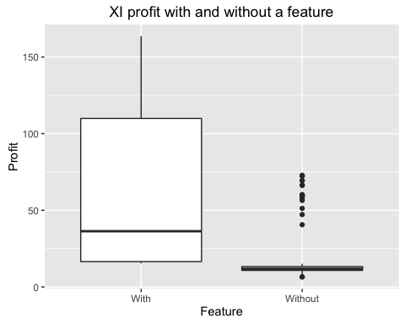

ggplot(summary_XI, aes(x=feat, y=oz)) + geom_boxplot() + labs(title="XI oz sold with and without a feature", x="Feature", y = "Oz")

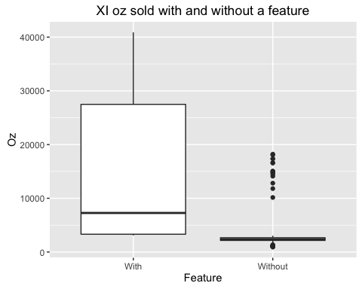

summary_YI <- data.ref %>% filter(brand=="Y", class=="nonorganic") %>% select(oz, p, c, deal, feat)  
summary_YI <- mutate(summary_YI, profit=oz*(p-c))  
summary_YI$deal[summary_YI$deal == 0] <- "Without"  
summary_YI$deal[summary_YI$deal == 1] <- "With"  
summary_YI$feat[summary_YI$feat == 0] <- "Without"  
summary_YI$feat[summary_YI$feat == 1] <- "With"  
ggplot(summary_YI, aes(x=deal, y=profit)) + geom_boxplot() + labs(title="YI profit with and without a deal", x="Deal", y = "Profit")

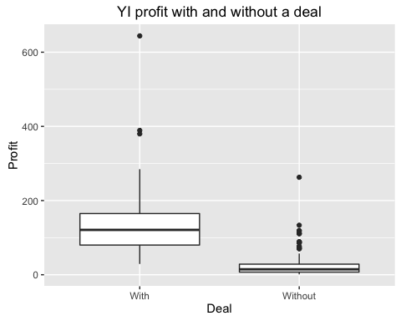

ggplot(summary_YI, aes(x=deal, y=oz)) + geom_boxplot() + labs(title="YI oz sold with and without a deal", x="Deal", y = "Oz")

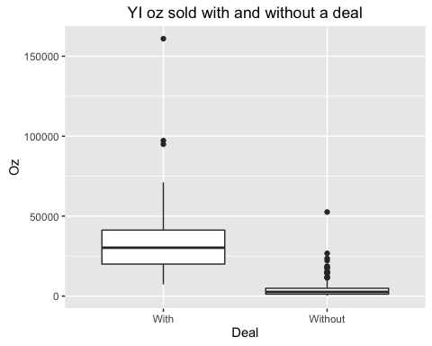

ggplot(summary_YI, aes(x=feat, y=profit)) + geom_boxplot() + labs(title="YI profit with and without a deal", x="Feature", y = "Profit")

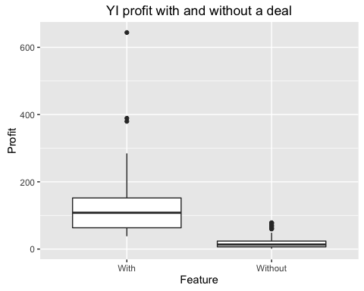

ggplot(summary_YI, aes(x=feat, y=oz)) + geom_boxplot() + labs(title="YI oz sold with and without a feature", x="Feature", y = "Oz")

