Example Manuscript Template for a Data Analysis Project

Andreas Handel & Aidan Troha

1/20/23

The structure below is one possible setup for a data analysis project (including the course project). For a manuscript, adjust as needed. You don’t need to have exactly these sections, but the content covering those sections should be addressed.

This uses MS Word as output format. [See here](https://quarto.org/docs/output-formats/ms-word.html) for more information. You can switch to other formats, like html or pdf. See [the Quarto documentation](https://quarto.org/) for other formats.

# 1. Summary/Abstract

*Write a summary of your project.*

# 2. Introduction

## 2.1 General Background Information

*Provide enough background on your topic that others can understand the why and how of your analysis*

## 2.2 Description of data and data source

*Describe what the data is, what it contains, where it is from, etc. Eventually this might be part of a methods section.*

## 2.3 Questions/Hypotheses to be addressed

*State the research questions you plan to answer with this analysis.*

To cite other work (important everywhere, but likely happens first in introduction), make sure your references are in the bibtex file specified in the YAML header above (here dataanalysis_template_references.bib) and have the right bibtex key. Then you can include like this:

Examples of reproducible research projects can for instance be found in (McKay, Ebell, Billings, et al., 2020; McKay, Ebell, Dale, Shen, & Handel, 2020)

# 3. Methods

*Describe your methods. That should describe the data, the cleaning processes, and the analysis approaches. You might want to provide a shorter description here and all the details in the supplement.*

## 3.1 Data aquisition

*As applicable, explain where and how you got the data. If you directly import the data from an online source, you can combine this section with the next.*

## 3.2 Data import and cleaning

*Write code that reads in the file and cleans it so it’s ready for analysis. Since this will be fairly long code for most datasets, it might be a good idea to have it in one or several R scripts. If that is the case, explain here briefly what kind of cleaning/processing you do, and provide more details and well documented code somewhere (e.g. as supplement in a paper). All materials, including files that contain code, should be commented well so everyone can follow along.*

## 3.3 Statistical analysis

*Explain anything related to your statistical analyses.*

# 4. Results

## 4.1 Exploratory/Descriptive analysis

*Use a combination of text/tables/figures to explore and describe your data. Show the most important descriptive results here. Additional ones should go in the supplement. Even more can be in the R and Quarto files that are part of your project.*

Table 1 shows a summary of the data.

Note the loading of the data providing a **relative** path using the ../../ notation. (Two dots means a folder up). You never want to specify an **absolute** path like C:\ahandel\myproject\results\ because if you share this with someone, it won’t work for them since they don’t have that path. You can also use the here R package to create paths. See examples of that below.

Table 1: Data summary table.

|  | Height | Weight | Sex | Age | BMI.Status |
| --- | --- | --- | --- | --- | --- |
| Min. | 133 | 45 | 3 | 17 | 9 |
| 1st Qu. | 155 | 54 | 6 | 24 | character |
| Median | 166 | 70 | 3 | 27 | character |
| Mean | 162.555555555556 | 70 | 6 | 28.8888888888889 | 9 |
| 3rd Qu. | 175 | 80 | 3 | 31 | character |
| Max. | 180 | 110 | 6 | 55 | character |

## 4.2 Basic statistical analysis

*To get some further insight into your data, if reasonable you could compute simple statistics (e.g. simple models with 1 predictor) to look for associations between your outcome(s) and each individual predictor variable. Though note that unless you pre-specified the outcome and main exposure, any “p<0.05 means statistical significance” interpretation is not valid.*

Figure 1 shows a scatterplot figure produced by one of the R scripts.

|  |
| --- |
| Figure 1: Height and weight stratified by sex. |

## 4.3 Full analysis

*Use one or several suitable statistical/machine learning methods to analyze your data and to produce meaningful figures, tables, etc. This might again be code that is best placed in one or several separate R scripts that need to be well documented. You want the code to produce figures and data ready for display as tables, and save those. Then you load them here.*

Example Table 2 shows a summary of a linear model fit.

Table 2: Linear model fit table.

| term | estimate | std.error | statistic | p.value |
| --- | --- | --- | --- | --- |
| (Intercept) | 138.5075828 | 17.6375233 | 7.8530064 | 0.0002255 |
| Weight | 0.2884414 | 0.2655154 | 1.0863453 | 0.3190313 |
| SexM | 5.7856082 | 11.3303870 | 0.5106276 | 0.6278491 |

Example (**figure-file1?**) and (**figure-file2?**) show figure options for the data.

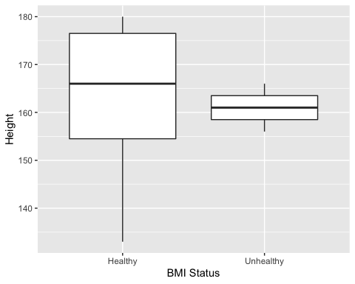

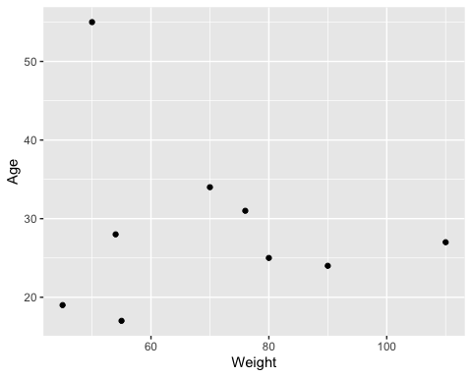

# 5. Discussion

## 5.1 Summary and Interpretation

*Summarize what you did, what you found and what it means.*

## 5.2 Strengths and Limitations

*Discuss what you perceive as strengths and limitations of your analysis.*

## 5.3 Conclusions

*What are the main take-home messages?*

*Include citations in your Rmd file using bibtex, the list of references will automatically be placed at the end*

This paper (Leek & Peng, 2015) discusses types of analyses.

These papers (McKay, Ebell, Billings, et al., 2020; McKay, Ebell, Dale, et al., 2020) are good examples of papers published using a fully reproducible setup similar to the one shown in this template.

Note that this cited reference will show up at the end of the document, the reference formatting is determined by the CSL file specified in the YAML header. Many more style files for almost any journal [are available](https://www.zotero.org/styles). You also specify the location of your bibtex reference file in the YAML. You can call your reference file anything you like, I just used the generic word references.bib but giving it a more descriptive name is probably better.

# 6. References

Leek, J. T., & Peng, R. D. (2015). Statistics. What is the question? *Science (New York, N.Y.)*, *347*(6228), 1314–1315. <https://doi.org/10.1126/science.aaa6146>

McKay, B., Ebell, M., Billings, W. Z., Dale, A. P., Shen, Y., & Handel, A. (2020). Associations Between Relative Viral Load at Diagnosis and Influenza A Symptoms and Recovery. *Open Forum Infectious Diseases*, *7*(11), ofaa494. <https://doi.org/10.1093/ofid/ofaa494>

McKay, B., Ebell, M., Dale, A. P., Shen, Y., & Handel, A. (2020). Virulence-mediated infectiousness and activity trade-offs and their impact on transmission potential of influenza patients. *Proceedings. Biological Sciences*, *287*(1927), 20200496. <https://doi.org/10.1098/rspb.2020.0496>