**Computer Science**

**COMP S456F - Software System Development Project**

**Initial Report**

**Project Title: Aspect Category Sentiment Analysis for Online Restaurant Review in Chinese**

|  |  |
| --- | --- |
| **Student name** | **Student ID** |
| Yeung Ho Yin Tommy | 13024570 |
| Wong Ping Kuen | 13031493 |
| LI Chi Fung | 13031837 |
| Jon Rai | 12749417 |

|  |  |
| --- | --- |
| Group Name | : 2023-Keith-4 |
| Supervisor | : Dr. Keith Lee |
| Submission date | : 10-11-2023 |

**Contents**

1. Problem Definition 2

1.1. Introduction 2

1.2. Project Aim 3

1.3. Project Objectives 3

1.4. Value Propositions 3

2. Literature Review 4

2.1. Review of Existing or Related Solutions for the Problem 4

2.1.1. Aspect-Category Sentiment Analysis (ACSA) 4

2.1.2. Aspect-Based Sentiment Analysis (ABSA) 4

2.1.3. Existing Models for ACSA and ABSA 5

2.1.4. Neural Network used in the existing models 6

2.1.5. Models used in existing models 6

2.1.6. Existing restaurant review dataset for the Chinese Language 6

2.2. Related terminologies of Deep Learning 7

2.2.1. Accuracy 7

2.2.2. F1-Score 7

2.2.3. Precision 7

2.2.4. Recall 7

2.3. Highlight of the proposed solution 8

3. Preliminary Methodology 9

3.1. Overview 9

3.2. Requirements and Key Technologies 9

3.2.1. Use-case diagram 9

3.2.2. Function List 10

3.2.3. Functional requirements 10

3.2.4. Essential key technologies 10

3.2.5. Technical Gap 11

3.3. Architecture or High-Level System Design 12

3.3.1. Component diagram 13

3.3.2. Data-flow diagram 14

4. References 15

5. Appendixes 16

Appendix A. Project Plan 16

Appendix B. (Group Project) Members’ Roles and Responsibilities 17

Appendix C. (Group Project) Meeting Minutes 18

# Problem Definition

## Introduction

As the internet is becoming more a part of our life, an increasing population are using the internet to collect and generate content, therefore various websites appeared that are close to our lives such as restaurant review websites (E.g. OpenRice and KeeTa, etc.). The restaurant review websites are providing the restaurant information, booking service, review, and rating etc. Many people appreciate sharing their experience in the restaurant in several aspects on these websites about the food quality, service, price etc. Therefore, restaurant customers could read the reviews and rating scores to look for suitable restaurants. Furthermore, restaurant owners could easily collect opinions from the clients for improving their restaurant. However, we found that most of the meaningful comments are always articles which are time-consuming to read.

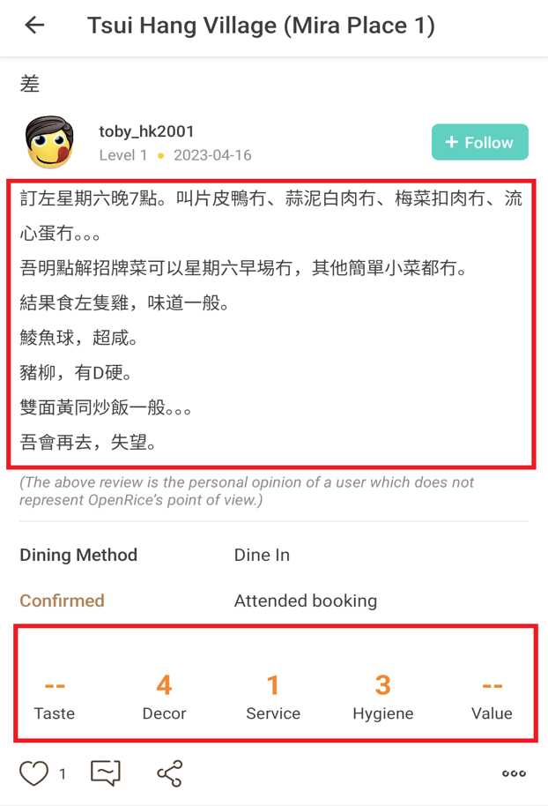

**Figure 1: A user comment screen captured on OpenRice** (toby_hk2001, 2023)**, the upper rectangle shows the reviewer’s review about the restaurant, and the lower rectangle shows the rating for each aspect in restaurant by reviewer.**

Moreover, we found that some of the review-mentioned aspects are not reflected in the rating. For example, in Figure 1, the reviewer complained the food quality overall was too bad, but he/she did not provide a rating score for food quality, which only provides the score of Decor (Environment), Service, and Hygiene. Furthermore, Aspect-Category Sentiment Analysis (ACSA) is popular research in natural language processing in Artificial Intelligence (AI), its aims to categorize the aspects from the given input and predicting its polarity in positive, negative, and neutral (Liang, et al., 2021). But we found that most of the ACSA research still focuses on English instead of Chinese, which is lack of Chinese resources. Therefore, a tool for summarizing each aspect of the score from the customer’s review text is especially important.

## Project Aim

This project aims to develop an Aspect-Category Sentiment Analysis (ACSA) tool named “Restaurant Review Analyzer for Chinese Language (RRACL)” for restaurant owners to better understand his/her restaurant(s) which parts need to be improved and for restaurant customers to see more accurate rating scores of the restaurant. This tool could also solve the problem of the lack of ACSA research in the Chinese language.

## Project Objectives

In our project, we will develop a web application that able to analyze the restaurant review in Chinese language and provide analyzed results. To achieve this aim, we are using the divide and conquer method to separate the development process into 7 objectives. The details are listed below:

* To collect Chinese review data (raw data) from HK restaurant review websites (E.g., OpenRice) for the preparation of building Chinese datasets.
* To cleanse the collected data (raw data) from the restaurant review website to ensure the dataset's accuracy and correctness (What is Data Cleansing?, n.d.).
* To label the cleansed data in each aspect to building the dataset.
* To adapt the existing models of Aspect-Category Sentiment Analysis (ACSA) for English to handle the Chinese dataset.
* To train the models with our created Chinese dataset.
* To develop a prototype web application for deploying the trained model to handle the restaurant review analysis task and show the analysis results.
* To initiate a user satisfaction survey via Google Forms to collect opinions from test users for web application improvement.

## Value Propositions

For restaurant owners, the tool “Restaurant Review Analyzer for Chinese Language” can help collect customer reviews and generate statistical reports about each aspect of his/her restaurant. The owner can improve their restaurant based on the above reports, so that the restaurant will attract more customers, and the restaurant table turnover rate will also increase (Agilence Staff, 2023). For restaurant review website’ users, they can quickly see the summarized restaurant score and the score of each comment for each aspect, and these scores are more accurately compared with the original score (provided by restaurant review websites). From the market perspective, the markets currently lack the existing tools that deployed the ACSA models in Chinese (Cantonese) language, which means our project develops a product that fewer people have done before.

# Literature Review

## Review of Existing or Related Solutions for the Problem

### Aspect-Category Sentiment Analysis (ACSA)

**Aspect-Category Sentiment Analysis (ACSA)** is part of the natural language processing of deep learning, it focuses on categorizing the aspects in coarse-grained from a given text and predicting its sentiment polarity, its predicted result usually is positive, negative, or neutral (Liang, et al., 2021).

### Aspect-Based Sentiment Analysis (ABSA)

**Aspect-Based Sentiment Analysis (ABSA)** is another method for handling the sentiment analysis in natural language processing, it mainly focuses on categorizing the aspects in fine-grained and predicting its sentiment polarity, its predicted result usually is positive, negative, or neutral (Trisna & Jie, 2022).

The major difference between ACSA and ABSA are coarse-grained and fine-grained. The details are listed below:

**Example sentence: “Although the steak is tasty, but the environment is so dirty.”**

According to (Li, Wei, Zhang, Zhang, & Li, 2019), the **coarse-grained** is an **Aspect Category (AC)** task that finds the aspects implicitly appearing from the input texts. The AC task assigns the found entities to the corresponding aspects based on the pre-defined categories on datasets, and those pre-defined categories are the domain terms. For the restaurant, the domain terms could be Taste, Decor, Service, Hygiene, and Value etc.

For the example sentence, it mentioned the entities of **“steak”** and **“environment”**, therefore it will assign the **“steak”** to **Taste** aspectand **“environment”** to **Hygiene** aspect.

According to (Li, Wei, Zhang, Zhang, & Li, 2019), the **fine-grained** is an **Aspect Term (AT)** task that finds the aspects explicitly appearing from the input texts. Different from the AC task, the AT task assigns the aspects by the terms of the found entities, and it is a model-based method that means the aspects do not need to be pre-defined by the datasets.

For the example sentence, it mentioned the entities of **“steak”** and **“environment”**, therefore the **“steak”** and **“environment"** will become the aspects.

### Existing Models for ACSA and ABSA

According to (Liang, et al., 2021), the **Aspect-aware graph convolutional network (AAGCN)** is an aspect-category sentiment analysis model used to extract aspects from text. This model uses contextual sentiment dependencies as the replacement of aspects categorizing in coarse-grained for graph construction. The process of finding contextual sentiment dependencies involves aspect-aware word, aspect-aware weight, and aspect-aware graph(s).

Aspect-aware words: AAGCN uses the distinct aspect word (E.g. price, environment) as the pivot to find the highly related aspect words from the external knowledge.

Aspect-aware weight: AAGCN educes how the aspect-aware word(s) is important to the corresponding aspect, and uses a Beta Distribution to modelling the appearance probabilities of important aspect-aware words to obtain the weights.

Aspect-aware graph(s): AAGCN uses found aspect-aware words and its aspect-aware weight to construct the aspect-aware graph, and this graph uses to learn the contextual sentiment dependencies.

Moreover, AAGCN has provided the non-BERT models and BERT-based models (Liang, et al., 2021).

However, the development of this model is based on the English datasets, which means it does not support the Chinese dataset, and also this model only provides the model training which does not provide a user interface for deploying the trained model.

According to a recent study, (Zhang, Zhou, & Wang, 2022) proposed a new aspect-based sentiment analysis model for deep learning, named **Syntactic and Semantic Enhanced Graph Convolutional Network (SSEGCN).** This model uses syntactic and semantic for graph-base learning task. The model contains several components to achieve the goal.

Contextualized Word Representations, contextualized representations of words are captured by using sentence encoder, it helps to understand the meaning of each word within the sentence context.

Aspect-Aware Attention, semantic correlations that related to different aspect terms or aspect of interest in the sentence are capture, enhance this mechanism combines with self-aware to learn both aspect-related and global semantic information effectively.

Syntactic Mask Matrices are constructs according to the distances between words in the sentence’s syntactic dependency structure to calculate the syntactic mask matrices. Combining

Both adjacency matrices and syntactic mask matrices are to enhance the GCN, allowing the model to fully utilize both syntactic and semantic. It will enhance the understanding and representation of sentences.

Moreover, SSEGCN also has provided the non-BERT models and BERT-based models (Zhang, Zhou, & Wang, 2022).

Although the SSEGCN model has a better performance compared with the AAGCN model, this is not suitable for our project because we are going to perform the ACSA project instead of the ABSA project. Furthermore, this solution has the same problem as the AAGCN model which is the model only supports the English datasets and it does not provide a user interface for deploying the trained model.

### Neural Network used in the existing models

**Graph Convolutional Network (GCN)** is based on Convolutional Neural Network (CNN) for development that operates on graph-structured data. GCN has two generations, there are Spectral Networks and Locally Connected Networks on Graphs (Bruna, Zaremba, Szlam, & LeCun, 2014), and Convolutional Neural Networks on Graphs with Fast Localized Spectral Filtering (Defferrard, Bresson, & Vandergheynst, 2016). Spectral Networks and Locally Connected Networks on Graphs is the first generation and is based on the spectrum of its graph-Laplacian. Convolutional Neural Networks on Graphs with Fast Localized Spectral Filtering is a second generation and based on bridging the gap between signal processing and spectral graph theory. Those GCN is good at graph analysis, it just little paper is for text analysis with classification. Also, it not completely supporting Chinese language analysis and cannot handling noisy.

### Models used in existing models

According to the survey of (Trisna & Jie, 2022), **Global Vectors for Word Representation (GloVe)** is one of the models that is used for ACSA and ABSA tasks, numerous researchers use GloVe as their word embedding. The GloVe model uses co-occurrence matrix that counts the number of words that appear in context, it factorizes the matrix to obtain the word vectors. GloVe can obtain word embedding from the restaurant's comments then represent the words in a high-dimensional space. Words with similar meanings are closer together, identifying the aspect in the comment and sentiment associated with each aspect.

According to the survey of (Trisna & Jie, 2022), **Word Embedding** is a type of word representing a word with similar meanings to have similar representation. Words are distributed to represent text, one of the keys to impressive performance in deep learning methods in natural language processing problems (NLP). The words represent vector capture semantic and syntactic between words through this method is more efficient and accurate processing in natural language data. Neural network models, such as Word2Vec or GloVe generate word embedding to learn to predict the context of words that appear in a large corpus of text.

According to the survey of (Trisna & Jie, 2022), **Bidirectional Encoder Representations from Transformers (BERT)** is another model designed to understand pretrained deep bidirectional representations by considering both the left and right text. BERT learns to improve its understanding of individual words by relationship between words in a sentence-level context. BERT has achieved state-of-the-art result in natural language processing task, leading to developer to use it on many other pre-trained language models.

According to the article of (aditya_taparia, 2023), **Bidirectional LSTM(BiLSTM)** is a model or architecture for sentiment analysis to use include Aspect-Based Sentiment Analysis (ABSA) or Aspect-Category Sentiment Analysis (ACSA). BiLSTM is a recurrent neural network technique which is for input in the forward direction and other is for processing in the backward , through this technique to find out the relationship between the word which the word is in the dataset or data, after checking the relationship with the word, the BiLSTM will analyze the word or data and that will output a result or classify the word or data include which sentence is positive or negative.

### Existing restaurant review dataset for the Chinese Language

**Aspect category Sentiment Analysis and rating Prediction (ASAP)** is a large-scale Chinese restaurant review dataset and used for the training dataset of ACSA (Bu, et al., 2021). This dataset collected 46,730 comments real restaurant reviews from the e-commerce platform in China, and each review has assigned 5 coarse-grained aspects for those comments: food, service, price, ambience and miscellaneous (Bu, et al., 2021). However, this dataset has the limitation that is only supported by the Simplified Chinese Language.

## Related terminologies of Deep Learning

### Accuracy

In our project, the results of our dataset will yield an accuracy score, which is calculated by dividing the number of correct predictions by the total number of predictions across all classes. However, if the number of positive examples is insufficient, the accuracy score may not be a reliable reference. To illustrate, let's consider a specific example where the dataset of positive Chinese comments, such as "good" or "tasty," is limited. In this case, the accuracy score may not be precise. Conversely, if there are enough positive Chinese comments, the accuracy score becomes a reliable and applicable reference. (Czakon, 2023)

Here is the equation for Accuracy:

$$Acc = \frac{tp+tn}{tp+fp+tn+fn}$$

### F1-Score

F1-score is a commonly used evaluated matric to measure the performance of a classification model, specifically tasks such as text classification and sentiment analysis. It combines **precision** and **recall** into one metric by calculating the harmonic mean between those two. (Czakon, 2023)

Here is the equation for F1-Score:

$$Ϝ_{beta} = \left(1+β^{2}\right)\frac{precision×recall}{β^{2}×precision×recall}$$

### Precision

Precision is defined as the number of true positives divided by the sum of true positives and false positives. This means that precision measures the proportion of correctly predicted positive observations out of the total predicted. In simpler terms, precision focuses on the number of predicted positives. (SarielWang, 2020)

Here is the equation for Precision:

$$Precision = \frac{TP}{TP+FP}$$

### Recall

Recall is defined as the number of true positives divided by the sum of the true positives and false negatives. In simple terms, recall focuses on actual positives number. (SarielWang, 2020)

Here is the equation of Recall:

$$Recall = \frac{TP}{TP+FN}$$

## Highlight of the proposed solution

The following table is a comparison of our solution and existing model.

|  |  |  |  |
| --- | --- | --- | --- |
|  | AAGCN-ACSA | SSEGCN-ABSA | Our Solution |
| Find the aspects in coarse-grained / fine-grained | Coarse-grained | Fine-grained | Coarse-grained |
| Neural network | GCN | GCN | GCN |
| Supported Models | non-BERT models with GloVe / BERT-based models | Non-BERT models / BERT-based models | Only support AAGCN non-BERT models with GloVe |
| Support Chinese Dataset | No | No | Yes |
| Training Model | Yes | Yes | Yes |
| Accuracy | 82.79 (Non-Bert) | 84.72 (Non-Bert) | To be evaluated after complete |
| 87.92 (Bert) | 87.31 (Bert) |
| F1 Score | 67.43 (Non-Bert) | 77.51 (Non-Bert) |
| 71.75 (Bert) | 81.09 (Bert) |
| User Interface for model deployment | No | No | Yes |

**Table 1: Solution Comparison**

# Preliminary Methodology

## Overview

Based on the documents we have researched, analyzing outsource and identifying the issues we have solutions to it. By creating a web application “Restaurant Review Analyzer for Chinese Language” (RRACL) provide a user interface that users can use on any device as long the device is connected to the internet.

Users can use RRACL to search for restaurant 's score that has been analyzed by using Natural language processing technology, by using the controller to retrieve the review of restaurant from the open rice platform, then the model will handle the retrieved review by analyzing the comments and generate score to restaurant’s overall performance and aspect.

## Requirements and Key Technologies

### Use-case diagram

The figure below shows the Use case of Restaurant Review Analyzer for Chinese Language (RRACL).

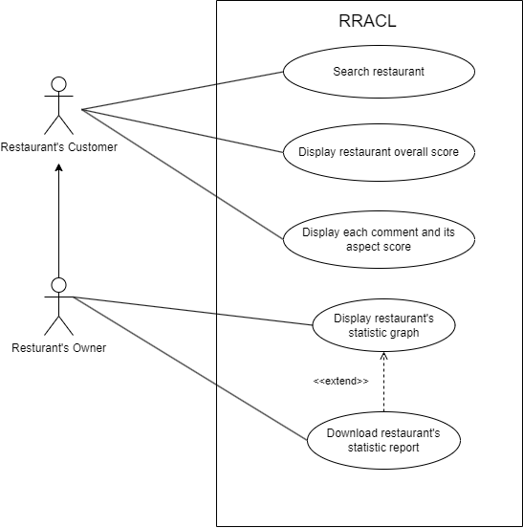

**Figure 2: Use Case of the system Restaurant Review Analyzer for Chinese Language (RRACL)**

### Function List

|  |  |
| --- | --- |
| **User Types** | **Functions** |
| Restaurant’s Customer | Search restaurant  Display restaurant overall score  Display each comment and its aspect score |
| Restaurant’s Owner | Search restaurant  Display restaurant overall score  Display each comment and its aspect score  Display restaurant’s statistic graph  Download restaurant’s statistic report |

**Table 2: Function List**

### Functional requirements

|  |  |
| --- | --- |
| Functions | Description |
| Search restaurant | A function provided for users to search restaurants that they want to see in the web dashboard.  p |
| Display overall score | Display the summarized aspect score for the restaurant. |
| Statistic calculation | A calculation function that calculates the statistic with restaurant comments is positive, negative, or neutral. |
| Display statistic result in table | Show the result of statistic calculation with table. |
| Display statistic in graph | Show the result of statistic calculation with graph. |
| Display comment and its aspect score | Display a list of restaurant customer comments and its corresponding aspect score. |
| Download statistic report | A download function for users to download a statistic report of currently viewed restaurant. |

**Table 3: Functional requirements**

### Essential key technologies

For our application development, the development language will use Python 3.6, and it is a web-based application that uses the Python Flask web framework (What is Flask Python, n.d.) to develop the application. For the web user interface creation, the Bootstrap 5 front-end framework (Bootstrap 5 Get Started, n.d.) will be used. For the hardware requirement, it is required to use the Nvidia Graphics Processing Unit (GPU) that contains CUDA cores to speed up the process of AI model training (NVIDIA CUDA in AI Deep Learning, 2022). For the software library, we will use Hugging Face (Lutkevich, 2023) to find NLP resources that benefit our application development. For the model, we will adapt the existing model Aspect-aware graph convolutional network (AAGCN) (Liang, et al., 2021) to handle Chinese dataset. For the Python modules, we will use PyTorch (What is PyTorch?, n.d.) as the deep-learning module to build the Aspect-Category Sentiment Analysis (ACSA) models. We also use the Beautiful Soup module (What is Beautiful Soup?, n.d.) to collect review data on the website for dataset creation.

### Technical Gap

We found that most of the Aspect-Category Sentiment Analysis (ACSA) models like Aspect-aware graph convolutional network (AAGCN) (Liang, et al., 2021) only provide the functionality of training models, which means it does not provide a user interface for deploying the model deployment. Furthermore, we also found that these models are usually developed for English datasets instead of Chinese datasets, so it cannot process the Chinese text. Moreover, although there are Chinese datasets like the Aspect category Sentiment Analysis and rating Prediction (ASAP) (Bu, et al., 2021), but it only provides Simplified Chinese review data.

To address these problems, we will make a web application for deploying an ACSA model that is able to process the Chinese text, and the application named “Restaurant Review Analyzer for Chinese Language (RRACL)”. The development details are listed below:

* Stage 1: To uses the software library “Hugging Face” to find the NLP resources.
* Stage 2: To write a script with the Beautiful Soup module to collect the data from the HK restaurant review website (E.g., OpenRice), and manually cleanse the invalid or wrong data for the dataset creation.
* Stage 3: Adapt the code of the AAGCN model to handle our created Chinese review dataset. (The implementation of AAGCN model use the PyTorch)
* Stage 4: Try to train the models using GPU and evaluate the models’ performance.
* Stage 5: Use Flask web framework to develop a web application for model deployment and web server deployment. Also, use Bootstrap 5 front-end framework to create user interfaces for showing the results in the format of a graph or board. Besides that, it will show a list of the customer comments as well.

## Architecture or High-Level System Design

The figure below shows the Restaurant Review Analyzer for Chinese Language (RRACL) architecture.

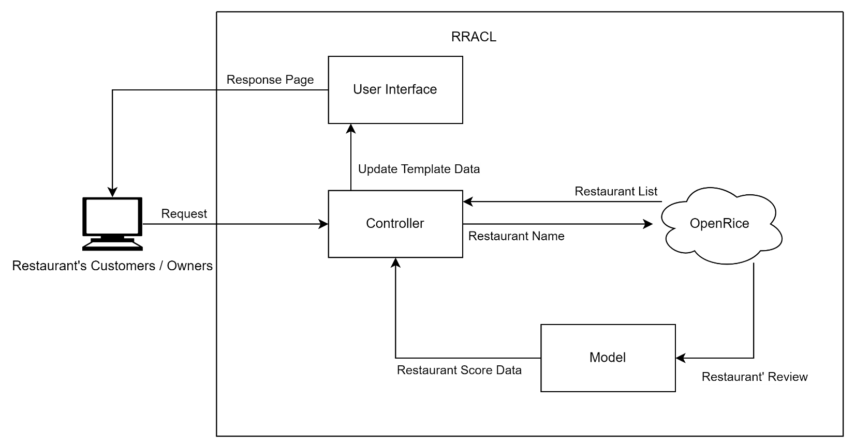**Figure 3: High-Level System Design of the system Restaurant Review Analyzer for Chinese Language (RRACL)**

* **Controller**: It handles user requests, processes the data from the Model or “Open Rice” website, and updates User Interface and page data.
* **User Interface**: It responds to web pages and displays data to the user.
* **Model**: It is the Aspect Category Sentiment Analysis (ACSA) model. It handles restaurant reviews from the “Open Rice” website and outputs the restaurant score data.
* **OpenRice**: It is the restaurant information and review website.

### Component diagram

The figure below shows the component of Restaurant Review Analyzer for Chinese Language (RRACL).

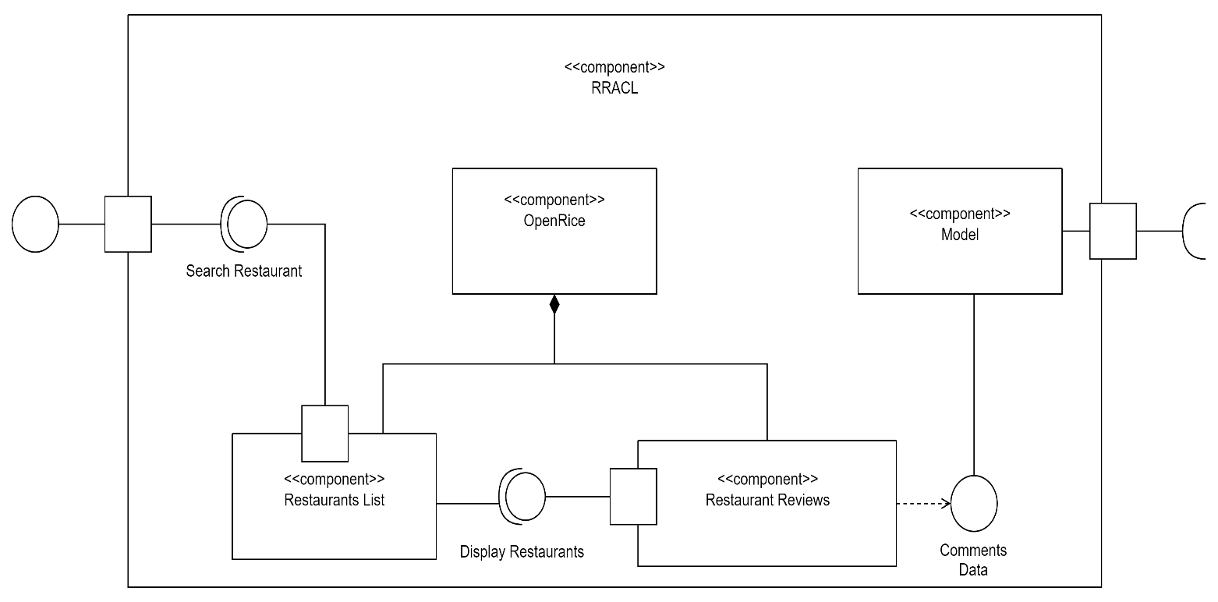

**Figure 4: Component of the system Restaurant Review Analyzer for Chinese Language (RRACL)**

* **RRACL**: It is system’s controller handles user requests, processes the data from the Model or “Open Rice” website, and updates User Interface and page data.
* **Search Restaurant**: It is searching web page. It handles user input the restaurant’s name and request to “OpenRice”’ “Restaurants List”.
* **OpenRice**: It is the restaurant information and review website.
* **Restaurants List**: Is the OpenRice restaurants' list. It will return a list of restaurants that the range be like user input restaurant’s name.
* **Display Restaurants**: It displays search results web page. It handles user select the restaurant’s name and request to “OpenRice”’ “Restaurants Reviews”.
* **Restaurants Reviews**: Is the OpenRice restaurants' list. It will return a list of restaurant reviews that the user selected restaurant.
* **Comments Data**: A list of restaurant review data returned by the OpenRice website, and these data will pass to our model after pre-processing.
* **Model**: It is the Aspect Category Sentiment Analysis (ACSA) model. It will return analyzed results that the OpenRice got reviews.

### Data-flow diagram

The figure below shows the dataflow of Restaurant Review Analyzer for Chinese Language (RRACL).

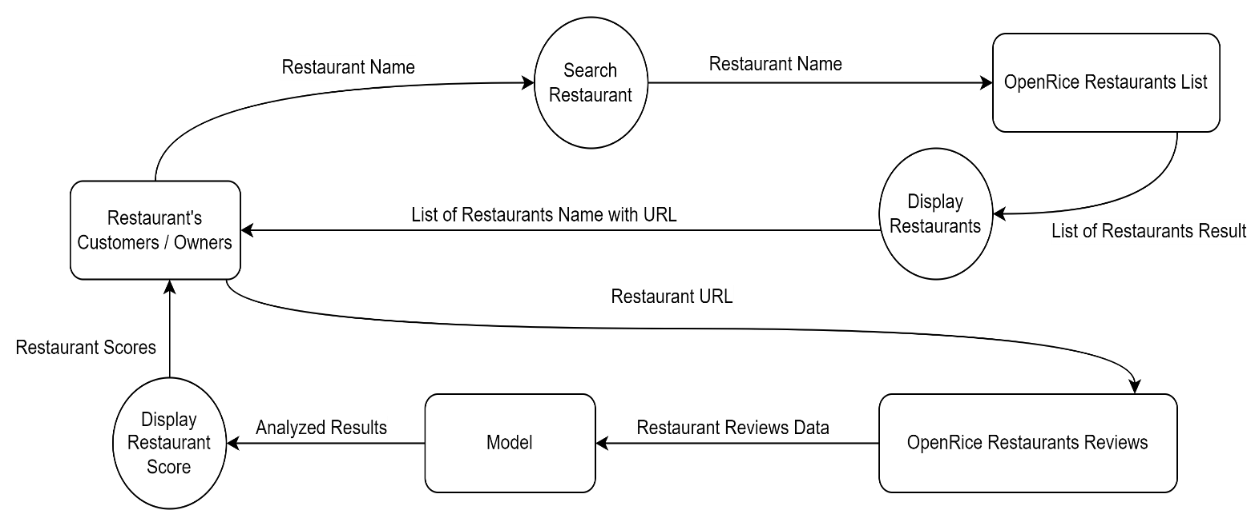

**Figure 5: Data-flow of the system Restaurant Review Analyzer for Chinese Language (RRACL)**

|  |  |
| --- | --- |
| Restaurant's Customers / Owners | Is the system user. He/she will input the restaurant's name. |
| Restaurant Name | It is a name given by the users who want to search for find the restaurant. |
| Search Restaurants | It is a function that displays search web page. |
| Restaurant Name | It is user input and passing from “Search Restaurant” to “OpenRice Restaurants List”. |
| Open Rice Restaurant List | Is the OpenRice restaurants' list. It will return a list of restaurants that the range be like user input. |
| List of Restaurants Result | A list of restaurant data returned by the OpenRice website, and this data will pass to Display Restaurants function. |
| Display Restaurants | It is a function that displays search results web page. |
| List of Restaurants Name with URL | It is the range of restaurants searched name by user. Each restaurant's name has their URL. |
| Restaurant's Customers / Owners | Is the system user. He/she will select the restaurant's name. |
| Restaurant URL | It is a name selected by the users who want to find the restaurant. |
| OpenRice Restaurants Reviews | Is the OpenRice restaurants' list. It will return a list of restaurant reviews that the user selected restaurant. |
| Restaurant reviews data | A list of restaurant review data returned by the OpenRice website, and these data will pass to our model after pre-processing. |
| Model | It is the Aspect Category Sentiment Analysis (ACSA) model. It will return analyzed results that the OpenRice got reviews. |
| Analyzed Results | The results given by the model are based on the restaurant review data and passed to the display restaurant score function. |
| Display Restaurant Score | It is a function that displays the model analyzed results web page. |
| Restaurant Scores | The scores given by analyzed results are each aspect have their score. |

**Table 4: Description of data flow diagram**

# References

aditya_taparia. (2023, June 8). *Bidirectional LSTM in NLP*. (GeeksforGeeks) Retrieved October 10, 2023, from GeeksforGeeks: https://www.geeksforgeeks.org/bidirectional-lstm-in-nlp/

*Bootstrap 5 Get Started*. (n.d.). (W3Schools) Retrieved November 3, 2023, from w3schools.com: https://getbootstrap.com/docs/5.0/getting-started/introduction/

Bruna, J., Zaremba, W., Szlam, A., & LeCun, Y. (2014). Spectral Networks and Locally Connected Networks on Graphs. *arXiv:1312.6203*. doi:https://doi.org/10.48550/arXiv.1312.6203

Bu, J., Ren, L., Zheng, S., Yang, Y., Wang, J., Zhang, F., & Wu, W. (2021). ASAP: A Chinese Review Dataset Towards Aspect Category Sentiment Analysis and Rating Prediction. *Proceedings of the 2021 Conference of the North American Chapter of the Association for Computational Linguistics: Human Language Technologies*, 2069–2079. doi:http://dx.doi.org/10.18653/v1/2021.naacl-main.167

Czakon, J. (2023, September 5). *F1 Score vs ROC AUC vs Accuracy vs PR AUC: Which Evaluation Metric Should You Choose?* (Neptune Labs) Retrieved November 1, 2023, from neptune.ai: https://neptune.ai/blog/f1-score-accuracy-roc-auc-pr-auc

Defferrard, M., Bresson, X., & Vandergheynst, P. (2016). Convolutional Neural Networks on Graphs with Fast Localized Spectral Filtering. *30th Conference on Neural Information Processing Systems (NIPS 2016), 29*, 3844-3852. Retrieved from https://proceedings.neurips.cc/paper_files/paper/2016/file/04df4d434d481c5bb723be1b6df1ee65-Paper.pdf

Li, Z., Wei, Y., Zhang, Y., Zhang, X., & Li, X. (2019). Exploiting Coarse-to-Fine Task Transfer for Aspect-Level Sentiment Classification. *Proceedings of the AAAI Conference on Artificial Intelligence, 33*(01), 4253-4260. doi:https://doi.org/10.1609/aaai.v33i01.33014253

Liang, B., Su, H., Yin, R., Gui, L., Yang, M., Zhao, Q., . . . Xu, R. (2021). Beta Distribution Guided Aspect-aware Graph for Aspect Category Sentiment Analysis with Affective Knowledge. *Proceedings of the 2021 Conference on Empirical Methods in Natural Language Processing*, 208–218.

Lutkevich, B. (2023, September). *What is Hugging Face?* (TechTarget) Retrieved November 3, 2023, from Whatls.com: https://www.techtarget.com/whatis/definition/Hugging-Face

*NVIDIA CUDA in AI Deep Learning*. (2022, October 6). (Exxact Corporation) Retrieved November 3, 2023, from EXXACT: https://www.exxactcorp.com/blog/Deep-Learning/NVIDIA-CUDA-in-AI-Deep-Learning

SarielWang. (2020, May 15). *機器學習模型評估指標-confusion matrix, precision, recall, and ,F1-score*. Retrieved November 1, 2023, from Medium: https://medium.com/@s716419/%E6%A9%9F%E5%99%A8%E5%AD%B8%E7%BF%92%E6%A8%A1%E5%9E%8B%E8%A9%95%E4%BC%B0%E6%8C%87%E6%A8%99-confusion-matrix-precision-and-recall-e9d64ff14d81

Agilence Staff. (2023, May 18). *How To Improve Your Restaurant’s Table Turnover: The Ultimate Guide*. (Agilence, Inc) Retrieved October 3, 2023, from Agilence: https://blog.agilenceinc.com/table-turnover

toby_hk2001. (2023, April 16). *Tsui Hang Village (Mira Place 1) - Review*. (OpenRice) Retrieved October 10, 2023, from https://www.openrice.com/en/hongkong/review/%E5%B7%AE-e4787429

Trisna, K. W., & Jie, H. J. (2022). Deep Learning Approach for Aspect-Based Sentiment Classification: A Comparative Review. *Applied Artificial Intelligence, 36*(1). doi:10.1080/08839514.2021.2014186

*What is Beautiful Soup?* (n.d.). (Educative, Inc) Retrieved November 3, 2023, from educative: https://www.educative.io/answers/what-is-beautiful-soup

*What is Data Cleansing?* (n.d.). (Amazon Web Services, Inc) Retrieved November 1, 2023, from aws: https://aws.amazon.com/what-is/data-cleansing/

*What is Flask Python*. (n.d.). (pythonbasics.org) Retrieved November 3, 2023, from Python Tutorial: https://pythonbasics.org/what-is-flask-python/

*What is PyTorch?* (n.d.). (NVIDIA Corporation) Retrieved November 3, 2023, from NVIDIA: https://www.nvidia.com/en-us/glossary/data-science/pytorch/

Zhang, Z., Zhou, Z., & Wang, Y. (2022). SSEGCN: Syntactic and Semantic Enhanced Graph Convolutional Network for Aspect-based Sentiment Analysis. *Proceedings of the 2022 Conference of the North American Chapter of the Association for Computational Linguistics: Human Language Technologies*, 4916–4925. doi:http://dx.doi.org/10.18653/v1/2022.naacl-main.362

# Appendixes

## Appendix A. Project Plan

|  |  |
| --- | --- |
| Date | Description |
| Week 0 – 5 | Research the existing model and test its code |
| Week 10 – 12 | Prepare the Chinese dataset |
| Week 13 – 18 | Adapt the existing model for handle Chinese dataset |
| Week 19 – 23 | Train and evaluate the models |
| Week 23 – 26 | Build web application for model deployment |
| Week 27 – 28 | Collect opinion with questionnaire for web application improvement |
| Week 28 – 33 | Finish the Final product and Final report |

## Appendix B. (Group Project) Members’ Roles and Responsibilities

**Roles**

|  |  |  |
| --- | --- | --- |
| Roles | Member(s) | Remarks |
| Team Coordinator | Yeung Ho Yin Tommy,  Rai Jon |  |
| Secretary | Yeung Ho Yin Tommy | Meeting agenda and minutes |
| Data Analyst | Yeung Ho Yin Tommy,  LI CHI FUNG |  |
| Programmer | Yeung Ho Yin Tommy,  Wong Ping Kuen,  LI Chi Fung,  Jon Rai |  |
| System Analyst and Designer | Yeung Ho Yin Tommy,  Wong Ping Kuen,  LI Chi Fung,  Jon Rai |  |
| Tester and Evaluator | Yeung Ho Yin Tommy,  Wong Ping Kuen,  LI Chi Fung,  Jon Rai |  |
| Artificial Intelligent Expert | Yeung Ho Yin Tommy,  Wong Ping Kuen, | Handle AI model with PyTorch |
| User Interface Expert | LI Chi Fung,  Jon Rai | Handle Flask web framework |

**Responsibilities**

|  |  |  |
| --- | --- | --- |
| Tasks | Responsible Member(s) | Target Date |
| Technology Test: AI model | Yeung Ho Yin Tommy,  Wong Ping Kuen,  LI Chi Fung,  Jon Rai | Oct 2023 |
| Datasets creation: data collection and data cleansing (Stage 1) | Yeung Ho Yin Tommy,  LI Chi Fung | Nov 2023 |
| Datasets creation: Label the aspects for each review (Stage 2) | Yeung Ho Yin Tommy,  Wong Ping Kuen,  LI Chi Fung,  Rai Jon | Dec 2023 |
| AI: Model Adaption (Stage 1) | Yeung Ho Yin Tommy,  Wong Ping Kuen | Dec 2023 |
| AI: Model Training (Stage 2) | Yeung Ho Yin Tommy,  Wong Ping Kuen | Jan 2024 |
| AI: Models Evaluation (Stage 3) | Yeung Ho Yin Tommy,  Wong Ping Kuen | March 2024 |
| Web Application: UI design (Stage 1) | Li Chi Fung  Rai Jon | Nov 2023 |
| Web Application: UI implementation (Stage 2) | Li Chi Fung  Rai Jon | Feb 2024 |
| Web Application: Web Server Setup (Stage 3) | Yeung Ho Yin Tommy  Wong Ping Kuen | Mar 2024 |
| Web Application: User satisfaction survey (Stage 4) | Rai Jon | Mar 2024 |
| Web Application: Data Analysis (Stage 5) | Wong Ping Kuen,  Yeung Ho Yin Tommy | April 2024 |
| Survey design | LI Chi Fung  Rai Jon | Feb 2024 |

## Appendix C. (Group Project) Meeting Minutes

|  |  |  |  |  |
| --- | --- | --- | --- | --- |
| Date | Meeting time | Place | Attended members | Decisions made |
| 11 September 2023 | 1 hour | HKMU JCC | All | Discussed and confirmed the project is topic ACSA |
| 18 September 2023 | 1 hour | HKMU JCC | All | Shared and tested the existing models |
| 25 September 2023 | 1 hour | HKMU JCC | All | Shared the ACSA findings |
| 4 October 2023 | 1 hour | HKMU JCC | All | Discussed the project proposal |
| 16 October 2023 | 1 hour | HKMU JCC | All | Discussed the initial report |
| 1 November 2023 | 1 hour | HKMU JCC | All | Discussed the initial report |