CHATBOT DEPLOYMENT WITH IBM
CLOUD WATSON ASSISTANT
INTRODUCTION:
At the most basic level, a chatbot is a computer program that simulates and processes human conversation (either written or spoken), allowing humans to interact with digital devices as if they were communicating with a real person. Chatbots can be as simple as rudimentary programs that answer a simple query with a single-line response, or as sophisticated as digital assistants that learn and evolve to deliver increasing levels of personalization as they gather and process information.

TYPES OF CHATBOTS:
Task-oriented (declarative) chatbots: They are single-purpose programs that focus on performing one function. Using rules, NLP, and very little ML, they generate automated but conversational responses to user inquiries. Interactions with these chatbots are highly specific and structured and are most applicable to support and service functions—think robust, interactive FAQs.
Data-driven and predictive (conversational) chatbots: They are often referred to as virtual assistants or digital assistants, and they are much more sophisticated, interactive, and personalized than task-oriented chatbots.
OBJECTIVES:
- BUSINESS
Chatbots boost operational efficiency and bring cost savings to businesses while offering convenience and added services to internal employees and external customers. They allow companies to easily resolve many types of customer queries and issues while reducing the need for human interaction.

- CUSTOMERS
By contrast, chatbots allow businesses to engage with an unlimited number of customers in a personal way and can be scaled up or down according to demand and business needs.
MERITS:
1. 24/7 Availability: Chatbots can operate round the clock, providing users with assistance and information at any time, enhancing customer service and user satisfaction.
2. Cost Efficiency:
3. Scalability:
4. Consistency
5. Quick Responses.
6. Multi-Platform Accessibility
7. Data Collection
8. Efficient Routing
9. Reduced Human Error
DEMERITS:
1. Limited Understanding
2. Lack of Context
3. Inability to Handle Unpredictable Scenarios
4. Dependency on Data Quality
5. Privacy Concerns
human interaction can be a drawback.
APPLICATIONS:
01.ChatGPT
Deploying a chatbot with IBM Cloud Watson Assistant can be valuable in various applications across industries. Here are some common use cases:
2.Customer Support03.E-commerce
3.Healthcare
4.Finance
Building a chatbot using Watson assistant in ibm cloud :

- Create a Watson Assistant Service:
- Go to the IBM Cloud dashboard and click on the 'Create Resource' button.
- Search for 'Watson Assistant' and select the service from the list.
- Give your service a name and click on the 'Create' button.
- Design the chatbot's persona and conversation flow:

- The chatbot we are going to create is a faq chatbot for the popular messaging platforms like facebook.
- Give the name to your chatbot – FAQ chatbot
- Choose an avatar or logo that represents the chatbot.
- Plan the conversation flow, considering common faq questions asked by the users of facebook and the appropriate responses to the questions.
- Build the chatbot using IBM Cloud Watson Assistant:
- Navigate to your Watson Assistant service and click on the 'Launch Watson Assistant' button.
- Click on the 'Create' button and select 'Dialog skill' as the skill type.
- Give the skill a name and description, and click on the 'Create' button.
- Define intents, entities, and dialog nodes:
- Intents:
Identify the types of questions or requests your users might have. For example, 'how to recover the old password', 'how to reset a new password', 'how to post an image in facebook', etc.
- Entities:
Recognize and extract specific information from user inputs. For example, 'password', 'recover', 'post', etc.

HOW TO DOWNLOAD FACEBOOK IN PYTHON
To log in to Facebook, we will use a Python Script that drives Selenium. The Selenium Python Script will
Step 1) Open Firefox
Step 2) Navigate to Facebook
Step 3) Search & Enter the Email or Phone field & Enter Password
Step 4) Click Login
Here is a quick video on the system will work
Note: You can configure Selenium to use any browser like Chrome, Safari, IE, etc. In this tutorial, we will use FireFox

Code to Login into Facebook using Python

from selenium import webdriver
from selenium.webdriver.support.ui import WebDriverWait
int (selenium):
Selenium =a:
int(a):
browser = webdriver.Firefox()

browser.get("http://www.facebook.com")
username = browser.find_element_by_id("email")
password = browser.find_element_by_id("pass")
submit = browser.find_element_by_id("loginbutton")
username.send_keys("you@email.com")
password.send_keys("yourpassword")

submit.click()

Sample Output

The values of the username “guru99” and password entered

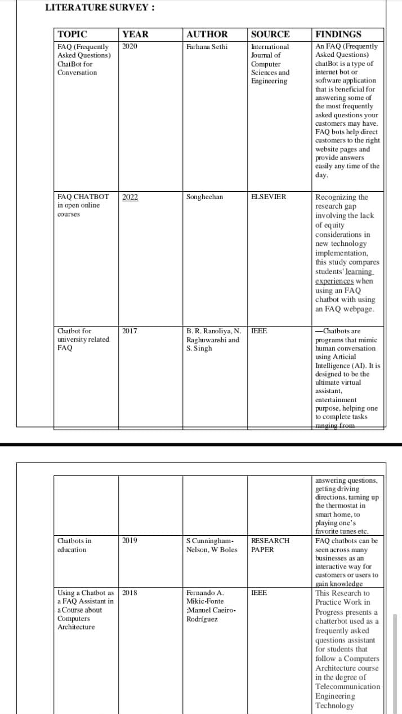

CONCLUSION:
A chatbot is one of the simple ways to transport data from a computer without having to think for proper keywords to look up in a search or browse several web pages to collect information; users can easily type their query in natural language and retrieve information

Project submitted by:
s.swetha
a.varsha
P.Kajoel
j.jael benedictia
jp.kaviya

