# Page 1

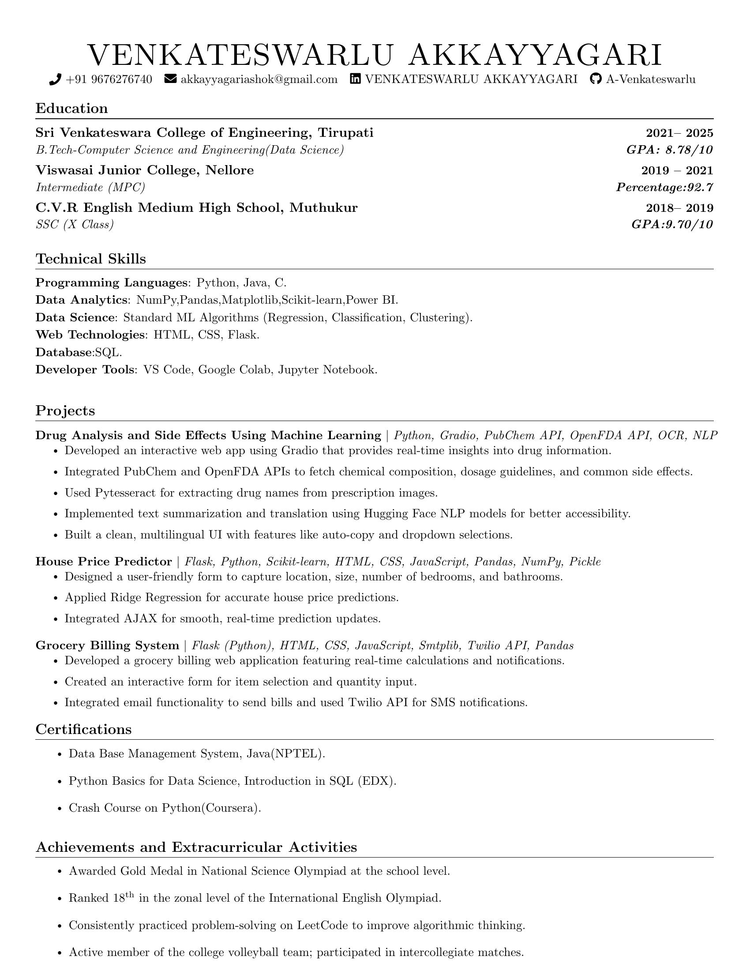

VENKATESWARLU AKKAYYAGARI  
  
oJ +91 9676276740 SG akkayyagariashok@gmail.com ff} VENKATESWARLU AKKAYYAGARI §€) A-Venkateswarlu  
  
Education  
  
Sri Venkateswara College of Engineering, Tirupati 2021— 2025  
B.Tech-Computer Science and Engineering(Data Science) GPA: 8.78/10  
Viswasai Junior College, Nellore 2019 — 2021  
Intermediate (MPC) Percentage:92.7  
C.V.R English Medium High School, Muthukur 2018— 2019  
SSC (X Class) GPA:9.70/10  
  
Technical Skills  
  
Programming Languages: Python, Java, C.  
  
Data Analytics: NumPy,Pandas,Matplotlib,Scikit-learn,Power BI.  
  
Data Science: Standard ML Algorithms (Regression, Classification, Clustering).  
Web Technologies: HTML, CSS, Flask.  
  
Database:SQL.  
  
Developer Tools: VS Code, Google Colab, Jupyter Notebook.  
  
Projects  
  
Drug Analysis and Side Effects Using Machine Learning | Python, Gradio, PubChem API, OpenFDA API, OCR, NLP  
¢ Developed an interactive web app using Gradio that provides real-time insights into drug information.  
  
¢ Integrated PubChem and OpenFDA APIs to fetch chemical composition, dosage guidelines, and common side effects.  
¢ Used Pytesseract for extracting drug names from prescription images.  
¢ Implemented text summarization and translation using Hugging Face NLP models for better accessibility.  
¢ Built a clean, multilingual UI with features like auto-copy and dropdown selections.  
House Price Predictor | Flask, Python, Scikit-learn, HTML, CSS, JavaScript, Pandas, NumPy, Pickle  
¢ Designed a user-friendly form to capture location, size, number of bedrooms, and bathrooms.  
« Applied Ridge Regression for accurate house price predictions.  
« Integrated AJAX for smooth, real-time prediction updates.  
Grocery Billing System | Flask (Python), HTML, CSS, JavaScript, Smtplib, Twilio API, Pandas  
« Developed a grocery billing web application featuring real-time calculations and notifications.  
¢ Created an interactive form for item selection and quantity input.  
  
¢ Integrated email functionality to send bills and used Twilio API for SMS notifications.  
  
Certifications  
  
* Data Base Management System, Java(NPTEL).  
¢ Python Basics for Data Science, Introduction in SQL (EDX).  
  
« Crash Course on Python(Coursera).  
  
Achievements and Extracurricular Activities  
  
¢ Awarded Gold Medal in National Science Olympiad at the school level.  
« Ranked 18" in the zonal level of the International English Olympiad.  
¢ Consistently practiced problem-solving on LeetCode to improve algorithmic thinking.  
  
« Active member of the college volleyball team; participated in intercollegiate matches.