**﷽**

Fdfd and press ALT + X AND SELECT AMIRI FONT

**CREATING BORDER LINE**

SINGLE LINE

--- dash three time and press enter

BOLD LINE

___ underscore three time and press enter

DOUBL LINE

=== is equal to three time and press enter

DOTTED LINE

*** steric three time and press enter

CURVE LINE

~~~ tile three time and press enter

THREE DESIGNED LINES

### three time and press enter

**GENERATING RANDOM PARA**

* =rand() (5 para , 3 sen)
* =rand(7, 4) (7 para , 4 sen)
* =lorem()
* =Lorem(3,2)

**CREAITNG ALL SHORT CUTS**

**ALT + F8**

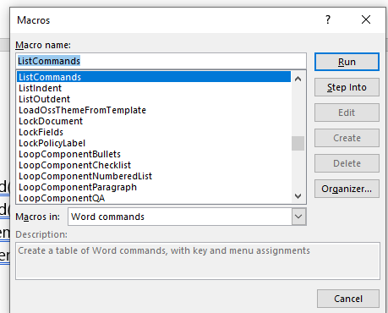

AND THEN OKAY