QUESTION 1

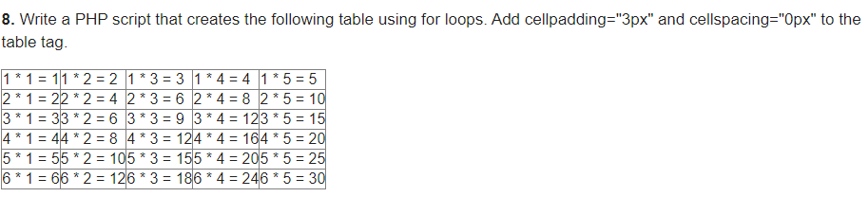

QUESTION 2

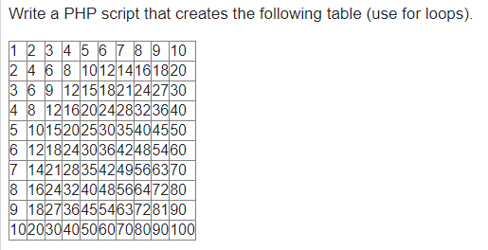

QUESTION 3

MAKE A GRADE CALCULATOR USING PHP

* CONSIDER 5 SUBJECTS
* TOTAL OBTAINED WILL BE 100
* YOU NEED TO CALCULATE
  + TOTAL MARKS
  + GRADE
  + PERCENTAGE
  + CGPA (FOR UNIVERSITY STUDENTS)

