CC 319 Advanced Programming Project Report

Our Team Presents: -

**Application: Smart Wallet**

Presented By: Abdallah Yhia 19103937

Reem Osama 19103183

Malak Raaof 19101355

Presented To: Dr. Karma M.Fathalla

Eng. Mohamed Fawzy

System Requirement Analysis

Target: This program targets almost everyone as it’s so hard for anyone to remember all his money transactions over long periods, and from here comes the importance of this system.

Mission: Secure, maintain & calculate one’s transactions over specified time interval.

Key-Attributes: -

1-Secure (Password-protected plus Human verification)

2-Data-base linked (so your information is always stored and updated)

3-Reliable

4-Easy to use

New Features: -

1-Multiple wallet feature

2-Full report summary feature

Operation Scheme: -

**IF**

Checks the login information with its equivalence in the database

**Login Page** The information inserted is not identical

The information inserted is identical

If wallet Created successfully & asked for access

IF Human Robot-Human

Home Page

Wallets Page

Then access is granted Check Page

Debit Page

Full Report

Expenses Page

Income Page

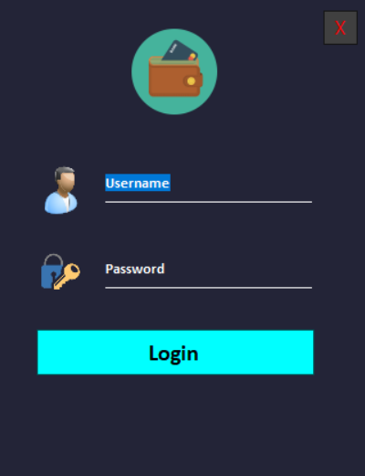Sample Shots Of The GUI

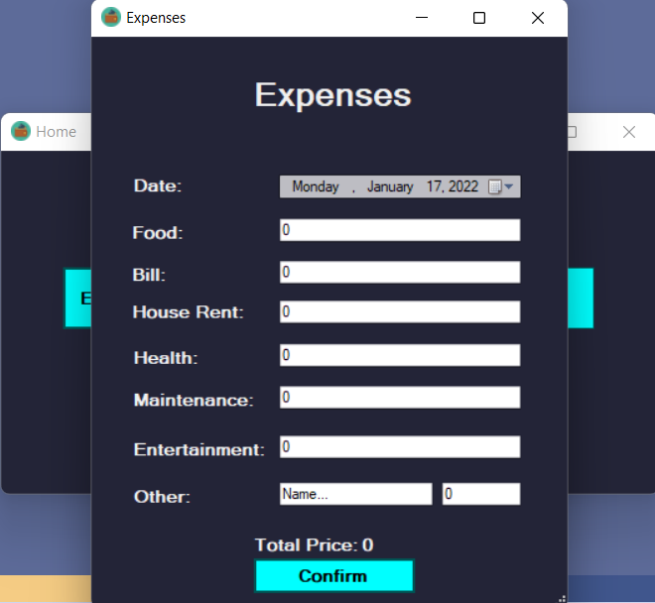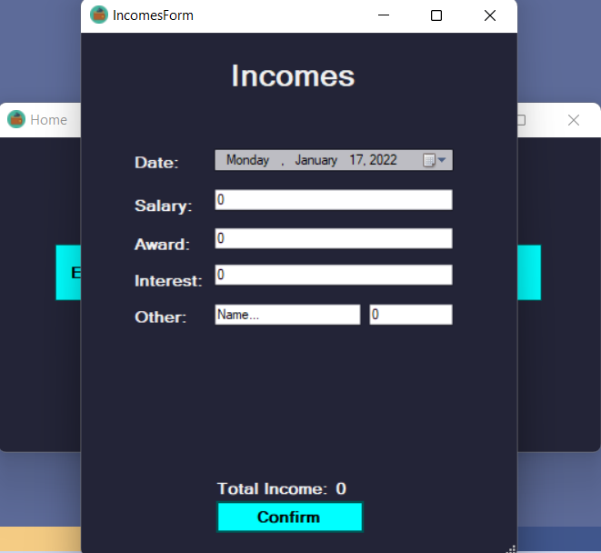

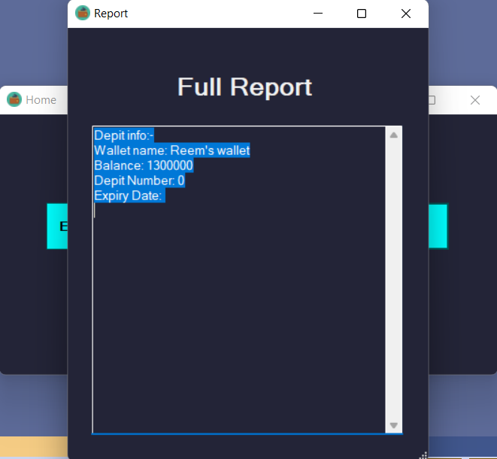

Class Hierarchy

|  |
| --- |
| ClassTransaction |
| +total: double  +Date: string |
|  |

|  |
| --- |
| ClassProduct |
| +ProdPrice: double  +ProdName: string |
| +<<constructor>> ClassProduct (name:string,price:double) |

|  |
| --- |
| ClassUser |
| +username: string  -password: string  +wallets: List<ClassWallet> |
| +<<constructor>> ClassUser()  +<<constructor>>ClassUser (name:string,pass:string) |

|  |
| --- |
| ClassWallet |
| +name: string  +balance: double  +transactions: List<ClassTransaction>  +DepitCard: ClassDepit |
| +<<constructor>> ClassWallet (name:string,balance:double) |

|  |
| --- |
| ClassIncome:ClassTransaction |
| +Salary: double  +Award : double  +Interest: double  +Others: ClassProduct |
| +Total (total:double) |

|  |
| --- |
| ClassDepit |
| +DepitNum: double  +ExpireDate: string |
|  |

|  |
| --- |
| ClassExpenses:ClassTransaction |
| +Health: double  +Entertainment: double  +FixAndMaintenance: double  +HouseRent: double  +Bill: double  +FoodAndDrinks: double  +Others: ClassProduct |
| +Total (total:double) |

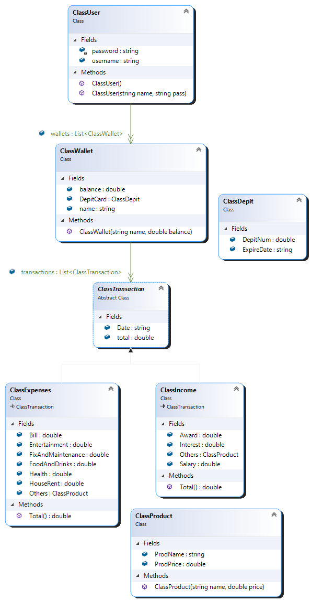Generated UML



First things first: What is a code of ethics?

A code of ethics is a guide of principles designed to help professionals conduct business honestly and with integrity. ... A code of ethics, also referred to as an "ethical code," may encompass areas such as business ethics, a code of professional practice, and an employee code of conduct.

So, we can say that the expression “Developer Ethics” describes the field of ethics when applied to the behavior of software developers.

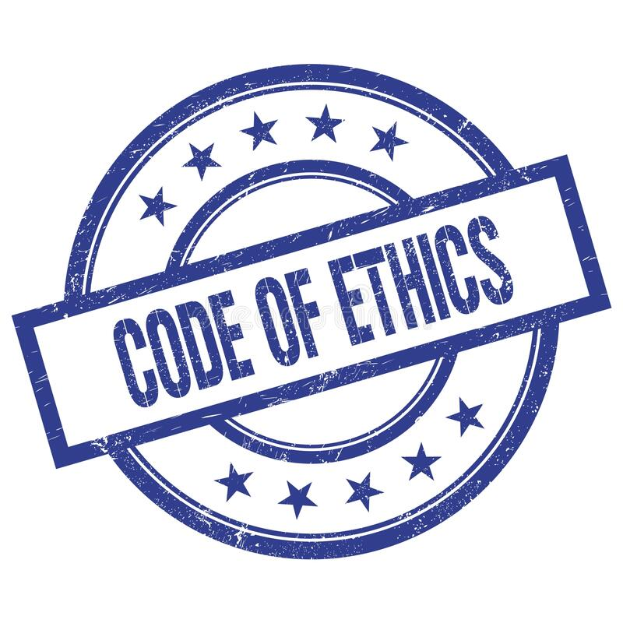

Coding Ethics

According to: <https://www.gammadyne.com/ethics.htm>

A programmer must...

1. ...never create or distribute **malware**.
2. ...never write code that is **obfuscated** or intentionally difficult to follow.
3. ...never write **documentation** that is intentionally confusing or inaccurate.
4. ...never reuse **copyrighted code** unless the proper license is purchased, or permission is obtained.
5. ...**acknowledge** (verbally and in source code comments) the work of other programmers on which the code is based, even if substantial changes are made.
6. ...never write code that is **deliberately inefficient** with the intent of later claiming credit for making efficiency improvements.
7. ...never intentionally introduce **bugs** with the intent of later claiming credit for fixing the bugs, or to stimulate the uptake of later versions.
8. ...never write code that intentionally **breaks** another programmer's code for the purpose of elevating one's status.
9. ...never hide known **obstacles** to a project's completion during any phase of development, especially the design phase.
10. ...never dishonestly **downplay** the difficulty of completing a project.
11. ...report any **illegal activities** of the employer.
12. ...never **defame** the profession.
13. ...never falsely **deny** the presence of bugs.
14. ...never **reveal** the secret corporate knowledge of an employer.
15. ...never accept compensation from multiple parties for the **same work** unless permission is given.
16. ...never perform **competitive work** without the employer's knowledge.
17. ...never conceal **pertinent information** from other members of the development team.
18. ...never conceal from the employer their **financial interest** in development resources.
19. ...never conceal any **conflict of interest** that may affect the project.
20. ...never seek **external profit** from a project that was funded by a second party without permission.  If permission is given to resell a product, the work should be discounted.
21. ...never maliciously **injure the reputation** of an employer or members of the development team.
22. ...never **misrepresent** their knowledge, experience, or abilities.
23. ...never **take credit** for another's work.
24. ...never **steal** software, especially development tools.
25. ...never conceal the **deficiencies** of other programmers by writing code for them and allowing them to pass it off as their own work.
26. ...install **third-party applications** without the user's permission.  Preferably not at all.
27. ...**stay current** on the advancement of the field of Computer Science.
28. ...never **force updates** on a user without their knowledge and approval.

To sum up the previous points, All Software engineers shall commit themselves to making the analysis, specification, design, development, testing and maintenance of software a beneficial and respected profession. In accordance with their commitment to the health, safety and welfare of the public, software engineers shall adhere to the following Eight Principles according to **IEEE-CS/ACM Joint Task Force on Software Engineering Ethics and Professional Practices:** <https://www.computer.org/education/code-of-ethics>

1. PUBLIC – Software engineers shall act consistently with the public interest.

2. CLIENT AND EMPLOYER – Software engineers shall act in a manner that is in the best interests of their client and employer consistent with the public interest.

3. PRODUCT – Software engineers shall ensure that their products and related modifications meet the highest professional standards possible.

4. JUDGMENT – Software engineers shall maintain integrity and independence in their professional judgment.

5. MANAGEMENT – Software engineering managers and leaders shall subscribe to and promote an ethical approach to the management of software development and maintenance.

6. PROFESSION – Software engineers shall advance the integrity and reputation of the profession consistent with the public interest.

7. COLLEAGUES – Software engineers shall be fair to and supportive of their colleagues.

8. SELF – Software engineers shall participate in lifelong learning regarding the practice of their profession and shall promote an ethical approach to the practice of the profession.

Last but not least: -

**Handshake with solid fill**Robert C. Martin (Uncle Bob) created the “**Clean Code”** initiative which declared the **programmer’s oath** that states the following:

In order to defend and preserve the honor of the profession of computer programmers,

I Promise that, to the best of my ability and judgement:

1. I will not produce harmful code.
2. The code that I produce will always be my best work. I will not knowingly allow code that is defective either in behavior or structure to accumulate.
3. I will produce, with each release, a quick, sure, and repeatable proof that every element of the code works as it should.
4. I will make frequent, small, releases so that I do not impede the progress of others.
5. I will fearlessly and relentlessly improve my creations at every opportunity. I will never degrade them.
6. I will do all that I can to keep the productivity of myself, and others, as high as possible. I will do nothing that decreases that productivity.
7. I will continuously ensure that others can cover for me, and that I can cover for them.
8. I will produce estimates that are honest both in magnitude and precision. I will not make promises without certainty.
9. I will never stop learning and improving my craft.