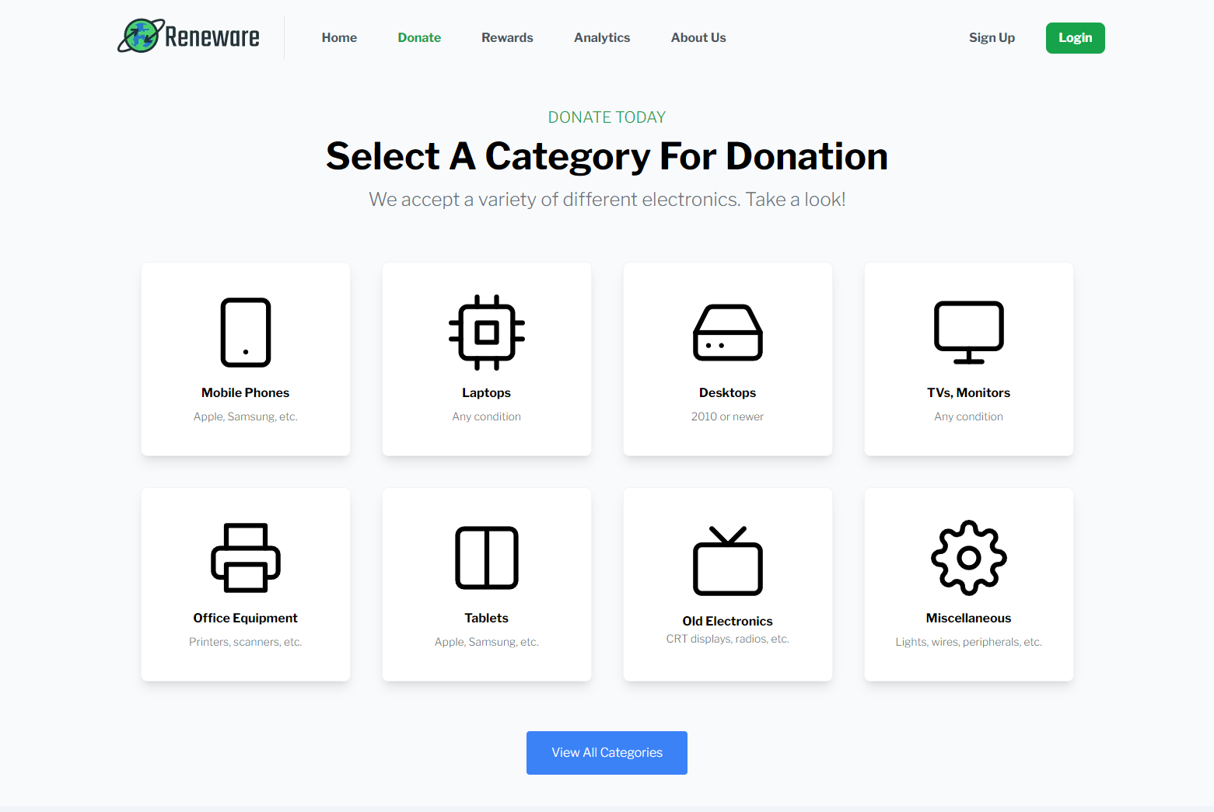

Reneware

<https://reneware.vercel.app/> TEAM AKR3

Aaron Chan

Khang(Kayden) Nguyen

Swati Chourey

Roger Wu

Jexequiel Ravni Arador

Ryan Leong

# Overview

Technological innovation is far outpacing our capacity to recycle past devices. Less than a quarter of e-waste is recycled per year and the amounts are increasing with no end in sight. We must create a solution that can help mitigate the amount of electronics ending up in landfills worldwide.

# Goals

1. Create a system to lower the amount of e-waste that ends up in landfills.
2. Target both the consumer and corporate side of the equation.
3. Collect metrics on all donated devices to quantify the improvement to current recycling statistics.
4. Create a platform where consumers can easily donate used electronics, offering tax deductions on applicable donations, as well as reward points for use on our site.
5. Distribute donated but functional electronics to low-income schools and families in the donator’s local community.
6. Repurpose all worn down but functional components, for use in our recycled cloud computing system.
7. Minimize the integration of “brand new” parts during the refurbishing process.
8. Stretch goal - partner with well known companies to increase our brand awareness and strengthen the recycling campaign

# Specifications

One of the main problems in e-waste recycling is that only a small percentage of waste is actually recycled, while the rest will either end up in landfills or go unaccounted for. In order to combat this problem, our team AKR3(S) decided our best option would be to limit our reliance on current recycling infrastructure to handle e-waste, and create our own platform to improve recycling metrics and build data analytics to improve the e-waste ecosystem.

In order to shift our focus from “immediate recycling” of all e-waste, we decided to go for the “repurposing” route. In our ever-growing technological age, there are still many low-income communities who don’t have access to updated technology, whether it be for online classes, work from home, or just casual entertainment. Using our platform, recipients can sign up to receive donated computers, phones, and other electronics. By approaching the problem in this way, we can be more certain that the devices will be put to good use and extend their lifespans, rather than simply throwing them in a recycling warehouse to be destroyed or forgotten. We can delay the need for recycling by 2 to 3 times the product’s current lifespan - that is, a mobile phone that someone used for only 2 or 3 years, could possibly be used for 3 to 6 more years if taken care of.

In order to incentivize consumers to use our platform, we will offer rewards points for use on exclusive promotions with our partnering brands. Secondly, users whose devices are sent to schools or individuals will receive thank you notes from the recipients, as well as possible updates to accomplishments made using their technology. For example a school may have won a robotics competition using donated laptops and PC parts. This allows donators to personally experience their impact on the community, rather than simply dropping a device off at a waste plant.

In addition to our distribution network, our data analytics will provide influential data in the fight against planned obsolescence and “fast tech” (basically like fast fashion but in tech). Nowadays, manufacturers build devices with only a few years lifespan, so they can purposely generate recurring customers who purchase the new device every other year. Today, profit rules most major companies. With greater data covering manufacturers’ devices, our platform can educate consumers on bad practices by big businesses, and help them shop smarter for longer lasting, less polluting devices.

There is also the problem of broken devices, for example, phones or laptops that have missing/broken components, while still retaining some function in other areas. Our plan to utilize these devices is to connect the processing power together in the form of a “distributed system,” otherwise known as parallel computing. The amount of processing power in modern phones (roughly 2005 onwards) and laptops rival antique supercomputers of the 20th century. Our cloud platform can operate fully on “green” hardware, providing computing power and servers to schools or hobbyists, and even medical researchers (one such project that uses a distributed system is Folding@Home).

In addition to compute power, the network is also capable of supporting the blockchain, paving the way for a greener Web3 ecosystem. Currently, one of the main arguments against DeFi (decentralized finance) is that cryptocurrency uses up a large amount of resources, both in mining and in hosting the network. If we repurpose technology that otherwise would have been junked, then we can build a network that is more environmentally friendly and also cheaper.

In order to keep the project running, it’s possible for the platform to break down items that are completely destroyed (a completely smashed phone, or a fire-damaged laptop, for example) into raw materials for recycling. Per device, this amount may not mean much, but when looking at bulk inventory, the revenue will quickly add up. This would only be done for devices that are broken beyond repair. Secondly, it’s possible to sell computing power at almost no cost to our company, since the components will be donated. Users can host static sites or other small projects using our servers, which will cost a fraction of the competition’s but still allow us to profit due to our low operating expenses. Lastly, corporate sponsorships will both increase our profit and our global reach, which will result in more donations and business for our brand.

# Milestones

## Build an MVP for the donation rewards and analytics platform

Allow users to donate and receive old electronics locally

## Gather users and generate brand awareness

Corporate partnerships and sponsors will be paramount

## Create a functioning parallel computing system using refurb hardware

Focus on minimal integrations with new components

## Begin partnerships with schools and community centers

Expand our reach to other regions in Canada, and eventually internationally