

**Assignment**

**Submitted to**

**Tania Khatun**

**Lecturer in Computer Science and Engineering**

**Daffodil International University**

**Submitted By**

**Md. Amirul Islam**

**Id No: 181-15-1748**

**Section: PC-A**

**Daffodil International University**

**Date: 22-01-2021**

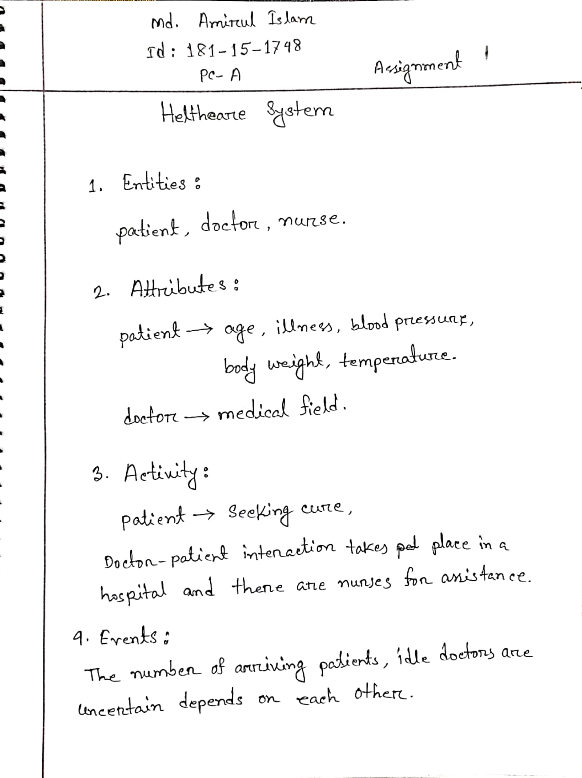

**Thank You**