

**Lab report-01**

**Submitted to**

**Hasin Rehana**

**Lecturer in Computer Science and Engineering**

**Daffodil International University**

**Submitted By**

**Md. Amirul Islam**

**Id No: 181-15-1748**

**Section: PC-A**

**Daffodil International University**

**Date: 14-06-2021**

**Experiment No:01**

**Experiment Name: Chess Board**

**Lab Code:**

**#include<windows.h>**

**#include <GL/gl.h>**

**#include <GL/glut.h>**

**int i,j,k;**

**void display(void)**

**{**

**glClear(GL_COLOR_BUFFER_BIT);**

**for(i=0; i<8; i++)**

**{**

**for(j=0; j<8; j++)**

**{**

**glBegin(GL_POLYGON);**

**if((i%2)==0)**

**{**

**if((j%2)==0)**

**{**

**glColor3f(1,1,1);**

**}**

**else**

**{**

**glColor3f(0,0,0);**

**}**

**}**

**else**

**{**

**if((j%2)==0)**

**{**

**glColor3f(0,0,0);**

**}**

**else**

**{**

**glColor3f(1,1,1);**

**}**

**}**

**glVertex2f(i,j);**

**glVertex2f(i+1,j);**

**glVertex2f(i+1,j+2);**

**glVertex2f(i,j+1);**

**glEnd();**

**}**

**glFlush ();**

**}**

**}**

**void init (void)**

**{**

**glClearColor (0.0, 0.0, 0.0, 0.0);**

**glMatrixMode(GL_PROJECTION);**

**glLoadIdentity();**

**glOrtho(0.0, 8, 0.0, 8, -1.0, 1.0);**

**}**

**int main(int argc, char** argv)**

**{**

**glutInit(&argc, argv);**

**glutInitDisplayMode (GLUT_SINGLE | GLUT_RGB);**

**glutInitWindowSize (900, 600);**

**glutInitWindowPosition (100, 100);**

**glutCreateWindow ("chess board");**

**init ();**

**glutDisplayFunc(display);**

**glutMainLoop();**

**return 0;**

**}**

**Input and output Screenshot:**

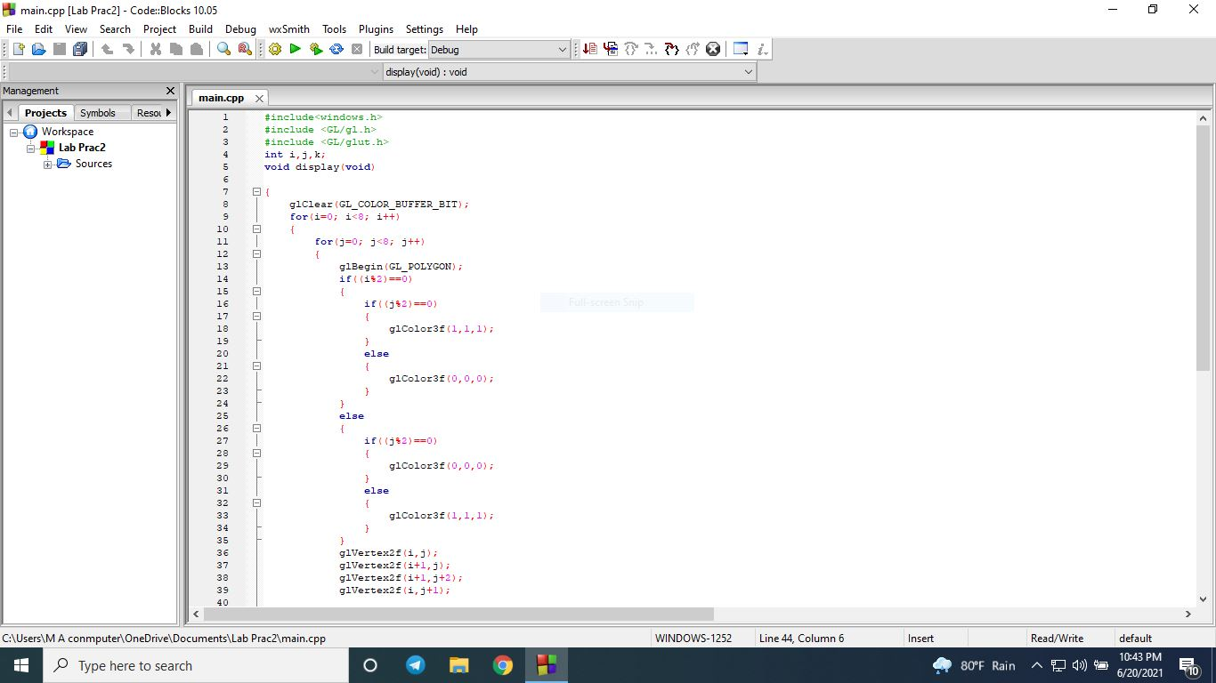

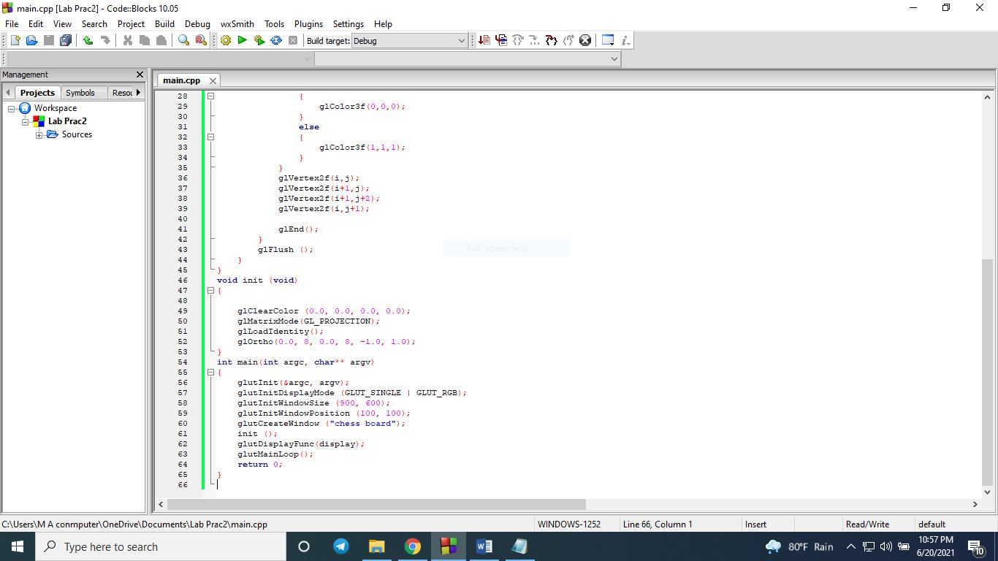

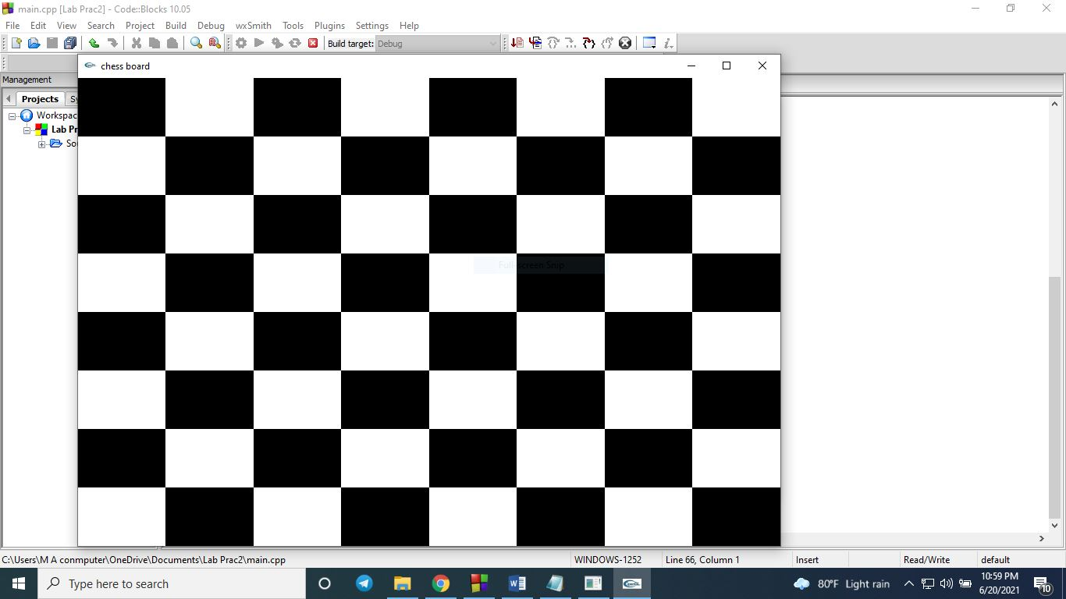

**Discussion:**

**We call here to “glClear(GL_COLOR_BUFFER_BIT);” clears the OpenGL color and depth buffers. Then we used for loop to fixed the row and columns number. We use "glBegin()" function which takes as one parameter the mode or type of object we want to draw. GL_POLYGON that's mean we want to draw polygon. Then we used “glColor3f(1,1,1); “ that where is white color value is 1, 1, 1 and then we used “glColor3f(0,0,0); “ that where is black color value is 0, 0, 0. The function “glVertex2f” specifies the x and y coordinates of the vertex, and the z coordinate is set to zero. The glBegin and glend functions delimit the vertices that define a primitive or a group of like primitives. The glFlush function empties all these buffers, causing all issued commands to be executed as quickly as they are accepted by the actual rendering engine. To select clearing background color we used “glClearColor (0.0, 0.0, 0.0, 0.0);”. This is initialize viewing values. Declare initial window size, position, and display mode we use " glutInitWindowSize (900, 600);" and "glutInitWindowPosition (100, 100);". To open window with Chess board we use "glutCreateWindow ("chess board");".It is the title bar. To Call initialization we use "init ();".To register callback function to display graphics we use "glutDisplayFunc(display);".To enter main loop and process events we use "glutMainLoop();".Finally return the program.**

**Thank You**