DOCUMENTAÇÃO

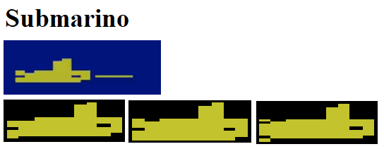

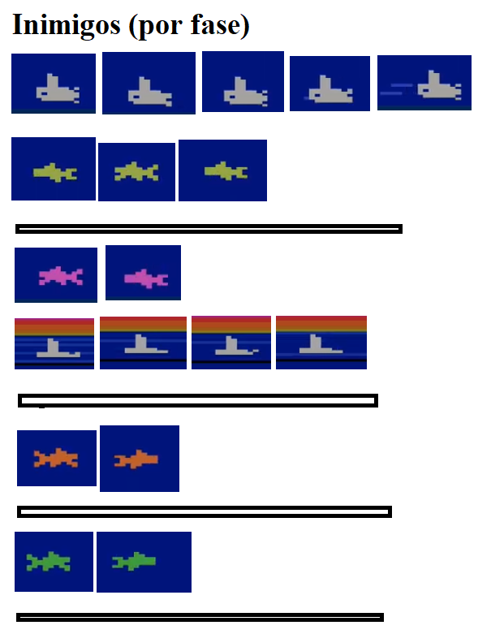
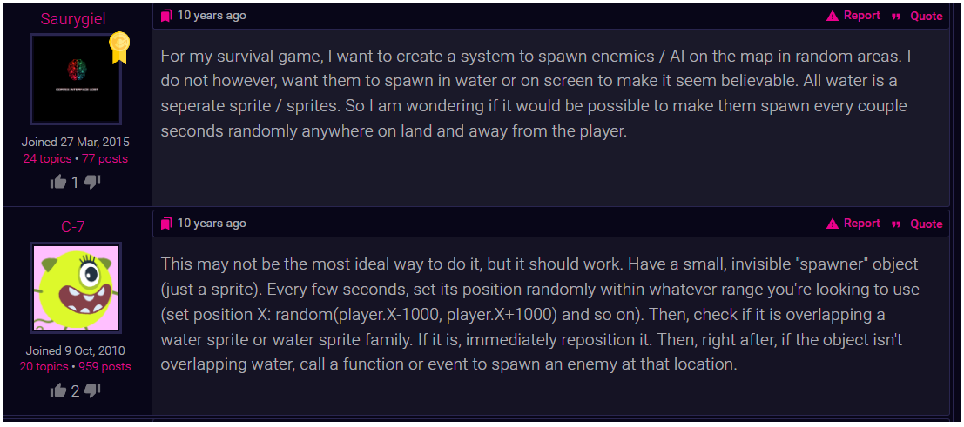
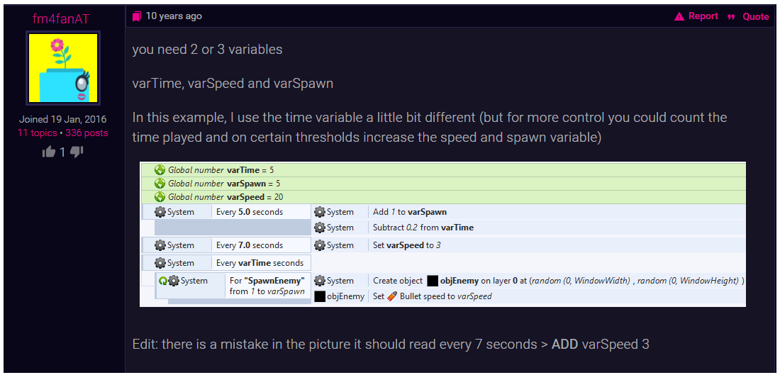
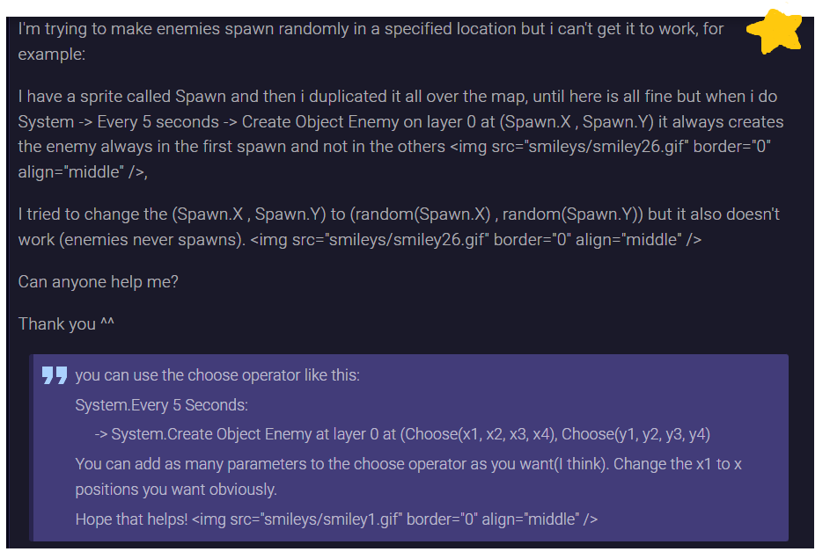
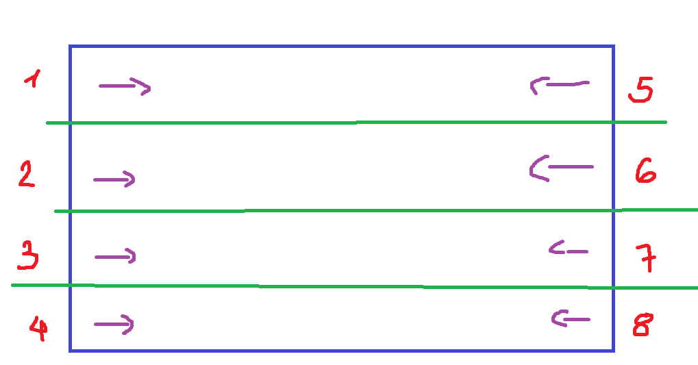

- https://github.com/kortkamp/SeaQuestJs
Rewards
Score points are your only reward.
Blasting enemy sub and killer shark is worth 20 points. Every time you surface with six divers, the value of enemy subs and killer sharks increases by 10, up to a maximum of 90 points each.
Rescued divers start at 50 points each. Then, their point value increases by 50, every time you surface, up to a maximum of 1000 points each.
You’ll be further rewarded with bonus points for all the oxygen you have remaining the moment you surface. The more oxygen you have left, the more bonus points you’re given.
For a more detailed documentation, see the AtariAge page.

10. Scoring. When the game begins, every killer shark and enemy sub is worth
20 points. Every time you surface with six divers, the value of enemy subs
and killer sharks increases by 10, up to a maximum of 90 points each. Rescued
divers start at 50 points each. Then, their point value increases by 50, every
time you surface, up to a maximum of 1000 points each. Also, you'll be
further rewarded with bonus points for all the oxygen you have remaining the
moment you surface. The more oxygen you have left, the more bonus points
you're given.
When the oxygen
tank is almost empty, a continuous beep alarm will sound and the alarm light
will flash. you have _8_ seconds to surface for air! If you don't surface in
time, your sub will blow up and you'll lose one diver.
Each time you
increase your score by 10,000 points, an extra sub will be delivered to your
base.

